JOB DESCRIPTION

JOB DETAILS
Job Title | Senior BMS, Section Lead – Haematology / Immunology
Reports to | Laboratory Manager
Band | AfC Pay scale Band 7
Department/Directorate | Blood Sciences – Specialist Services

JOB PURPOSE
To ensure provision of the scientific service commitment of the laboratory in line with Trust objectives and commensurate with grade and responsibilities.

Dimensions:
The laboratory provides a comprehensive service of routine and specialised analysis for Haematology and Immunology investigations.
The laboratory has full UKAS accreditation.
The department offers a full clinical interpretive service in all areas
The department employs 30 scientific members of staff within the areas of Automated Haematology, Coagulation, Proteins, Morphology, Automated Immunology, Fluorescent Microscopy, Specialist Serology.

KEY RESULT AREAS/PRINCIPAL DUTIES AND RESPONSIBILITIES
The post holder will be responsible for overseeing the day-to-day operations of the Haematology / Immunology sections within the Blood Sciences Department. The primary task is to efficiently manage the assigned section of the laboratory, conducting a diverse range of highly specialised and diagnostic techniques to ensure the provision of a laboratory service that meets the required standards. These responsibilities encompass activities such as sample analysis, technical validation, interpretation and reporting of results, method evaluation and the development of staff.

The overarching goal is to contribute to effective patient care, meet service demands and turnaround times, foster continuous quality improvement, and enhance the quality management system within the laboratory section.

In order to achieve these objectives, the post holder must effectively communicate with colleagues, managers, clinicians and service users. They must also ensure the availability of necessary reagents and consumables. Additionally, the post holder will be required to troubleshoot analytical and technical issues to maintain the reliability of service delivery.

KEY WORKING RELATIONSHIPS
Areas of Responsibility: Haematology / Immunology

No. of Staff reporting to this role: 5/6

The post holder is required to deal effectively with staff of all levels throughout the Trust as and when they encounter on a day to day basis. In addition, the post holder will deal with the wider healthcare community, external organisations and the public. This will include verbal, written and electronic media.

Of particular importance are working relationships with:

Internal to the Trust | External to the Trust
Clinical Head of Department  Laboratory Manager (Blood Sciences)  Deputy Laboratory Manager  Other Band 7 BMS  Other BMS Grades  MTO staff  Trust and Primary Care Clinical/Nursing Staff | Company Representatives  External engineers  Primary care staff

ORGANISATIONAL CHART
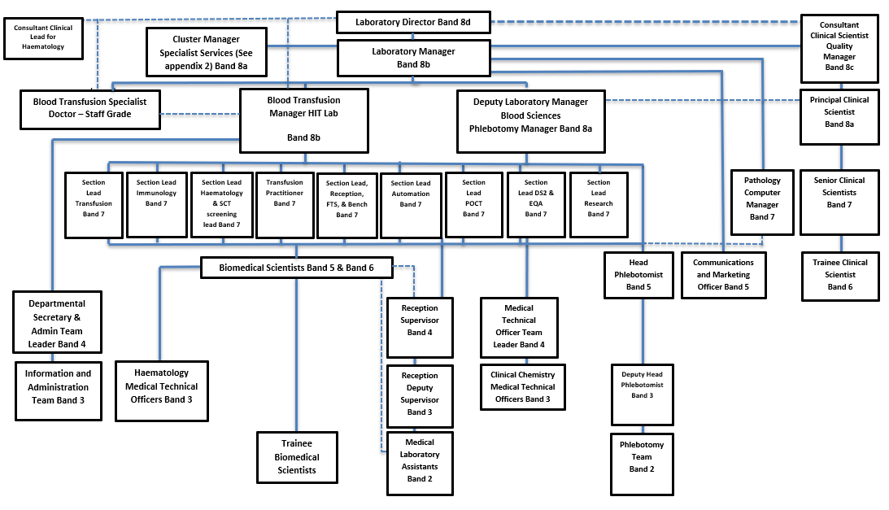
FREEDOM TO ACT
The post holder is guided clearly defined policies and protocols. Work is managed, rather than supervised, and results/outcomes are assessed at agreed intervals.

COMMUNICATION/RELATIONSHIP SKILLS
To give appropriate scientific advice to clinical staff within the Trust and Community.
To use electronic and verbal communication within the department and the Trust.
To participate in the laboratories operational and educational meetings.
To attend meetings with other health care professionals to develop departmental policies.
To meet with representatives from companies providing materials or services to ensure an efficient and cost-effective service is maintained.
To maintain the departments policies and information on the Trust current communication system.

ANALYTICAL/JUDGEMENTAL SKILLS
To manage the day to day scientific work of the department and to provide support where necessary.
To give specialist advice to clinicians and other scientific staff.
To appraise new techniques and equipment and give appropriate advice to the laboratory managers on their implementation.

PLANNING/ORGANISATIONAL SKILLS
In liaison with the Laboratory Manager/Deputy ensure that services are delivered within agreed turnaround times in an efficient cost-effective manner to agreed quality levels.
To ensure the department adheres to current legislation. Including Health and Safety, UKAS, MHRA, where appropriate.

PATIENT/CLIENT CARE
There is no direct patient care in this role but the results generated, and advice given provides highly specialised clinical information that forms a significant part of clinical decision making.

POLICY/SERVICE DEVELOPMENT
To be responsible for developing, implementing and maintaining the department’s documentation.
To manage and monitor the External and Internal Quality Assurance schemes in the relevant areas in the department.
To ensure the maintenance of the laboratory Quality Management systems.
To plan and monitor compliance with the departments audit program.
To ensure the department complies with the laboratories current change control and validation system.
To ensure all work undertaken in the department is compliant with current UKAS and MHRA standards and legal requirements.
To develop and maintain the departments continuous improvement plan in line with the laboratories Quality Objectives.
To ensure all non-conformances are reported, investigated and improvement/actions acted on, within the laboratories Quality Management framework.

FINANCIAL/PHYSICAL RESOURCES
To order and authorise products to maintain the continuous provision of the department.
To be responsible for maintaining the provision of service within agreed quality and financial parameters.

HUMAN RESOURCES
To work with the Laboratory Manager/Deputy in organising staff rotations through the sections and to provide 24/7 cover.
To participate in the selection and recruitment of BMS staff in accordance with current Trust policies.
To be responsible with other laboratory Band 7 s for the selection and recruitment of support staff.
To ensure all staff within the department have the appropriate training and maintain their competency assessments in all areas.
To undertake CPD to maintain Health and Care Professions Council registration
To undertake annual PDR and PDP interviews with staff to whom they are line managers.
To manage all HR policy aspects of staff for which they act as line manager including performance, sickness and disciplinary.
To undertake training required in order to maintain competency, including mandatory training i.e. Fire, Manual Handling.

INFORMATION RESOURCES
To be involved in the development, maintenance and implementation of the departments IT systems.
To undertake final clinical approval of results from the laboratory computer system.

RESEARCH AND DEVELOPMENT
The post holder is required to regularly undertake R&D activities and will be required to conduct evaluation of new technology and instrumentation.

PHYSICAL SKILLS
Good hand-eye coordination is essential to ensure precision, safety, and efficiency.

PHYSICAL EFFORT
Perform occasional manual handling duties of moderate intensity such as stock rotation and replenishing instrument reagent supplies.
The post holder may be required to partake in the 24/7 shift system.

MENTAL EFFORT
Daily management of competing demands, including sample analysis, requests for information, staff shortages, roster changes, and equipment breakdowns, necessitating quick transitions between tasks.
The ability to maintain consistently high levels of concentration in a setting characterised by frequent and unpredictable distractions.
The role involves working in a highly automated and noisy environment with multiple competing demands.
Individuals are required to sustain high levels of concentration for extended periods.

EMOTIONAL EFFORT
Required to deal with staffing issues in a busy work environment which needs effective resource management, conflict resolution, morale maintenance and adaptability.

WORKING CONDITIONS
Daily exposure to potentially infectious and biohazardous materials, including blood and other body fluids.
The post holder may be required to partake in the 24/7 shift system.

OTHER RESPONSIBILITIES
Take part in regular performance appraisal.

Undertake any training required in order to maintain competency including mandatory training, e.g. Manual Handling

Contribute to and work within a safe working environment

You are expected to comply with Trust Infection Control Policies and conduct him/herself at all times in such a manner as to minimise the risk of healthcare associated infection

As an employee of the Trust, it is a contractual duty that you abide by any relevant code of professional conduct and/or practice applicable to you. A breach of this requirement may result in action being taken against you (in accordance with the Trust’s disciplinary policy) up to and including dismissal.

You must also take responsibility for your workplace health and wellbeing:
- When required, gain support from Occupational Health, Human Resources or other sources.
- Familiarise yourself with the health and wellbeing support available from policies and/or Occupational Health.
- Follow the Trust’s health and wellbeing vision of healthy body, healthy mind, healthy you.
- Undertake a Display Screen Equipment assessment (DES) if appropriate to role.

GENERAL
This is a description of the job as it is now. We periodically examine employees' job descriptions and update them to ensure that they reflect the job as it is then being performed, or to incorporate any changes being proposed. This procedure is conducted by the manager in consultation with the jobholder. You will, therefore, be expected to participate fully in such discussions. We aim to reach agreement on reasonable changes, but if agreement is not possible, we reserve the right to insist on changes to your job description after consultation with you.

Everyone within the Trust has a responsibility for, and is committed to, safeguarding and promoting the welfare of vulnerable adults, children and young people and for ensuring that they are protected from harm, ensuring that the Trusts Child Protection and Safeguarding Adult policies and procedures are promoted and adhered to by all members of staff.

PERSON SPECIFICATION

Job Title | Section Lead – Haematology / Immunology

Requirements | Essential | Desirable
QUALIFICATION/ SPECIAL TRAINING  State Registration HCPC  Have a suitable Masters degree or IBMS higher specialist diploma or equivalent (or willingness to complete one)  Evidence of formal management training  Evidence of CPD | E  E  E | D
KNOWLEDGE/SKILLS  Specialist knowledge of:  Haematology, Coagulation Blood Morphology and / or Immunology.  Haemoglobinopathies and ANC screening programme  Laboratory Governance and accreditation requirements  Laboratory health and safety requirements | E  E  E | D
EXPERIENCE  Post HCPC registration experience in an NHS Haematology / Immunology Laboratory  Experience of maintaining and developing laboratory computer systems  Experience of Automated Laboratory Equipment  Previous experience of managing staff  Evidence of delivering training within a clinical laboratory | E  E | D  D  D
PERSONAL ATTRIBUTES  Excellent Team Leader  Good Communication Skills verbal and written  Self motivated and ability to motivate others  Good Attendance Record  Flexibility and ability to prioritise to meet deadlines | E  E  E  E  E
OTHER REQUIREMENTS  Ability to participate in 7 day work pattern  Experience of change management | E  E

FREQUENCY

(Rare/ Occasional/ Moderate/ Frequent)
WORKING CONDITIONS/HAZARDS |  | R | O | M | F
Hazards/ Risks requiring Immunisation Screening
Laboratory specimens | Y |  |  |  | F
Contact with patients | N
Exposure Prone Procedures | N
Blood/body fluids | Y |  |  |  | F
Laboratory specimens | Y |  |  |  | F
Hazard/Risks requiring Respiratory Health Surveillance
Solvents (e.g. toluene, xylene, white spirit, acetone, formaldehyde and ethyl acetate) | Y |  | O
Respiratory sensitisers (e.g isocyanates) | N
Chlorine based cleaning solutions  (e.g. Chlorclean, Actichlor, Tristel) | Y |  | O
Animals | N
Cytotoxic drugs | N
Risks requiring Other Health Surveillance
Radiation (>6mSv) | N
Laser (Class 3R, 3B, 4) | N
Dusty environment (>4mg/m3) | N
Noise (over 80dBA) | N
Hand held vibration tools (=>2.5 m/s2) | N
Other General Hazards/ Risks
VDU use ( > 1 hour daily) | Y |  |  |  | F
Heavy manual handling (>10kg) | Y | R
Driving | N
Food handling | N
Night working | Y |  |  | M
Electrical work | N
Physical Effort | N
Mental Effort | Y |  | O
Emotional Effort | Y |  | O
Working in isolation | Y |  |  | M
Challenging behaviour | N

