Patient Flow Coordinator, matched 10/07/2019

J
O
B

D
E
S
C
R
I
P
T
I
O
N

“Our vision is to provide safe, high quality seamless service delivered with courtesy and respect. To achieve our vision we expect all our staff to uphold our Trust Values”

JOB DETAILS
Job Title | Haemodialysis Flow Co-ordinator
Reports to | Admin Line Manager
Band | Band 4
Department/Directorate | Renal unit, Medicine Division

JOB PURPOSE
- The post holder (HDFC) will be responsible for the day to day co-ordination of haemodialysis patient flow using knowledge of EPIC, Snapboard and Ensuring that all documentation is produced to an excellent standard
- Assess referrals from consultants and nurse specialists and plan Haemodialysis start date as appropriate.
- To ensure records and filing systems are maintained in line with Trust policies
- Monitor sessions and commitments provided by the clinical staff and reconcile this to contractual commitments
- Provide advance warnings of capacity issues
- Monitor and process any waiting list initiative claims accordingly, passing to the appropriate senior member for authorisation
- Ensure both planned and unplanned absences are communicated appropriately including back to work interviews being conducted within Trust timeframes, updating both HR and ESR (Electronic Staff Record).
- Use multiple computer systems as required within the department
- Respond to complaints where appropriate, escalating to Line Manager if unable to resolve
- Have an awareness of service continuity plan and Winter contingency plan.
Dialysis excel programming.
They will:
- Ensure excellent planning and organisation of Haemodialysis patients’ admissions, discharge, patient transfers and inpatient transfers and coordination with our Satellite units for ongoing dialysis.
- Use own initiative and be able to work without supervision and efficiently liaise with all stakeholders facilitating allocation of appropriate patients.
- Ensure all information is secure, and confidentiality of information is maintained at all times
- Be responsible for a small team including some admin and Holiday Haemodialysis coordinator, manage annual leave and cross cover between this team.
- Ensure the professional image of the Trust is maintained at all times.

KEY WORKING RELATIONSHIPS
- Senior Management Teams
- Trust Executive members
- Non-Executive Directors
- HR Department
- Lead Clinician, Consultants, Juniors Doctors, Specialist Nurses and other members of the medical and multi-disciplinary teams.
- Administrative Services Manager/Administrative Line Manager
- Divisional Management team
- Members of the multi-professional clinical team
- Administration and secretarial teams across the Trust
- Administrative and Clerical staff within area of responsibility
- External NHS organisations
- External organisations/providers

ORGANISATIONAL CHART
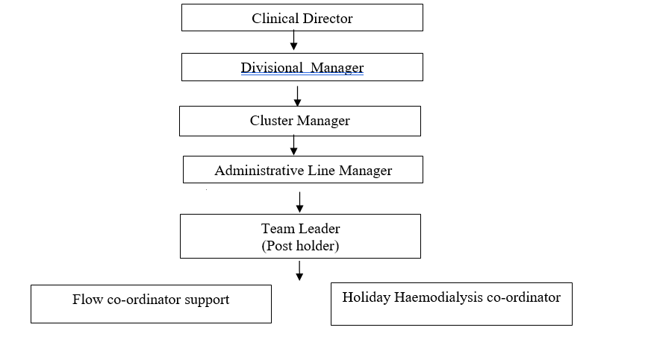

KEY RESULT AREAS/PRINCIPAL DUTIES AND RESPONSIBILITIES
COMMUNICATION/RELATIONSHIP SKILLS
- Communicate regarding a variety of enquiries on behalf of staff, using initiative, and following advice as directed
- Make and receive telephone calls both external and internal according to Trust standards
- Communicate effectively including discussion and written communication
- Proactively manage email communication in line with the RD&E’s Email Best Practice guidance
- Provide excellent customer care, in a calm and professional manner – some situations may be challenging
- Organise and/or support meetings through effective communication
- Liaise with transport providers
Liaise with clinical staff, nurse in charge on Dialysis unit and Creedy ward as well as clinical managers and ward clerks in our Satellite units.
ADMINISTRATION SKILLS
- Ensuring that all documentation is produced to an excellent standard
- Assess referrals from consultants and nurse specialists and plan Haemodialysis start date as appropriate.
- To ensure records and filing systems are maintained in line with Trust policies
Monitor sessions and commitments provided by the clinical staff and reconcile this to contractual commitments
PLANNING/ORGANISATIONAL SKILLS
- Provide advance warnings of capacity issues
- Monitor and process any waiting list initiative claims accordingly, passing to the appropriate senior member for authorisation
- Ensure both planned and unplanned absences are communicated appropriately including back to work interviews being conducted within Trust timeframes, updating both Healthroster and ESR (Electronic Staff Record).
- Use multiple computer systems as required within the department
- Respond to complaints where appropriate, escalating to Line Manager if unable to resolve
- Have an awareness of service continuity plan and Winter contingency plan.
POLICY/SERVICE DEVELOPMENT
- To contribute to service improvement by identifying areas for improvement.
- Participate in tests of change and gather data to assess benefits of any changes.
HUMAN RESOURCES
- Assist with on the job training of new staff when appropriate on the role of a HDFC.
INFORMATION RESOURCES
- Monitor information from a number of sources and systems to gain an overview of the state of the department and expected patients.
RESEARCH AND DEVELOPMENT
- Staff are encouraged to undertake surveys and audits as necessary in relation to your role/department.
FREEDOM TO ACT
- Demonstrate initiative in delivering any plans agreed with NIC.
- Ensure any issues that will prevent the smooth flow of patients are escalated to the NIC.
OTHER RESPONSIBILITIES
- To undertake any other duties appropriate to the grade as may be required to support patient flow.
- To take part in regular performance appraisal.
- To undertake any training required in order to maintain competency including mandatory training, e.g. Manual Handling.
- To contribute to and work within a safe working environment.
- The post holder is expected to comply with Trust Infection Control Policies and conduct him/herself at all times in such a manner as to minimise the risk of healthcare associated infection.
- As an employee of the Trust, it is a contractual duty that you abide by any relevant code of professional conduct and/or practice applicable to you. A breach of this requirement may result in action being taken against you (in accordance with the Trust’s disciplinary policy) up to and including dismissal.

This post has been identified as involving access to vulnerable adults and/or children and in line with Trust policy successful applicants will be required to undertake a Disclosure & Barring Service Disclosure Check.

THE TRUST- VISION AND VALUES
Our vision is to provide safe, high quality seamless services delivered with courtesy and respect. To achieve our vision we expect all our staff to uphold our Trust values. Our Trust values are:

Honesty, Openness & Integrity
Fairness,
Inclusion & Collaboration
Respect & Dignity

We recruit competent staff that we support in maintaining and extending their skills in accordance with the needs of the people we serve. We will pay staff fairly and recognise the whole staff’s commitment to meeting the needs of our patients.

We are committed to equal opportunity for all and encourage flexible working arrangements including job sharing.

We are committed to recruiting and supporting a diverse workforce and welcome applications from all sections of the community, regardless of age, disability, gender, race, religion, sexual orientation, maternity/pregnancy, marriage/civil partnership or transgender status. We expect all staff to behave in a way which recognises and respects this diversity, in line with the appropriate standards.
GENERAL
This is a description of the job as it is now. We periodically examine employees' job descriptions and update them to ensure that they reflect the job as it is then being performed, or to incorporate any changes being proposed. This procedure is conducted by the Manager in consultation with the jobholder. You will, therefore, be expected to participate fully in such discussions. We aim to reach agreement on reasonable changes, but if agreement is not possible, we reserve the right to insist on changes to your job description after consultation with you.

The RD&E is a totally smoke-free Trust. Smoking is not permitted anywhere on Trust property, including all buildings, grounds and car parks. For help to quit call: 01392 207462.

POST | Haemodialysis Flow Co-ordinator
BAND | 4
P
E
R
S
O
N

S
P
E
C
I
F
I
C
A
T
I
O
N

Requirements | Essential | Desirable
QUALIFICATION/ SPECIAL TRAINING  NVQ III in Customer Care or equivalent relevant experience  GCSE A-C or equivalent in Maths and English  Key board skills  Medical terminology | E  E  E | D
KNOWLEDGE/SKILLS  Basic computer skills  Excellent telephone manner  Ability to problem solve  Extracting information/listening skills  Motivation/negotiation skills  Good decision making skills  Knowledge of patient flow  Knowledge of Trust procedures including admissions | E  E  E  E  E  E | D  D
EXPERIENCE  Previous proven admin/clerical/reception  Dealing with the general public  Working in a busy, acute environment  Previous NHS experience  Experience of dealing with difficult/distressed people and situations | E  E | D  D  D
PERSONAL ATTRIBUTES  Excellent communication skills  Excellent organisational skills  Ability to work in a multidisciplinary team  Able to use own initiative and work with minimal supervision  Ability to remain calm and work under pressure  Ability to prioritise and multi-task  Flexible to meet needs of service  Confidence in dealing with a variety of people both professionals and others  Approachable  Willingness to learn new skills  Smart appearance  Highest integrity  Professional approach  Caring disposition | E  E  E  E  E  E  E  E  E  E  E  E  E  E
OTHER REQUIRMENTS  To work additional hours to provide cover for annual leave or sickness  Excellent attendance record  Bank holiday working | E  E | D

FREQUENCY

(Rare/ Occasional/ Moderate/ Frequent)
WORKING CONDITIONS/HAZARDS |  | R | O | M | F
Hazards/ Risks requiring Immunisation Screening
Laboratory specimens | Y/N
Contact with patients | Y/N
Exposure Prone Procedures | Y/N
Blood/body fluids | Y/N
Laboratory specimens | Y/N
Hazard/Risks requiring Respiratory Health Surveillance
Solvents (e.g. toluene, xylene, white spirit, acetone, formaldehyde and ethyl acetate) | Y/N
Respiratory sensitisers (e.g isocyanates) | Y/N
Chlorine based cleaning solutions  (e.g. Chlorclean, Actichlor, Tristel) | Y/N
Animals | Y/N
Cytotoxic drugs | Y/N
Risks requiring Other Health Surveillance
Radiation (>6mSv) | Y/N
Laser (Class 3R, 3B, 4) | Y/N
Dusty environment (>4mg/m3) | Y/N
Noise (over 80dBA) | Y/N
Hand held vibration tools (=>2.5 m/s2) | Y/N
Other General Hazards/ Risks
VDU use ( > 1 hour daily) | Y/N |  |  |  | Y
Heavy manual handling (>10kg) | Y/N |  | Y
Driving | Y/N
Food handling | Y/N
Night working | Y/N
Electrical work | Y/N
Physical Effort | Y/N |  |  |  | Y
Mental Effort | Y/N |  |  |  | Y
Emotional Effort | Y/N |  |  | Y
Working in isolation | Y/N
Challenging behaviour | Y/N |  | Y

COMPETENCY REQUIREMENTS
To be completed for all new positions
Please tick which of these essential learnings is applicable to this role
(NB those that are mandatory for all staff with no variation on frequency are pre-populated with a tick)

Safeguarding Children | Group 1 |  |  | Blood Transfusion | BDS18 collection |  | Consent Training
 | Group 2 |  |  |  | BDS 19 & 20  Preparing & Administering |  | VTE Training
 | Group 3 |  |  |  | BDS 17 Receipting |  | Record management and the nhs code of practice
 | Group 4 |  |  |  | Obtaining a blood sample for transfusion |  | The importance of good clinical record keeping
 | Group 5 |  |  |  | Annual Update |  | Antimicrobial Prudent Prescribing
 | Group 6 |  |  | Safeguarding Adults Awareness | Clinical Staff |  | Control & Restraint Annual
Not mapped this one |  |  |  |  | Non Clinical Staff |  | Mental Capacity/DOL’s
 | Group 8 |  |  | Falls, slips, trips & falls | Patients
Manual Handling – Two Year |  |  |  |  | Staff/Others
Equality & Diversity – One-Off requirement |  |  |  | Investigations of incidents, complaints and claims
Fire |  | Annual |  | Conflict Resolution – 3 yearly
 |  | Two Yearly |  | Waterlow
Infection Control/Hand Hygiene |  | Annual requirement |  | PUCLAS
 |  | One-Off requirement |  | Clinical Waste Management | Application principles for clinical staff
Information Governance |  |  |  |  | Application principles for housekeeping
Harassment & Bullying (Self Declaration – One off requirement) |  |  |  |  | Application principles for portering and waste

