|  |
| --- |
| J  O  B  D  E  S  C  R  I  P  T  I  O  N |

Job Evaluation complete: 22/07/2021



|  |  |  |
| --- | --- | --- |
| JOB DETAILS |  | |
| Job Title | Information Officer for Nursing, Midwifery and Allied Health Professionals | |
| Reports to | Senior Information Officer for Nursing, Midwifery and AHPs | |
| Band | Band 7 | |
| Department/Directorate | MY CARE/Operations | |
| JOB PURPOSE | | | |
| The post holder will play a key role in shaping and leading digital transformation at Royal Devon and Exeter NHS Foundation Trust. This will be a pivotal role in the adoption and optimisation of our clinical systems, including new and developing workflows designed and implemented as part of the MY CARE programme and our Epic Systems Electronic Patient Record (EPR).  The Information Officer role will ensure digital transformation is achieved in a way which enables continued cultural/behavioural change within the sphere of clinical informatics, championing our digital opportunities and maximising staff and stakeholder engagement. The Information Officer will be embedded within the divisional team in order to represent nursing, midwifery and AHPs across multi-disciplinary teams and services.  At all times the role will have a focus on building the capability of the organisation to continuously improve and sustain the delivery of safe, high quality and financially sustainable efficient services for our patients and our community. | | | |
| KEY WORKING RELATIONSHIPS | |  | |
| Areas of Responsibility:  The post holder will work collaboratively with key stakeholders to ensure safe and effective integration and optimisation of digital capabilities into nursing, midwifery and AHPs care practice. The post holder will take a leading role in representing the division and professional colleagues in the on-going optimisation of our Epic integrated EPR.  The post holder will be required to champion innovative, effective and lasting solutions to complex information requirements across the division and the trust. Improving patient safety, quality and patient experience is an explicit priority.  In addition, the post holder will deal with the wider healthcare community, external organisations and the public. | | | |

|  |  |  |  |
| --- | --- | --- | --- |
| Of particular importance are working relationships with: | | | |
|  | Internal to the Trust | External to the Trust |  |
| Senior Information Officer for Nursing,  Midwifery an AHPs  Clinical Matrons (Nursing and  Midwifery)  Clinical Managers (Nursing and  Midwifery)  AHP Service Leads  Assistant Directors of Nursing  Chief Nursing Information Officer  Chief Clinical Information Officer  Senior Medical Information Officers Medical Information Officers | Clinical Information Officers and digital peers across region  Clinical Information Officers across  Epic UK network  External patients/public groups  Northern Devon Healthcare NHS  Trust  Devon county Council |
| ORGANISATIONAL CHART | | | |
|  | | | |
| KEY RESULT AREAS/PRINCIPAL DUTIES AND RESPONSIBILITIES | | | |
| To act as a digital clinical expert in liaison with divisional leads, clinicians, peers, service leads, digital and divisional governance structures, Senior IO for Nursing, Midwifery and AHPs, CNIO and CCIO  Advising key stake holders on EPR and clinical systems optimisation and configuration and participating in clinical informatics advisory discussions within the division and as a team across the trust  Supporting, promoting and embedding digital capabilities from our clinical systems | | | |

amongst colleagues in their respective areas

Work in a strong and effective corporate manner with key stakeholders building strong influential relationships with staff at all levels

Build effective alliances to ensure digital priorities are understood and reflect the needs of patients, in order to have significant impact on safety, quality, performance, patient and staff experience and staff effectiveness

Act as a leader for change ensuring that all activities and plans are effective and in line with shared divisional, digital and overall trust priorities and objectives

Work with the Assistant Director of Nursing Digital/CNIO to establish and embed appropriate data collection systems/processes to ensure changes are evidencedbased and service and healthcare improvements can be quantified and monitored

Escalate concerns about our clinical system functionality or its adoption in practice to Senior IO for Nursing, Midwifery and AHPs, Divisional leads, CNIO and CCIO where appropriate.

Analysis of complex data including compliance and proficiency statistics amongst end users of the EPR to shape our training and adoption strategy and to realise the

capacity releasing and quality benefits associated with implementing the EPR

# FREEDOM TO ACT

Work autonomously within delegated levels of authority

Maintain own high professional standards

Work within Trust policies and procedures

Use managerial and judgemental skills to analyse situations and formulate appropriate solutions/responses, recognising when escalation to line manager is required

Responsible for organising and prioritising own workload

Take a divisional lead on risk management and clinical governance associated with

# COMMUNICATION/RELATIONSHIP SKILLS

Identify and incorporate the views and needs of patients, the public, NHS staff and stakeholders and ensure their voices are evident in work taken forward

Cultivate strong working relationships with other clinical leaders and change agents across the division and the trust, ensuring that initiatives are always developed in collaboration with the wider organisation

Meet frequently with division leadership teams and secure membership of key forums such as the divisional governance group

Frequently present complex information and data via written or verbal means to groups of stakeholders across the division and the trust

Build effective alliances to ensure both clinical governance and digital priorities are understood and reflect the needs of patients, in order to have significant impact on safety, quality, performance, patient and staff experience and staff effectiveness

# ANALYTICAL/JUDGEMENTAL SKILLS

Make judgements in situations involving the analysis and interpretation of multifaceted clinical data and support the creation of related action plans

Make judgements on clinical risk associated with existing or planned digital/clinical system solutions and escalate accordingly

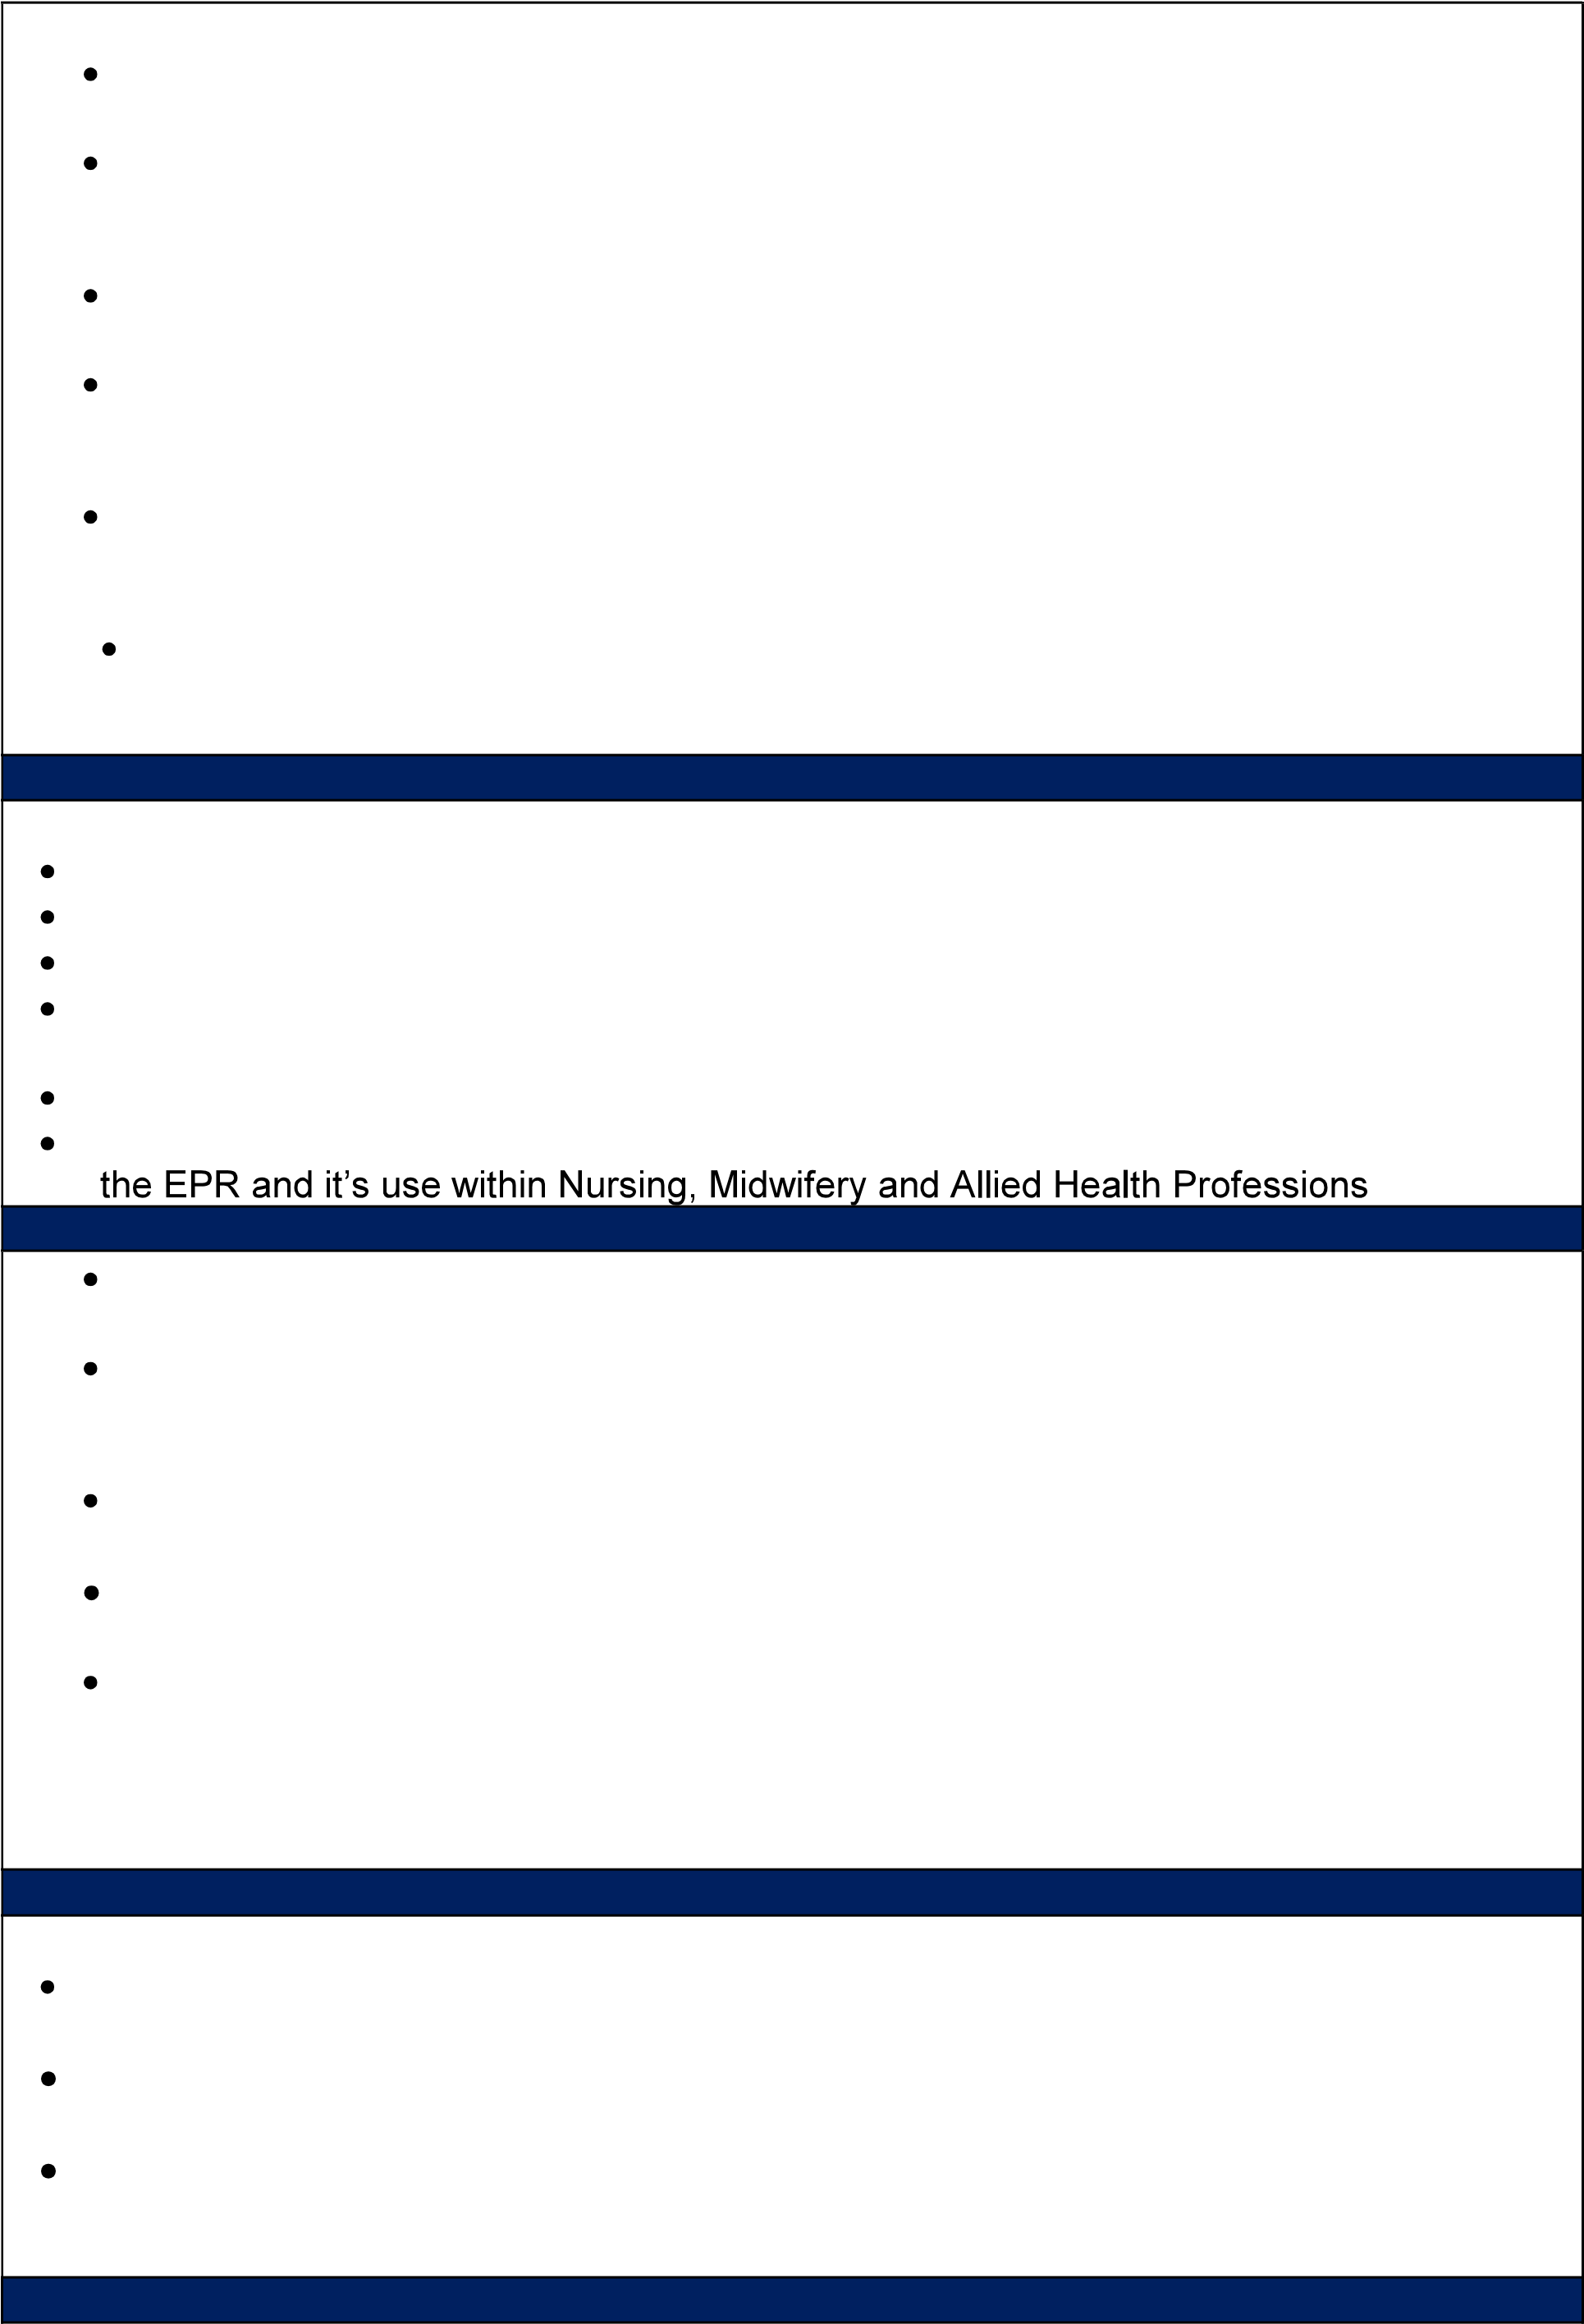 Be abreast of national guideline changes designed to improve practice, ensuring these changes or developments are considered in relation to the EPR and other clinical systems

# PLANNING/ORGANISATIONAL SKILLS

|  |
| --- |
| Apply creativity and innovation techniques to projects including learning from outside the organisation  Ensure a focus on objectives which deliver the highest standards of performance and patient care  Contribute to service improvement /capital revenue investment cases as required to secure investments to achieve sustainable change  To formulate complex activities or projects which require planning and on-going adjustment and to include:   * Co-design and deliver specific training packages for nurses, midwives and   AHPs   * Develop and review new and existing policies associated with the EPR and ensure national and local policy changes are incorporated into the system |
| PATIENT/CLIENT CARE |
| To support the Senior IO for Nursing, Midwifery and AHPs and CNIO to work with patients and service users to improve our services for the people that we serve  Frequent in-direct contact with patients in the clinical setting when supporting peers and colleagues with the use of our clinical systems and EPR in practice and at elbow  Provides specialised clinical and technical advice which contributes to the improvement of patient care and quality of sensitive patient data. |
| POLICY/SERVICE DEVELOPMENT |
| To support the divisional service leads, Senior IO for Nursing, Midwifery and AHPs and the CNIO in the development and implementation of protocols and policies relating to areas of responsibility as appropriate  Work collaboratively with nursing, midwifery and AHP leadership and IO peers to develop and implement processes to continuously monitor, evaluate and improve  patient and staff satisfaction in relation to the use of the EPR or other digital platforms |
| FINANCIAL AND PHYSICAL RESOURCES |
| Support the divisional team, Senior IO for Nursing, Midwifery and AHPs and the CNIO to establish systems to monitor performance through department and Trust monitoring systems, including regular interpretation of data taking corrective action and escalation as necessary  Work with the divisional team and the CNIO to identify opportunities to make efficiencies in order to realise benefits associated with the MY CARE programme for nursing, midwifery and AHPs  Responsible for ensuring safe and careful use of hardware devices used in relation to the EPR and other clinical systems |
| HUMAN RESOURCES |
| Design and deliver training and familiarisation sessions for nursing, midwifery and AHP colleagues to promote proficiency and clinical governance in the system. This will be done in close collaboration with the Digital Training Manager, Senior IO for Nursing, Midwifery and AHPs, Epic Principal and Credentialed Trainers |
| INFORMATION RESOURCES |
| Monitoring and analysis of clinical data to include: o Key performance indicators for monitoring and managing patient safety and quality. Subsequent development of necessary action plans to embed KPIs and achieve necessary improvements |

|  |
| --- |
| o Monitoring and presentation of compliance and proficiency statistics amongst end users of the EPR, to be shared with key stake holders  Organise and maintain clinical governance information in relation to the EPR and other clinical systems used within the trust |
| RESEARCH AND DEVELOPMENT |
| To explore opportunities for the introduction of new technologies for additional clinical applications  To lead on the delivery of clinical practice audits as directed by divisional and digital leadership teams  To submit posters, verbal presentation and papers for publication at local, regional and national level |
| PHYSICAL SKILLS |
| Standard keyboard skills  Use of clinical equipment/physical skills to maintain clinical practice as required in order to maintain professional registration/CPD |
| PHYSICAL EFFORT |
| Occasional travel to other sites including RD&E community base sites and NDHT  Daily requirement to visit multiple clinical areas and to move around the various RD&E departments within the division and trust wide |
| MENTAL EFFORT |
| Prolonged concentration is required when analysing data, compiling reports, delivering presentations and training  Requirement to investigate incidents associated with the EPR and to work with the divisional and digital team to formulate plans for mitigation of risk |
| EMOTIONAL EFFORT |
| Use conflict resolution strategies in response to barriers of understanding or acceptance in respect of professional standards/requirements, processes, procedures  Handle change management issues professionally and sometimes in hostile or antagonistic situations.  Deal with staff problems and patient/public complaints |
| WORKING CONDITIONS |
| Work within clinical working conditions with the potential for exposure to bodily fluids  Concentrate in an intense and sometimes noisy environment  Fulfil Trust health and safety policies and procedures when performing risk associated procedures including dealing with hazardous substances  Frequent use of a VDU is required for this role |
| OTHER RESPONSIBILITIES |
| Take part in regular performance appraisal.    Undertake any training required in order to maintain competency including mandatory training, e.g. Manual Handling    Contribute to and work within a safe working environment    You are expected to comply with Trust Infection Control Policies and conduct him/herself at all times in such a manner as to minimise the risk of healthcare associated infection    As an employee of the Trust, it is a contractual duty that you abide by any relevant code of professional conduct and/or practice applicable to you. A breach of this requirement may  to and including dismissal.    You must also take responsibility for your workplace health and wellbeing: |

|  |
| --- |
| Be physically active at work (i.e. take breaks away from your desk, taking the stairs where possible)  When required, gain support from Occupational Health, Human Resources or other sources.  Familiarise yourself with the health and wellbeing support available from policies and/or Occupational Health.    you.  Undertake a Display Screen Equipment assessment (DES) if appropriate to role. |
| DISCLOSURE AND BARRING SERVICE CHECKS delete section if not applicable |
| This post has been identified as involving access to vulnerable adults and/or children and in line with Trust policy successful applicants will be required to undertake a Disclosure & Barring Service Disclosure Check. |
| GENERAL |
| This is a description of the job as it is now. We periodically examine employees' job descriptions and update them to ensure that they reflect the job as it is then being performed, or to incorporate any changes being proposed. This procedure is conducted by the manager in consultation with the jobholder. You will, therefore, be expected to participate fully in such discussions. We aim to reach agreement on reasonable changes, but if agreement is not possible, we reserve the right to insist on changes to your job description after consultation with you.  Everyone within the Trust has a responsibility for, and is committed to, safeguarding and promoting the welfare of vulnerable adults, children and young people and for ensuring that they are protected from harm, ensuring that the Trusts Child Protection and Safeguarding Adult policies and procedures are promoted and adhered to by all members of staff.    Northern Devon Healthcare NHS Trust and the Royal Devon and Exeter NHS Foundation Trust continue to develop our long-standing partnership with a view to becoming a single integrated organisation across Eastern and Northern Devon. Working together gives us the  track record of excellence in res innovation and adaptability. |

|  |  |
| --- | --- |
| Job Title | Information Officer Nursing, Midwifery and AHPs |

|  |
| --- |
| P  E  R  S  O  N  S  P  E  C  I  F  I  C  A  T  I  O  N |

|  |  |  |
| --- | --- | --- |
| Requirements | Essential | Desirable |
| QUALIFICATION/ SPECIAL TRAINING  Registered Nurse, Midwife or Allied Health Professional with current Nursing & Midwifery Council or Health Professions Council registration  Professional knowledge plus additional specialist clinical governance and risk management knowledge acquired    Demonstrates evidence of commitment to professional development | E      E      E |  |
| KNOWLEDGE/SKILLS  Ability to think and plan strategically, tactically and creatively, and to prioritise work  Demonstrable previous success in supporting and delivering change and performance in a healthcare environment  Proven ability to analyse complex problems and to develop and successfully implement practical and workable solutions to address them | E    E    E |  |
| EXPERIENCE  A proven track record of clinical service management in a healthcare environment, including staff management, financial management and change management  Experience in the implementation, stabilisation and optimisation of a digital clinical system and ideally an Electronic Patient Record (EPR)  Experience as part of a programme team implementing and/or optimising Epic Systems Corporation EPR  Demonstrable understanding of clinical governance and risk management within a clinical leadership role  Experience of training and mentoring junior colleagues and peers within a healthcare setting | E      E          E    E | D |
| PERSONAL ATTRIBUTES  High level of work organisation, self-motivation, drive for performance and improvement, and flexibility in approach and attitude  Excellent inter-personal and communication skills with good listening skills  A positive attitude with demonstrable ability to persevere and overcome obstacles and resistance to change | E      E    E |  |
| OTHER REQUIREMENTS  The post holder must demonstrate a positive commitment to uphold diversity and equality policies approved by the Trust. Ability to travel to other locations as required | E    E |  |

|  |  |  |  |  |  |
| --- | --- | --- | --- | --- | --- |
|  |  | FREQUENCY  (Rare/ Occasional/  Moderate/ Frequent) | | | |
| WORKING CONDITIONS/HAZARDS |  | R | O | M | F |
|  |  |  | | | |
| Hazards/ Risks requiring Immunisation Screening |  |  |  |  |  |
| Laboratory specimens | Y/N |  | Y |  |  |
| Contact with patients | Y/N |  |  | Y |  |
| Exposure Prone Procedures | Y/N |  | Y |  |  |
| Blood/body fluids | Y/N |  |  | Y |  |
|  |  |  | | | |
| Hazard/Risks requiring Respiratory Health Surveillance |  |  |  |  |  |
|  |  |  | | | |
| Solvents (e.g. toluene, xylene, white spirit, acetone, formaldehyde and ethyl acetate) | Y/N | YY |  |  |  |
| Respiratory sensitisers (e.g isocyanates) | Y/N | YY |  |  |  |
| Chlorine based cleaning solutions (e.g. Chlorclean, Actichlor, Tristel) | Y/N |  | Y |  |  |
| Animals | Y/N | Y |  |  |  |
| Cytotoxic drugs | Y/N | Y |  |  |  |
|  |  |  |  |  |  |
| Risks requiring Other Health Surveillance |  |  |  |  |  |
| Radiation (>6mSv) | Y/N | Y |  |  |  |
| Laser (Class 3R, 3B, 4) | Y/N | Y |  |  |  |
| Dusty environment (>4mg/m3) | Y/N | Y |  |  |  |
| Noise (over 80dBA) | Y/N | Y |  |  |  |
| Hand held vibration tools (=>2.5 m/s2) | Y/N | Y |  |  |  |
|  |  |  | | | |
| Other General Hazards/ Risks |  |  |  |  |  |
| VDU use ( > 1 hour daily) | Y/N |  |  |  | Y |
| Heavy manual handling (>10kg) | Y/N | Y |  |  |  |
| Driving | Y/N |  |  |  |  |
| Food handling | Y/N | Y |  |  |  |
| Night working | Y/N | Y |  |  |  |
| Electrical work | Y/N | Y |  |  |  |
| Physical Effort | Y/N |  |  | Y |  |
| Mental Effort | Y/N |  |  | Y |  |
| Emotional Effort | Y/N |  |  | Y |  |
| Working in isolation | Y/N |  |  |  | Y |
| Challenging behaviour | Y/N |  | Y |  |  |