JOB DESCRIPTION
Job Title: | Multi Skilled Tradesperson (Mechanical)
Band: | Band 4
Responsible To: | Operations and Maintenance Manager
Accountable To: | Head of Estates
Section/Department/Directorate: | Facilities Directorate
JOB PURPOSE
To provide an efficient maintenance service carrying out work of a wide ranging nature, with an aim to support the provision of a high quality, flexible, proactive customer orientated service. This will be in the areas of Planned Preventative Maintenance (PPM), repair, alteration, testing and installation of engineering services, equipment and fixtures maintained by the Facilities Maintenance Department.
Requiring a multi skilled, Mechanically biased engineer, who is willing to work flexible hours to meet the needs of the service at locations in Devon. The successful applicant must have experience with Air Handling Units and commercial heating systems and pipework.
Will contribute to the development of the service ensuring that the Trusts “Visions and Values” are maintained at all times, focusing on engineering excellence, integrity and support for the wider team.

CONTEXT
As part of the maintenance team, the post holder will support the provision of a high quality, flexible, proactive customer orientated service.
It is essential that the applicant has experience in Air Handling Units, Motors, Bearings and commercial/industrial heating systems.
Will work on a wide range of electrical/mechanical equipment and services across all areas within the Trusts estate.
This will require the individual to possess a multi-skilled ability working safely but effectively outside their core skill as a mechanically or electrically biased engineer.
Skilled fault finding is required, often in circumstances where a limited amount of initial information is provided, with an aim to support the provision of a high quality, flexible, proactive customer orientated service. The post holder will ensure that the work they carry out is done effectively to ensure that patients, staff and visitors are provided with a clean safe and pleasant environment suitable for the Trust and service provided.
Experience and knowledge around Air Handling Units and their controls is required.
Will contribute to the development of the service ensuring that the Trusts “Visions and Values” are maintained at all times, focusing on engineering excellence, integrity and support for the wider team.
In all cases compliance is required to Statutory and Regulatory requirements, which includes Legionella, Electrical Safety Policy, Asbestos and Permit to Work Policies and Procedures in a professional manner.
Hours of working for this post shall be 37.5 hours 5 day period (Monday to Friday)

KEY WORKING RELATIONSHIPS
The post holder is required to deal effectively with staff of all levels throughout the Trust, the wider Healthcare community, external organisations and the public. This will include verbal, written and electronic media. In all instances this shall be carried out in line with the Trusts “Vision and Values” policy with particular adherence to Excellence, Integrity and Support for the wider Facilities team.

ORGANISATIONAL CHART
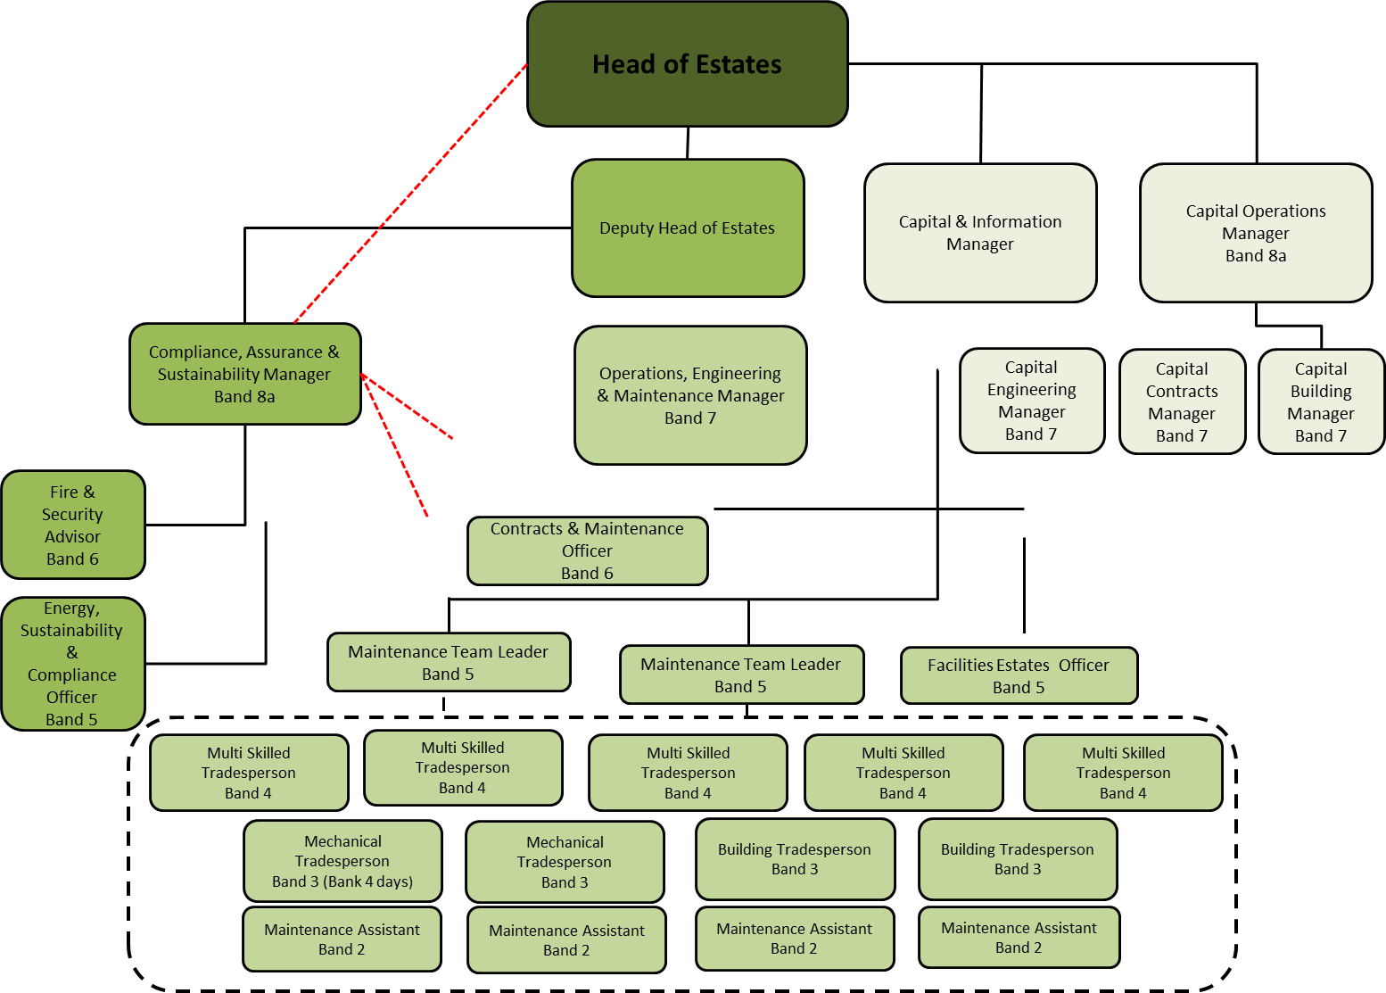
KEY RESULT AREAS / PRINCIPAL DUTIES AND RESPONSIBILITIES

The Skilled Tradesperson will be expected to provide an efficient maintenance service carrying out work of a wide ranging nature. This will be through the following processes:-

- The departments Planned Preventative Maintenance (PPM) programme
- Breakdown and repair
- Possible alterations to services
- Testing and re-verification of services (subject to training)
- Possible installation of mechanical/electrical systems, equipment and fixtures
- Witnessing and accepting new Capital works
- Identifying new PPM requirements and redundant PPM
- Due to the size of the Trusts estate flexible working will be required
- Participation in the departments on call out of hours service

Diagnose and repair faults, carry out planned preventative maintenance and testing in mechanical installations, plant and equipment.
The post holder should have experience in all types of engineering building services maintenance and repair, preferably within a hospital environment, however this is not essential.
Understand the workings of engineering systems throughout the Trusts properties in the community and at North Devon District Hospital (NDDH) and operate a permit to work system prior to isolating any services as required.
Capable of understanding schematic drawings and specifications.
Able to work from stepladders, scaffolding and other access equipment as required.
Capable of working on own initiative.
Have experience in AHU’s, Commercial/Industrial Heating Systems and Motors.
Have experience with digital Building Management Systems.
After suitable training release trapped passengers from lifts.
Work in mental health and children’s wards, taking appropriate precautions as required.
Request stores, parts, service contractors as required.
Assist in accomplishing the objectives set to the Facilities Department.
Enhance quality of service.
Make suggestions on any changes to procedures or working practices that would be more cost effective and / or increase efficiency.
Support the Facilities departments’ energy and water savings programme and be proactive in reducing utility and water costs.
Instruct others on the above features and other aspects of work, support induction of new starters/professional supervision, training of apprentices, trainees and support workers.
Perform a wide range of work of other crafts. In particular work on elements in general maintenance tasks (GMT).
Deal with new situations as they arise and pass on knowledge to others.
Manufacture, assemble, erect and install new work.
Maintain and efficiently run plant and equipment.
Use relevant tools and equipment.
Understand fully the inter-relationship between various maintenance trades.
Work from planned maintenance instruction schedules
Participate in the labour management systems for NHS Maintenance Departments.
Will be required to participate in the on-call procedure outside of normal working hours, providing emergency repairs within your ability or referring further works to the on-call PTB officer. The on call periods are one week in every six weeks. Frequency of call periods are subject to change due to staffing levels.
Able to work unsociable hours and work overtime if required.
Carry communication devices (mobile phone, pager, two way radio, PDA) to respond to emergencies and be contactable.
Comply with all legislation guidance notes, HTM’s and Health and Safety rules for Trades staff.
On a daily basis ensure that all relevant documentation is carried out accurately, legibly and is returned to the line manager on time, this includes work dockets, weekly time sheets, service report sheets, test sheets etc.
Post holder may be requested to undertake tasks outside of their core training, and/or work in unoccupied locations and therefore a very good understanding of Health and Safety procedures will be required.
To ensure that the maintenance section has cover each working day, the post holder will be required to
Co-ordinate with the line manager before booking any holiday or time off.
The post holder will need the ability to appreciate the requirements of the other trades/contractors working on site.
Possess a willingness to take on new technology and working practices
Possess a full UK driving licence to enable them to drive Trust transport when required.
Undertake training where necessary to learn new techniques or to keep skills updated.
The post holder will be required to undertake any identified training that will improve the service delivery of the Facilities Maintenance Department.
Maintain the quality of their own work and encourage others to do so.

COMMUNICATION AND RELATIONSHIP SKILLS
Provide and receive routine information to inform work colleagues. Exchange routine information with colleagues, particularly about progress on current work
Communicates technical issues to maintenance staff/explain technical issues to other staff.
ANALYTICAL AND JUDGEMENT SKILLS
Range of facts or situations requiring analysis, comparison of range of options. Problem solves technical issues, fault diagnosis and solution finding.
PLANNING AND ORGANISATIONAL SKILLS
Prioritise and organise maintenance and breakdown activities as requested to ensure cost-effective outcomes. Ensure allocated work is undertaken and followed-through to completion and satisfaction of the service user in a timely professional manner.
PHYSICAL SKILLS
Highly developed physical skills accuracy important; manipulation of fine tools, materials manipulation of fine tools and equipment.
RESPONSIBILITY FOR PATIENT AND CLIENT CARE
To assist patients/clients during incidental contact/provide non-clinical advice. Incidental contact with patients/advises patients/clients on use of equipment in a community setting as a significant aspect of the work.
Compliance with the Trust Infection Control Policy.
RESPONSIBILITY FOR POLICY AND SERVICE DEVELOPMENT
Follow policies in own role, may be required to comment/implement policies and purpose changes to policies, may comment/proposes changes to protocols and procedures in the light of experience.
RESPONSIBILITY FOR FINANCIAL AND PHYSICAL RESOURCES
Installation and/or repair and maintenance of physical assets. Maintain and repairs trust properties and equipment.

RESPONSIBILITY FOR HUMAN RESOURCES
May be required to demonstrate own activities to new or less experienced employees, providing advice, practical training and support to trainees/apprentices & maintenance assistants.

RESPONSIBILITY FOR INFORMATION RESOURCES

Responsible for the receiving of information relating to maintenance activities and entering on to existing data bases.
Update planned and reactive maintenance management information. Use of specialist proprietary test & monitoring equipment during the course of work to record test & verify data.
Carry out risk assessment when required, in accordance with Health and Safety procedures and safe systems of work.
RESPONSIBILITY FOR RESEARCH AND DEVELOPMENT
Undertake required testing and verification.
DECISION MAKING
Manage own allocated workload during periods of planned maintenance. To work unsupervised in the course of maintenance duties. Including responding to out of hour’s requests in co-operation with other staff involved in the Maintenance on-call service.
Working autonomously on a routine basis and as part of a multi-disciplined team reporting directly to the Acute Maintenance Officer or designate.
To adhere and be guided by procedures and protocols
PHYSICAL EFFORT
Occasional/frequent moderate physical effort for several long periods/occasional requirements to exert intense physical effort for short periods. Heavy repairs, moves equipment/lifts manhole covers.
MENTAL EFFORT
Frequent concentration with an unpredictable work pattern required for fault finding equipment subject to interruptions from carrying a pager, mobile telephone or two way radios.
EMOTIONAL EFFORT
Limited exposure to distressing or emotional circumstances, which can include working in close proximity to patients in both a wide range of acute care situations, a high security mental health unit and cadavers/post-mortem rooms.
WORKING CONDITIONS
Occasional exposure to highly unpleasant conditions e.g. sewage/gases during the course of duties. Requirement to work on site, sometimes out of doors. Regular exposure to dust (building site) noise (plant rooms) high temperature (plant rooms/boiler house). All of which are to be managed in line with the relevant health and safety regulations and guidance.
GENERAL
This is a description of the job as it is at present constituted. It is the practice of this organisation periodically to examine employees' job descriptions and to update them to ensure that they relate to the job as then being performed, or to incorporate whatever changes are being proposed. This procedure is jointly conducted by each manager in consultation with those working directly to him or her. You will, therefore, be expected to participate fully in such discussions. It is the organisations' aim to reach agreement to reasonable changes, but if agreement is not possible management reserves the right to insist on changes to your job description after consultation with you.
We are committed to serving our community. We aim to co-ordinate our services with secondary and acute care.
We aim to make all our services exemplary in both clinical and operational aspects. We will show leadership in identifying healthcare needs to which we can respond and in determining the most cost-effective way of doing so. We will share our knowledge with neighbouring healthcare agencies and professionals.
We recruit competent staff that we support in maintaining and extending their skills in accordance with the needs of the people we serve. We will pay staff fairly and recognise the whole staff’s commitment to meeting the needs of our patients.
The Trust operates a 'non smoking' policy. Employees are not able to smoke anywhere within the premises of the Trust or when outside on official business.
All employees must demonstrate a positive attitude to Trust equality policies and Equality Scheme. Employees must not discriminate on the grounds of sex, colour, race, ethnic or national beliefs, marital status, age, disability, sexual orientation, religion or belief and will treat patients, colleagues and members of the public with dignity and respect.
If the post holder is required to travel to meet the needs of the job, we will make reasonable adjustments, if required, as defined by theEquality Act 2010.

SAFEGUARDING
To be fully aware of and understand the duties and responsibilities arising from the Children’s Act 2004 and Working Together in relation to child protection and safeguarding children and young people as this applies to the worker’s role within the organisation.
To also be fully aware of the principles of safeguarding as they apply to vulnerable adults in relation to the worker’s role, which will include recognising the types and signs of abuse and neglect and ensuring that the worker’s line manager is made aware and kept fully informed of any concerns which the worker may have in relation to safeguarding adults and/or child protection.
Everyone within the Trust has a responsibility for, and is committed to, safeguarding and promoting the welfare of vulnerable adults, children and young people and for ensuring that they are protected from harm, ensuring that the Trusts Child Protection and Safeguarding Adult policies and procedures are promoted and adhered to by all members of staff.

HEALTH AND SAFETY AT WORK
The employer will take all reasonably practical steps to ensure your health, safety and welfare while at work. You must familiarise yourself with the employer's Health & Safety policy, and its safety and fire rules. It is your legal duty to take care for your own health and safety as well as that of your colleagues.
CONFIDENTIALITY
You may not disclose any information of a confidential nature relating to the employer or in respect of which the employer has an obligation of confidence to any third party other than where you are obliged to disclose such information in the proper course of your employment or as required by law. Any failure to comply with this term of your employment will be treated as an act of misconduct under the employer's disciplinary procedure.
JOB DESCRIPTION AGREEMENT
Job holder’s Signature: .....................................................................................
Date: .....................................................................................
Manager’s Signature: .....................................................................................
Date: .....................................................................................

PERSON SPECIFICATION
POST: Multi skilled Tradesperson Band 4
REQUIREMENTS  E= Essential  D= Desirable | E/D | HOW TESTED?  Application Form/Interview/Reference/Test | INTERVIEW COMMENTS | SCORE  (1 Low – 10 High)
QUALIFICATIONS/SPECIAL TRAINING :  CITB/EITBApprenticeship or other approved training  Electrical/Mechanical/Building services  Engineering – relevant experience having demonstrated levels of versatility and flexibility in electrical/mechanical/building services engineering.  A National Qualification Framework NQF achievement to level 3 or above  C&G 236 Electrical Installation and Maintenance  C&G 7671 17TH Edition IEE Regs latest amendment  2391 Electrical Testing and Inspection Course  Or  C&G 205 Mechanical Installation and Maintenance or equivalent Mechanical Installation and Maintenance certified training at level 3  Approved Electrical awareness course or Safe Isolation  Advanced specialist training will be in at least one of the following areas.  - Sterilisation, test person  - Decontamination, test person  Must possess UK driving license Cat B | E  E  E  E  E  D  E  D  E | Application Form  Application Form  Application Form  Application Form  Application Form  Application Form  Application Form  Or willingness to undertake training
KNOWLEDGE/SKILLS:  Knowledgeof the application of: Health and Safety legislation, ACOPs, guidance and rules, NHS technical standards (e.g. Health Technical Memoranda) and Trust polices, basic life support and emergency aid and where required a readiness to train.  To act with integrity and with a professional disposition | D  E | Application Form/Interview
EXPERIENCE:  Skilled in maintenance, fault finding, test & repair work on a very wide range of engineering services & equipment, with the ability to work unassisted in varying, often technical environments whilst complying with Health & Safety/environmental regulations and standards.  IT literate | E  E | Application Form/Interview  Interview
PERSONAL REQUIREMENTS:  Reliability and Flexibility, able to contribute to changing demands of the service.  Willing to undertake training relevant to the post.  Required to climb ladders, access walkways, ducts cellars, roof spaces etc.  Light manual handling but must be able to demonstrate ability to meet medium to high risk manual handling when acting in an operational role.  Ability to demonstrate a diplomatic caring attitude whilst maintaining confidentiality adhering to the Trusts policy on “Vision and Values”. In particular:  - Understanding excellence  - Acting with integrity  - Support to members of the team and customers | E  E  E  E  E | Interview  Interview  Interview  Interview  Interview
OTHER REQUIREMENTS:  The post holder must demonstrate a positive commitment to uphold diversity and equality policies approved by the Trust.  Ability to travel to other locations as required  Will be expected to participate in the Estates on call team | E  E  E | Interview  Interview  Interview

HAZARDS :
Laboratory Specimens  Proteinacious Dusts | X  X | Clinical contact with patients |  | Performing Exposure  Prone Invasive Procedures
Blood/Body Fluids |  | Dusty Environment | X | VDU Use | X
Radiation |  | Challenging Behaviour |  | Manual Handling | X
Solvents | X | Driving | X | Noise | X
Respiratory Sensitisers |  | Food Handling |  | Working in Isolation | X

