“Our vision is to provide safe, high quality seamless service delivered with courtesy and respect. To achieve our vision we expect all our staff to uphold our Trust Values”

J
O
B

D
E
S
C
R
I
P
T
I
O
N

JOB DETAILS
Job Title | Medical Physicist in Imaging and Radiation Safety
Reports to | Lead Physicist for Diagnostic Radiology Physics
Band | 7
Department/Directorate | Medical Physics/Specialist Services

JOB PURPOSE
The main role of this position is to participate in all aspects of the work of the Clinical & Radiation Physics Groups which provide highly specialist clinical technical services.

Responsibilities are across both the Royal Devon University Healthcare NHS Foundation Trust (0.5 wte) and Torbay and South Devon NHS Foundation Trust (0.5 wte). Services are also provided to Northern Devon Healthcare NHS Trust, and other customers including the University of Exeter PET-CT.

The position will be based at either the Royal Devon & Exeter (Wonford) site, or at Torbay Hospital, with opportunity to travel to other NHS and private customers as required.

The major component of this position is scientific services to Diagnostic Radiology

This includes:
- Undergoing Advanced Training in all areas of Diagnostic Radiology Imaging Physics and Radiation Safety, to include non-ionising as required.
- Handling complex dosimetry equipment to perform routine calibration and monitoring of highly complex radiation-producing equipment.
- Providing specialised advice and guidance, where necessary, to the department in matters relating to imaging with ionising radiations, patient dosimetry and radiation safety of patients and staff.
- Presenting clinical data to medical staff and upholding legal requirements.
- Being responsible on a day-to-day basis to the relevant Physicist in charge of the areas in which work is currently being performed.
- Having a keen sense of responsibility with a high degree of accuracy and taking personal initiative.
- Contributing to research and development projects where assigned, including making a major contribution to the commissioning of new radiological equipment, software and techniques.
- Occasionally performing Quality Control measurements in evenings or weekends in order to maintain essential clinical services
KEY WORKING RELATIONSHIPS
The key working relationships are primarily those with staff from departments utilising medical exposures – Radiology , Nuclear Medicine, Cardiology etc, other members of the Clinical & Radiation Physics teams together with staff elsewhere in Medical Physics, but will also include external customers and third parties such as equipment maintenance engineers

These will include :
- Clinical Scientists
- Clinical Technologists
- Radiographers
- Medical staff
- Nursing staff
- Clerical staff
- External customers
- External contractors

There will also be some liaison with Medical Physics and Clinical Scientist staff on a regional/national basis.
ORGANISATIONAL CHART
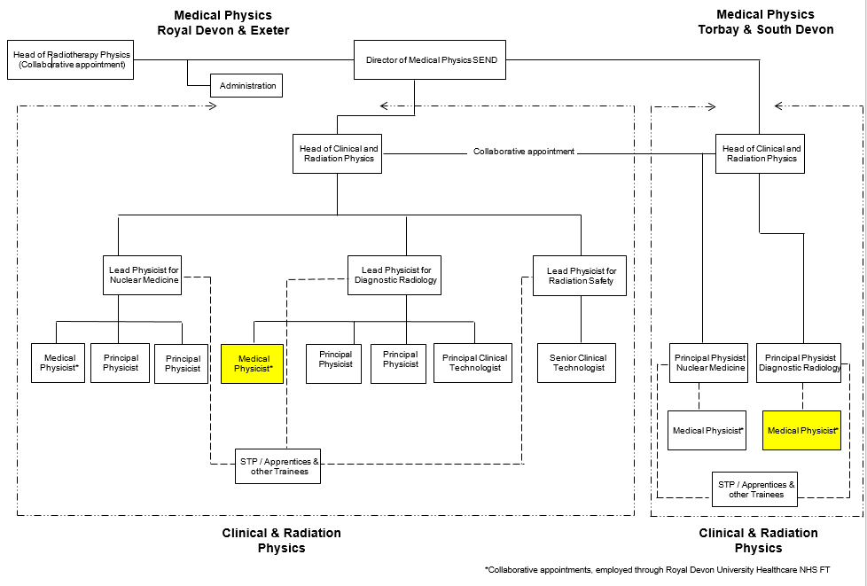

KEY RESULT AREAS/PRINCIPAL DUTIES AND RESPONSIBILITIES

Clinical/Scientific
- Provide scientific support for all aspects of imaging with ionising radiations, making judgements involving complex facts & situations which require the analysis and interpretation of a range of options.
- Contribute to the specification and selection of radiological equipment
- Perform acceptance and commissioning measurements on new radiological equipment and advise of suitability for clinical use
- Undertake routine and non-routine quality control measurements to a high degree of accuracy on a broad spectrum of highly complex patient-critical equipment.
- Undertake complex analysis of images
- Advise on safety and suitability of equipment for clinical use.
- Contribute to optimisation of medical exposures for patients undergoing diagnosis and treatment
- Coordinate the programme of Dose Audit and in conjunction with the MPE advise on Diagnostic Reference Levels for medical exposures.
- Carry out complex dose calculations using computational methods to calculate dose and risk to patients
- Advise medical staff on events which may result in doses exceeding the thresholds for tissue effects
- Contribute to the investigation and analysis of untoward events and, in conjunction with the MPE determine if any such events are notifiable to CQC as a Significant Accidental or Unintended Exposure
- Prepare radioactive substances for administration to patients, maintaining eye/hand physical coordination skills in order that accurate doses may be given and radioactive contamination is contained safely.
- Maintain sterile conditions within biological containment systems when preparing injectable radionuclides in line with Infection Control guidance
- Participate in the delivery of the radionuclide therapy service
- Assist the lead physicist for Radiation Safety in the provision of services:
- Design and specification of facilities for use with ionising and non-ionising radiations
- Calculations of shielding required for new or modified facilities, including application of dose constraints
- Perform radiation risk assessments
- Development of procedures for safe working
- Contribute to the optimisation of exposure of staff and public. Review of personal and environmental dosimetry measurements and contribute to investigations where Dose Investigation Levels have been exceeded
- Performance of radiation safety audits
- Undertake routine work in all areas of Clinical & Radiation Physics when required. Plan and organise straightforward tasks/activity programmes to meet service requirements.
- Contribute to the provision of scientific services in support of MRI, Ultrasound, UV and Lasers
COMMUNICATION/RELATIONSHIP SKILLS
- Communicate with patients and staff regarding highly complex information regarding exposure to ionising and non-ionising radiations, recognising and dealing with emotional stress and other barriers to receiving information.
- Liaise with clinical staff, non-clinical staff, managers, third party representatives and external suppliers to ensure interpretation and implementation of specialist radiation protection advice, to ensure work with ionising and non-ionising radiations is safe and within statutory requirements
- Perform and advise on dosimetry measurements in relation to medical exposures. Provide advice to medical staff regarding the changing of clinical protocols so that doses are restricted and procedures optimised.
- Advise medical and radiographic staff concerning the physics aspects of uses of ionising and non-ionising radiations in diagnosis and treatment.
ANALYTICAL/JUDGEMENTAL SKILLS
- Perform Quality Control checks on complex medical equipment, analysing the results to ensure performance is within tolerance and equipment is safe for clinical use.
- Inform the principal physicist and/or the lead physicist of quality control or routine results that require immediate attention.
- Undertake radiation protection measurements so risks to staff and members of the public are minimised.
PLANNING/ORGANISATIONAL SKILLS
- Participate in the working of the Medical Physics Department Quality System, suggesting Quality Improvements, undertaking audits and contributing to developments in the documentation system.
- Under the supervision of the lead physicists, maintain and develop departmental documentation (Instructions, Procedures, Clinical protocols etc.) recording all relevant information.
PHYSICAL SKILLS
- Ability to concentrate for long (hours) periods of time
- Good eye-hand coordination
- Ability to stand up for hours at time while performing computer-aided measurements
PATIENT/CLIENT CARE
Incidental contact with patients is required, courtesy and respect for patient confidentially is required at all times.
POLICY/SERVICE DEVELOPMENT
Participate in the development and implementation of protocols and procedures as required by the lead physicists and/or head of clinical and radiation physics.
HUMAN RESOURCES
Participate in the training and supervision of medical physics trainees, technologists and undergraduate students as required by the head of clinical and radiation physics.

INFORMATION RESOURCES
Maintain, enhance and process clinically relevant information associated with:
- Acceptance and commissioning of Medical devices
- Patient related doses, quality control and clinical outcomes
- Protocols and procedures
RESEARCH AND DEVELOPMENT
- Commission new equipment, techniques and software.
- Propose changes to working practices for own work area to improve and develop systems in terms of efficiency and quality, after liaising closely with colleagues implement developments in own area.
- Provide support for clinical trials and assist in the medical physics expert assessments of formal research programmes.
- Participate in clinically relevant research & development, presenting the results in the literature and at meetings and at conferences to large groups of staff and members of the public, so that the innovations and improvements may become embedded in clinical practice.
- Develop and design techniques, software and equipment to enhance the quality and efficiency of clinical & radiation physics.
- Write software where necessary modifying and customising existing scripts, programmes and macros to model clinical and dosimetric situations.
FREEDOM TO ACT
- Prioritise and manage own work to meet service demands
- Supervise the work of trainees, radiographers and medical-technical staff as required
OTHER RESPONSIBILITIES
To take part in regular performance appraisal.

To undertake any training required in order to maintain competency including mandatory training, e.g. Manual Handling

To contribute to and work within a safe working environment

The post holder is expected to comply with Trust Infection Control Policies and conduct him/herself at all times in such a manner as to minimise the risk of healthcare associated infection

As an employee of the Trust, it is a contractual duty that you abide by any relevant code of professional conduct and/or practice applicable to you. A breach of this requirement may result in action being taken against you (in accordance with the Trust’s disciplinary policy) up to and including dismissal.
THE TRUST- VISION AND VALUES
Our vision is to provide safe, high quality seamless services delivered with courtesy and respect. To achieve our vision we expect all our staff to uphold our Trust values. Our Trust values are:

Honesty, Openness & Integrity
Fairness,
Inclusion & Collaboration
Respect & Dignity

We recruit competent staff that we support in maintaining and extending their skills in accordance with the needs of the people we serve. We will pay staff fairly and recognise the whole staff’s commitment to meeting the needs of our patients.

We are committed to equal opportunity for all and encourage flexible working arrangements including job sharing.

We are committed to recruiting and supporting a diverse workforce and welcome applications from all sections of the community, regardless of age, disability, gender, race, religion, sexual orientation, maternity/pregnancy, marriage/civil partnership or transgender status. We expect all staff to behave in a way which recognises and respects this diversity, in line with the appropriate standards.
GENERAL
This is a description of the job as it is now. We periodically examine employees' job descriptions and update them to ensure that they reflect the job as it is then being performed, or to incorporate any changes being proposed. This procedure is conducted by the Manager in consultation with the jobholder. You will, therefore, be expected to participate fully in such discussions. We aim to reach agreement on reasonable changes, but if agreement is not possible, we reserve the right to insist on changes to your job description after consultation with you.

The Royal Devon University Healthcare NHS FT and Torbay and South Devon NHS FT are totally smoke-free Trusts. Smoking is not permitted anywhere on Trust property, including all buildings, grounds and car parks. For help to quit call: 01392 207462.

P
E
R
S
O
N

S
P
E
C
I
F
I
C
A
T
I
O
N

POST | Medical Physicist in Imaging and Radiation Safety
BAND | 7
Requirements | Essential | Desirable
QUALIFICATION/ SPECIAL TRAINING  BSc in a Physical Science  MSc or higher degree in Medical Physics  MIPEM or equivalent  State Registration as a Clinical Scientist | E  E  E | D
KNOWLEDGE/SKILLS  Advanced IT skills including Excel, Word and PowerPoint  Ability to communicate effectively with different staff groups – including clinical scientists, clinical technologists, radiographers, medical staff and clerical staff  Presentation Skills  Knowledge of radiology QC and dosimetry in Radiological Physics, patient dosimetry techniques for diagnostic radiology | E  E  E  E  E
EXPERIENCE  Experience of working within a medical physics environment during training | E
PERSONAL ATTRIBUTES  Ability to prioritise work and to meet deadlines  Needs to be able to work with concentration and accuracy on complex technical issues where the work pattern is unpredictable, handling interruptions as they arise.  Interpersonal skills for collaboration with colleagues  Ability to make accurate measurements using sophisticated fine testing equipment, where accuracy is important but there is no requirement for speed.  While operating QA and test equipment (6-15kg / delicate & cumbersome), able to occasionally exert moderate physical effort for several short periods during a shift  Emotionally robust enough to work daily on aspects of the diagnosis of cancer patients, who may be children or may be terminally ill (indirect exposure to distressing/emotional circumstances)  Able to deal with occasional exposure to highly unpleasant conditions. | E  E  E  E  E  E  E
OTHER REQUIRMENTS  The post holder must demonstrate a positive commitment to uphold diversity and equality policies approved by the Trust.  Ability to travel to other locations as required.  Driving Licence | E  E | D

FREQUENCY

(Rare/ Occasional/ Moderate/ Frequent)
WORKING CONDITIONS/HAZARDS |  | R | O | M | F
Hazards/ Risks requiring Immunisation Screening
Laboratory specimens | N
Contact with patients | Y |  | O
Exposure Prone Procedures | N
Blood/body fluids | Y | R
Hazard/Risks requiring Respiratory Health Surveillance
Solvents (e.g. toluene, xylene, white spirit, acetone, formaldehyde and ethyl acetate) | N
Respiratory sensitisers (e.g. isocyanates) | N
Chlorine based cleaning solutions  (e.g. Chlorclean, Actichlor, Tristel) | N
Animals | N
Cytotoxic drugs | N
Risks requiring Other Health Surveillance
Radiation (>6mSv) | N
Laser (Class 3R, 3B, 4) | N
Dusty environment (>4mg/m3) | N
Noise (over 80dBA) | N
Hand held vibration tools (=>2.5 m/s2) | N
Other General Hazards/ Risks
VDU use (> 1 hour daily) | Y |  |  |  | F
Heavy manual handling (>10kg) | Y | R
Driving | Y |  | O
Food handling | N
Night working | N
Electrical work | N
Physical Effort | Y | R
Mental Effort | Y |  |  | M
Emotional Effort | Y |  | O
Working in isolation | Y | R
Challenging behaviour | Y | R

