JOB DESCRIPTION
Job Title: | Skilled Tradesperson Mechanical
Band: | 3
Responsible To: | Workshop Supervisor
Accountable To: | Operations and Maintenance Manager
Section/Department/Directorate: | Facilities
Job Purpose:
The post holder will be responsible for carrying out the day to day mechanical work in planned preventative maintenance, repair, alteration and new works of the mechanical systems and fixtures maintained by the Maintenance Department.
The post holder as a part of their duties must provide the trust with suitable assurance, which is to be communicated by regular and professional feedback of all issues to the works supervisor.

Context:
The post holder will originate from a Mechanical Services background with training and experience relative to working on all types and age of general buildings. Have the ability to be customer facing and be able to project the aims and services provided by the Maintenance Team in a diplomatic and sensitive manner.
To be able to offer solutions, effect routine repairs reactively to plumbing systems and heating system pipework and radiators, macerator units and their drainage systems (training provided) and to carry out PPM’s, such as:
- General Plumbing Services
- All types of local heating and storage vessels
- All types and grades of drainage equipment
- Plumbing control equipment, blending valves, isolation valves etc...
- Heating thermostatic valves and heating equipment
- Macerator repair and maintenance (training provided)
- (There is no requirement for unsupervised works on Boiler plant, heat Exchanger plant or BMS control systems and actuators.)

As a part of the Maintenance Team, the post holder will support the provision of a high quality, flexible, proactive customer orientated service. The post holder will ensure that the work they carry out is done effectively to ensure that patients, staff and visitors are provided with a clean, safe and pleasant environment suitable for the Trust and service provided.

The post holder will be expected to work on a wide range of Mechanical systems and equipment; this will also include some non-mechanical. Skilled fault finding is required, often in circumstances where a limited amount of initial information is provided.

The post holder in all cases must comply with Statutory and Regulatory requirements, which include Legionella, Asbestos and Permit to Work Policies and Procedures as example, in a professional manner.

Key Working Relationships:
The post holder is required to deal effectively with staff of all levels throughout the Trust, the wider Healthcare community, external organisations and the public. This will include verbal, written and electronic media.

Organisational Chart:

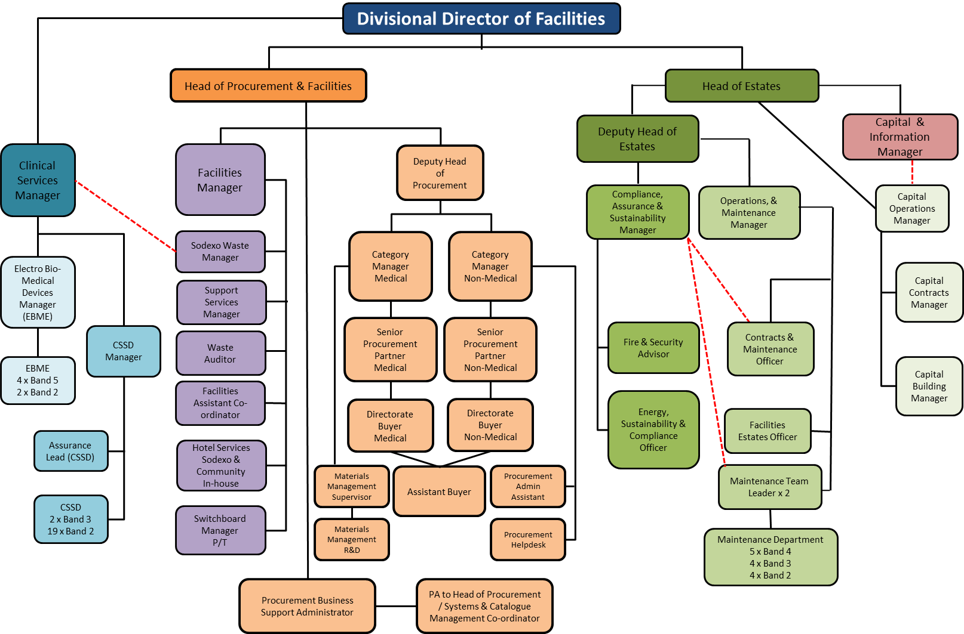
Key Result Areas/Principal Duties and Responsibilities:

Communication and Relationship Skills
- The post holder will be required to adhere to the organisation’s standards of customer care. The post holder is required to communicate with hospital staff, contractors, patients and members of the public.
- To provide and receive routine information.
- To exchange routine information with colleagues.
- To report all non-routine repairs to Supervisor for instruction.
- To carry communication devices (i.e. mobile phone, pager, palm top, 2 way radios) to respond to emergency’s where required.
- The post holder will be expected to behave in accordance with the Trust's values of demonstrating compassion, striving for excellence, respecting diversity, acting with integrity and to listen and support others.

Planning and Organisational Skills
- The post holder will be capable of working on their own initiative.
- To work in mental health and children’s wards taking the appropriate precautions as required.
- On a daily basis ensure that all relevant documentation is carried out accurately, legibly and is returned to the workshop on time.
- To comply with all legislation guidance notes, HTM’s and Health & Safety rules for trades staff.
- Deal with new situations as they arise and pass on knowledge to others.
- Understand fully the inter-personal relationship between staff.

Physical Skills
- The post holder will be required to work from step ladders/scaffolding as required.
- The role requires highly developed physical skills requiring accurate use of tools and equipment.
- The role involves lifting and manual tasks
- Maintain and effectively run plant and equipment

Responsibility for Patient and Client Care
- Ensure safe practices to minimise the risks of infection to patients and staff in accordance with national and Trust policy, in particular to be aware of their responsibilities as listed in the Infection Control Operational Policy. Adhere to any guidance issued by the Infection Control Team.
- The post holder will need the ability to appreciate the requirements of other trades working on site.
- To ensure the maintenance section has cover each working day, the post holder will be required to co-ordinate with the supervisor before booking any annual leave.

Responsibility for Policy and Service Development
- To help accomplish the objectives set to the Maintenance Department.
- To enhance the quality of the service.

Responsibility for Financial and Physical
- To support the Facilities departments energy savings and be proactive in reducing the utility costs.

Responsibility for Human Resources
- Maintain and update own training relevant to the post. Taking an active part in the development review of own work suggesting areas for learning and development in the coming year.
- Have a willingness to take on new technology and working practices.
- The post holder will be required to undertake any identified training that will improve the service delivery of the Facilities Department.

Responsibility for Information Resources
- Participate in the Labour Management Systems for NHS Maintenance Departments.
- On a daily basis ensure work logs are updated, completed and logged. This is to include work dockets, weekly timesheets, service report sheets etc...

Responsibility for Research and Development
- Comply with Trust’s requirements and undertake surveys as necessary to own work.

Decision Making
- To work within Trust policies and procedures. Use initiative to deal with routine matters and complex queries, deciding when it is necessary to refer to the available line manager. Work is managed rather than supervised and the post holder will organise their own workload on a day to day basis.

Mental Effort
- There is a frequent requirement for concentration where the work pattern is predictable with few competing demands for attention.

Emotional Effort
- Exposure to distressing or emotional circumstances is rare.

Working Conditions
- Occasional exposure to unpleasant working conditions
- Occasional exposure to highly unpleasant working conditions

GENERAL
This is a description of the job as it is at present constituted. It is the practice of this organisation periodically to examine employees' job descriptions and to update them to ensure that they relate to the job as then being performed, or to incorporate whatever changes are being proposed. This procedure is jointly conducted by each manager in consultation with those working directly to him or her. You will, therefore, be expected to participate fully in such discussions. It is the organisations' aim to reach agreement to reasonable changes, but if agreement is not possible management reserves the right to insist on changes to your job description after consultation with you.

We are committed to serving our community. We aim to co-ordinate our services with secondary and acute care.

We aim to make all our services exemplary in both clinical and operational aspects. We will show leadership in identifying healthcare needs to which we can respond and in determining the most cost-effective way of doing so. We will share our knowledge with neighbouring healthcare agencies and professionals.

We recruit competent staff that we support in maintaining and extending their skills in accordance with the needs of the people we serve. We will pay staff fairly and recognise the whole staff’s commitment to meeting the needs of our patients.

The Trust operates a 'non-smoking' policy. Employees are not able to smoke anywhere within the premises of the Trust or when outside on official business.

All employees must demonstrate a positive attitude to Trust equality policies and Equality Scheme. Employees must not discriminate on the grounds of sex, colour, race, ethnic or national beliefs, marital status, age, disability, sexual orientation, religion or belief and will treat patients, colleagues and members of the public with dignity and respect.

If the post holder is required to travel to meet the needs of the job, we will make reasonable adjustments, if required, as defined by the Equality Act 2010.

SAFEGUARDING
To be fully aware of and understand the duties and responsibilities arising from the Children’s Act 2004 and Working Together in relation to child protection and safeguarding children and young people as this applies to the worker’s role within the organisation.

To also be fully aware of the principles of safeguarding as they apply to vulnerable adults in relation to the worker’s role, which will include recognising the types and signs of abuse and neglect and ensuring that the worker’s line manager is made aware and kept fully informed of any concerns which the worker may have in relation to safeguarding adults and/or child protection.

Everyone within the Trust has a responsibility for, and is committed to, safeguarding and promoting the welfare of vulnerable adults, children and young people and for ensuring that they are protected from harm, ensuring that the Trusts Child Protection and Safeguarding Adult policies and procedures are promoted and adhered to by all members of staff.

HEALTH AND SAFETY AT WORK
The employer will take all reasonably practical steps to ensure your health, safety and welfare while at work. You must familiarise yourself with the employer's Health & Safety policy, and its safety and fire rules. It is your legal duty to take care for your own health and safety as well as that of your colleagues.

INFECTION CONTROL - ROLE OF ALL STAFF
It is the responsibility of all members of staff to provide a high standard of care to patients they are involved with. This includes good infection prevention practice.
All staff have a responsibility to comply with Infection Prevention and Control policies and procedures, this includes:

- Attending mandatory and role specific infection prevention education and training.
- Challenging poor infection prevention and control practices.
- Ensuring their own compliance with Trust Infection Prevention and Control policies and procedures for example, standard precautions, hand hygiene, prevention & management of inoculation incidents

CONFIDENTIALITY
You may not disclose any information of a confidential nature relating to the employer or in respect of which the employer has an obligation of confidence to any third party other than where you are obliged to disclose such information in the proper course of your employment or as required by law. Any failure to comply with this term of your employment will be treated as an act of misconduct under the employer's disciplinary procedure.

JOB DESCRIPTION AGREEMENT

Job holder’s Signature: .....................................................................................

Date: .....................................................................................

Manager’s Signature: .....................................................................................

Date: .....................................................................................

PERSON SPECIFICATION

POST: PA to Facilities Manager and Facilities Clinical Services Manager

REQUIREMENTS | E/D* | HOW TESTED?  Application Form/Interview/  Reference/Test | INTERVIEW COMMENTS | SCORE  (1 Low – 10 High)
QUALIFICATIONS /  SPECIAL TRAINING :  Registered EITB Apprenticeship  C&G course 205 in Mechanical Engineering Maintenance or equivalent | E  E | Application Form  Application Form
KNOWLEDGE/SKILLS:  Water bye-laws  Legionella awareness  Health & Safety at Work Act  To be able to prioritise work delegated from the Supervisor  To carry out work unsupervised  Manual handling  COSHH Regulations  Safety rules for trades staff | E  E  E  E  E  E  E  E | Application Form/Interview  Application Form/ Interview  Application Form/Interview  Application Form/Interview  Application Form/Interview  Application Form/Interview  Application Form/Interview
EXPERIENCE:  Experience of maintenance work | E | Application Form/Interview
PERSONAL REQUIREMENTS:  Reliability and flexibility, able to contribute to changing demands of the service.  Willing to undertake training relevant to the post.  Ability to work independently, within a team  Ability to demonstrate a diplomatic caring attitude whilst maintaining confidentiality. | E  E  E  E | Interview  Interview  Interview  Interview
OTHER REQUIREMENTS:  The post holder must demonstrate a positive commitment to uphold diversity and equality policies approved by the Trust.  Ability to travel to other locations as required | E  E | Interview  Interview
* Essential/Desirable

HAZARDS :
Laboratory Specimens  Proteinacious Dusts |  | Clinical contact with patients |  | Performing Exposure  Prone Invasive Procedures
Blood/Body Fluids |  | Dusty Environment | X | VDU Use | X
Radiation |  | Challenging Behaviour | X | Manual Handling | X
Solvents | X | Driving |  | Noise | X
Respiratory Sensitisers |  | Food Handling |  | Working in Isolation | X
Cytotoxic drugs |  | Night working

