J
O
B

D
E
S
C
R
I
P
T
I
O
N

“Our vision is to provide safe, high quality seamless service delivered with courtesy and respect. To achieve our vision we expect all our staff to uphold our Trust Values”

JOB DETAILS
Job Title | Clinical Nurse Specialist
Reports to | Clinical Matron
Band | 7
Department/Directorate | Nutrition Support Team (NST) – Medicine

JOB PURPOSE
pending job matching….
- The postholder will work as a Clinical Nurse Specialist in our NST service to provide specialist care to patients across the hospital.
- The postholder will be expected to provide specialist and advanced clinical management, education, information and support to patients and their families / carers requiring enteral or parenteral support.
- The postholder will undertake unsupervised outpatient/outreach clinics for patients requiring enteral or parenteral support, including those in need of assessment for the placement of gastrostomy.
- To act as a specialist resource in Nutrition support.
- Together with fellow Nutrition Nurse Specialists, provide education and training in the specialist area to nurses, patients and other disciplines.
- To collaborate with the team on the development of the service.
- To provide flexibility with working hours, allowing for cover during periods of annual leave
KEY WORKING RELATIONSHIPS
• Clinical Matron
• Cluster Manager
• Advanced Care Practitioner (ACP) Intestinal Failure
• Enteral Feeding Specialist Dietician
• NST Consultants
• Wider Gastroenterology Medical Team
• Endoscopy Nursing Team
• Okement Nursing Team
• ED Nursing Team
• Clerical staff
• Lowman Nursing Team
• Eating Disorder Task Group

Patients/relatives:

• Communicate effectively with patients and their families – information and complaints.
• Maintain accurate and contemporary patient records and datasets.
• To act as patient advocate within service planning.

Professionals:

• Leads communication with professional colleagues.
• Maintain communication with – multidisciplinary colleagues within the department, Trust Directorates and Trust Management.

ORGANISATIONAL CHART
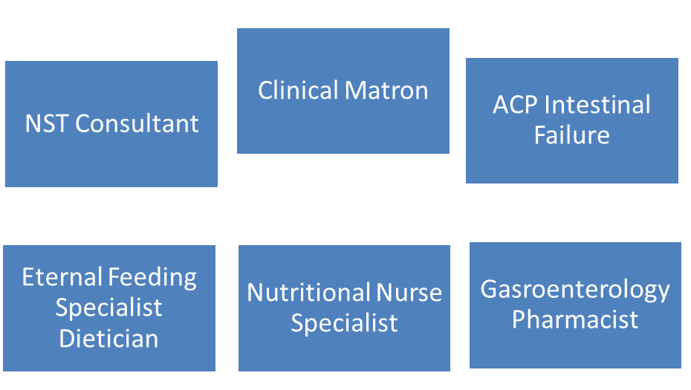

KEY RESULT AREAS/PRINCIPAL DUTIES AND RESPONSIBILITIES
CLINICAL PRACTICE
- To practice autonomously with a high level of accountability, providing a specialist service to patient requiring artificial nutrition
- To work as part of the MDT, assessing patients prior to admission for elective enteral feeding and then follow them through the process and in patient stay, finally liaising with the community teams upon discharge.
- Provide inpatient and outpatient services as required, managing own clinical caseload.
- Plan and manage complete episodes of care, working in partnership with others and delegating and referring as appropriate to optimise health outcomes and resource use as well as providing direct support to patients and clients.
- Make operational judgements, manages conflicting views, reconciles inter and intra professional differences of opinion and escalates for senior clinician review when required.
- Contribute to the co-ordination and effective management of admission and discharge processes taking a lead in areas of complexity.
- Assist in the placement of PEG tubes in endoscopy by under taking the Second Assist Course in Hull.
- Assist in the management of patients central lines
Leadership
- To act as expert clinical lead for artificial nutrition within the department of Gastroenterology and the wider Trust
- To provide strategic leadership within the trust on all nutrition support matters providing an advisory role to clinicians and other senior health professionals
- Take on lead or project management roles within team e.g. in relation to health and safety, student training, audit.
- To deal with complaints sensitively avoiding escalation where possible.
- Support the Intestinal Failure ACP in the development of the Nutrition Support team
- Take on delegated responsibilities to enable contribution to decision making process in relation to these specialities, reporting back promptly to rest of the team on actions/decisions taken in order to contribute effectively to clinical care across healthcare community.

EDUCTAION AND DEVELOPMENT
- Act as a role model demonstrating high standard of holistic care and provide clinical leadership across the Trust for this specialist area.
- Advise patients, their carers and staff on the promotion of health and prevention of illness.
- Lead and contribute to the regular training of others
- Identify own personal development needs and take appropriate action to ensure these needs are met.
- Develop and deliver education programmes to patients, carers, other healthcare professionals and peers to share best practice, evaluating and reviewing delivery and content of educational sessions which may be formal, informal and to groups of varying size. This may include sharing best practice with other organisations and presentation of complex information to large groups at multi-professional events.

COMMUNICATION/RELATIONSHIP SKILLS
- Communicate information, which may be complex and sensitive, about treatment plans to other healthcare professionals and patients, overcoming barriers to understanding e.g. posed by clinical condition, disability, language.
- Frequently apply advanced communication skills in communicating complex, sensitive and emotive information to patients and carers. This includes discussions about diagnosis, disease progression or end of life.

ANALYTICAL/JUDGEMENTAL SKILLS
- Contribute to data collection in order to analyse effectiveness, service improvements and gaps in service.

PLANNING/ORGANISATIONAL SKILLS
- Manage time independently prioritising workload to meet objectives and service demands, responding to requirements of role as priorities change and responding to urgent demands

POLICY/SERVICE DEVELOPMENT
- To lead on the development and implementation of trust policies, protocols and guidelines for the safe, appropriate and effective use of all artificial nutrition.
- Contribute to the development of and work within agreed service standards to ensure quality of care, taking an active role in the continuous evaluation of service delivery by audit, and lead the further development of speciality specific standards in area of practice.

FINANCIAL/PHYSICAL RESOURCES
- To be responsible for ensuring the effective selection and use of all treatment resources available against budget for the nutrition team,
HUMAN RESOURCES
- Contribute to quality improvement, and take appropriate action, working with the Clinical Matron when there are concerns in the areas of:

- Conduct of Care
- Scope of Professional Practice
- Multidisciplinary Team Working
- Data & Information Gaps
- Ineffective Systems
- Poor communication
- Workload issues
- Poor individual or team practice
- Complaints
- Financial and resource implications
- Health and safety deficits

- Have access to and full understanding of the following systems:

- Health Roster
- ESR – Supervisor access

RESEARCH AND DEVELOPMENT
- Seek out knowledge by reading, enquiring and participating in continuing education and attend relevant clinical/professional meetings, seminars and conferences
- Review and disseminate new information to relevant staff
- Evaluate clinical practice in relation to its evidence base and clinical effectiveness
- Participate in research within scope of clinical practice, to include active participation in research and audit projects and Quality Assurance projects.
- Use audit skills to enable the specialist team and other professions to improve quality of care by undertaking audits of clinical practice and actively contribute to the implementation of the findings/recommendations
- Acts as an expert therapy resource in specialist field.

OTHER RESPONSIBILITIES
To take part in regular performance appraisal.

To undertake any training required in order to maintain competency including mandatory training, e.g. Manual Handling

To contribute to and work within a safe working environment

The post holder is expected to comply with Trust Infection Control Policies and conduct him/herself at all times in such a manner as to minimise the risk of healthcare associated infection

As an employee of the Trust, it is a contractual duty that you abide by any relevant code of professional conduct and/or practice applicable to you. A breach of this requirement may result in action being taken against you (in accordance with the Trust’s disciplinary policy) up to and including dismissal.

THE TRUST- VISION AND VALUES
Our vision is to provide safe, high quality seamless services delivered with courtesy and respect. To achieve our vision we expect all our staff to uphold our Trust values. Our Trust values are:

Honesty, Openness & Integrity
Fairness,
Inclusion & Collaboration
Respect & Dignity

We recruit competent staff that we support in maintaining and extending their skills in accordance with the needs of the people we serve. We will pay staff fairly and recognise the whole staff’s commitment to meeting the needs of our patients.

We are committed to equal opportunity for all and encourage flexible working arrangements including job sharing.

We are committed to recruiting and supporting a diverse workforce and welcome applications from all sections of the community, regardless of age, disability, gender, race, religion, sexual orientation, maternity/pregnancy, marriage/civil partnership or transgender status. We expect all staff to behave in a way which recognises and respects this diversity, in line with the appropriate standards.

GENERAL
This is a description of the job as it is now. We periodically examine employees' job descriptions and update them to ensure that they reflect the job as it is then being performed, or to incorporate any changes being proposed. This procedure is conducted by the Manager in consultation with the jobholder. You will, therefore, be expected to participate fully in such discussions. We aim to reach agreement on reasonable changes, but if agreement is not possible, we reserve the right to insist on changes to your job description after consultation with you.

The RD&E is a totally smoke-free Trust. Smoking is not permitted anywhere on Trust property, including all buildings, grounds and car parks. For help to quit call: 01392 207462.

POST | Acute team lead Dietitian with clinical interest in Nutrition Support and Enteral Feeding
BAND | 7

P
E
R
S
O
N

S
P
E
C
I
F
I
C
A
T
I
O
N

Requirements | Essential | Desirable
QUALIFICATION/ SPECIAL TRAINING
Registered Nurse with experience at Band 6 or above
Evidence of postgraduate study and demonstrates ability to work at masters level
Post Grad Teaching qualification or equivalent
Management qualification - min level 3 or equivalent

KNOWLEDGE/SKILLS
Previous knowledge and experience of Intestinal Failure
Previous knowledge and experience of looking after patients with Enteral feeding devises
Able to second assist in the placement of PEGS
Ability to manage own patient caseload
Ability to apply specialist knowledge within a variety of healthcare settings
Good communication skills
Established Teaching skills
Research and audit skills and an understanding of their application to improve quality of services
Ability to assess complex medical requirements and use analytical skills to make decisions on treatment options
Good time management and clinical prioritisation skills with ability to respond to urgent demands as required
Information technology skills to enter data accurately, prepare presentations, search literature
Able to demonstrate ability to lead on projects / effect change in practice
Negotiating skills in resolving contentious issues

EXPERIENCE
Experience in working in Endoscopy/Gastroenterology
Demonstrable teaching ability
Innovator with ability to problem solve
Experience in applying research findings to practice
Counselling knowledge & experience
PERSONAL ATTRIBUTES
Effective communication and leadership skills
Ability to motivate self and others
Committed to service development
Ability to work autonomously and in a Multidisciplinary team
Flexible working practice
Effective organisational skills

OTHER REQUIRMENTS
Committed to further personal and professional development
Able to understand requirement to manage resources effectively
High level of dexterity in relation to clinical procedures as required

FREQUENCY

(Rare/ Occasional/ Moderate/ Frequent)
WORKING CONDITIONS/HAZARDS |  | R | O | M | F
Hazards/ Risks requiring Immunisation Screening
Laboratory specimens | N
Contact with patients | Y
Exposure Prone Procedures | Y
Blood/body fluids | Y
Hazard/Risks requiring Respiratory Health Surveillance
Solvents (e.g. toluene, xylene, white spirit, acetone, formaldehyde and ethyl acetate) | N
Respiratory sensitisers (e.g isocyanates) | N
Chlorine based cleaning solutions  (e.g. Chlorclean, Actichlor, Tristel) | N
Animals | N
Cytotoxic drugs | N
Risks requiring Other Health Surveillance
Radiation (>6mSv) | N
Laser (Class 3R, 3B, 4) | N
Dusty environment (>4mg/m3) | N
Noise (over 80dBA) | N
Hand held vibration tools (=>2.5 m/s2) | N
Other General Hazards/ Risks
VDU use ( > 1 hour daily) | N
Heavy manual handling (>10kg) | N
Driving | Y | X
Food handling | Y
Night working | N
Electrical work | N
Physical Effort | Y
Mental Effort | Y
Emotional Effort | Y
Working in isolation | Y
Challenging behaviour | Y

COMPETENCY REQUIREMENTS
To be completed for all new positions
Please tick which of these essential learning s is applicable to this role
(NB those that are mandatory for all staff with no variation on frequency are pre-populated with a tick)

Safeguarding Children | Group 1 |  |  | Blood Transfusion | BDS18 collection |  |  | Consent Training | x
 | Group 2 |  |  |  | BDS 19 & 20  Preparing & Administering |  |  | VTE Training
 | Group 3 |  |  |  | BDS 17 Receipting |  |  | Record management and the nhs code of practice
 | Group 4 |  |  |  | Obtaining a blood sample for transfusion |  |  | The importance of good clinical record keeping
 | Group 5 |  |  |  | Annual Update |  |  | Antimicrobial Prudent Prescribing
 | Group 6 |  |  |  |  |  |  | Control & Restraint Annual
Not mapped this one |  |  |  | Safeguarding Adults Awareness | Clinical Staff |  | x | Mental Capacity/DOL’s
 | Group 8 |  |  |  | Non Clinical Staff
Manual Handling – Two Year |  |  |  | Falls, slips, trips & falls | Patients
Equality & Diversity – One-Off requirement |  |  |  |  | Staff/Others
Fire |  | Annual | x | Investigations of incidents, complaints and claims |  |  | x
 |  | Two Yearly |  | Conflict Resolution – 3 yearly |  |  | x
Infection Control/Hand Hygiene |  | Annual requirement | x | Waterlow
 |  | One-Off requirement |  | PUCLAS
Information Governance |  |  |  | Clinical Waste Management |  | Application principles for clinical staff
Harassment & Bullying (Self Declaration – One off requirement) |  |  |  |  |  | Application principles for housekeeping
 |  |  |  |  |  | Application principles for portering and waste

