JOB DESCRIPTION

JOB DETAILS
Job Title | Business Administration and Projects -  Laboratory Administrator
Reports to | Laboratory Administration Team Leader
Band | 3
Department/Directorate | Specialist Services

JOB PURPOSE
- To generate, input, analyse and present data on staff competency and training, audit, point of care testing, patient results and quality activities on behalf of the Blood Sciences Departments.
- To maintain the quality and content of data held within laboratory quality information systems.
- To provide administration and coordination for Q-pulse document control and audit activities and deal with any associated enquiries.
- To provide high quality administration and clerical support to the Clinical Head of Department and Management team of the Blood Sciences Departments, using own initiative when necessary.
- To provide administrative support to maintain, gather and store IVIg data collection and transfusion incident reporting.
- To assist Management team of the Blood Sciences Departments in meeting UKAS ISO 15189 standards for accreditation.
- To help assist with the customer service and marketing platform for Monitor My Health.

KEY RESULT AREAS/PRINCIPAL DUTIES AND RESPONSIBILITIES
- To generate, input, analyse and present data on behalf of the Blood Sciences Departments. This will include:
- Generating reports of training and appraisal status of staff to be presented at departmental communication cells.
- Download complex patient results and details from Pathology IT system and manipulate into meaningful information. This will require the analysis of large and complex data sets of patient’s results and demographics using statistical programmes and formulae.
- Collect data and generate reports for Clinical Effectiveness Committee (CEC) behalf of the Patient Blood Management Group (PBMG).
- Prepare Terms of Reference for PBMG, Hospital Transfusion Team and finance department.
- To carry out analysis of information as directed by manager, carrying out research to support analysis of information. This will require a good knowledge of data manipulation and understanding of basic statistical analysis, packages and formulae.
- To create reports using spreadsheets to summarise data ensuring systems are adapted to reflect changes in data collected. This will include making creating bespoke download enquiries from Pathology IT system meet the specifications of others.
- To provide weekly and monthly reports for the laboratory management on specific Key Performance Indicators including:
  - Test turnaround times.
  - Emergency Department sample processing times.
  - Emergency Department breach investigations.
  - Quality management reports including overdue documents and outstanding change requests on documents.
  - Incidents and trend analysis.
  - Training activities.
- Deal with queries relating to data or information, assessing whether standard analyses are robust e.g. undertaking a data cleansing role or comparing data from different sources to ensure quality, consistency and accuracy.
- To maintain the quality and content of data held within laboratory quality information systems (Q-pulse).
- To provide administration and coordination for Q-pulse document control, plan audit activities and deal with any associated enquiries.
- To assist Management team of the Blood Sciences Departments in meeting the standards for accreditation for:
  - Medicines & Healthcare products Regulatory Agency (MHRA).
  - UK Accreditation Service (UKAS).
  - Human Tissues Act (HTA).
- Prepare issue and maintain new starters local induction packs.
- Maintain staff contacts records on ESR, contact lists and in personal files.
- Assist in maintaining all staff records on ESR (training, absence etc).
- To manage any miscellaneous clerical items for staff of the Blood Science Laboratories.
- Calculate annual leave entitlement for Departmental Staff on an annual basis.
- Record and monitor staff annual leave taken by staff on a monthly basis. Produce templates for Departmental Annual Leave sheets.
- Maintain departmental mandatory training records and ensure staff members remain up to date with mandatory Trust training.
- Ensuring that all documentation is produced to an excellent standard.
- To participate in team and directorate meetings as required.
- Customer Service for directive patients and members of the public.
- Prepare agendas, attend meetings to take minutes and write up / distributes minutes after meetings.
- Provide end user support for the ICE GP Order comm system in setting up new users and answering phone queries.
- Maintain multiple email accounts dealing with all queries in a timely manner and forwarding to the correct department to deal if cannot be dealt with by the admin team.
- Assist with the organisations blood tracking system and data.
- To assist with any departmental audits in relation to quality management.
- To help senior management with payroll and TOIL queries maintaining this on a monthly basis.
- To be a source of information and communication with the charitable trust fund team and laboratory ensuring all requests are put through in a timely manner.
- To respond back to any Monitor My Health emails/queries, in a timely manner. Ensuring all emails are dealt within 24-48 hours.
- To collect data on samples that have failed through Monitor My Health, ensuring this has been escalated on the second kit log, to ensure customers received a second sample; as part of our Terms & Conditions.
- To help dispatch kits, as well as unpack deliveries when needed.
- To help the Communication & Marketing Officer promote Monitor My Health on social media platforms, ensuring that we are also keeping customers updated.

KEY WORKING RELATIONSHIPS
No. of Staff reporting to this role: None

The post holder is required to deal effectively with staff of all levels throughout the Trust as and when they encounter on a day to day basis.

This will include verbal, written and electronic media.

Of particular importance are working relationships with:

Internal to the Trust | External to the Trust
- Head of Departments  - Laboratory Managers  - Deputy Laboratory Managers  - Senior Technical and Scientific Staff  - Medical / Nursing Staff  - Medical Records staff  - Clerical and MLA staff  - Personnel  - Phlebotomy  - Estates Department  - Catering Department | - Patients  - Commercial customers  - Access to Work  - Suppliers

ORGANISATIONAL CHART
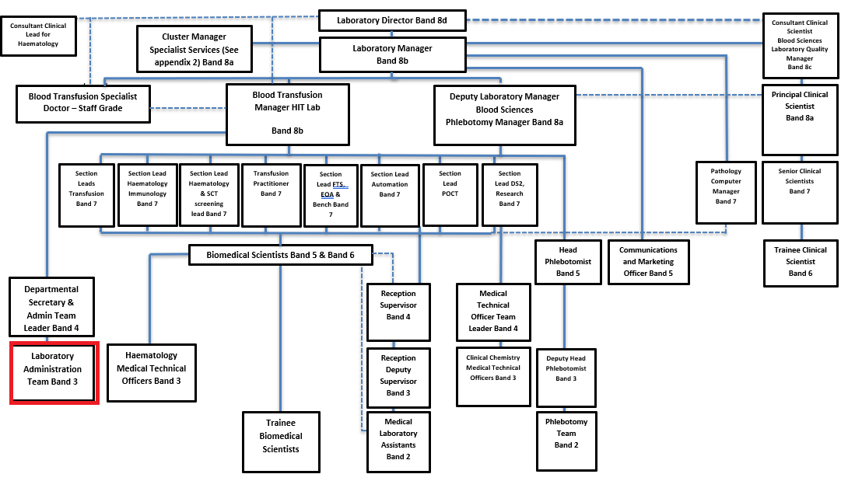
FREEDOM TO ACT
Works to clearly defined occupational policies.
Work is managed, rather than supervised.
Deals with enquiries and implements procedures guided by standard operating procedures.
Someone always available for reference.
COMMUNICATION/RELATIONSHIP SKILLS
Provides and receives routine information often requiring tact or persuasive skills
Exchange information with patients, relatives and staff on a variety of departmental matters and procedures.
Has to dealt with anxious patients and is required to overcome cultural or language difficulties.
Communicates complicated administrative information to staff from other departments, external contacts
To communicate with staff, external organisations and colleagues in a courteous, professional and timely manner at all times.
To assist in dealing with all day to day correspondence within the department – initiating appropriate responses in order to provide, staff and other parties with required information in a friendly and professional manner.
Receiving telephone calls and accepting messages on behalf of members of the management team and taking appropriate action where necessary.
To manage email communication in a timely way and in line with the RD&E’s Email Best Practice guidance.
To supply information to managers on immunoglobulin usage and the universal haemoglobinopathy screening programme
To Communicate with Medical and Nursing staff on issues of requesting immunoglobulin products.
To receive and collate data necessary for maintaining accurate databases.
Maintain the highest level of patient confidentiality.
To recognise the importance of harmonious relationships and maintain an atmosphere conducive to this.

ANALYTICAL/JUDGEMENTAL SKILLS
Makes judgements involving facts or situations, some requiring analysis.
Exercises judgement when dealing with enquiries.
Analyses information to resolve problems for patients, commercial customers and staff.
PLANNING/ORGANISATIONAL SKILLS
Plans and organises straightforward activities, some ongoing.
Plans staff rotas and cover; schedules clinics; arranges meetings; manages diaries
PATIENT/CLIENT CARE
Assist patients during incidental contacts.
Regularly assists commercial customers providing non-clinical advice and information.
POLICY/SERVICE DEVELOPMENT
Follow policies in own role, may be required to comment / Implement policies and propose changes to practices, procedures for own area.
To contribute to the NHS service improvement by participating fully in new projects and developments such as service redesign work.

FINANCIAL/PHYSICAL RESOURCES
Responsibility for petty cash, office equipment, orders and maintains office supplies and stationery.
The post holder will ensure that all consumables are used correctly and that wastage is minimized.
Investigates Reference Laboratory centre pricing and sample requirements for any analysis not performed by the Department and maintain current register, highlighting any potential savings to Laboratory Managers.
Ensure all outstanding Reference Laboratory work is completed in a timely fashion working from an outstanding worklist and investigate any non-compliances.
Liaising with Senior BMS staff and Laboratory Manager to investigate invoicing anomalies or discrepancies as and when necessary.
Raises credit notes when required.

HUMAN RESOURCES
The post holder provides training in own discipline to other staff.
Demonstrates administrative, secretarial duties to new starters, less experienced staff.
INFORMATION RESOURCES
A significant aspect if the role is data entry, text processing and storage of data.
Take, transcribe formal minutes.
Updates, maintains, stores clinical or non-clinical records, appointment details.
RESEARCH AND DEVELOPMENT
Undertake surveys or audits, as necessary to own work.

PHYSICAL SKILLS
Physical skills obtained through practice.
Keyboards skills for regular use of computer systems/touch or audio typing
PHYSICAL EFFORT
Combination of sitting, standing, walking.
Occasional light effort for several long periods
Light physical effort/Keyboard work for long periods; lifting case notes; pushing notes trolleys; moving equipment
MENTAL EFFORT
Concentration for administrative and secretarial duties, work pattern predictable
Interruptions from other staff and external agencies.
EMOTIONAL EFFORT
Limited exposure to distressing or emotional circumstances.
WORKING CONDITIONS
Exposure to unpleasant conditions is rare.
Use VDU equipment more or less continuously.
Office or similar conditions.

OTHER RESPONSIBILITIES
Take part in regular performance appraisal.

Undertake any training required in order to maintain competency including mandatory training, e.g. Manual Handling

Contribute to and work within a safe working environment

You are expected to comply with Trust Infection Control Policies and conduct him/herself at all times in such a manner as to minimise the risk of healthcare associated infection

As an employee of the Trust, it is a contractual duty that you abide by any relevant code of professional conduct and/or practice applicable to you. A breach of this requirement may result in action being taken against you (in accordance with the Trust’s disciplinary policy) up to and including dismissal.

You must also take responsibility for your workplace health and wellbeing:
- When required, gain support from Occupational Health, Human Resources or other sources.
- Familiarise yourself with the health and wellbeing support available from policies and/or Occupational Health.
- Follow the Trust’s health and wellbeing vision of healthy body, healthy mind, healthy you.
- Undertake a Display Screen Equipment assessment (DES) if appropriate to role.

DISCLOSURE AND BARRING SERVICE CHECKS
This post has been identified as involving access to vulnerable adults and/or children and in line with Trust policy successful applicants will be required to undertake a Disclosure & Barring Service Disclosure Check.
GENERAL
This is a description of the job as it is now. We periodically examine employees' job descriptions and update them to ensure that they reflect the job as it is then being performed, or to incorporate any changes being proposed. This procedure is conducted by the manager in consultation with the jobholder. You will, therefore, be expected to participate fully in such discussions. We aim to reach agreement on reasonable changes, but if agreement is not possible, we reserve the right to insist on changes to your job description after consultation with you.

Everyone within the Trust has a responsibility for, and is committed to, safeguarding and promoting the welfare of vulnerable adults, children and young people and for ensuring that they are protected from harm, ensuring that the Trusts Child Protection and Safeguarding Adult policies and procedures are promoted and adhered to by all members of staff.

Northern Devon Healthcare NHS Trust and the Royal Devon and Exeter NHS Foundation Trust continue to develop our long standing partnership with a view to becoming a single integrated organisation across Eastern and Northern Devon. Working together gives us the opportunity to offer unique and varied careers across our services combining the RD&E’s track record of excellence in research, teaching and links to the university with NDHT’s innovation and adaptability.
This is

PERSON SPECIFICATION

Job Title | Business Administration and Projects -  Laboratory Administrator

Requirements | Essential | Desirable
QUALIFICATION/ SPECIAL TRAINING  Educated to level NVQ3 or equivalent & additional knowledge or equivalent experience / technical diploma.  Minimum GCSE or equivalent in English and Mathematics (Grades A-C)  RSA III Typing/ or equivalent. | E  E
KNOWLEDGE/SKILLS  Knowledge of data analysis and associated software/computer systems acquired through diploma or equivalent experience/qualification.  Ability to undertake detailed investigations, analyse complex data, present results in an appropriate manner and make sound recommendations.  IT literacy and data handling experience.  Medical terminology or willingness to learn.  Comprehensive PC skills including databases, word-processing and email, including All Microsoft Packages.  Excellent telephone manner.  Knowledge of Quality management IT systems (e.g. Q-pulse). | E  E  E  E  E | D  D
EXPERIENCE  Previous Customer service experience.  Previous NHS experience.  Working with the public.  Previous secretarial / admin experience.  Contribution to service development.  Previous experience of collection, analysis and presentation of data. | E  E  E | D  D  D
PERSONAL ATTRIBUTES  Proven experience of adaptability in the workplace.  Excellent interpersonal/Communication skills.  Good understanding of working within a team.  A flexible approach to work.  Ability to work as part of a team.  Able to plan and organise workload.  Proven ability to use own initiative and to work with minimum supervision.  Remain calm and professional in a busy environment.  Adhere to data protection and confidentiality requirements. | E  E  E  E  E  E  E  E  E
OTHER REQUIREMENTS  The post holder must demonstrate a positive commitment to uphold diversity and equality policies approved by the Trust.  Ability to travel to other locations as required. | E  E

FREQUENCY

(Rare/ Occasional/ Moderate/ Frequent)
WORKING CONDITIONS/HAZARDS |  | R | O | M | F
Hazards/ Risks requiring Immunisation Screening
Laboratory specimens | Y |  |  | M
Contact with patients | Y | R
Exposure Prone Procedures | N
Blood/body fluids | Y |  |  | M
Hazard/Risks requiring Respiratory Health Surveillance
Solvents (e.g. toluene, xylene, white spirit, acetone, formaldehyde and ethyl acetate) | Y | R
Respiratory sensitisers (e.g isocyanates) | Y | R
Chlorine based cleaning solutions  (e.g. Chlorclean, Actichlor, Tristel) | Y | R
Animals | N
Cytotoxic drugs | N
Risks requiring Other Health Surveillance
Radiation (>6mSv) | N
Laser (Class 3R, 3B, 4) | N
Dusty environment (>4mg/m3) | N
Noise (over 80dBA) | N
Hand held vibration tools (=>2.5 m/s2) | N
Other General Hazards/ Risks
VDU use ( > 1 hour daily) | Y |  |  |  | F
Heavy manual handling (>10kg) | N
Driving | Y | R
Food handling | N | R
Night working | N | R
Electrical work | N | R
Physical Effort | Y |  |  | M
Mental Effort | Y |  | O
Emotional Effort | Y |  | O
Working in isolation | Y | R
Challenging behaviour | Y | R

