

JOB DESCRIPTION

|  |  |
| --- | --- |
| **JOB DETAILS** |  |
| **Job Title** | Chief Respiratory and Sleep Physiologist |
| **Reports to** | Lead Respiratory & Sleep Physiologist/ Healthcare Science Service Manager / Cluster  Manager |
| **Band** | Band 7 |
| **Department/Directorate** | Respiratory and Sleep Physiology/Medicine |

|  |
| --- |
| **JOB PURPOSE** |
| Working autonomously as an advanced practitioner within the Respiratory and Sleep Physiology services you will undertake and report on a range of routine, specialised and advanced tests and procedures in accordance with local, national and international guidance.    As a senior member of the team you will support the deputy and clinical lead in the operational and clinical management of the respiratory and sleep physiological diagnostic and treatment services across Eastern site and the wider Devon region, including the community diagnostic centre in the Nightingale Hospital.    You will support the review, development and facilitate the implementation of standard operating procedures and guidelines within the department in accordance with current research, and national / local guidelines.    You will provide highly specialist advice, teaching and training to both physiologists and other health care professionals within the multi-disciplinary team.    You will take a lead role in department research and audit, and support trainees undertaking Healthcare Science apprenticeship programmes. |
| **KEY RESULT AREAS/PRINCIPAL DUTIES AND RESPONSIBILITIES** |
| * Independently undertake a range of routine, specialised and advanced physiological measurements, often of a complex and non-routine nature. This will include the following: Spirometry, gas transfer, lung volumes by plethysmography and helium dilution, challenge testing, flight assessment; adult and paediatric oximetry setup and reporting, polygraphy setup, analysis and reporting, and treatment of sleep disordered breathing. * Compile a detailed report relating to the physiological measurement investigation via interpretation of relevant technical detail and transferring this into a coherent and understandable format. * Receive and categorise often complex referrals; producing advanced scientific reports. * Prioritisation of clinical workload to ensure effective delivery of the Physiologist led Sleep pathway and Respiratory physiology services. * Participate in regular quality control regimes for all diagnostic equipment, which requires precision and co-ordination. * Assist in the training of Healthcare Scientists and other Medical / Non-medical Staff where appropriate. |

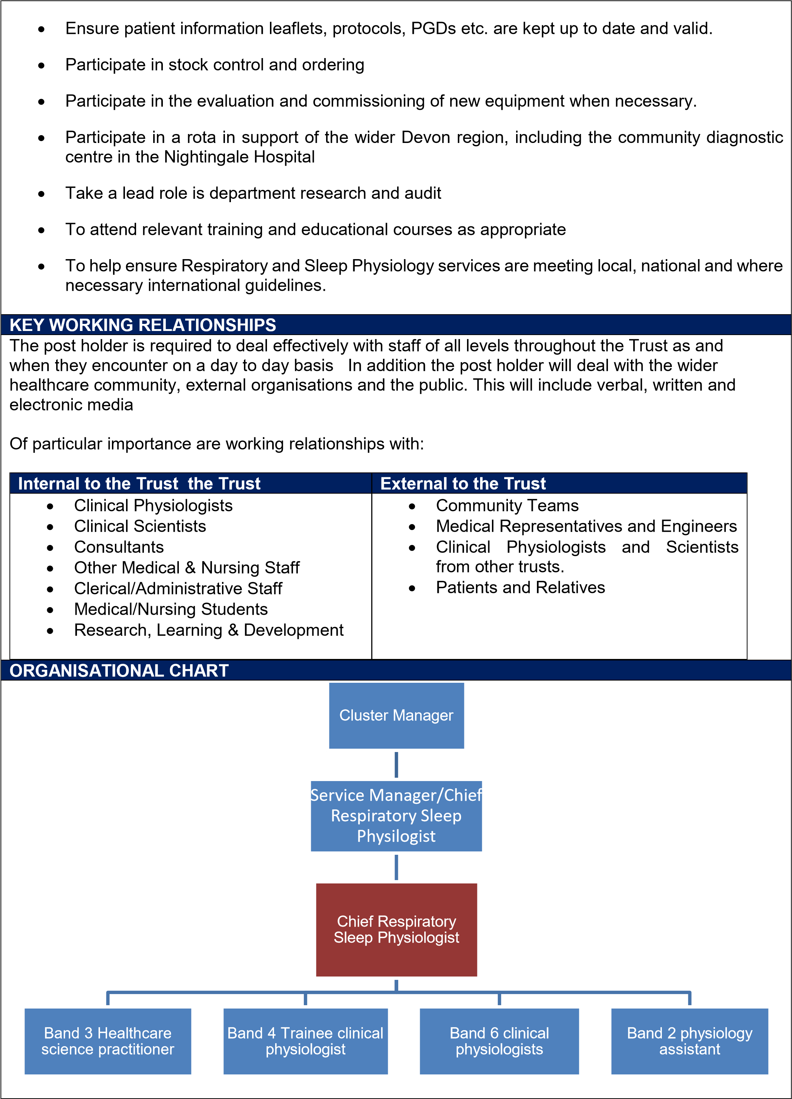

|  |
| --- |
| **FREEDOM TO ACT** |
| Works as an advanced practitioner in the hospital setting without immediate supervision  Conducts investigations independently without immediate supervision but under managerial and service operating guidelines.  Adheres to professional and organisational standards of practice.  Is professionally accountable for all aspects of your own work, within the context of an autonomous practitioner.  Uses own knowledge, skills and experience to determine when investigation is complete and comprehensive enough to end examination.  Undertakes Interpretation of complex data and compiles investigation reports which rarely require managerial input.  Initiates and leads specific projects as required without immediate supervision but under managerial guidelines  Works with the nursing and medical teams to contribute towards, lead and support decisions about patient care.  Works with the Respiratory and Sleep Physiology team manager to lead and support development of the service  Promotes and participates in Clinical Audit to develop and establish standards.  Actively participates in Multidisciplinary Team (MDT) meetings to aid decision making around patient care.  Works with other members of the team to identify, assess and develop plans for minimising clinical risk, ensures compliance with Health and Safety policies, and reflects on significant events. |
| **COMMUNICATION/RELATIONSHIP SKILLS** |
| Communication with a range of healthcare professions including Physiologists, Scientists, Nurses, Consultants and Senior Managers, along with Patients and Carers relating to various aspects of the service, including referrals and complex reports which can contain emotionally charged and sometimes time critical information.    Communication of investigation results via Interpretation and assimilation of relevant technical detail into a coherent and understandable written report format is vital. Communication of results can additionally be verbal in nature in order to successfully communicate the results to the necessary multi-disciplinary teams in a timely manner in relation to on-going patient care. Offers advice to clinicians, where appropriate, on the findings of investigations, and possible further investigations etc.    Communicate with administrative staff relating to patient appointments, referrals, waiting lists and clinic allocation.    Communicate the intricacies of the diagnostic test procedures to the patient/relatives/carers in an appropriate, professional and informative manner. Communicate effectively test results to meet the needs of a diverse patient population including children and those with learning disabilities, dementia and mental health issues. Tact, reassurance and persuasive skills are often required to enable patients to commence treatment for sleep disordered breathing.    Communicate with company representatives to obtain quotes for stock or to discuss equipment faults and errors.  Presents research, educational or specialist information to panels, conferences or to large groups via online digital media. |
| **ANALYTICAL/JUDGEMENTAL SKILLS** |
| Post holder has highly specialised knowledge, training and experience in Respiratory and Sleep physiology    Investigates and assimilates evidence and then interprets the relevance of this evidence to form a report which will guide treatment. Provides expert opinion on the content of reports. Where sections of data/traces are un-interpretable decide if sufficient evidence has been identified from the remaining data |

|  |
| --- |
| or whether the investigation needs to be abandoned/rebooked or whether an alternative investigation is more appropriate.    Additionally, undertakes interpretation and reporting of paediatric and neurological investigations, compiling reports that do not always conform to recognised normal ranges but can be communicated as trends and patterns of function.    Currently holds an up professional registration in Sleep and Respiratory Physiology, and has a highly specialised understanding of Respiratory and Sleep investigative equipment enabling the prompt identification of problems, errors, and equipment failures.    Leads in relevant clinical audits and research. |
| **PLANNING/ORGANISATIONAL SKILLS** |
| Plans and prioritises own workload on a daily basis in accordance with clinical demands    Prioritises patient referrals based on clinical urgency    Collaborates across other disciplines and areas in order to arrange and perform patient investigations. Advance planning regarding patients’ appointments which may require communication and planning based on staff and equipment availability or test results.    Works with members of the team to ensure patient information leaflets, protocols, PGDs, risk assessments, etc. are kept up to date and valid, requires organisational skills to ensure these assessments are updated in a timely manner. |
| **PATIENT/CLIENT CARE** |
| Has direct contact with patients to perform Sleep and Respiratory physiology investigations. This involves communicating the nature of investigations, reassuring and responding to patient needs and balancing the requirements of the quality of the investigation against the emotional/support requirements of the patient.  Investigations are adapted as appropriate to align with patients’ abilities, and do not necessarily follow a set process. Physiologist uses own knowledge and skills, and adapts practice to obtain optimal results for the patient.  Often communicates with patients and carers in advance or following an appointment to plan their care or offer advice post-procedure. Communication can be in both verbal and/or written format    Treats all patient information with confidentiality in accordance with relevant policies |
| **POLICY/SERVICE DEVELOPMENT** |
| Contributes towards the development of Sleep and Respiratory Physiology investigations including the development of Standard Operating Procedures, Patient Information leaflets, Protocols, Patient Group Directives, and Clinical Audits  Investigations are adapted as appropriate to align with patients’ abilities, and do not necessarily follow a set process. Physiologist uses own knowledge and skills, and adapts practice to obtain optimal results for the patient.  Attends national/international conferences and meetings in order to inform and update clinical practise.  Keeps up to date on relevant clinical guidance and policies and applies this into practice as agreed locally. |

|  |
| --- |
| Involved in evaluating and commissioning new Respiratory and Sleep equipment. |
| **FINANCIAL/PHYSICAL RESOURCES** |
| Contributes towards the evaluation of new equipment and consumables associated with the service.  Calibrates equipment and ensures the accuracy/validity of data.  Participates in stock control ensuring items are ordered items in a timely manner in suitable quantities.  Communicates with company representatives to obtain quotes for stock and relating to equipment repairs.  Participate in regular quality control and calibration regimes for diagnostic equipment used.  Contributes towards the undertaking of risk assessments to help ensure the safety and security of staff, patients and others. |
| **HUMAN RESOURCES** |
| Involved in delivering teaching and training to multi-disciplinary staff relating to the investigations undertaken in the department  Participates in delivering Respiratory and Sleep courses and assesses competencies of staff following such training.  Facilitates and supervises the development of other Physiologists, Nurses and Healthcare Assistants within the service as appropriate  Works as part of the Physiologist led Sleep pathway whereby the Physiologist determines the diagnosis and implements subsequent treatment or onward referral. Is involved in booking bank staff |
| **INFORMATION RESOURCES** |
| The majority of the investigative equipment utilised is computer operated and utilises software and databases which are frequently used to record and analyse data, and to compile reports.( Eg Investigations are conducted on specialist equipment ,then uploaded to the network location. They are then downloaded to the postholders desktop or laptop for analysis and compilation of a diagnostic report) Additionally, the role involves producing scientific reports that require interpretation, statistical analysis and graphical presentation utilising nomograms and figures that are compared to normal ranges. These reports are complex and inform patient care and treatment.  Post holder participates in Clinical audit, the results of which require statistical interpretation and which inform patient care.  Utilises computers for other activities such as compiling risk reports, documenting communication with patients, staff and others |
| **RESEARCH AND DEVELOPMENT** |
| Involved in evaluating and commissioning new Respiratory and Sleep equipment.  Leads department research and clinical audits.    Support Healthcare Science apprentices within own discipline in completing research as part of course. |

|  |
| --- |
| Contributes to national research projects such as FIBRONEER etc.    Ensures clinical practice developments are based on best available evidence and participates in the development of evidence based clinical guidelines and protocols for the Respiratory and Sleep Physiology service  Reviews and disseminate new information to relevant staff.    Conducts regular calibration as a part of quality control process using quantitative measuring instruments. Maintain or keep a log report of calibrated values which is referenced to a known or recommended set of parameters. |
| **PHYSICAL SKILLS** |
| Participate in regular quality control regimes for all our diagnostic equipment, which require precision and co-ordination.    High degree of hand eye co-ordination and timing when obtaining body plethysmography and gas transfer measurements.    Physical ability to safely handle AK (60kg) sized gas cylinders and fine motor skills to connect gas regulators and ensure regulator pressures are adjusted correctly.    Fine motor skills to assemble/disassemble Jaeger equipment valves, and identify and replace faulty components i.e. hairline cracks in plastic components, worn gas cylinder rubber seals.    Fine motor skills to manipulate small components and identify minor damage/defect in Ventilator consumable equipment.    Highly developed physical skills are required to carry out-patient procedures and scientific measurements where a high degree of precision or speed is essential. |
| **PHYSICAL EFFORT** |
| Manual handling to assist patients as appropriate some of whom may be inpatients, elderly or frail.  Physical ability to safely handle AK (60kg) sized gas cylinders and fine motor skills to connect gas regulators and ensure regulator pressures are adjusted correctly.    Stock control involving moving and unpacking boxes of consumables. Ability to regularly move and handle large boxes of ventilator/compressor devices and consumable items.  Moving equipment around rooms  Clinics are carried out daily |
| **MENTAL EFFORT** |
| Sustained periods of time concentrating (3-4hour sessions), when analysing diagnostic results and reporting on results.    Sustained mental effort required to motivate and support patients during effort dependant pulmonary function measurements.    The ability to perform rapid, accurate and precise analysis during appointments to establish if adequate results are obtained and provide corrective instructions to obtain diagnostic results. |

|  |
| --- |
| Required to deal with frequent interruptions to support Physiology team members and trainees, urgent ward queries/requests and patients under long term care of the sleep service.    Maintain and improve in-depth specialist knowledge within clinical field (specialist technical, academic and procedural knowledge).    Demonstrate motivation and enthusiasm in the specialist role.    Frequent sustained mental effort required to include accurate clinical information, technical documentation, and results from multiple information sources.  Frequent periods of concentration required in order to set up, conduct, analyse and report on highly specialised investigations, whilst ensuring that local and national guidance is adhered to.  Frequent periods of concentration required to triage and categorise referrals.  Frequent periods of concentration required to conduct quality control regimes for diagnostic equipment.  Occasional periods of concentration required to train Healthcare Scientists and other Medical / Nonmedical Staff.  Occasional periods of concentration required to ensure patient information leaflets, protocols, PGDs etc. are kept up to date and valid.  Frequent periods of concentration required to undertake stock control and ordering  Occasional periods of concentration required to participate in the evaluation and commissioning of new equipment when necessary.  Concentration required to maintain and improve in-depth specialist knowledge within clinical field |
| **EMOTIONAL EFFORT** |
| To provide a high level of persuasion, motivation, support and encouragement during measurements that are effort and technique dependant to ensure acceptable, reproducible diagnostic measurements are obtained, often in patients who have significant disease impairment, may be limited by pain/discomfort or shortness of breath (including those with oxygen requirements), and may be distressed following a significant diagnosis.    To be skilled at communicating with patients, relatives and carers the relevance of investigations and where appropriate, the results obtained and possible future treatment, sometimes under pressure with distressed and anxious patients, relatives and carers.    To be skilled in dealing with young children, those with learning disabilities (adults and children), persons detained at His Majesty’s pleasure and those with psychiatric or challenging behaviour are essential. |
| **WORKING CONDITIONS** |
| The role involves frequent exposure to respiratory droplets and aerosols due the nature of the respiratory measurements, including forced expirations.    The role involves handling of devices and mask that are located in the community, often not maintained by the patient as prescribed.    Occasional exposure to bodily fluids such as urine and vomit. |
| Occasional handling of cleaning products subject to COSHH regulation (i.e. Oxygenon-I).  Patients can occasionally become aggressive and threatening, and appropriate communication is required to diffuse the situation.  Staff are required to disinfect and clean equipment with appropriate cleaning solutions/wipes.  Frequent use of VDUs and other electronic equipment. |
| **OTHER RESPONSIBILITIES** |
| Take part in regular performance appraisal.    Undertake any training required in order to maintain competency including mandatory training, e.g. Manual Handling    Contribute to and work within a safe working environment    You are expected to comply with Trust Infection Control Policies and conduct him/herself at all times in such a manner as to minimise the risk of healthcare associated infection    As an employee of the Trust, it is a contractual duty that you abide by any relevant code of professional conduct and/or practice applicable to you. A breach of this requirement may result in action being taken against you (in accordance with the Trust’s disciplinary policy) up to and including dismissal.    You must also take responsibility for your workplace health and wellbeing:   * When required, gain support from Occupational Health, Human Resources or other sources. * Familiarise yourself with the health and wellbeing support available from policies and/or Occupational Health. * Follow the Trust’s health and wellbeing vision of healthy body, healthy mind, healthy you. * Undertake a Display Screen Equipment assessment (DES) if appropriate to role. |
| **GENERAL** |
| This is a description of the job as it is now. We periodically examine employees' job descriptions and update them to ensure that they reflect the job as it is then being performed, or to incorporate any changes being proposed. This procedure is conducted by the manager in consultation with the jobholder. You will, therefore, be expected to participate fully in such discussions. We aim to reach agreement on reasonable changes, but if agreement is not possible, we reserve the right to insist on changes to your job description after consultation with you.  Everyone within the Trust has a responsibility for, and is committed to, safeguarding and promoting the welfare of vulnerable adults, children and young people and for ensuring that they are protected from harm, ensuring that the Trusts Child Protection and Safeguarding Adult policies and procedures are promoted and adhered to by all members of staff.  At the Royal Devon, we are committed to reducing our carbon emissions and minimising the impact of healthcare on the environment, as outlined in our Green Plan available on our website. We actively promote sustainable practices and encourage colleagues to explore and implement greener ways of working within their roles. |

PERSON SPECIFICATION

|  |  |
| --- | --- |
| **Job Title** | Chief Clinical Physiologist, Band 7 |

|  |  |  |  |
| --- | --- | --- | --- |
| **Requirements** | | **Essential** | **Desirable** |
| **QUALIFICATION/ SPECIAL TRAINING**  Relevant First Degree in Clinical Physiology or in a relevant/qualifying discipline  Relevant Master’s degree in Clinical Physiology via the NHS Scientist Training Programme OR Registered clinical scientist, who has been through the Higher Specialist Scientist Training Programme OR equivalent experience  Current registration on a recognised statutory or voluntary register as appropriate. | | **E**        **E**        **E** | **E**        **E**        **E** |
| **KNOWLEDGE/SKILLS**  Excellent presentation skills (including large groups)  Practiced in evaluating complex physiological tracings/results.  Practiced in producing advance diagnostic reports.  Good levels of competency in computing skills.  Skilled in history taking. |  | **E**  **E**  **E**  **E**  **E** | **E**  **E**  **E**  **E**  **E** |
| **EXPERIENCE**  Previous experience at level or equivalent.  Significant experience in the chosen physiological specialisation.  Working as part of a multi-disciplinary team. | measurement | **E**  **E**    **E** | **E**  **E**  **E** |
| **PERSONAL ATTRIBUTES**  Excellent interpersonal / communication skills at all levels.  Planning, organisational and prioritisation skills.  Accurate and methodical.  Highly motivated and enthusiastic.  Remain calm in a busy environment.  Empathetic and caring.  Cope with emotional and difficult circumstances. |  | **E**  **E**  **E**  **E**  **E**  **E**  **E** | **E**  **E**  **E**  **E**  **E**  **E**  **E** |
| **OTHER REQUIREMENTS**  Flexible working practices.  Ability to initiate and facilitate change.  Motivated to further personal and professional development of self and team. |  | **E**  **E**  **E** | **E**  **E**  **E** |

|  |  |  |  |  |  |
| --- | --- | --- | --- | --- | --- |
|  |  | **FREQUENCY**    **(Rare/ Occasional/**  **Moderate/ Frequent)** | | | |
| **WORKING CONDITIONS/HAZARDS** |  | **R** | **O** | **M** | **F** |
|  |  |  | | | |
| **Hazards/ Risks requiring Immunisation Screening** |  |  |  |  |  |
| Laboratory specimens | N |  |  |  |  |
| Contact with patients | Y |  |  |  |  |
| Exposure Prone Procedures | Y |  | 🗸 |  |  |
| Blood/body fluids | Y | 🗸 |  |  |  |
|  |  |  | | | |
| **Hazard/Risks requiring Respiratory Health Surveillance** |  |  |  |  |  |
|  |  |  | | | |
| Solvents (e.g. toluene, xylene, white spirit, acetone, formaldehyde and ethyl acetate) | N |  |  |  |  |
| Respiratory sensitisers (e.g isocyanates) | N |  |  |  |  |
| Chlorine based cleaning solutions (e.g. Chlorclean, Actichlor, Tristel) | Y |  |  |  | 🗸 |
| Animals | N |  |  |  |  |
| Cytotoxic drugs | N |  |  |  |  |
|  |  |  |  |  |  |
| **Risks requiring Other Health Surveillance** |  |  |  |  |  |
| Radiation (>6mSv) | N |  |  |  |  |
| Laser (Class 3R, 3B, 4) | N |  |  |  |  |
| Dusty environment (>4mg/m3) | N |  |  |  |  |
| Noise (over 80dBA) | N |  |  |  |  |
| Hand held vibration tools (=>2.5 m/s2) | N |  |  |  |  |
|  |  |  | | | |
| **Other General Hazards/ Risks** |  |  |  |  |  |
| VDU use ( > 1 hour daily) | Y |  |  |  | 🗸 |
| Heavy manual handling (>10kg) | Y |  |  | 🗸 |  |
| Driving | N |  |  |  |  |
| Food handling | N |  |  |  |  |
| Night working | N |  |  |  |  |
| Electrical work | N |  |  |  |  |
| Physical Effort | Y |  |  | 🗸 |  |
| Mental Effort | Y |  |  |  | 🗸 |
| Emotional Effort | Y |  |  |  | 🗸 |
| Working in isolation | Y |  |  | 🗸 |  |
| Challenging behaviour | Y |  |  | 🗸 |  |