JOB DESCRIPTION

JOB DETAILS
Job Title | Legacy and Fundraising Manager
Reports to | Head of Fundraising
Band | Band 7
Department/Directorate | Strategy

JOB PURPOSE
We are seeking a Legacy and Fundraising Manager to support the Royal Devon Hospitals Charity raise funds to enhance our patient care and staff health and wellbeing.

Reporting to the Head of Fundraising, the Legacy and Fundraising Manager will play a pivotal role in the development and management of our Legacy and In Memory giving strategy, as well as overseeing the management of our Eastern Fundraising team. You will have a proven track record of meeting legacy and fundraising targets.

The postholder will line manage a team of three fundraisers, based in Exeter and is also responsible for legacy income planning across the entire charity footprint (Exeter, north and east Devon)

Key responsibilities:

- Legacy strategy, plan and implementation: The post holder will implement the development of our Legacy and In Memory giving strategy. This includes engaging potential donors, meeting growth targets as well as guiding the NHS teams on how to maximise the benefit of legacy income to patients and staff
- Ongoing legacy Management: Manage a case load of pecuniary, residuary and life interest trust legacies, dealing with them efficiently and effectively – adding value and safeguarding Royal Devon Hospitals Charity interest. Correspond with Executors, families and friends and ensure the positive impact of the legacy is demonstrated and acknowledged
- Supporter Care Journey: Create a meaningful supporter care journey and information materials that sensitively and effectively informs our supporters about ways to contribute to the Royal Devon Hospitals Charity through leaving a legacy and donating In Memory of a loved one. Nurture key internal and external relationships over many years
- Team leadership: Line management of the fundraising team based at RD&E. Ensuring they receive excellent supervision and support and meet income generation targets. The postholder will oversee all aspects of the RD&E team’s day to day fundraising, engagement, and campaign management. This includes responsibilities such as legacy marketing, participation, risk assessments, budget management, and donor engagement.

KEY RESULT AREAS/PRINCIPAL DUTIES AND RESPONSIBILITIES
- Legacy and fundraising operational planning and delivery
- Planning and oversight of eastern-led fundraising appeals
- Supportive team management. Workforce planning and development
- Business planning and performance management
- Financial and resource management
- Information management
- Patient/supporter involvement
- Legacy and charity governance compliance
- Policy and service development
KEY WORKING RELATIONSHIPS
The post holder is required to deal effectively with staff of all levels throughout the Trust, the wider Healthcare community, external organisations and the public. This will include verbal, written and electronic media.

Of particular importance are working relationships with:

Internal to the Trust | External to the Trust
- Fundraising teams across the Trust | - NHS Charities together
- Finance teams | - Solicitors
- Communication, marketing and engagement team including web and designers | - Members of the public
- NHS staff | - Executors, families and friends of legacy donors
- Corporate Trustee (includes executive and non-executive directors) | - Auditors
- Care Group leads and operational managers
- Clinicians and service leads
- Colleagues in other divisions, especially estates

ORGANISATIONAL CHART
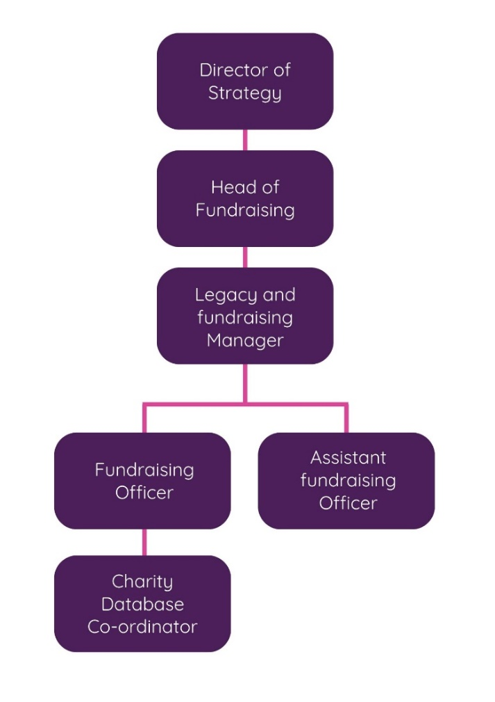

FREEDOM TO ACT
The postholder is required to manage their own workload, within the team environment and will be expected to act independently, following internal procedures and processes for sign-off and escalation.
COMMUNICATION/RELATIONSHIP SKILLS
The postholder will have excellent communication skills to ensure all stakeholders are aware of In Memory giving to the Royal Devon Hospitals Charity and that their legacy experience is sensitive and supportive.
They are required to develop and foster good, long-lasting relationships with donors, executors and solicitors and liaise with them on the Trust’s behalf to agree legacy investments. Develop strong relationships with internal clinical, operational and corporate teams to ensure the Charity supports the greatest benefit of legacy donations.
- Deliver presentations on proposals and performance reports to the charitable funds committee/Board of Directors as required.
- Ensure effective systems for involving patients/donors in planning of services and providing feedback.
ANALYTICAL/JUDGEMENTAL SKILLS
The postholder will have significant autonomy in the delivery of the above and be responsible for their professional actions. Postholder is expected to work within set guidelines but act on own initiative to develop and improve their areas of service responsibility in order to improve chartable effectiveness and maintain quality services.
The postholder will determine key performance indicators for specific projects and monitor their delivery. If necessary they will be expected to identify and take necessary actions to ensure delivery.
- Monitor monthly performance indicators for legacy and fundraising services/income generation requirements, including governance, productivity, contract activity, key performance targets, efficiency, and where necessary prepare and manage corrective actions.
- Identify cost improvements, service developments and income generation opportunities as appropriate.
- Monitor, control and report on activity against expenditure, working with charity/finance colleagues and delegated budget holders to ensure the delivery of balanced budgets.
- Produce regular legacy and fundraising performance reports to the Head of Fundraising on the specified services’ income and expenditure performance.
The Director of Strategy/Head of Fundraising, who will provide indirect supervision and analysis of results, will delegate authority to the postholder as not always available for decision making.
PLANNING/ORGANISATIONAL SKILLS
- Prepare legacy income plans in partnership with charity/finance colleagues and partner organisations to deliver targets and negotiate the financial and capacity resources necessary to deliver.
- Prepare and oversee the eastern fundraising team’s annual workplan and events calendar ensuring that fundraising income targets are met, that our fundraising activities are inclusive, engaging and demonstrate a return on investment
- Under the direction of the Director of Strategy/Head of Fundraising develop business cases and other proposals for service improvement in partnership with clinical/charity colleagues and partner organisations.
PATIENT/CLIENT CARE
The postholder will be required to advise stakeholders and members of the public on their involvement with any fundraising activity relating to the Trust and respond to their queries.
Ensure that the patients/charity supporters are involved in the review and development of services within the charity.
POLICY/SERVICE DEVELOPMENT
The postholder will be required to follow fundraising and finance policies and procedures and contribute to their review and development. As part of the fundraising leadership team to also ensure that their team comply with all policies and procedures.
- Contribute to the delivery of the Charity Fundraising Strategy and development of the fundraising annual plans and campaigns
- Create a creative and supportive team environment which promotes innovation and continually demonstrates the positive impact fundraising can have on patient and staff experience in the NHS
- Participate in, contribute to and where necessary lead, internal and external service improvement programmes including projects arising from sector improvement organisations such as the Institute of Legacy Management, Chartered Institute of Fundraising and the Fundraising Regulator.
- Lead specific actions arising from findings of internal or external audits to continuously improve the quality and compliance of the fundraising and legacy services.
- Wherever possible and appropriate, seek the involvement of supporters/patients/donors in service planning and monitoring.
- Maintain and contribute to the Charity risk register.
- Ensure that their actions on behalf of the Charity comply with charity law and regulations to improve practice. Interpret national policy and ensure its consistent application.
- Provide leadership to ensure that charitable services are patient centered and that a culture of continuous quality improvement is embedded.

FINANCIAL/PHYSICAL RESOURCES
- Deploy staffing resources, both human and financial, to ensure the Charity is effective in delivering a positive impact.
- Manage a specified budget(s) and the effective use of resources. Develop action plans to manage any adverse variances.
- Ensure the team delivers a 1:3 expenditure to income target.
- Ensure adherence to Standing Financial Instructions and Standing Orders, Written Financial Procedures, and Standards of Business Conduct.
HUMAN RESOURCES
- Support effective recruitment and selection of staff.
- Lead the effective management of individuals and teams within the services, providing operational management to all patient areas within the services.
- Work closely with the Head of Fundraising to develop an effective workforce plan.
- Maintain and improve briefing and consultative team communication systems so that they involve and support staff.
- Produce a training and development plan, in conjunction with the Head of Fundraising and partner organisations, which will realise the capabilities and personal development of staff in order to deliver the fundraising plans and support staff to develop their personal abilities.
- Ensure that the Trust’s appraisal system is applied to all members of staff, and ensure that staff receive mandatory training in line with Trust guidance.
- Proactively and positively contribute to the achievement of objectives through individual and team effort.
- Understand the requirements of fundraising team and support to maximise efficiency of substantive and temporary staffing resources.
- In partnership with colleagues and partner organisations actively exchange ideas, good practice and innovation to achieve better quality and value for money services across the Trust.
- Apply Trust HR policies and practices for staff e.g. Equal Opportunities, recruitment/ selection, employee relations, individual performance reviews etc.
- Uphold the Trust Values by demonstrating them in your day to day work and recognising staff who uphold them in their interactions with other staff, patients and service users.
INFORMATION RESOURCES
- Ensure compliance with GDPR and information governance policies in the storing, use and destruction of all donor records and personal information.
- Use analytical software to create reports on the impact of fundraising activity
- Ensure compliance with data quality standards and take appropriate corrective action as required.
- Use information in a timely way to monitor trends in activity, finance, human resources, incidents and complaints.
- Provide agreed reports – both internal and external - for the specified areas of income generation using qualitative and quantitative data and present analysis in concise and understandable form to engage action.

RESEARCH AND DEVELOPMENT
The post holder may be required to undertake or assist in surveys and audits within the scope of the role.
PHYSICAL SKILLS
The post holder will require driving skills or access to an appropriate means of transport to travel to events and sites across Devon.
They will also require standard keyboard skills, and skills in photography and filming, with the ability to use multiple IT and media tools to present information in meaningful ways to various audiences, for example Canva, audio and visual editing suites, and webinar software.
The post holder may have to travel to Trust sites as required by their duties.

To facilitate flexible working, the post holder will be required to carry a laptop computer (approx. 3kg).
PHYSICAL EFFORT
- Frequent use of computers and Microsoft Teams.
- Frequent periods of walking around site to visit wards and departments.
- Regular travel between sites as post works across the organisation (although some hybrid working will be supported).
- Frequent standard driving skills are needed to drive within and external to the Trust to attend meetings and visit wards and departments.
- Frequent requirement to carry documents to meetings due to cross-site working.
- Able to work unsociable hours – to attend events out of hours
MENTAL EFFORT
- Post requires extended periods of concentration.
- Ability to reassess priorities in an ever-changing environment i.e. dealing with urgent enquiries/unforeseen incidents.
- Frequent requirement to prioritise and reprioritise workload to meet deadlines and priorities.
- Chair meetings and project groups.
- Absorb and retain large quantities of diverse information and make connections.
- Participate in a wide range of meetings.
- Frequently changing work patterns and demands due to organisation and team needs.
- Regular interruptions as well as managing challenging behaviours.
- Flexibility of hours to respond to service pressures.
EMOTIONAL EFFORT
- Able to work as part of a team and able to lead and direct multi-disciplinary teams.
- Able to provide leadership, motivation and inspiration to facilitate collaborative working.
- Maintain energy and a positive approach to reach objectives.
WORKING CONDITIONS
- Uses display screen equipment for substantial proportion of the day.
- Deal with complex issues or those of a sensitive nature, particularly with executors, friends and relatives.
- Average office conditions with frequent travel
- Hybrid model with some remote working (1-2 days) and majority of office-based working (3-4 days per week)

OTHER RESPONSIBILITIES
Some flexibility regarding working hours to ensure service for media enquiries and attendance and participation in meetings and events: infrequently out of office hours and very occasionally at weekends.
Take part in regular performance appraisal.
Undertake any training required in order to maintain competency including mandatory training, e.g. Manual Handling.
Contribute to and work within a safe working environment.
You are expected to comply with Trust Infection Control Policies and conduct him/herself at all times in such a manner as to minimise the risk of healthcare associated infection.
As an employee of the Trust, it is a contractual duty that you abide by any relevant code of professional conduct and/or practice applicable to you. A breach of this requirement may result in action being taken against you (in accordance with the Trust’s disciplinary policy) up to and including dismissal.
You must also take responsibility for your workplace health and wellbeing:
- When required, gain support from Occupational Health, Human Resources or other sources.
- Familiarise yourself with the health and wellbeing support available from policies and/or Occupational Health.
- Follow the Trust’s health and wellbeing vision of healthy body, healthy mind, healthy you.
- Undertake a Display Screen Equipment assessment (DES) if appropriate to role.
APPLICABLE TO MANAGERS ONLY
Leading the team effectively and supporting their wellbeing by:
Championing health and wellbeing.
Encouraging and support staff engagement in delivery of the service.
Encouraging staff to comment on development and delivery of the service.
Ensuring during 1:1’s / supervision with employees you always check how they are
GENERAL
This is a description of the job as it is now. We periodically examine employees' job descriptions and update them to ensure that they reflect the job as it is then being performed, or to incorporate any changes being proposed. This procedure is conducted by the manager in consultation with the jobholder. You will, therefore, be expected to participate fully in such discussions. We aim to reach agreement on reasonable changes, but if agreement is not possible, we reserve the right to insist on changes to your job description after consultation with you.
Everyone within the Trust has a responsibility for, and is committed to, safeguarding and promoting the welfare of vulnerable adults, children and young people and for ensuring that they are protected from harm, ensuring that the Trusts Child Protection and Safeguarding Adult policies and procedures are promoted and adhered to by all members of staff.

PERSON SPECIFICATION

Job Title | Service Manager

Requirements | Essential | Desirable
QUALIFICATION/ SPECIAL TRAINING  - First degree or equivalent experience  - Legacy Management and Fundraising qualification or equivalent experience  - Member of the Institute of Legacy Management or Chartered Institute of Fundraising | E  E  D
KNOWLEDGE/SKILLS  - Ability to develop and implement successful legacy and fundraising strategies  - IT systems including Microsoft Office and CRM/fundraising databases  - High level verbal and written skills  - High level numerical skills and data analysis  - High level IT skills  - Understanding of legacy giving and in-memory campaigns.  - Proactive approach to identifying and pursuing new opportunities.  - Driving licence is essential | E  E  E  E  E  E  E  E
EXPERIENCE  - A proven track record of legacy and fundraising management  - Experience achieving legacy and fundraising income targets  - Experience of managing staff  - Operational/service management experience in the charity sector  - Experience of business planning and preparation of business cases | E  E  E  E  E
PERSONAL ATTRIBUTES  - Proven ability to problem-solve and to achieve change, while at the same time balancing competing demands  - Ability to analyse, interpret and summarise financial and other data  - A proven capacity to balance competing demands to achieve local and Trust objectives  - Ability to attend external meetings  - Ability to cope with pressure, demands and ambiguities, whilst still achieving results  - Ability to see things through to completion by adopting a pragmatic approach to problem solving  - Demonstrate that he/she is highly motivated and keen to deliver  - Demonstrate that he/she is politically aware  - Motivate, influence, inspire and lead others  - Demonstrate that he/she is self-motivated, organised, able to prioritise and deliver short deadlines  - Demonstrate that he/she is a self-starter with the ability to learn quickly  - Influence, persuade and negotiate at all levels  - Ability to work independently and as part of a team  - Strong negotiating skills  - Proven leadership skills within a multi-disciplinary environment | E  E  E  E  E  E  E  E  E  E  E  E  E  E  D
OTHER REQUIREMENTS
The post holder must demonstrate a positive commitment to uphold diversity and equality policies approved by the Trust.

Ability to travel to other locations as required.

FREQUENCY

(Rare/ Occasional/ Moderate/ Frequent)
WORKING CONDITIONS/HAZARDS |  | R | O | M | F
Hazards/ Risks requiring Immunisation Screening
Laboratory specimens | N
Contact with patients | N
Exposure Prone Procedures | N
Blood/body fluids | N
Laboratory specimens | N
Hazard/Risks requiring Respiratory Health Surveillance
Solvents (e.g. toluene, xylene, white spirit, acetone, formaldehyde and ethyl acetate) | N
Respiratory sensitisers (e.g isocyanates) | N
Chlorine based cleaning solutions  (e.g. Chlorclean, Actichlor, Tristel) | N
Animals | N
Cytotoxic drugs | N
Risks requiring Other Health Surveillance
Radiation (>6mSv) | N
Laser (Class 3R, 3B, 4) | N
Dusty environment (>4mg/m3) | N
Noise (over 80dBA) | N
Hand held vibration tools (=>2.5 m/s2) | N
Other General Hazards/ Risks
VDU use ( > 1 hour daily) | Y |  |  |  | X
Heavy manual handling (>10kg) | Y | X
Driving | Y |  |  | X
Food handling | Y | X
Night working | N
Electrical work | N
Physical Effort | Y |  | X
Mental Effort | Y |  |  | X
Emotional Effort | Y |  |  | X
Working in isolation | Y |  |  | X
Challenging behaviour | Y | X

