J
O
B

D
E
S
C
R
I
P
T
I
O
N

“Our vision is to provide safe, high quality seamless service delivered with courtesy and respect. To achieve our vision we expect all our staff to uphold our Trust Values”

JOB DETAILS
Job Title | Experienced MSK Physiotherapist (based in Occupational health) at Band 6. Potential Development post.  Subject to job matching.
Reports to | Lead Band 7 OH Physiotherapist and Head of Occupational Health and Wellbeing
Band | Band 6 AfC Pay scale
National Job Profile used | Specialist physiotherapy
Department/Directorate | Peoples’ Directorate, Human Resources, Royal Devon and Exeter NHS Foundation Trust

JOB PURPOSE
- To provide a high quality, evidence based MSK physiotherapy service as part of a specialist multidisciplinary Occupational Health and Wellbeing team (OHWB).
- To ensure the efficient and effective use of resources available within the team.
- To work with other members of the multidisciplinary team and to develop performance/outcome measures for both the patients and service and consider ways of service improvement to provide an efficient, effective and responsive service.
- To ensure Clinical Governance is integral to service delivery within the speciality area.
- The practitioner works collaboratively with others or independently to meet the needs of the Service.
- It is expected the post holder will also participate in the education and development of other staff members and assist with the development of clinical services and enhanced practice.
KEY WORKING RELATIONSHIPS
Internal to the Trust | External to the Trust
EXOHS  - Head of OHWB  - Occupational Health Physiotherapy lead  - Consultant Occupational Physician and medical staff  - O.H. Nurses  - Admin team  - Head of staff support and counselling  Trust:  - Department heads and managers  - Governance/Health & Safety team  - Communications team  - Risk management team  - Data manager | - Physiotherapists/other AHP’s and OH teams across the South west and nationally  - GP’s  - Other relevant external stakeholders relating to wider wellbeing agenda

ORGANISATIONAL CHART
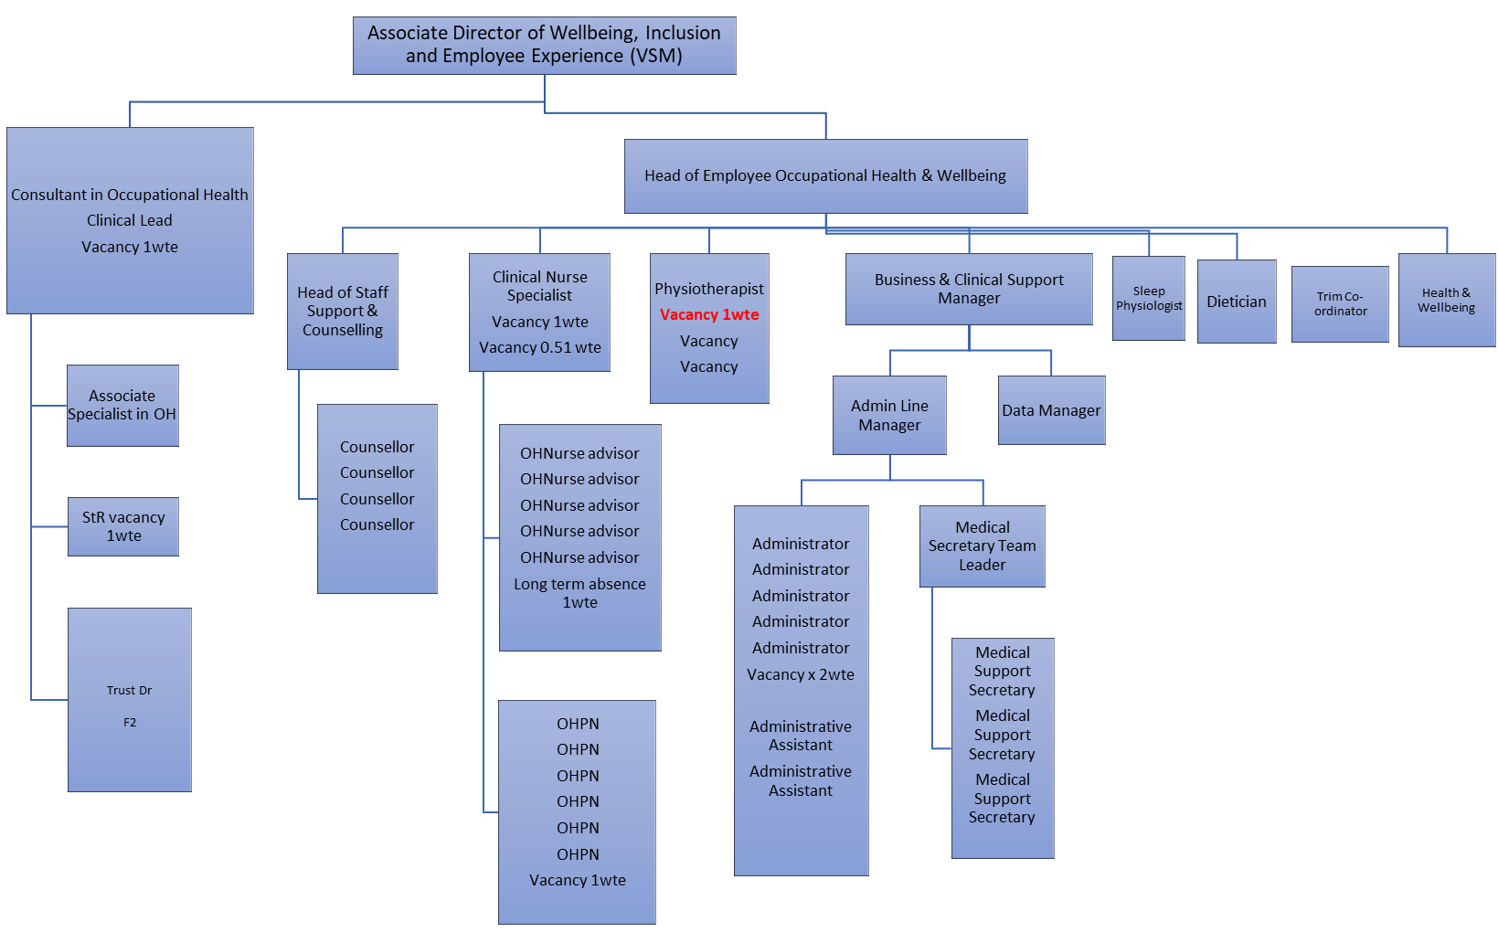
KEY RESULT AREAS/PRINCIPAL DUTIES AND RESPONSIBILITIES
- To provide an expert, early access to the OH MSK physiotherapy service offering : advice, assessment, treatment and management, for staff with diverse range of MSK clinical conditions and patient types, acting as a specialist in this field, ensuring appropriate referral for further treatment if indicated.
- To develop and maintain close clinical links with the occupational health consultants and nurse specialists/ advisors.
- To undertake clinical and functional assessments with the aim of writing management reports, advising managers on fitness for work or adjustments/ adaptations/ aids that may be required to keep employee at work with support/guidance from the Team lead OH Physiotherapist.
- To help with provision of specialist advice to General Practitioners, other Occupational Health practitioners and managers on employee fitness for work and occupational issues related to employee musculoskeletal health.
- To assist in the provision of health education and contribute to health promotion programmes.
- To undertake proactive clinical work e.g. workplace audits/ visits, health and wellbeing initiatives as per the annual work plan will also be undertaken.
- Maintain timely, accurate, adequate and accessible records both on paper and electronic records as appropriate.
- Evaluate and audit the service
COMMUNICATION/RELATIONSHIP SKILLS
- Communicate complex, difficult or sensitive physiotherapy matters utilising sound clinical and management intelligence and insight.
- Support and assist the OH Lead Physiotherapist with pro-active work within the Trust.
- Report to Lead Physiotherapist areas of potential musculoskeletal risk.
- Collaborate with Occupational Health Physicians, Occupational Health Practitioners, General Practitioners, Human Resource personnel, Manual Handling Department, Health and Safety Advisor and Line Managers to provide effective workplace support for staff with musculoskeletal problems.
- Communicate and make recommendations to all relevant disciplines of staff to maximise patient care and promote multidisciplinary working.
- To communicate highly complex information, gaining informed consent and understanding of treatment strategies. This will involve patients who may have complex emotional, physical and physiological problems.
- Provide and receive information regarding assessment, diagnosis, prognosis and treatment to encourage compliance.
- Patients will have a range of medical problems and require the physiotherapist to utilise highly developed motivational and persuasive skills to facilitate rehabilitation in an individual.
- Patients will predominantly have complex medical psychosocial and occupational problems which require the Physiotherapist to have highly developed interpersonal skills.
- To provide and receive highly complex information which may be sensitive, unwelcome or difficult to accept.
- Deal with verbal complaints.
- Network with appropriate physiotherapy colleagues and others, in undertaking development work to ensure delivery of clinically effective care.
- Provide and receive information regarding complex and sensitive issues with regard to the on-going management of the patient.
- Report patient assessment findings, patient progress with treatment and suggest other professional input requirements.
- Provide and receive information regarding complex issues with regard to the health and safety of staff in the Trust.
- Collaborate on interpretation of national occupational health and safety legislation for the Trust’s policies and procedures.
- Refer patients to Manual Handling Department for training and/or on-site manual handling risk assessment.
- Collaborate with and participate in projects with Health Promotion and Occupational Health colleagues to maintain and achieve award standards.
ANALYTICAL/JUDGEMENTAL SKILLS
- Independently assess and evaluate patients with a wide range of musculoskeletal conditions, including complex patients, providing an expert clinical diagnosis and determine their need for intervention within occupational health physiotherapy.
- Design and case manage occupational health packages e.g. workplace/job modifications for staff who have musculoskeletal problems to support staff in promoting a safer and healthier workplace and workforce.
- Identify individuals requiring work-site assessments and recommend ergonomically sound and practical solutions where possible.
- Has own caseload and autonomously makes decisions on assessment, diagnosis, treatment and discharge as well as identifying appropriate occupational health or rehabilitation needs for patients.
- Prioritise own caseload.
- Triage patients via telephone or face to face self-referral system and prioritise referrals depending on professional opinion of clinical need.
- Assist the Lead Physiotherapist in developing and offering new occupational health physiotherapy services to staff based on service clinical audit/research and other research.
PLANNING/ORGANISATIONAL SKILLS
- Autonomously plan, implement, evaluate, treat and progress patient care maximising rehabilitation potential and independently discharging patients with musculoskeletal problems.
- Manage a caseload of patients effectively and efficiently.
- Maintain patient documentation records and accurate statistical information to reflect care provided and meet professional standards.
- Develop and update clinical knowledge and skills in Occupational Health and musculoskeletal physiotherapy to ensure delivery of evidence-based care.
- Manage own time independently prioritising and managing an unpredictable workload to meet objectives within agreed timescale, and readjusting plans as situations change from interruptions i.e. telephone calls, emails and unforeseen deadlines
PHYSICAL SKILLS
- To demonstrate physical ability to carry out physiotherapy assessment, manual examination and interventions including manual therapy techniques.
- To demonstrate expert, highly developed dexterity, co-ordination and palpatory sensory skills for assessment and manual treatment of patients.
- To demonstrate adequate keyboard skills for use of computer based systems.
- To carry out manual therapy techniques with moderate physical effort and prolonged repetitive movement frequently throughout the day.
PATIENT/CLIENT CARE
- To undertake in/direct contact with face to face, telephone and video appointments with patients. In the case of face to face contact, hands on assessment and palpation sensory skills are required.
- To communicate with distressed/anxious/worried patients or managers.
- To assess, develop and implement specialist physiotherapy treatment programmes.
- To deal with patient demands in a sensitive and supportive manner while coping with the demands of clinical service delivery within a tight time frame.
- To answer telephone calls from anxious patients enquiring about injury and treatment.
- To demonstrate highly developed interpersonal and listening skills to ensure that patients are correctly triaged over the phone.
- To cope with occasional verbal abuse from patients.
- To be exposed to unpleasant body odours.
- To concentrate when assessing and treating patients throughout the day.
- To respond to varying workload priorities which can, at times, be unpredictable, as a result of service requirements.
- To deal with frequent interruptions throughout the day this may lead to one task being abandoned to respond to a more urgent need of the service.
POLICY/SERVICE DEVELOPMENT
- Implement and maintain appropriate clinical guidelines ensuring clinical effectiveness to optimise patient care.
- Work to national policy regarding musculoskeletal health. Contribute to service improvement within the staff physiotherapy service as well as broader Health & Wellness team to meet national guidelines.
FINANCIAL/PHYSICAL RESOURCES
No direct financial responsibility is required but an awareness of costs of workplace items that may be recommended for work relevant MSK issues.
Responsibility for equipment used in course of treatment and used by patient.

HUMAN RESOURCES
- Participate in the departmental Personal Development and Performance Review system to promote personal and service developments.
- Support and attend physiotherapy in-service training to promote personal development and lead in-services in own specialty.
- Contribute to training for wider team on musculo-skeletal topics. Support Health & Wellness practitioner to provide training for Health & Wellbeing champions.
INFORMATION RESOURCES
- Evaluate, organise and disseminate information in order to improve staff physiotherapy service quality and delivery.
- Maintain clear concise records in terms of patient documentation, staff records and own portfolio
- Maintain effective communications and physiotherapy systems and constantly seek to improve such systems where appropriate.
- Participate where required in regular clinical and managerial audits and ensure recommendation are completed within agreed timescales.
- Use statistical skills to gather own information regarding physiotherapy activities e.g. clinics, talks etc. including inputting, storing, maintaining, analysing and presenting data.
- Use data skills to direct service improvement and comply with governance arrangements
RESEARCH AND DEVELOPMENT
- Assist in the collection and analysis of qualitative and quantitative data to provide accurate statistical information in order to effectively monitor the provision and development of the service.
- Assist the Lead OH Physiotherapist in implementing clinical audit, clinical research and quality programmes within the specialist occupational health physiotherapy service to support the Trusts strategies.
- Contribute regularly to health education and health promotion programmes/strategies and other pro-active work.
- Undertake clinical audit using validated outcome measures
- To maintain regular contact with clinical interest groups and ensure knowledge is up to date whilst influencing the national approach.
FREEDOM TO ACT
- Work as an autonomous practitioner providing an expert specialist service to employees of RDE and associated organisations.
- Follows professional protocols and codes of conduct and professional guidelines/manages specialist caseload
- Interpret relevant policies and standard operating procedures and apply to professional practice.
- Able to provide specialist advice based on analysis of utilisation information available.
OTHER RESPONSIBILITIES
- To take part in regular performance appraisal.
- To undertake any training required in order to maintain competency including mandatory training, e.g. Manual Handling
- To contribute to and work within a safe working environment
- The post holder is expected to comply with Trust Infection Control Policies and conduct him/herself at all times in such a manner as to minimise the risk of healthcare associated infection
- As an employee of the Trust, it is a contractual duty that you abide by any relevant code of professional conduct and/or practice applicable to you. A breach of this requirement may result in action being taken against you (in accordance with the Trust’s disciplinary policy) up to and including dismissal.
APPLICABLE TO MANAGERS ONLY
Evidence that supporting employee health and wellbeing is included in any documents outlining the skills and knowledge that line managers need.

All managers hold the responsibility of the health and safety and wellbeing of their staff.

This post has been identified as involving access to vulnerable adults and in line with Trust policy successful applicants will be required to undertake a Disclosure & Barring Service Disclosure Check.

THE TRUST- VISION AND VALUES
Our vision is to provide safe, high quality seamless services delivered with courtesy and respect. To achieve our vision we expect all our staff to uphold our Trust values. Our Trust values are:
- Honesty, Openness & Integrity
- Fairness,
- Inclusion & Collaboration
- Respect & Dignity
We recruit competent staff that we support in maintaining and extending their skills in accordance with the needs of the people we serve. We will pay staff fairly and recognise the whole staff’s commitment to meeting the needs of our patients.

We are committed to equal opportunity for all and encourage flexible working arrangements including job sharing.
We are committed to recruiting and supporting a diverse workforce and welcome applications from all sections of the community, regardless of age, disability, gender, race, religion, sexual orientation, maternity/pregnancy, marriage/civil partnership or transgender status. We expect all staff to behave in a way which recognises and respects this diversity, in line with the appropriate standards.
GENERAL
This is a description of the job as it is now. We periodically examine employees' job descriptions and update them to ensure that they reflect the job as it is then being performed, or to incorporate any changes being proposed. This procedure is conducted by the Manager in consultation with the jobholder. You will, therefore, be expected to participate fully in such discussions. We aim to reach agreement on reasonable changes, but if agreement is not possible, we reserve the right to insist on changes to your job description after consultation with you.

The RD&E is a totally smoke-free Trust. Smoking is not permitted anywhere on Trust property, including all buildings, grounds and car parks. For help to quit call: 01392 207462.

POST  P  E  R  S  O  N  S  P  E  C  I  F  I  C  A  T  I  O  N | Experienced MSK physiotherapist (based in Occupational health) - Potential Development post.
BAND | Band 6

Requirements | Essential | Desirable
QUALIFICATION/SPECIAL TRAINING  - SRP, Diploma/Degree in Physiotherapy.  - Health Professions Council (HCPC) Registration.  - Specialist knowledge gained through a minimum 3 years post qualification experience and at least 18 months experience working in MSK Out Patients.  - Evidence of continuing professional development including attendance at recent post-graduate course(s) relevant to the clinical field.  - Commitment to further clinical, professional and managerial development.  - Member of the Association of Chartered Physiotherapists in Occupational Health and Ergonomics (ACPOHE).  - Post-graduate course(s) in Occupational Health and Ergonomics | E  E  E  E  E | D  D
KNOWLEDGE/SKILLS  - Good presentation skills.  - Demonstrated understanding of the role of physiotherapy within current emerging health environment and national initiatives  - Exceptional team-building and team working skills.  - Excellent time management and organisational skills.  - Demonstrated leadership qualities to effectively manage the Staff self-referral Physiotherapy Service.  - Conduct professional affairs in a confident and assertive manner.  - Willing to participate in training of staff.  - Ability to plan and prioritise workloads.  - Highly developed communication skills with the ability to deal with sensitive, conflicting and contentious matters in a sometimes hostile environment on an individual or group basis.  - Ability to react sensitively and professionally to unforeseen clinical and non-clinical situations.  - Ability to make decisions based on partial information and own knowledge, experience and skills.  - Ability to carry out concurrent activities (multi-tasking) and work in an unpredictable working pattern.  - Good verbal and written skills in English.  - Ability to keep legible and accurate records in English  - Ability to recognise and cope with stress and pressures at work.  Ability to work under pressure, unsupervised.  - Competent IT skills.  - Research skills. | E  E  E  E  E  E  E  E  E  E  E  E  E  E  E  E | D  D
EXPERIENCE  - At least 3 years post-registration experience with a minimum of 18 months experience working in Out Patients MSK services.  - Experience of multi-disciplinary team working.  - Understanding of clinical governance. | E  E  E
PERSONAL ATTRIBUTES  - Enthusiastic, self-motivated and reliable.  - Clear vision of role/commitment to specialty.  - Confident, motivated and enthusiastic.  - Committed to personal and team development. | E  E  E  E
OTHER REQUIRMENTS  The post holder must demonstrate a positive commitment to uphold diversity and equality policies approved by the Trust.  Ability to travel to other locations as required.  Membership of the Chartered Society of Physiotherapy  Flexibility in working practice to meet demands of service including 7 day working | E | D  D

FREQUENCY

(Rare/ Occasional/ Moderate/ Frequent)
WORKING CONDITIONS/HAZARDS |  | R | O | M | F
Hazards/ Risks requiring Immunisation Screening
Laboratory specimens | N
Contact with patients | Y
Exposure Prone Procedures | N
Blood/body fluids | N
Laboratory specimens | N
Hazard/Risks requiring Respiratory Health Surveillance
Solvents (e.g. toluene, xylene, white spirit, acetone, formaldehyde and ethyl acetate) | N
Respiratory sensitisers (e.g isocyanates) | N
Chlorine based cleaning solutions  (e.g. Chlorclean, Actichlor, Tristel) | N
Animals | N
Cytotoxic drugs | N
Risks requiring Other Health Surveillance
Radiation (>6mSv) | N
Laser (Class 3R, 3B, 4) | N
Dusty environment (>4mg/m3) | N
Noise (over 80dBA) | N
Hand held vibration tools (=>2.5 m/s2) | N
Other General Hazards/ Risks
VDU use ( > 1 hour daily) | Y
Heavy manual handling (>10kg) | Y
Driving | Y
Food handling | N
Night working | N
Electrical work | N
Physical Effort | Y
Mental Effort | Y
Emotional Effort | Y
Working in isolation | Y
Challenging behaviour | Y

