JOB DESCRIPTION

JOB DETAILS
Job Title | Our Future Hospital Project Accountant - Capital
Reports to | Our Future Hospital Finance Lead
Band | 7
Department/Directorate | Facilities, Our Future Hospital Programme

JOB PURPOSE
The Project Accountant is a pivotal role supporting Our Future Hospital (OFH) programme, as directed by the Finance Lead – OFH.
To interpret, present and provide advice on financial implications of the project to a variety of stakeholders, including clinicians and managers.
To line manage the Assistant Project Accountant and supervise their work.
To take individual responsibility for managing and delivering specific complex financial and management objectives.
KEY RESULT AREAS/PRINCIPAL DUTIES AND RESPONSIBILITIES
North Devon District Hospital (NDDH) has received Health Infrastructure Plan 2 (HIP2) funding for the redevelopment/refurbishment of the acute site in Barnstaple. This funding and programme sits under the national New Hospital Programme (NHP). The programme at NDDH is the Our Future Hospital Programme (OFH).
The Our Future Hospital Programme is a long term, complex programme, comprising of three major projects: Estates, Clinical and Digital and is supported by six functions; Finance, Business Intelligence, Communications and Engagement, Health and Wellbeing, HR/Workforce and Procurement. The Project Accountant will be required to work across the entire programme projects and functions due to the complex interdependent nature of the programme.
The Project Accountant will be appointed in line with the Trust’s Agile Working Policy, with NDDH as the base for the role, with core programme office days being Tuesday, Wednesday and Thursdays.
The post holder will fulfil all tasks and work as part of a team. To meet the needs of the service, the post holder may be required to work in other areas as appropriate as directed by the line manager.
Hours of work for this post will be 37.5 hours per week, to be agreed with the Finance Lead - OFH.

Strategic Capital Projects - General
- Provide a finance lead role in the OFH Programme, as driven by national initiatives, to ensure that the project is fully supported and developed with reliable and robust financial input and advice.
- Work with non-financial managers up to Executive level to support the construction of business cases ensuring all aspects of finance are included and all areas to be impacted are covered.
- Play an active member of the project delivery team assigned to ensuring all areas of Finance are updated. Work will need to be delivered against project plans and this role will need to create and monitor local finance project plans, progress against plan, risk and issue logs and other documentation as required.
- Represent the finance function at key internal and external meetings.
- Produce regular monthly reports (internal and external) including to the Trust Board, Finance Committee, and Capital Steering Group as required, undertaking analysis on complex financial matters and make judgements on financial decisions and financial risk where opinions may be conflicting. Completion of national programme submissions will also be required.
- To support the Finance Lead - OFH in the management, recording and reporting of capital expenditure.

Strategic Capital Project – Capital Budgets
- To develop the capital model for the business case, working with the cost consultants to ensure that the costs are provided in appropriate format for inclusion in the business case. This will include understanding requirements of the Treasury Green Book and the NHSE/I Fundamental criteria.
- To liaise with the District Valuer in the expected valuation at the completion of the project and projected asset lives in order to assist with the financial modelling of the consequences of the build
- To ensure the projected costs are within the cost envelope directed by NHSE/I
- To translate information received into the Capital Investment Appraisal Model (CIAM) as part of the Green Book requirements

Strategic Capital Projects – Revenue Modelling
- To lead on costing of the revenue implications of the new model of care, liaising with the Operational Lead, Workforce Modeller and staff across the organisation
- To lead on quantifying all benefits for inclusion in both the financial case and economic case, liaising with the Operational Lead
- To lead on costing of the revenue implications of the new build, liaising with the estates team
- To liaise with external consultants in respect of support for the modelling
- To liaise with the Valuer in respect of potential impairment of assets and assessment of asset lives
- To lead on populating the data into the Trust’s Long Term Financial Model (LTFM), which then leads into populating the tables for the financial and economic cases

KEY WORKING RELATIONSHIPS
No. of Staff reporting to this role: 1 – Finance Officer
The post holder is required to deal effectively with staff of all levels throughout the Trust as and when they encounter on a day to day basis
In addition the post holder will deal with the wider healthcare community, external organisations and the public.
This will include verbal, written and electronic media.

Of particular importance are working relationships with:
Internal to the Trust | External to the Trust
- OFH Programme Delivery Team | - Finance Colleagues across the Devon ICS
- Finance staff at all levels of the organisation | - External consultants  - Other NHP programme finance colleagues
- Clinicians and Managers within the Trust | - NHSE
- Staff across the organisation | - National NHP Delivery Team

ORGANISATIONAL CHART
The structure chart below shows the Finance Management Accountant role circled in black and how this role fits into the overall OFH Programme.
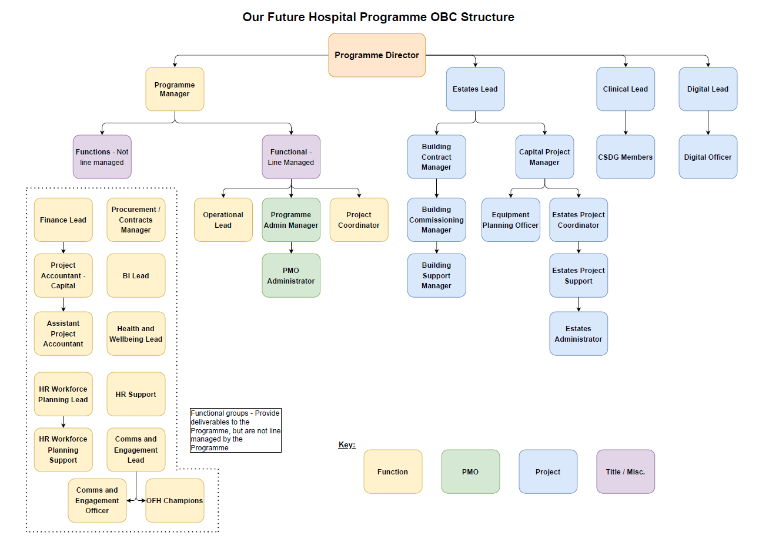

FREEDOM TO ACT
The post holder will need to:
- Make decisions autonomously, advising the Finance Lead of the impacts of these decisions.
- Influence decision making with regards to the project through the provision of expert financial advice
- Interpret national policy and regulations, taking action to ensure the Trust meets the requirements of such policies and advising the Finance Lead of the interpretation made
COMMUNICATION/RELATIONSHIP SKILLS
The post holder will communicate with a range of senior stakeholders concerning their views in relation to complex projects/plans. The post holder will need to facilitate collaborative working between senior managers in a number of organisations in order to achieve project objectives; this will require developed negotiation and motivation skills to deal with complex and contentious information.

The post holder will need to be able to communicate effectively with a wide range of people and will need to be able to present information in a variety of ways to both large groups as well as on a 1:1 basis.
ANALYTICAL/JUDGEMENTAL SKILLS
The post holder will be required to analyse highly complex finance and performance data and trends in order to assess and interpret the impact on project plans. The post holder will be responsible for determining how potential conflicting information will affect project priorities.
PLANNING/ORGANISATIONAL SKILLS
The post holder will need to manage their own day to day activities as well as delegating and re-allocating work to team members. This will require the ability to work with multiple competing priorities across a broad range of complex activities and the ability to use own judgement regarding allocation of resources within the team to complete required tasks within deadlines under time pressure.

PATIENT/CLIENT CARE
The post holder is required to put the patient, as the first priority, at the centre of all activities. The post holder may have contact with patients/clients by phone or face to face and will provide non-medical information and advice to patients and carers.

POLICY/SERVICE DEVELOPMENT
Identify process improvements and develop projects and assignments to respond to organisational and/or policy changes and initiatives more effectively. Proposes changes to policies which may impact beyond own area. Implements policy for own work area

FINANCIAL/PHYSICAL RESOURCES
Responsible for ensuring that all staff have the necessary equipment and resources required to undertake their duties. Responsible for non-pay budget ordering and maintaining equipment such as laptops, printers for the directorate and effectively reporting any problems that may arise.

HUMAN RESOURCES
Support new employee integration into the team. The post holder has responsibility for the day to day supervision of the team including allocation of work and service continuity. The post holder will be required to undertake staff appraisals and provide specialist training to the team as required to ensure workforce development and succession planning opportunities are maximised.
There may be the requirement for out of hours or weekend working at peak programme times.
Provide absence cover and support for other programme team members where required.
Provide coordination of and participate in relevant meetings, providing information advice and support where requested.
The post holder will take an active part in the development review of own work suggesting areas for learning and development in the coming year.
INFORMATION RESOURCES
The post holder will need to input, store, modify, analyse, process and present complex information on a day to day basis. The post holder will develop reports and spreadsheets based on financial information to use to inform key stakeholders of on-going developments.
RESEARCH AND DEVELOPMENT
The post holder will respond to requests to undertake surveys and audits relevant to own work and to work closely with the Local Counter Fraud Specialist and Internal Audit leads with regards to audits of financial information.
PHYSICAL SKILLS
Standard keyboard skills are required to produce reports, presentations and project plans. An advanced IT skill set is required to support the presentation of complex information.
PHYSICAL EFFORT
This post is predominantly desk based using VDU equipment with a frequent requirement to be seated for long periods of time.
The post requires travelling, meetings in various venues and office based work
MENTAL EFFORT
This post requires frequent concentration for long periods of time for collating, analysing, interpreting and presenting complex financial data and requires responding quickly and accurately to complex emails with regards to financial data.
The post holder will have the ability to think quickly and constructively and make decisions autonomously.
The post holder will be able to adapt to frequent interruptions and working in a large open plan office.
Adaptability, flexibility and ability to cope with uncertainty and change.

EMOTIONAL EFFORT
There will be occasional exposure to distressing and emotional circumstances where the post holder may have to part unwelcome news to staff, or effectively influence and negotiate with stakeholders in difficult circumstances.

WORKING CONDITIONS
Office conditions.

OTHER RESPONSIBILITIES
Take part in regular performance appraisal.

Undertake any training required in order to maintain competency including mandatory training, e.g. Manual Handling

Contribute to and work within a safe working environment

You are expected to comply with Trust Infection Control Policies and conduct him/herself at all times in such a manner as to minimise the risk of healthcare associated infection

As an employee of the Trust, it is a contractual duty that you abide by any relevant code of professional conduct and/or practice applicable to you. A breach of this requirement may result in action being taken against you (in accordance with the Trust’s disciplinary policy) up to and including dismissal.

You must also take responsibility for your workplace health and wellbeing:
- When required, gain support from Occupational Health, Human Resources or other sources.
- Familiarise yourself with the health and wellbeing support available from policies and/or Occupational Health.
- Follow the Trust’s health and wellbeing vision of healthy body, healthy mind, healthy you.
- Undertake a Display Screen Equipment assessment (DES) if appropriate to role.

APPLICABLE TO MANAGERS ONLY
Leading the team effectively and supporting their wellbeing by:
- Championing health and wellbeing.
- Encouraging and support staff engagement in delivery of the service.
- Encouraging staff to comment on development and delivery of the service.
- Ensuring during 1:1’s / supervision with employees you always check how they are.
- To undertake the line management responsibility for staff directly line managed, including undertaking staff performance and disciplinary issues. Ensure that personal development plans are in place and completed according to agreed timescales.
- Allocate work to junior staff within the team to ensure completion of work within required timeframes.
GENERAL
This is a description of the job as it is now. We periodically examine employees' job descriptions and update them to ensure that they reflect the job as it is then being performed, or to incorporate any changes being proposed. This procedure is conducted by the manager in consultation with the jobholder. You will, therefore, be expected to participate fully in such discussions. We aim to reach agreement on reasonable changes, but if agreement is not possible, we reserve the right to insist on changes to your job description after consultation with you.
Everyone within the Trust has a responsibility for, and is committed to, safeguarding and promoting the welfare of vulnerable adults, children and young people and for ensuring that they are protected from harm, ensuring that the Trusts Child Protection and Safeguarding Adult policies and procedures are promoted and adhered to by all members of staff.

PERSON SPECIFICATION

Job Title | OFH Project Accountant

Requirements | Essential | Desirable
QUALIFICATION/ SPECIAL TRAINING  Good Standard of Education  Qualified accountant to Masters level and member of an accountancy body which is a member of the Consultative Committee of Accountancy Bodies (CCAB), or equivalent experience. | Y  Y
KNOWLEDGE/SKILLS  Specialist knowledge of the NHS financial regime, policies and legislation.  Should have an appreciation of the relationship between the Department of Health, NHS Improvement, providers and commissioners  Excellent communication skills both written and verbal.  Excellent organisational skills, working collaboratively, methodically and flexibly to exacting deadlines, whilst high standards are maintained  To assimilate information quickly and accurately, analyse options and present workable solutions.  Work with a high degree of accuracy and be able to demonstrate attention to detail  Ability to make judgements and assess risks on financial decisions using complex data across a range of options. | Y  Y  Y  Y  Y  Y | Y
EXPERIENCE  Significant experience working within the finance department of a complex organisation, to include financial reporting.  Experience of leading a team working across a complex environment.  Experience of detailed financial reporting and planning across complex functions | Y  Y | Y
PERSONAL ATTRIBUTES  Approachable, responsive, resourceful, enthusiastic and flexible approach.  Well developed leadership skills  Tactful, diplomatic, empathic  Self motivated and proactive | Y  Y  Y  Y
OTHER REQUIREMENTS  Willingness to undertake a wide variety of duties  The post holder must demonstrate a positive commitment to uphold diversity and equality policies approved by the Trust.  Ability to travel to other locations | Y  Y  Y

FREQUENCY

(Rare/ Occasional/ Moderate/ Frequent)
WORKING CONDITIONS/HAZARDS |  | R | O | M | F
Hazards/ Risks requiring Immunisation Screening
Laboratory specimens | N
Contact with patients | N
Exposure Prone Procedures | N
Blood/body fluids | N
Laboratory specimens | N
Hazard/Risks requiring Respiratory Health Surveillance
Solvents (e.g. toluene, xylene, white spirit, acetone, formaldehyde and ethyl acetate) | N
Respiratory sensitisers (e.g isocyanates) | N
Chlorine based cleaning solutions  (e.g. Chlorclean, Actichlor, Tristel) | N
Animals | N
Cytotoxic drugs | N
Risks requiring Other Health Surveillance
Radiation (>6mSv) | N
Laser (Class 3R, 3B, 4) | N
Dusty environment (>4mg/m3) | N
Noise (over 80dBA) | N
Hand held vibration tools (=>2.5 m/s2) | N
Other General Hazards/ Risks
VDU use ( > 1 hour daily) | Y |  |  |  | X
Heavy manual handling (>10kg) | Y | X
Driving | Y |  | X
Food handling | N
Night working | N
Electrical work | N
Physical Effort | N
Mental Effort | Y |  |  |  | X
Emotional Effort | Y |  | X
Working in isolation | Y |  |  |  | X
Challenging behaviour | Y |  | X

