J
O
B

D
E
S
C
R
I
P
T
I
O
N

JOB DETAILS
Job Title | Associate Medical Director
Reports to | Director of Service Improvement and NDHT and RD&E Medical Directors
Band | Consultant – 4 PAs & 1 responsibility payment
Department | Chief Medical Officer’s Office
Areas of Operation | Royal Devon University Healthcare NHS Foundation Trust
Trust Size | Northern – Medium Trust (Turnover of >£200m & >3,000 employees)  Eastern - Large Trust (Turnover of >£500m & >8,000 employees)

JOB PURPOSE
Accountable to the Director of Service Improvement, (DSI) and working with the Northern and Eastern Medical Directors & the Chief Medical Officer the Associate Medical Director (AMD) will provide support and cross site leadership to shape and enable the delivery of the service transformation portfolio.

The postholder will help create a culture of transformation and quality improvement across both organisations and all aspects of our care system including elective and urgent care. In particular the AMD will provide visible leadership to enable clinical staff to engage with and drive transformational change.

KEY WORKING RELATIONSHIPS
Internal to the Trusts | External to the Trusts
- Patients  - Director of Service Improvement  - Chief Medical Officer / Medical Directors  - Associate Medical Directors/Clinical Directors/Clinical Leads  - Service Improvement team across NDHT & the RD&E  - Consultant/Doctor/Medical Staff/Healthcare Scientists/Senior nursing staff/Ward Matrons  - Operational Managers/Heads of Department  - Governance Leads  - Corporate Services  - Medical Staff Committee | - Patients /families and representatives  - Regional clinical networks  - Peninsula Deanery  - Regional Acute Trusts  - Third Sector partners  - Other regulatory bodies e.g. NMC, HCPC, CQC, NHSE/I  - ICS

ACCOUNTABILITY
- To play a leading role alongside the DSI in designing the transformation programme across the organisation.
- To play a leadership role in engaging with teams, hosting events, chairing meetings etc to consider complex organisational problems and arrive at a consensus regarding transformational change.
- To represent the Trust as required in attending or leading external meetings, such as system meetings, GIRFT etc.
- To be responsible for the successful delivery of workstreams / projects as agreed with the DSI.
- To play a leadership role in the delivery of more cost-efficient models of care and the delivery of any associated cash releasing savings.
- Alongside or deputising for the DSI, present updates on progress regarding the transformation agenda to relevant groups, including the Joint Delivery Group and the Board of Directors as required.
- Together with the CMO, and Medical Directors, provide assurance to the CEO and boards that the Trusts have effective clinical governance systems and processes in place, which maximise the potential for providing the best clinical outcomes, minimise harm and create a learning/improvement culture
- Encouraging a culture that promotes Clinical Effectiveness, Clinical Audit, Innovation, Research and Development and to deputise for the CMO where required to support the Research and Development Director.
- To deputise, as required, for the CMO and MDs at a range of Trust Committees and groups, such as the Joint Governance Committee, Safety and Risk Committee, Patient Safety and Mortality Group and Incident Review Group and attend Safety Huddle. To deputise, as required, in chairing Clinical Effectiveness Committee / Clinical Reference Group.
- To provide senior medical support, as directed by the CMO / MDs to relevant Trust wide roles, such as Trust Mortality Lead, Lead Medical Examiner, Trust Appraisal Lead, Director of Medical Education, Caldicott Guardian, Radiation Safety Advisor and Guardian of Safe Working Hours.
- Chair appropriate Trust-wide meetings and Sub-Committees as delegated by the CMO and MDs.
- Deputise for the Medical Directors in their absence such as during periods of leave, as well as at a range of internal and external meetings, including attending the Board of Directors meetings and system-wide meetings, as required on an ad-hoc basis.
- Produce reports or presentations for the Board of Directors or other Trust Committees and meetings, communicating complex issues relating to patient safety and quality, practitioner performance or service delivery in a way which facilitates effective Board discussion and oversight.
- Support and enable delivery of the People plan and providing a healthy, supportive and inclusive working environment to the whole workforce. Enabling the empowerment of managers and providing an operating context where staff can speak out.
- Providing the leadership and culture that supports, recruits, nurtures, develops and retains a compassionate, skilled and flexible team aligned to our values. This includes enabling diversity in all its forms, a just culture of learning and improvement and an ability to lead workforce innovation.
- Acting in the best interests of the Trusts and the NHS and ensuring the integrity of the organisation’s activities and contributing to the achievement of its objectives in the best interests of patients and the wider public
- Constructively challenging the decisions of Joint executive team/ Board of Directors and helping develop proposals on priorities, risk mitigation, values, standards and strategy.
- Actively supporting the Trust’s diversity and inclusion strategy, leading on improvements to ensure we are inclusive for all our people and patients
ORGANISATIONAL CHART
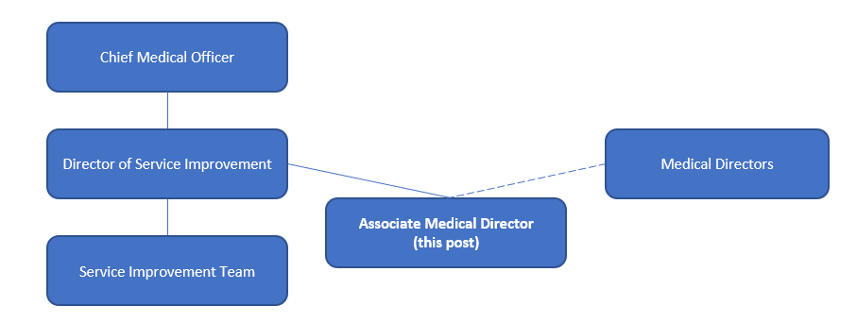

OTHER RESPONSIBILITIES
- Take part in regular performance appraisal.

- Undertake any training required in order to maintain competency including mandatory training.

- Contribute to and work within a safe working environment

- The post holder is expected to comply with Trusts Infection Control Policies and conduct him/herself at all times in such a manner as to minimise the risk of healthcare associated infection

- As an employee of the Trusts, it is a contractual duty that you abide by any relevant code of professional conduct and/or practice applicable to you. A breach of this requirement may result in action being taken against you (in accordance with the Trust’s disciplinary policy) up to and including dismissal.

APPLICABLE TO MANAGERS ONLY
- Evidence that supporting employee health and wellbeing is included in any documents outlining the skills and knowledge that line managers need.

- All managers hold the responsibility of the health and safety and wellbeing of their staff

P
E
R
S
O
N

S
P
E
C
I
F
I
C
A
T
I
O
N

Requirements | Essential | Desirable
KNOWLEDGE, SKILLS & EXPERIENCE
Breadth of experience of working at senior management level of large/complex organisations  Evidence of experience of working in a clinical leadership role | ✓  ✓
Evidence of collaborative working with partner organisations resulting in successful innovation and change | ✓
Able to articulate and demonstrate leadership that enables diversity in all its forms to thrive. | ✓
Knowledge of risk management and governance within a regulated environment | ✓
Demonstrate effective system working and excellent collaboration skills |  | ✓
Evidence of delivery of complex projects from conception to delivery and evaluation | ✓
Proven track record of successful and sustained management of patient pathways |  | ✓
Experience of large scale programme management and continuous improvement | ✓
Knowledge of communication and engagement strategy and planning |  | ✓
QUALIFICATION / SPECIAL TRAINING
Current registration with the GMC  Experience as practicing as a senior clinician | ✓  ✓
Evidence of Continuing Professional Development | ✓
PERSONAL ATTRIBUTES
Inspirational leadership style with credibility, respect and knowledge; and the ability to manage people well. | ✓
Collaboration and involvement with cross divisional teams/across the Trusts | ✓
Stakeholder relationship building – internally and externally | ✓
Truly inclusive and able to lead on embracing difference | ✓
Engaging, motivational and able to support teams recognising great performance | ✓
Compassionate, honest and aligned with the Trusts values | ✓
Ownership, personal responsibility and accountability for delivering commitments | ✓
Gravitas and integrity – building confidence and assurance | ✓
Strategic thinking, translating strategy into action | ✓
Effective at planning and organising | ✓
Organisational development | ✓
OTHER REQUIREMENTS
The post holder must demonstrate a positive commitment to uphold diversity and equality policies approved by the Trust. | ✓
Ability to travel to other locations as required. | ✓

FREQUENCY

(Rare/ Occasional/ Moderate/ Frequent)
WORKING CONDITIONS/HAZARDS |  | R | O | M | F
Hazards/ Risks requiring Immunisation Screening
Laboratory specimens | N
Contact with patients | Y |  | X
Exposure Prone Procedures | N
Blood/body fluids | N
Laboratory specimens | N
Hazard/Risks requiring Respiratory Health Surveillance
Solvents (e.g. toluene, xylene, white spirit, acetone, formaldehyde and ethyl acetate) | N
Respiratory sensitisers (e.g isocyanates) | N
Chlorine based cleaning solutions  (e.g. Chlorclean, Actichlor, Tristel) | N
Animals | N
Cytotoxic drugs | N
Risks requiring Other Health Surveillance
Radiation (>6mSv) | N
Laser (Class 3R, 3B, 4) | N
Dusty environment (>4mg/m3) | N
Noise (over 80dBA) | N
Hand held vibration tools (=>2.5 m/s2) | N
Other General Hazards/ Risks
VDU use ( > 1 hour daily) | Y |  |  |  | X
Heavy manual handling (>10kg) | Y | X
Driving | Y |  |  | X
Food handling | N
Night working | Y |  | X
Electrical work | N
Physical Effort | Y | X
Mental Effort | Y |  |  | X
Emotional Effort | Y |  |  | X
Working in isolation | Y |  | X
Challenging behaviour | Y |  |  | X

