|  |  |
| --- | --- |
|  | |
| **JOB DESCRIPTION** |  |
| **Job Title:** | **Maintenance Technician** |
| **Band:** | **Band 5** |
| **Responsible To:** | **Operations and Maintenance Manager** |
| **Accountable To:** | **Deputy Head of Estates** |
| **Section/Department/Directorate:** | **Facilities Directorate** |

**JOB PURPOSE**

|  |  |
| --- | --- |
| To undertake fault finding/diagnostics, test, installation and repair work associated with complex mechanical, electrical and electronic installations and equipment in an economic, efficient and safe manner. Ensure that the business continuity of the key engineering services within the Trust is continuously improved.  To carry out work appropriate to the core specialist skills assigned to this post and provide technical advice to other maintenance staff and contractors to ensure compliance with safety standards and procedures.  The post holder will be required to undertake condition surveys and inspection reports to ensure that statutory compliance is maintained at all times, key risks will be appropriately risk assessed and substantiated with relevant evidence.  Will contribute to the development of the service ensuring that the Trusts “Visions and Values” are maintained at all times, focusing on engineering excellence, integrity and support for the wider team.  The post holder will be expected to maintain an awareness of theoretical knowledge in line with scope of the post.  This post will play a lead role within a small team to ensure that energy consumption within the Trust continually improves, the out of hours breakdowns are reduced year on year and that waste is minimised. | |
| **CONTEXT** |
| This Maintenance Technician will be based at the acute hospital and will travel to community hospitals as and when required.  The post holder will fulfil all tasks and work as part of a team. To meet the needs of the service, the post holder may be required to work in other areas as appropriate as directed by the line manager.  Hours of working for this post shall be 37.5 hours Monday – Friday.   |  | | --- | | **KEY WORKING RELATIONSHIPS**  The post holder is required to deal effectively with staff of all levels throughout the Trust, the wider Healthcare community, external organisations and the public. This will include verbal, written and Electronic media. In all instances this shall be carried out in line with the Trusts “Visions and Values” policy with particular adherence to Excellence, Integrity and Support of the wider Facilities team. | |

**ORGANISATIONAL CHART**

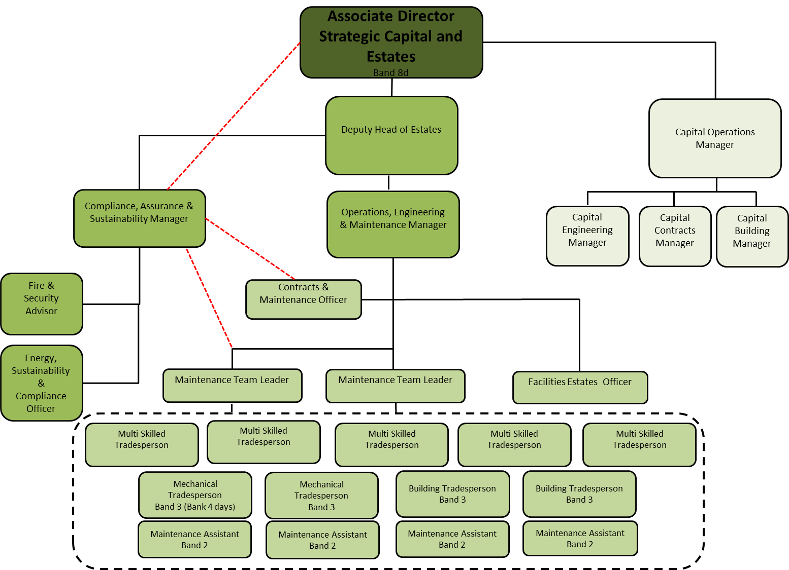

|  |
| --- |
|  |
|  |
| **KEY RESULT AREAS / PRINCIPAL DUTIES AND RESPONSIBILITIES**  Maintain and repair installations, plant and equipment to keep unplanned downtime to a minimum, hence ensuring a general improvement in business continuity across all key engineering services, particularly out of normal working hours.  To test, maintain and repair the Trust mechanical/electrical installations and services, in an economic, efficient and safe manner, in accordance with legislation and agreed standards.  Medical gases, authorised person support  Electrical services, authorised person support  Building on general trades duties the post holder may have to undertake:  Sterilisation, test person support  Decontamination, test person support  The above are examples and are not exhaustive.  Work from and understand detailed engineering drawings and specifications and to ensure that current regulations are followed at all times.  Learn new techniques to develop skills as appropriate to ensure that the most effective methods are used in the course of their work.  Demonstrate own activities to new or less experienced employees, providing advice, training and technical support to trainees and maintenance assistants.  Maintain quality and performance standards to ensure that allocated work is completed effectively and efficiently.  Support the Maintenance Officers and other Maintenance staff to fulfil Service Level Agreements between the Maintenance team and other Trust departments and customer Primary Care Trusts, advising line managers of any difficulties to ensure that communications are maintained at all times.  Attend to major incidents such as loss of electrical services to critical areas, Loss of Medical gas to critical areas, loss of heating and hot water services to critical areas.  To carry out and use Trust supplied mobile communication equipment, as required by management.  Assist the PFI Facilities Provider in an emergency.  To supervise and assist contractors in carrying out surveys and works, as required, including assisting with access to service areas (plant rooms, roofs, duct ways, etc.) and plant.  Participation in the Maintenance team weekdays/evening shift rotas (Monday – Friday). Work overtime to carry out planned work with reasonable prior notice and deal with emergency repairs, as required by management – often at very short notice.  Participate in Trades On-Call Rotas, to ensure that emergencies and major problems occurring out of hours are attending and resolved.  Actively promote and ensure Health and Safety is prioritised within the maintenance team.  To maintain patient safety through rigorous and consistent compliance with Trust Policies, for the prevention and control of infection, including hand hygiene. To undertake appropriate mandatory training and update in infection prevention and control. |
| **COMMUNICATION AND RELATIONSHIP SKILLS**  To provide and receive technically complex information to and from other staff suppliers, contractors, consultants, statutory and legislative bodies orally, in writing and electronically. Provides technical/practical training to Maintenance staff and equipment users.  To form effective working relationships with relevant third parties and with colleagues throughout the Maintenance team and the wider Facilities Directorate.  Liaise with Trust employees and others, as required – always promoting a positive customer orientated department.  **ANALYTICAL AND JUDGEMENT SKILLS**  Assess the safety/operational situation, problem solve technical issues, carry out analysis and fault diagnosis of complex, multi-faceted equipment, building services plant and systems; finding and then, implementing the solution. Interpreting technical issues and formulating technical solutions to improve performance and maintain delivery of service, based on engineering excellence and integrity.  **PLANNING AND ORGANISATIONAL SKILLS**  Plan and organise maintenance activity to ensure cost-effective outcomes, activities and/or programmes, some of which may be on-going e.g. prioritising emergency repair request, requesting spare parts and materials. Ensuring allocated work is undertaken and followed-through to completion and satisfaction of the service user, building on the Trust’s vision and values.  Assist in contingency planning for critical services; contribute to development of site contingency plans and Engineering Emergency Manual.  **PHYSICAL SKILLS**  Developed physical skills to fulfil maintenance duties requiring dexterity and co-ordination gained through training and experience.  Standard driving skills to use Trust vehicles.  Standard keyboard skills/use of handheld computers/wireless devices.  **RESPONSIBILITY FOR PATIENT AND CLIENT CARE**  To assist patients/clients during incidental contact.  Compliance with the Trust Infection Control Policy.  Living by the Trust’s vision and values at all times.  **RESPONSIBILITY FOR POLICY AND SERVICE DEVELOPMENT**  Propose changes to protocols and procedures to improve service, quality and cost reduction.  To follow policies for own role, commenting on policies, procedures or development which effect the Facilities Operations teams and supporting the implementation of departmental procedures.  **RESPONSIBILITY FOR FINANCIAL AND PHYSICAL RESOURCES**  Responsibility for the safe use, installation, testing maintenance and repair of property, plant and equipment used throughout the hospital. Upkeep of high-value test and calibration equipment. Ensuring supplies/stores/consumables are correctly booked and charged.  **RESPONSIBILITY FOR HUMAN RESOURCES**  The post holder may occasionally be required to deputise for Facilities and Maintenance Officers.  Supervise Maintenance Personnel, monitor maintenance contractors as required demonstrate own activities to new or less experienced employees, providing advice, practical training and technical support to trainees/apprentices & maintenance assistants.  **RESPONSIBILITY FOR INFORMATION RESOURCES**  Responsible for the receiving of information relating to maintenance activities and entering on to existing data bases. May also be required to create data bases, documents and spread sheets to be used by themselves and others.  Updates planned and reactive maintenance management information. Use of specialist proprietary test & monitoring equipment during the course of work to record test & validation data.  Carry out risk assessment when required, in accordance with Health and Safety procedures and safe systems of work.  **RESPONSIBILITY FOR RESEARCH AND DEVELOPMENT**  Respond to requests to undertake surveys or audits relevant to own work  Undertake required testing, verification and validation.  **DECISION MAKING**  To manage own allocated workload during periods of planned maintenance. To work unsupervised in the course of maintenance duties. Including responding to out of hours request in co-operation with other staff involved in the Facilities on-call service.  Working autonomously on a routine basis and as part of a multi-disciplined team within the Facilities and Maintenance department, reporting directly to the Energy and Technical Services Officer, Acute Maintenance Officer or other Officers designated by the Operations and Maintenance Manager.  To adhere and be guided by procedures and protocols  **PHYSICAL EFFORT**  Frequent requirement to exert moderate physical effort, e.g. climbing ladders, lifting, moving or replacing equipment, kneeling & crawling. Undertaking heavy repairs and moving of equipment. Covering significant distances on foot in a shift e.g. 8km/day.  **MENTAL EFFORT**  Frequent concentration with an unpredictable work pattern required for fault finding on technical equipment subject to interruptions from carrying a pager, mobile telephone or two way radios.  **EMOTIONAL EFFORT**  Limited exposure to distressing or emotional circumstances, which can include working in close proximity to patients in both a wide range of acute care situations, a high security mental health unit and cadavers/post-mortem rooms.  **WORKING CONDITIONS**  Occasional exposure to highly unpleasant conditions e.g. sewage/gases during the course of duties. Requirement to work on site, sometimes out of doors. Regular exposure to dust (building site) noise (plant rooms) high temperature (plant rooms/boiler house). All of which are to be managed in line with the relevant health and safety regulations and guidance. |

**GENERAL**

This is a description of the job as it is at present constituted. It is the practice of this organisation periodically to examine employees' job descriptions and to update them to ensure that they relate to the job as then being performed, or to incorporate whatever changes are being proposed. This procedure is jointly conducted by each manager in consultation with those working directly to him or her. You will, therefore, be expected to participate fully in such discussions. It is the organisations' aim to reach agreement to reasonable changes, but if agreement is not possible management reserves the right to insist on changes to your job description after consultation with you.

We are committed to serving our community. We aim to co-ordinate our services with secondary and acute care.

We aim to make all our services exemplary in both clinical and operational aspects. We will show leadership in identifying healthcare needs to which we can respond and in determining the most cost-effective way of doing so. We will share our knowledge with neighbouring healthcare agencies and professionals.

We recruit competent staff that we support in maintaining and extending their skills in accordance with the needs of the people we serve. We will pay staff fairly and recognise the whole staff’s commitment to meeting the needs of our patients.

The Trust operates a 'non-smoking' policy. Employees are not able to smoke anywhere within the premises of the Trust or when outside on official business.

All employees must demonstrate a positive attitude to Trust equality policies and Equality Scheme. Employees must not discriminate on the grounds of sex, colour, race, ethnic or national beliefs, marital status, age, disability, sexual orientation, religion or belief and will treat patients, colleagues and members of the public with dignity and respect.

If the post holder is required to travel to meet the needs of the job, reasonable adjustments if required will be made as defined by the Equality Act 2010.

**HEALTH AND SAFETY AT WORK**

The employer will take all reasonably practical steps to ensure your health, safety and welfare while at work. You must familiarise yourself with the employer’s Health & Safety policy, and its safety and fire rules. It is your legal duty to take care for your own health and safety as well as that of your colleagues.

**INFECTION CONTROL – ROLE OF ALL STAFF**

It is the responsibility of all members of staff to provide a high standard of care to patients they are involved with. This includes good infection prevention practice.

All staff have a responsibility to comply with Infection Prevention and Control policies and procedures, this includes:

* Attending mandatory and role specific infection prevention education and training
* Challenging poor infection prevention and control practices
* Ensuring their own compliance with Trust Infection Prevention and Control policies and procedures for example, standard precautions, hand hygiene, prevention & management of inoculation incidents

**CONFIDENTIALITY**

You may not process or disclose any information of a confidential or personal nature relating to the employer or in respect of which the employer has a duty of confidence to any third part other than where you are obliged to disclose such information in the proper course of your employment or as required by law. Any failure to comply with this term of your employment will be treated as an act of misconduct under the employer’s disciplinary procedure.

**SAFEGUARDING**

To be fully aware of and understand the duties and responsibilities arising from the Children’s Act 2004 and Working Together in relation to child protection and safeguarding children and young people as this applies to the worker’s role within the organisation.

To also be fully aware of the principles of safeguarding as they apply to vulnerable adults in relation to the worker’s role, which will include recognising the types and signs of abuse and neglect and ensuring that the worker’s line manager is made aware and kept fully informed of any concerns which the worker may have in relation to safeguarding adults and/or child protection.

Everyone within Royal Devon University Healthcare NHS Foundation Trust has a responsibility for, and is committed to, safeguarding and promoting the welfare of vulnerable adults, children and young people and for ensuring that they are protected from harm. Royal Devon University Healthcare NHS Foundation Trust ensures that the Trusts Child Protection and Safeguarding Adult policies and procedures are promoted within the Trust and adhered to by all members of staff.

**JOB DESCRIPTION AGREEMENT**

**Job holder’s Signature: .....................................................................................**

**Date: .....................................................................................**

**Manager’s Signature: .....................................................................................**

**Date: .....................................................................................**

**PERSON SPECIFICATION**

**POST: Maintenance Technician Band 5**

|  |  |  |  |  |
| --- | --- | --- | --- | --- |
| REQUIREMENTS | E/D* | HOW TESTED?  Application Form/Interview/Reference/Test | INTERVIEW COMMENTS | SCORE  (1 Low – 10 High) |
| QUALIFICATIONS/SPECIAL TRAINING :  CITB/EITB Apprenticeship or other approved training  Electrical/Mechanical/Building services Engineering – significant relevant experience having demonstrated high levels of versatility and flexibility in electrical/mechanical/building services engineering.  A National Qualification Framework NQF achievement to level 4 or above e.g. BTEC/HNC/LCGI – plus advanced specialist qualification and extended experience equivalent to Graduate Professional Level.  Advanced specialist training will be required in one of the following areas.   * Sterilisation, test person * Decontamination, test person * Medical gases, authorised person * Electrical services, authorised person * Must possess UK driving license Cat B | E  E  E  D | Application Form  Application Form  Application Form  Or willingness to undertake training |  |  |
| KNOWLEDGE/SKILLS:  Knowledge of the application of: Health and Safety legislation, ACOPs, guidance and rules, NHS technical standards (e.g. Health Technical Memoranda) and Trust polices, basic life support and emergency aid and where required a readiness to train.  Knowledge and/or commitment to continuing professional development through higher education, on-the-job and/or residential training on order to maintain, test and repair building services in a healthcare environment. As required, to be assessed and appointed as a registered/licensed operative and/or Competent Person in a range of specialisms related to the post.  To act with integrity and with a professional disposition. | E  E  E | Application Form/Interview  Application Form/Interview  Interview |  |  |
| EXPERIENCE:  Skilled in maintenance, fault finding, test & repair work on a very wide range of complex engineering services & equipment, with the ability to work unassisted in varying, often technical environments whilst complying with Health & Safety/environmental regulations and standards.  IT literate or willing to train to ECDL level 2 standards (use of Microsoft Office suite) Knowledge of/readiness to undertake training and use of the Trust’s computer based maintenance management system (First FM). | E  E | Application Form/Interview  Interview |  |  |
| PERSONAL REQUIREMENTS:  Reliability and Flexibility, able to contribute to changing demands of the service.  Ability to demonstrate a diplomatic caring attitude whilst maintaining confidentiality adhering to the Trusts policy on “Vision and Values. In particular:   * Understanding excellence * Acting with integrity * Support to members of the team and customers   Willing to undertake training relevant to the post. In line with CPD.  Required to climb ladders, access walkways, ducts cellars, roof spaces etc.  Light manual handling but must be able to demonstrate ability to meet medium to high risk manual handling when acting in an operational role. | E  E  E  E  E | Interview  Interview  Interview  Interview  Interview |  |  |
| OTHER REQUIREMENTS:  The post holder must demonstrate a positive commitment to uphold diversity and equality policies approved by the Trust.  Ability to travel to other locations as required | E  E | Interview  Interview |  |  |

*Essential/Desirable

|  |  |  |  |  |  |
| --- | --- | --- | --- | --- | --- |
| **HAZARDS :** | | | | | |
| Laboratory Specimens  Proteinacious Dusts | X  X | Clinical contact with patients |  | Performing Exposure  Prone Invasive Procedures |  |
| Blood/Body Fluids |  | Dusty Environment | X | VDU Use | X |
| Radiation |  | Challenging Behaviour |  | Manual Handling | X |
| Solvents | X | Driving | X | Noise | X |
| Respiratory Sensitizers |  | Food Handling |  | Working in Isolation | X |