# JOB DESCRIPTION

This post has been identified as involving access to vulnerable adults and/or children and in line with Trust policy successful applicants will be required to undertake a Criminal Records Bureau Disclosure Check.

The Trust is committed to recruiting and supporting a diverse workforce and so we welcome applications from all sections of the community, regardless of age, disability, gender, race, religion, sexual orientation, maternity/pregnancy, marriage/civil partnership or transgender status. The Trust expects all staff to behave in a way which recognises and respects this diversity, in line with the appropriate standards.

## 1. JOB DETAILS

Job Title: Radiography Assistant

### Band: 2

Reports to: Superintendent Radiographers

Department / Directorate: Medical Imaging /Specialist Services

## 2. JOB PURPOSE

• To be a part of a multidisciplinary team within the Department of Medical Imaging at the RD&E site and the NHS Nightingale, assisting in the provision of high level care to patients undergoing diagnostic imaging procedures.

• To maintain good working relationships with all other wards and departments.

• To assist the radiographers/ sonographers and radiologists to carry out their day to day duties.

• To work in any area of the department as required.

• To offer support to the Imaging Support Team as and when required.

## 3. DIMENSIONS/ KEY WORKING RELATIONS

The Department of Medical Imaging carries out approximately 300,000 examinations per year, and is staffed by a multidisciplinary team of approximately 100 staff members.

• Superintendent Radiographers

• Radiology Services Manager

• Departmental Nursing Staff

• Consultant Radiologists

• Departmental administrative, clerical and support staff

• Radiographers/ Sonographers

Ref No: RAJD024 Page 1 of 7

Document Name: Job Description – Radiology Assistant

Review Date: December 2020

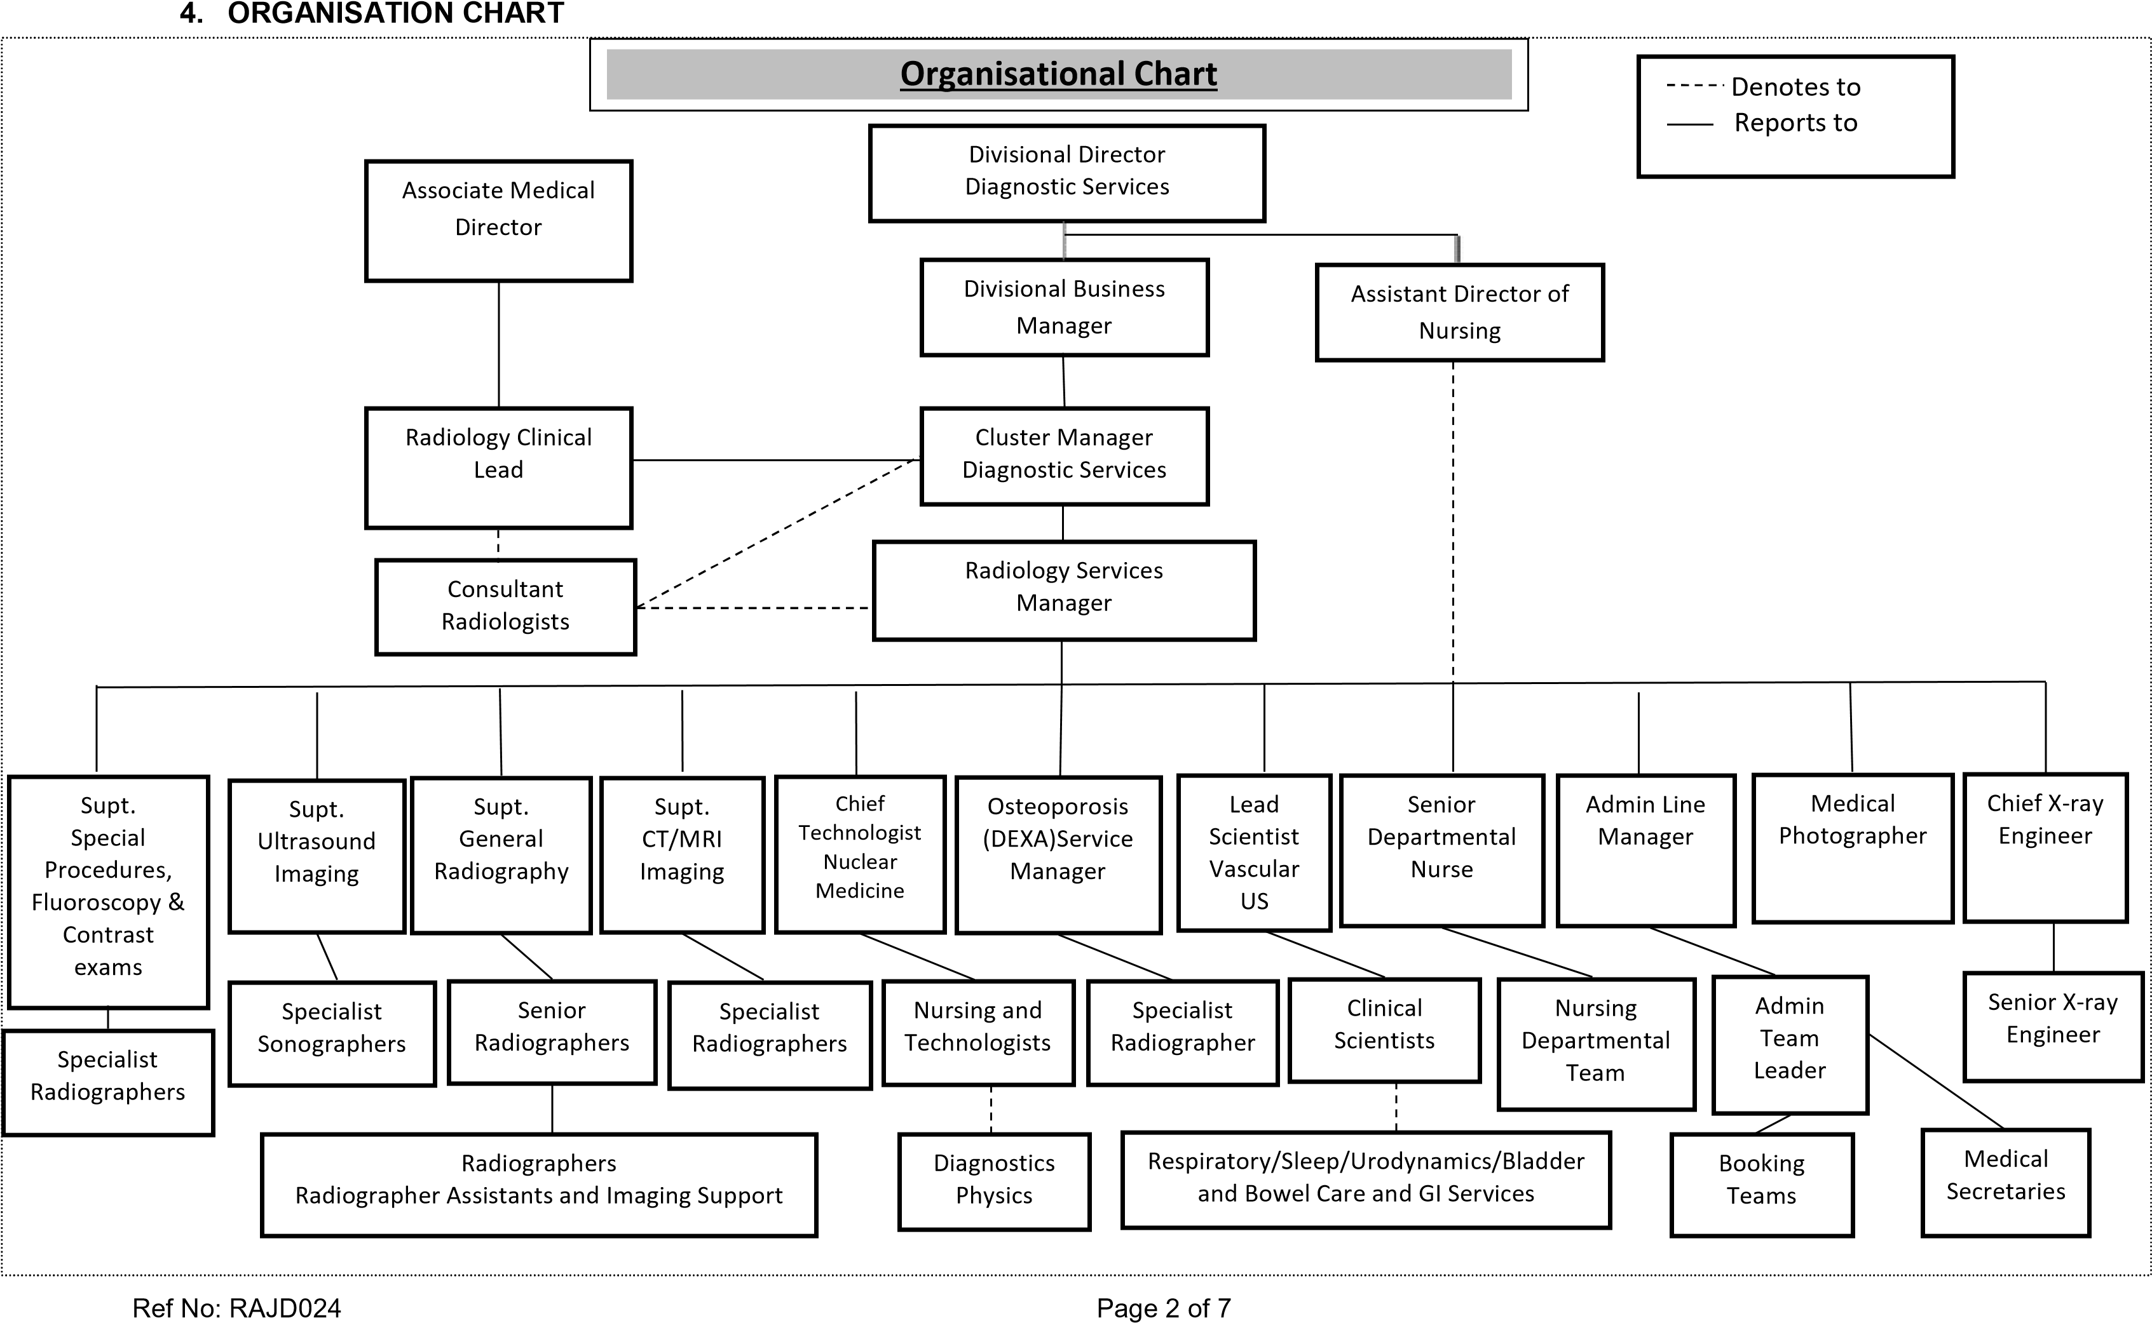

Document Name: Job Description – Radiology Assistant

Review Date: December 2020

5. KEY RESULT AREAS/PRINCIPAL DUTIES AND RESPONSIBILITIES:

### Communication

• To meet and greet patients, relatives and visitors to the department escorting them where necessary to the appropriate area of the department.

• To work and communicate effectively with other members of the staff to provide an efficient service to the Trust and to work as part of a multidisciplinary team.

• To liaise with wards and other departments within the Trust as and when necessary, including the communication of arrangements of patients’ appointments, preparation etc.

• To report to line managers incidences of verbal complaints received, or incidences of verbal or physical aggression or abuse.

### Professional & Clinical

• To maintain a high standard of professional conduct and appearance at all times.

• After a suitable period of induction and training to assist other staff carry out their duties in all areas of the department as required, under the supervision of senior trained staff.

• To observe, help and reassure patients during their stay within the department, reporting any significant events to a member of trained staff.

• To be caring, alert and attentive at all times, to patients, relatives and visitors and to other staffs’ emotional and physical requirements; for example assisting patients with toiletry needs, as and when appropriate.

• To assist in the transfer of patients on and off the examination tables, using mechanical lifting aids where necessary.

• To care for the children of patients whilst the parent is undergoing an imaging examination.

• Understand the use of the Medical Imaging Information System, and use it to enter the appropriate information required in an accurate and timely manner, as required.

• To work in the Patient Archiving and Communication Room (PACS), producing CD’s of duplicate images, uploading CD’s on to the PACS system.

• To be familiar with and adhere to all departmental clinical documentation procedures.

• To perform specific basic operations of specialised imaging equipment in Ultrasound (including procedures involving paediatric and musculo-skeletal patients) under the direct supervision of the radiographic / radiological staff.

• To provide a patient portering service within the department at all times and on occasions, to and from wards, as required.

• To restock clinical areas of the department with ‘consumable’ items from the storerooms, reporting shortages to the appropriate member of staff.

• To assist staff in performing interventional imaging procedures such as drainages and aspirations and to take samples to the Pathology department when required.

• To adhere to the Trust uniform policy at all times.

### Quality systems and organisational / operational objectives

* To bring to the attention of the Superintendent Radiographers or other senior staff and the Medical Imaging engineers any equipment malfunction or faults.
* To be responsible for weekly checks and cleaning of stretchers and wheelchairs used within the department.
* To perform daily checks to ensure that the oxygen and suction equipment is functioning satisfactorily and that emergency call bells are in full working order.
* To have a flexible approach to working hours and be prepared to participate in weekend and evening working if required.
* To be prepared to carry out any duties appropriate for the role and grade in any area of the department.

### Training, education and personal development

* To undertake such training as may be required in order to maintain the required levels of competency in all aspects of the duties required, with particular reference to the operation of patient handling equipment.
* To be aware of and adhere to all relevant Trust-wide and departmental policies and procedures and to undertake such mandatory training as required. Particular reference is made to the following policies: Patient identification procedures, Control of Infection, Risk Management, Fire, Cardiac arrest, Manual handling and Local Rules for Radiation Protection.
* To seek help if adversely affected by anything seen during day to day duties e.g. major trauma and critically ill patients, particularly children.

### Other Responsibilities

* To take part in regular performance appraisal
* To undertake any training required in order to maintain competency including mandatory training, i.e. Fire, Manual Handling
* To contribute to and work within a safe working environment
* The post holder is expected to comply with Trust Infection Control Policies and conduct him/herself at all times in such a manner as to minimise the risk of healthcare associated infection
* To attend and participate in such departmental meetings as deemed necessary by the Radiology Services Manager.
* To provide advice and guidance and help with training of newly appointed assistants in the performance of their duties.

### THE TRUST - PURPOSE AND VALUES

We are committed to serving our community by being a high quality specialist Hospital with consultantled services. We aim to co-ordinate our services with primary and community care, and to develop a limited number as Sub-Regional Referral Centres with appropriate levels of research, development and educational involvement. Where appropriate, and consistent with our services, we may provide services aimed at preventing disease and debilitation.

We aim to make all our services exemplary in both clinical and operational aspects. We will show leadership in identifying healthcare needs to which we can respond and in determining the most costeffective way of doing so. We will share our knowledge with neighbouring healthcare agencies and professionals.

We recruit competent staff that we support in maintaining and extending their skills in accordance with the needs of the people we serve. We will pay staff fairly and recognise the whole staff’s commitment to meeting the needs of our patients.

We are committed to equal opportunity for all and encourage flexible working arrangements including job sharing.

#### GENERAL

This is a description of the job as it is now. We periodically examine employees' job descriptions and update them to ensure that they reflect the job as it is then being performed, or to incorporate any changes being proposed. This procedure is conducted by the Manager in consultation with the jobholder. You will, therefore, be expected to participate fully in such discussions. We aim to reach agreement on reasonable changes, but if agreement is not possible, the Trust reserves the right to insist on changes to your job description after consultation with you.

The RD&E is a totally smoke-free Trust. Smoking is not permitted anywhere on Trust property, including all buildings, grounds and car parks. For help to quit call: 01392 207462.

As an employee of the Trust, it is a contractual duty that you abide by any relevant code of professional conduct and/or practice applicable to you. A breach of this requirement may result in action being taken against you (in accordance with the Trust’s disciplinary policy) up to and including dismissal.

The post holder is expected to comply with Trust Infection Control Policies and conduct him/her at all times in such a manner as to minimise the risk of healthcare associated infection.

# PERSON SPECIFICATION

|  |  |  |
| --- | --- | --- |
| REQUIREMENTS | At  Recruitment | At  PDR |
| QUALIFICATIONS / TRAINING    Literacy and Numeracy at GCSE Grade D or above  Basic I.T. skills  Good general education | E  E  E | E  E  E |
| KNOWLEDGE / SKILLS  Ability to communicate clearly and concisely with a wide range of staff, patients and visitors  To be able to understand and follow instructions  To be able to demonstrate a basic knowledge of IT skills e.g by possession of the ECDL etc  To be able to work within a multidisciplinary team  To have a flexible approach to working patterns  To be able to understand and maintain confidentiality | E    E  E    E  E  E | E    E  E    E  E  E |
| EXPERIENCE    Some experience of working unsupervised as a member of a multidisciplinary team  Experience of working with patients  Understanding and compassion for patients and their visitors. | E    D  E | E    E  E |
| PERSONAL ATTRIBUTES    Be enthusiastic, motivated and organised  Be of smart, professional appearance with a good standard of personal hygiene  Flexible approach to duties and ability to participate in shift / extended day and on-call working schedules  Ability to communicate well with all grades and disciplines of staff, patients and relatives  Be reflective in thinking and outlook and be able to cope with multiple demands during the working day | E  E    E    E    E | E  E    E    E    E |
| OTHER REQUIREMENTS    Be prepared to deal with distressing and emotional situations on a daily basis, for example, badly injured, or intoxicated patients; patients and relatives who may be aggressive or abusive    To be physically able to safely and competently position and manoeuvre patients and equipment as a routine part of the daily duties, including wheelchairs, beds and stretchers | E      E | E      E |

PERSON SPECIFICATION

## POST: RADIOGRAPHY ASSISTANT BAND: 2

* Essential/Desirable

|  |  |  |  |  |  |
| --- | --- | --- | --- | --- | --- |
| Hazards within the role, used by Occupational Health for risk assessment | | | | |  |
| Laboratory Specimens Proteinacious Dusts |  | Clinical contact with patients | ☑ | Performing Exposure  Prone Invasive Procedures |  |
| Blood/Body Fluids | ☑ | Dusty Environment |  | VDU Use | ☑ |
| Radiation | ☑ | Challenging Behaviour | ☑ | Manual Handling | ☑ |
| Solvents |  | Driving |  | Noise |  |
| Respiratory Sensitisers |  | Food Handling |  | Working in Isolation |  |