

J
O
B

D
E
S
C
R
I
P
T
I
O
N

JOB DETAILS
Job Title | Workforce Intelligence Analyst
Reports to | Workforce Intelligence Business Partner
Band | Band 4
Department/Directorate | HR – Workforce Systems & Data

JOB PURPOSE
The Trust has implemented a number of national HR systems across the organisation including the national Electronic Staff Record (ESR), an e-rostering system, and a Learning Management System. The postholder will play a key role in the support and provision of data and information about our workforce to customers both within the Trust and for our regional and national stakeholders.
Internal to the Trust | External to the Trust
Head of Workforce Systems, Data and Insight  Workforce Intelligence Manager  Workforce Intelligence Business Partners  Senior Workforce Solutions Product Owner and Product Managers  AFC and Medical Rostering Teams  Payroll and Recruitment Teams  HR Absence Hub  HR Helpdesk  Divisional Managers  Finance Department  Administrative Services Managers  Heads of Department | NHS England  Integrated Care System – South West

ORGANISATIONAL CHART
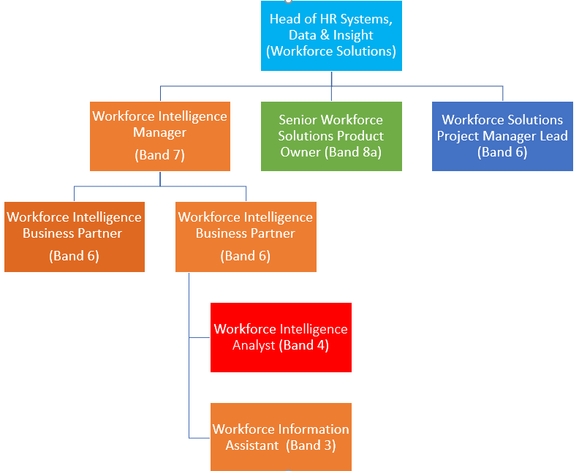

KEY RESULT AREAS/PRINCIPAL DUTIES AND RESPONSIBILITIES
- Be a key member of the support team for all workforce systems reporting, providing operational advice and guidance on the use of the systems.

- Maintain regular communication links to all levels of staff and managers to promote best practice and inform users of issues, upgrades and changes to the systems and to realise system benefits.

- Ensure information flows are appropriate and the data maintained within the systems are maintained to the Trusts and national quality standards.

- Achieving the timetables for the provision of information, whilst maintaining accuracy and the quality standards required. These timetables may at such times as Trust or national deadlines dictate include an element of unsocial hours on weekends and public holidays (unsocial pay enhancements would be applied in these circumstances).

- Ensure monthly, quarterly and annual workforce data returns, both internal and for national or regional bodies are submitted accurately and by stated deadlines.

- Liaising with Workforce Intelligence Business Partners and systems Product Managers to gain an in depth understanding of reporting from said systems.

- Escalate data quality issues and related risks to the Workforce Intelligence Partner and Product Managers.

- Participate in audit reviews and other initiatives as agreed.

- To undertake other duties as required.

FREEDOM TO ACT
Works to achieve agreed objectives and strategy and is given freedom to do this in own way of working within broad professional policies (ie Information Governance Policy, Information Security Policy etc; acts with reference to manager; acts as a lead specialist in that area; works autonomously, guided by national policy and regulations
COMMUNICATION/RELATIONSHIP SKILLS
Communicates Workforce Systems service issues to internal stakeholders and understanding and identifying matters for escalation where appropriate.
ANALYTICAL/JUDGEMENTAL SKILLS
Ability to understand information and data requests and provide clear and accurate outputs to fully meet the expectation of the customer.
PLANNING/ORGANISATIONAL SKILLS
Plan workload to be able to meet regular deadlines and ability to prioritise more urgent ad-hoc requests for information as required.
PATIENT/CLIENT CARE
The post holder is required to put the patient, as the first priority, at the centre of all activities. The post holder will not deal directly with patients.
POLICY/SERVICE DEVELOPMENT
There may be instances where expertise is required in supporting policy reviews and changes, e.g. Professional Registration
Actively propose and support service improvement and policy changes where appropriate. This may impact within the department or Trust-wide
FINANCIAL/PHYSICAL RESOURCES
n/a
HUMAN RESOURCES
By sharing knowledge of the reporting systems integral to this role, you will help to ensure the Trust’s resources are utilised effectively

INFORMATION RESOURCES
Embed good practice regarding data protection and information governance procedures, offering advice and raising concerns as appropriate, thereby ensuring legislative requirements are met as a minimum standard

RESEARCH AND DEVELOPMENT
Comply with Trust’s requirements and undertake surveys as necessary.
PHYSICAL SKILLS
The post predominately desk based for the majority of time requiring contact use of a VDU/PC Webex systems at this time, call conferencing and use of the telephone.

Sitting, walking use of keyboard/mouse for long periods. This position will involve some driving with the occasional need to carry laptops, guides and manuals. Office based post with a frequent requirement to sit in a restricted position at display screen equipment. Occasional lifting of files, laptops, Productors, conference phones, presentation materials and stationery.

The post holder will be required to have an awareness of health and safety guidelines in respect of VDU working.

PHYSICAL EFFORT
As above
MENTAL EFFORT
You must be able to work in a highly time-bound environment and be able to work well under pressure at all times
Prolonged periods of concentration will be required on a regular basis
Attention to detail and accuracy will be paramount in this role
You will be responsible for organising and prioritising your own workload and day to day allocation of work.
Forward planning and delegation may be required to ensure delivery against internal and external workforce information reporting deadlines

EMOTIONAL EFFORT
The constant requirement to meet tight deadlines and targets, along with competing demands, may impose some pressure on the post holder and/or on other people, both inside and outside the Trust, with whom the post holder has to work for which they would need to demonstrate resilience.

This will require the post holder to prioritise their own workloads and explain/negotiate those priorities with other stakeholders. This could also lead to confrontational relationships which the post holder will have to manage with support of the line manager.
Limited exposure to distressing or emotional circumstances.

WORKING CONDITIONS
The post will predominantly be based in an office or remote working environment with high levels of visual display unit use.
Uses display screen equipment for substantial proportion of the days. May be required to frequently drive around Trust sites.
OTHER RESPONSIBILITIES
Take part in regular performance appraisal.

Undertake any training required in order to maintain competency including mandatory training, e.g. Manual Handling

Contribute to and work within a safe working environment

You are expected to comply with Trust Infection Control Policies and conduct him/herself at all times in such a manner as to minimise the risk of healthcare associated infection

As an employee of the Trust, it is a contractual duty that you abide by any relevant code of professional conduct and/or practice applicable to you. A breach of this requirement may result in action being taken against you (in accordance with the Trust’s disciplinary policy) up to and including dismissal.

You must also take responsibility for your workplace health and wellbeing:
- Be physically active at work (i.e. take breaks away from your desk, taking the stairs where possible)
- When required, gain support from Occupational Health, Human Resources or other sources.
- Familiarise yourself with the health and wellbeing support available from policies and/or Occupational Health.
- Follow the Trust’s health and wellbeing vision of healthy body, healthy mind, healthy you.
- Undertake a Display Screen Equipment assessment (DES) if appropriate to role.
APPLICABLE TO MANAGERS ONLY – delete section if not applicable
- n/a
DISCLOSURE AND BARRING SERVICE CHECKS– delete section if not applicable
- n/a
GENERAL
This is a description of the job as it is now. We periodically examine employees' job descriptions and update them to ensure that they reflect the job as it is then being performed, or to incorporate any changes being proposed. This procedure is conducted by the manager in consultation with the jobholder. You will, therefore, be expected to participate fully in such discussions. We aim to reach agreement on reasonable changes, but if agreement is not possible, we reserve the right to insist on changes to your job description after consultation with you.

Everyone within the Trust has a responsibility for, and is committed to, safeguarding and promoting the welfare of vulnerable adults, children and young people and for ensuring that they are protected from harm, ensuring that the Trusts Child Protection and Safeguarding Adult policies and procedures are promoted and adhered to by all members of staff.

Northern Devon Healthcare NHS Trust and the Royal Devon and Exeter NHS Foundation Trust continue to develop our long standing partnership with a view to becoming a single integrated organisation across Eastern and Northern Devon. Working together gives us the opportunity to offer unique and varied careers across our services combining the RD&E’s track record of excellence in research, teaching and links to the university with NDHT’s innovation and adaptability.

This is
FREQUENCY

(Rare/ Occasional/ Moderate/ Frequent)
WORKING CONDITIONS/HAZARDS |  | R | O | M | F
Hazards/ Risks requiring Immunisation Screening
Laboratory specimens | N
Contact with patients | N
Exposure Prone Procedures | N
Blood/body fluids | N
Laboratory specimens | N
Hazard/Risks requiring Respiratory Health Surveillance
Solvents (e.g. toluene, xylene, white spirit, acetone, formaldehyde and ethyl acetate) | N
Respiratory sensitisers (e.g isocyanates) | N
Chlorine based cleaning solutions  (e.g. Chlorclean, Actichlor, Tristel) | N
Animals | N
Cytotoxic drugs | N
Risks requiring Other Health Surveillance
Radiation (>6mSv) | N
Laser (Class 3R, 3B, 4) | N
Dusty environment (>4mg/m3) | N
Noise (over 80dBA) | N
Hand held vibration tools (=>2.5 m/s2) | N
Other General Hazards/ Risks
VDU use ( > 1 hour daily) | Y |  |  |  | X
Heavy manual handling (>10kg) | N
Driving | Y |  | X
Food handling | N
Night working | N
Electrical work | N
Physical Effort | N
Mental Effort | Y |  |  |  | X
Emotional Effort | Y |  |  | X
Working in isolation | Y | X
Challenging behaviour | Y |  | X

Job Title | Workforce Intelligence Analyst
P
E
R
S
O
N

S
P
E
C
I
F
I
C
A
T
I
O
N

Requirements | Essential | Desirable
QUALIFICATIONS / TRAINING  - Minimum 4 “O” Levels/ GCSE Grade C or above, one of which must be English Language or equivalent.  - Excellent knowledge of the MS Office Suite | E  E  D | E  E  E
KNOWLEDGE/SKILLS  - Experience in producing Excel reports from a range of systems and databases to exacting deadlines  - Previous experience and knowledge in the use of electronic rostering systems  - Knowledge of Connecting for Health and the implications on training/teaching to Primary and Secondary Care organisations  - Excellent planning and interpersonal and communication skills (verbal and written) | E  D  D  D | E  E  E  E
EXPERIENCE  - An understanding of the workings of NHS  - Working with staff at all levels across a multidisciplinary team  - Previous experience working within the NHS  - Experience with using ESR and Allocate Healthroster | D  E  E  E | E  E  E  E
PERSONAL ATTRIBUTES  - Self motivator and ability to motivate others  - Intuitive and able to use own initiative  - Committed to develop self  - Flexible and adaptable to change  - Able to work unsupervised with excellent organisational skills  - Able to work accurately particularly when under pressure | E  E  E  E  E  E | E  E  E  E  E  E
OTHER REQUIREMENTS | n/a | n/a

