**JOB DESCRIPTION**

**1. JOB DETAILS**

**Job Title : Operations Manager**

**Band : 6**

**Responsible To : Practice Manager / General Manager**

**Accountable To : Practice Manager**

**Department/Division : Castle Place Practice**

**2. JOB PURPOSE**

The Operations Manager is accountable for the Operational Management and on-going development of the administrative services to support and meet the on-going needs of the clinical services. They will further support the Trust through the development and implementation of specific projects with reference to service and strategic needs of the Division. Specifically, the post holder will:

* Ensure that the administrative service is appropriately resourced, and the work is closely aligned to the needs of individual service lines with reference to the broader Trust’s strategic agenda and direction
* Ensure that administrative services function effectively on a day-to-day basis, supporting the needs of Service Lines and their patients.
* Support and motivate the administrative workforce to focus on the needs and experience of patients.
* Engender a learning and supportive environment where best practice is shared across the whole organisation and adopted as standard operating practice.
* Promote a culture of continuous improvement and share this knowledge across the trust to improve efficiencies, increase patient care and drive down costs.
* Ensure implementation and continual compliance with relevant Standard Operating Procedures (SOPs)
* Assist in creating appropriate, robust, and sustainable structures Trust-wide to ensure the effective line management and support of administrative staff.
* Provide support to CSMs.
* Ensure all information is secure and confidentiality of information is maintained at all times.
* Provide excellent customer care which may include communication with distressed and anxious patients and relatives, treating them with tact and empathy.
* Ensure the professional image of the Trust is maintained at all times.

**3. KEY WORKING RELATIONS**

* Practice Manager
* Administration team
* Care Coordinating team
* Reception team
* Clinical teams
* Patients and their relatives
* GPs
* Divisional Management team
* Other members of the multi-professional clinical team
* Health Records & IM&T Departments
* Administration and secretarial teams across the Trust
* Central Support Team
* Management accountants

**4. DIMENSIONS**

This is a key role that will work closely with the Practice Manager to ensure that the overall operations of the GP practice run effectively and efficiently. This will include administration, reception, finance, IT, HR estates and other logistics.

**5. ORGANISATIONAL CHART**

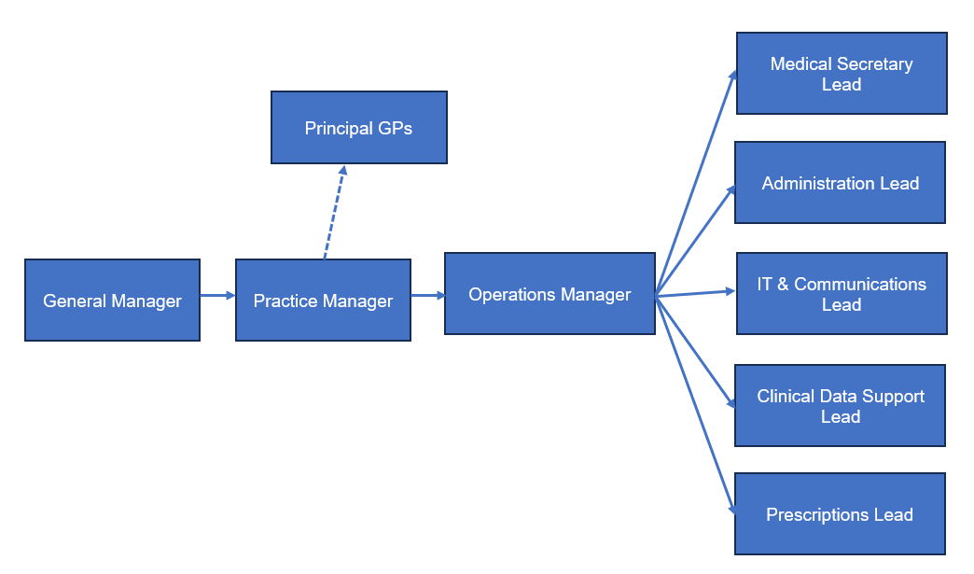

**6.         KEY RESULT AREAS/PRINCIPAL DUTIES AND RESPONSIBILITIES:**

* The post holder will be responsible for the overall administrative services function within Castle Place Practice. This will include line management of the Administration, Secretaries and Reception Leads. They will also be responsible for the line management of the Hotel Services team.
* The post holder will be responsible for maintaining the operational systems and processes within the practice which will including working with colleagues to ensure that systems are kept up to date including appointment templates, rotas and schedules of work.
* The post holder will be responsible for line management of the IT Support Manager and will provide support to this post to ensure that work is prioritised appropriately.
* The post holder will be responsible for working closely with the Practice Manager to ensure that the overall operations including administration, finance, IT and estates run smoothly in the practice.
* The post holder will play a key role in managing and sharing knowledge of all NHS processes and procedures.

**Supervisory and Human Resources**

* Personal accountability for the overall operational management of administrative services
* Leadership of administrative staff to foster a positive, supportive culture conducive to the effective delivery of administrative services.
* Development and maintenance of robust and effective line management arrangements for the administrative workforce
* To coach and mentor Administrative Line Managers in all aspects of performance management including sickness, conduct and capability management.
* Support to administration line managers in resolving complex or contentious issues including performance management of staff through to final disciplinary/capability hearings and the performance management of staff with protected characteristics.
* To drive down percentage of sickness absence, performance and capability costs and cases within administrative and clerical teams
* Responsibility for robust and effective recruitment and retention of administrative staff to meet the needs of the Division.
* To provide an effective link between administrative staff and senior Trust management, cascading information as appropriate and briefing senior management on relevant issues.
* Direct line management of administrative staff
* Effective liaison and co-operation with ASMs in other areas to ensure administrative services across the Trust are consistently aligned.
* Ensuring that administrative services and their management are aligned to all relevant Trust policies including HR, health and safety and all relevant employment legislation.
* Creation, development, and control of performance reports relating to administrative services.
* Support the day-to-day management of agreed policies and protocols in relation to patient access.
* Ensure that day to day access issues can be resolved in an effective and timely manner.
* Ensure that performance related information is accurate, relevant, and validated as appropriate.
* Support the Division to meet all relevant performance indicators.
* Ensure that all PDRs (appraisals), return to work (sickness) interviews, mandatory (essential) training are completed by all administrative and clerical staff within the Trust’s defined timelines, and that this information is accurately recorded on the Trust’s system (ESR) in a timely manner.

**Administrative functions**

* Use multiple computer systems as required within the department such as PAS, NHS e-referrals, ESR.
* Ensure accurate and up-to-date patient details are maintained on patient information systems such as PAS, in line with Trust Information Governance policy.
* Maintain health records and patient files in line with Trust Health Records Policy
* Support the ALM/CSM in ensuring that complaints are dealt with promptly and effectively and where appropriate, escalate if unable to resolve.
* Execution of action plans in response to patient complaints or clinical incidents related to their administrative services.

**Service delivery/improvement**

* On-going review and development of the administrative service to best meet the needs of patients with reference to the trust’s strategic direction.
* Lead on administrative change across diverse systems and multiple specialties.
* Plan and execute of service development projects with complex issues and multiple interdependencies.
* Anticipate potential issues arising from service development and taking appropriate action to mitigate them.
* Devise new ways of working, including the initiation and development of Standard Operating Procedures
* Support effective workforce planning to ensure the Trust has an administrative workforce aligned to its strategic objectives.
* Accountable for the development and delivery of specific projects as required by the Trust.
* Effective engagement with stakeholders during the development and implementation of specific projects
* Coordination of complaint responses related to administrative services, including meeting patients and relatives as and when required.
* Development and execution of action plans in response to patient complaints.
* Coordination of investigations into clinical incidents related to administrative issues and the development of action plans arising from those investigations.
* Ensure that appropriate risk assessments are undertaken and acted upon for administrative services within the Division.
* Be the local expert for the Division in matters relating to information governance.
* Membership of the relevant divisional governance body
* Maintain an up-to-date knowledge of HR policies and their impact on staff.
* Contribute to the NHS service improvement/modernisation agenda e.g., service redesign.
* Lead on developing processes within the department to meet the demands of a growing service.
* Participate in team and directorate meetings as required.
* Contribute to audits regarding departmental procedures.
* Have a flexible approach to working hours to meet the demands of the service.
* Adhere to the Trust Access Policy and Health Records Policy and appropriate standard operating procedures, Key Performance Indicators, government targets and standard operational policies.

**Communication**

* Make and receive telephone calls both external and internal according to Trust standards.
* Communicate effectively including discussion and written communication.
* Proactively manage email communication in line with the RD&E’s Email Best Practice guidance
* Provide excellent customer care, in a calm and professional manner – some situations may be challenging.
* Organise and/or support team meetings through effective communication.

**Governance**

* Undertake training as required to maintain competency/comply with trust policies.
* Work within Trust policies – including those for confidentiality, data protection, health and safety fire protection, and annual appraisal.
* Adhere to the Trust Access Policy, Health Records Policy and Key Performance Indicators, government targets and standard operational policies and procedures.

**Resource/Finance Management**

* Accountability for the effective management of administrative budgets
* Accountability for ensuring effective financial control of administrative budgets in line with the Trust’s objectives.
* Continuous delivery of value for money and Cost Improvement Program as required by the Trust.
* Ensure robust mechanisms for the timely and cost-effective procurement of equipment and consumables for administrative services.
* Provide cover in periods of absence as directed by the Practice Manager, this may involve moving to other areas.
* Monitor use of supplies and stationery and ensure this is done efficiently and cost effectively in line with the needs of the service.

### Additional Responsibilities

* The post holder will be expected to carry out any other duties as required, commensurate with their pay band.
* The post holder will be required to facilitate and support new starters to carry out their role.
* The post holder will understand the limitations of the role and how to access support.
* *Any other specific requirements to support the division in achieving its quality and financial performance targets, as directed by the CSM or Divisional Manager*

**Trust wide Responsibilities**

* To take part in regular performance appraisal
* To undertake any training required in order to maintain competency including mandatory training, e.g., Manual Handling
* To contribute to and work within a safe working environment
* The post holder is expected to comply with Trust Infection Control Policies and conduct him/herself at all times in such a manner as to minimise the risk of healthcare associated infection.

As an employee of the Trust, it is a contractual duty that you abide by any relevant code of professional conduct and/or practice applicable to you. A breach of this requirement may result in action being taken against you (in accordance with the Trust’s disciplinary policy) up to and including dismissal.

The post holder is expected to comply with Trust Infection Control Policies and conduct him/her at all times in such a manner as to minimise the risk of healthcare associated infection.

**THE TRUST – Vision and Values**

Our vision is to provide safe, high quality seamless services delivered with courtesy and respect. To achieve our vision, we expect all our staff to uphold our Trust values. Our Trust values are:

* HONESTY, OPENNESS & INTEGRITY
* FAIRNESS
* INCLUSION & COLLABORATION
* RESPECT & DIGNITY

We recruit competent staff that we support in maintaining and extending their skills in accordance with the needs of the people we serve. We will pay staff fairly and recognise the whole staff’s commitment to meeting the needs of our patients.

We are committed to equal opportunity for all and encourage flexible working arrangements including job sharing.

We are committed to recruiting and supporting a diverse workforce and welcome applications from all sections of the community, regardless of age, disability, gender, race, religion, sexual orientation, maternity/pregnancy, marriage/civil partnership or transgender status. We expect all staff to behave in a way which recognises and respects this diversity, in line with the appropriate standards.

### GENERAL

This is a description of the job as it is now. We periodically examine employees' job descriptions and update them to ensure that they reflect the job as it is then being performed, or to incorporate any changes being proposed. This procedure is conducted by the Manager in consultation with the jobholder. You will, therefore, be expected to participate fully in such discussions. We aim to reach agreement on reasonable changes, but if agreement is not possible, we reserve the right to insist on changes to your job description after consultation with you.

The RDUH is a totally smoke-free Trust. Smoking is not permitted anywhere on Trust property, including all buildings, grounds and car parks. For help to quit call: 01392 207462.

**PERSON SPECIFICATION**

**POST: Operations Manager**

**BAND: 6**

|  |  |  |
| --- | --- | --- |
| **REQUIREMENTS** | Essential / Desirable at: | |
|  | Recruitment | 1st PDR or (award of) increment |
| **QUALIFICATIONS / TRAINING:**  Educated to ‘A’ level standard or equivalent  Minimum of 3 qualifications to include GCSE grade A-C/4-9 or equivalent in Maths and English  NVQ 3 in Business Admin or equivalent  ILM Level 3 in Team Leading  Clinical Document Management (CDM)  Patient Administration System (PAS) Level 4 outpatients  ECDL, CLAIT or equivalent  AMSPAR Medical Terminology or equivalent  Postgrad. Management qualification or equivalent professional experience | **E**  **E**  **E**  **E**  **D**  **E**  **D**  **D**  **E** | **E**  **E**  **E**  **E**  **E**  **E**  **E**  **E**  **E** |
| **KNOWLEDGE / SKILLS:**  Excellent planning & organisational skills  Ability to prioritise workload to respond to changing demand  Ability to liaise and communicate with staff at all levels  Motivation and negotiation skills  Excellent interpersonal & communication skills inc. demonstrating empathy & sensitivity to patients and relatives  Ability to promote good working liaisons (staff, patients, relatives)  Extracting information / Listening Skills  Ability to handle complex enquiries - distressed & anxious patients  Ability to deal with challenging behaviour  Ability to provide excellent customer care  Knowledge of IT databases and computer systems  Comprehensive PC skills - databases, word-processing, email, Excel  Understanding of hospital IT systems  Knowledge of PAS or equivalent information system  Analytical skills & ability to problem solve  Proven strong administration skills  Accurate data entry  Excellent telephone manner  Knowledge of Trust procedures  Able to work independently, with minimum supervision  Proven ability to motivate staff and encourage team work  Ability to coach and mentor others  Ability to effectively supervise staff on a day to day basis  Ability to effectively performance manage staff  Ability to engage and influence staff within their area of responsibility  Knowledge of PDR process  Practical knowledge of change management  Ability to deal with members of a multi-disciplinary team  Ability to co-ordinate complex diary management  Good decision making skills  Thorough understanding of NHS performance targets  Basic understanding of the compliance framework for NHS Foundation Trusts  Understanding of the basics of finance and health and safety  Understanding of the principles of audit  Knowledge of patient flow  Knowledge of Trust procedures | **E**  **E**  **E**  **E**  **E**  **E**  **E**  **E**  **E**  **E**  **E**  **E**  **E**  **E**  **E**  **E**  **E**  **E**  **E**  **E**  **E**  **E**  **E**  **E**  **E**  **E**  **D**  **E**  **E**  **E**  **E**  **E**  **D**  **D**  **E**  **E** | **E**  **E**  **E**  **E**  **E**  **E**  **E**  **E**  **E**  **E**  **E**  **E**  **E**  **E**  **E**  **E**  **E**  **E**  **E**  **E**  **E**  **E**  **E**  **E**  **E**  **E**  **E**  **E**  **E**  **E**  **E**  **E**  **E**  **E**  **E**  **E** |
| **EXPERIENCE:**  Previous clerical experience  Working in an NHS/clinical environment e.g. hospital, GP surgery, CCG  Supervision and the development of staff  Operational managing or sufficient experience of a service on a day to day basis  Managing Administrative functions within a large complex organisation  Formal performance management of staff  Managing sickness absence and conduction of performance or capability investigations  Staff rostering  Implementing change in a discrete area  Managing a change process  Holding budgetary responsibility | **E**  **E**  **E**  **E**  **E**  **E**  **E**  **E**  **E**  **E**  **D** | **E**  **E**  **E**  **E**  **E**  **E**  **E**  **E**  **E**  **E**  **E** |
| **PERSONAL ATTRIBUTES:**  Enthusiastic highly motivated & committed to delivering a service  Understand team work and work within a team  Able to plan and organise workload  Able to prioritise own work load and meet deadlines  Ability to work un-supervised  Can remain calm and professional in a busy environment  Empathetic, but able to understand professional boundaries  Smart appearance, adhering to the Uniform Policy  Welcoming friendly and approachable manner  An adaptable approach to work  Flexible approach to working hours  Commitment to continual development to inc. relevant new systems, policies and procedures  Adheres to relevant Trust policies & procedures  Adheres to confidentiality & data protection requirements | **E**  **E**  **E**  **E**  **E**  **E**  **E**  **E**  **E**  **E**  **E**  **E**  **E**  **E** | **E**  **E**  **E**  **E**  **E**  **E**  **E**  **E**  **E**  **E**  **E**  **E**  **E**  **E** |

|  |  |  |  |  |  |
| --- | --- | --- | --- | --- | --- |
| **Hazards within the role, used by Occupational Health for risk assessment** | | | | | |
| Laboratory specimens |  | Clinical contact with patients |  | Dealing with violence & aggression of patients/relatives |  |
| Blood / Body Fluids |  | Dusty environment |  | VDU Use | 🗸 |
| Radiation / Lasers |  | Challenging behaviour | 🗸 | Manual Handling | 🗸 |
| Solvents |  | Driving |  | Noise / Vibration |  |
| Respiratory sensitisers |  | Food Handling |  | Working in isolation |  |
| Cytotoxic drugs |  | Electrical work |  | Night working |  |