JOB DESCRIPTION

Job Title: Nurse Specialist (Community)

Band: 6

Responsible To: Community Nurse Team Manager

Accountable To: Community Nurse Team Manager Senior Nurse Community (Professional Lead)

# Section/Department/Directorate: Community Nursing - Health & Social Care Directorate

Job Purpose:

Work clinically to offer expert direction and day to day leadership to a team of community nurses. Carry their own patient caseload. Provide assessment and nursing care, advice and information to patients and carers within the home environment or alternative care setting.

Aim to, wherever possible, maintain patients in their own preferred place of care enabling them to maximise their independence and optimise their quality of life.

Work under the direction of the Community Nurse Team Manager and the Community Services Manager, using skills and knowledge as a registered nurse.

Have responsibility for the overall caseload of the team, including management of the caseload, reviewing caseloads and overseeing of any designated patients.

The post will be 20% managerial and 80% clinical activity and contact.

Deputise for the Community Nurse Team Manager in their absence.

Manage referrals into and onto the community nursing caseload.

Mentor students during their community placement.

Context:

* Lone working
* Remote working without direct supervision
* Supervising, teaching and involvement with the development of peers and other relevant team members, carers and patients
* Leadership and management of a designated team

The Nurse Specialist (Community) will be based in the community setting.

The post holder will fulfil all tasks and work as part of a team. To meet the needs of the service, the post holder may be required to work in other areas as appropriate and under the direction of line manager or appropriate manager.

Key Working Relationships:

The post holder is required to work with:

Patients, Relatives and Carers

Community Nursing Team

Senior Nurse Community

Community Services Managers

Community Matron

Adult Health and Social Care

Community Hospitals

General Practitioners and other members of the Primary Health Care Team

Palliative Care Teams

Continuing Healthcare

Safeguarding Lead/Team and Care Home Educators

Rapid Intervention Centre/Rapid Response

Statutory and Voluntary Agencies

Secondary Care Providers including Discharge Teams

Specialist Nurses

Out of Hours Services

Adult Mental Health Teams

Public Health Teams

Other Agencies/Providers

# Organisational Chart

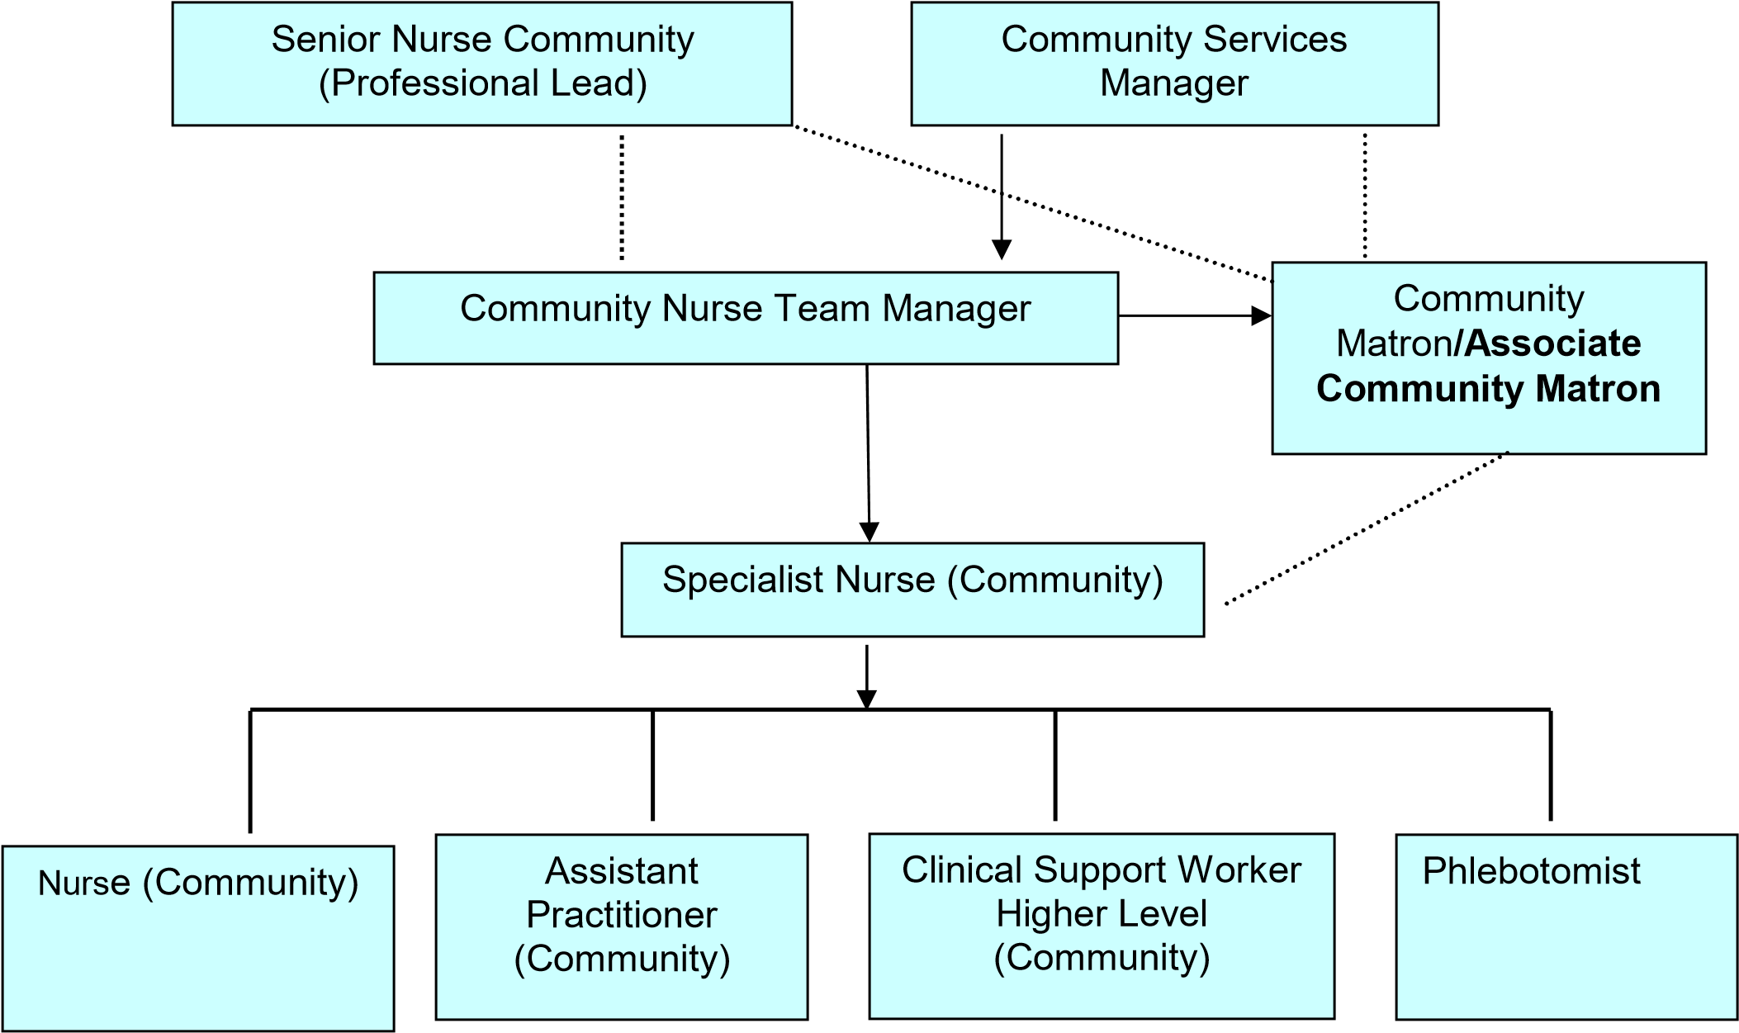

Direct Line Mangement

Key Working Relationship

Key Result Areas/Principal Duties and Responsibilities

# Communication and Relationship Skills

Communicating and building effective therapeutic relationships with patients, relatives, carers and professional partners to ensure patient care is focal and managed effectively.

Effectively communicates complex and sensitive information concerning patient’s medical conditions, requiring tact, persuasion and reassurance skills.

Acts at all times in a manner which illustrates compassion, respect for privacy, dignity and confidentiality.

Understands the implications of the Mental Capacity Act and acts to assess capacity as appropriate.

Understands the safeguarding adult’s issues and acts within the guidance of the policy to keep adults within their care safe.

Able to keep accurate contemporaneous documentation and care plans using the Trust’s documentation.

This role requires excellent communication skills, verbal, written and use of IT.

# Analytical and Judgement Skills

Analyse and act appropriately in complex situation and escalate wherever applicable eg to Safeguarding Lead.

Make judgements on complex facts requiring interpretation and comparing options. Skills required for assessment and interpretation of patient conditions and determining the appropriate course of action.

# Planning and Organisational Skills

The post holder will be expected to:

* Review team caseload.

* Oversee the planning, implementing and evaluation of programmes of care for individual patients.

* Manage the day to day organisation of the team and caseload.

* Co-ordinate with other providers, where appropriate, regarding care provision.

* Triage and prioritise the referrals to the community nursing team.

* Use effective and efficient leadership and management skills.

# Physical Skills

A range of highly developed clinical skills including dexterity and accuracy for intravenous injections, syringe pumps, insertion of catheters and removal of sutures. This is not an exhaustive list.

# Responsibility for Patient and Client Care

The post holder hold their own patient caseload and will assess, plan, implement and evaluate nursing care programmes in the community setting.

Work within the standards set out within the Nursing and Midwifery Council (NMC) Code: Professional Standards of Practice Behaviour for Nurses and Midwives.

Demonstrate clinical competence developed through continual professional development, reflective practice and maintenance of a skills portfolio.

Undertake training to develop a range of knowledge and skills in order to deliver high quality evidenced based nursing care.

Assess patients with complex healthcare needs and develop appropriate care plans.

Monitor and maintain standards of care.

Recognise and appropriately address risk factors to patients and carers within their healthcare setting. Develop risk reduction strategies and escalate where appropriate.

Recognise, record and report all changes in the patient’s condition to the appropriate professional at the earliest opportunity.

Report any untoward incidents, complaints and clinical emergencies to the appropriate professional within the required timescales, including safeguarding.

Initiate the management of incidents in accordance with Trust policy, including safeguarding, with the support of the Community Nurse Team Manager.

Ensure appropriate delegation and use of resources.

Promote health and wellbeing.

Work to prevent adverse effects on health and wellbeing.

Provide assurance on quality care delivery through audit reports and organisational performance data.

# Responsibility for Policy and Service Development

Work to Trust Policies, Procedures and Standard Operating Procedures (SOP).

Maintain Trust Standards of Clinical Governance.

Maintain Professional Standards of Practice.

Monitor nursing teams Standards of Practice.

Support the implementation and audit of policies, protocol and pathways, facilitating change in practice which will improve clinical outcomes and meet the needs to patients, relatives and carers.

# Responsibility for Financial and Physical Resources

Ensure the efficient use of resources i.e. appropriate wound dressing choice that is evidence-based and use agreed formularies.

Authorise and oversee the maintaining of stocks and supplies.

Carry out nurse prescribing as appropriate.

Higher level prescribing of equipment from the joint equipment store.

# Responsibility for Human Resources

Day to day management of the community nursing team.

Responsible for ensuring adherence to lone working polices and staff tracking systems.

Individual responsibility to attend mandatory training.

Training, supervising and supporting all staff within the Community Nursing Team including induction programmes, pre and post registration students, QCF candidates, work experience students, support workers, formal and informal carers.

Ensure the community nursing team participate in clinical supervision.

Complete appropriate staff appraisals and Personal Development Plans.

Participate in supervision and appraisal with line manager to support professional development focussing on the individual skill set and competency.

Assist the Community Nurse Team Manager in the recruitment and selection of staff.

Support the Community Nurse Team Manager in taking appropriate action to deal with poor work performance and initiating any appropriate initial investigation regarding complaints.

Organise staff rotas to ensure adequate staffing levels for the delivery of an effective community nursing service.

Assist in the management of absence according to policy.

Individual responsibility, and overseeing the team, to ensure everyone in the team attends mandatory training.

Ensure community nursing team have the appropriate knowledge skills and competency to undertake their roles.

To ensure registrants in the community nursing service have/gain mentorship qualifications and are updated to support pre-registration students of nursing.

# Responsibility for Information Resources

Inputting, storing and providing information in relation to patient records.

Accurately completing and maintaining effective patient’s records including addressing confidentiality issues.

Completing activity data using Trust agreed data collection sets.

Inputting and storing information on relevant IT systems.

# Responsibility for Research and Development

Demonstrate commitment and work regularly with senior colleagues to develop further expertise in developing own and team research skills and future evidence based nursing practice; contribute towards the audit process and policy formation.

# Decision Making

As lead specialist, expected results are defined but the post holder decides how these are achieved. Is a lone worker, working remotely, work is managed without direct supervision.

Works autonomously, manages own time, manages own patient caseload and the team’s caseload in the community.

Works within codes of practice and professional guidelines.

Works within Trust Policies, Procedures and Standard Operational Procedures (SOP).

Responsible to take decisions alone when necessary.

Decide when appropriate to refer to specialist services, adult health and social care team or other providers.

Can identify, through risk assessment, actions to be taken to mitigate risk and following this process when to escalate to: the Community Nurse Team Manager, Community Services Manager, Senior Nurse Community (Professional Lead) or on-call escalation process and/or other healthcare professionals.

# Physical Effort

Daily work involves frequent driving, sitting/standing and walking, moving equipment, frequent manual handling and treatment of patients in restricted positions.

Working hours negotiated according to service need.

Frequent use of IT equipment (including mobile phones, laptops, tablets etc). Basic keyboard skills required.

# Mental Effort

Understand a range of procures which are evidenced based:

* Community procedures
* Clinical observations
* Basic life support
* Assessing, planning, implementing and evaluating patient care
* Infection control

Liaise with and develop effective partnerships with a wide range of individuals and organisations in the statutory, voluntary and private sectors, in relation to patients with complex and/or long term conditions

Work pattern requires delivering a schedule of patient visits with frequent concentration for developing care plans, treating and interacting with patients/carers etc. The workload is deadline driven, unpredictable and subject to change and interruption i.e. calls being re-prioritised, interactions with work colleagues, family/patients/carers needs.

Capacity to balance the clinical and the day to day management aspects and leadership elements of the role and potential conflict is required.

Ability to use and concentrate for long periods using IT.

# Emotional Effort

Caring for patients at end of life, chronic conditions and their relatives, carers and friends. This includes having to break bad news or give distressing news to patients/relatives/carers and dealing with emotional circumstances.

Working with patients with mental health, learning disabilities and challenging behaviour.

Frequently deals with and copes with areas of complexity and conflict.

Instigates emergency procedures i.e. finding a collapsed patient and commencing basic life support.

# Working Conditions

Frequent daily contact with

* Body fluids e.g. faeces, vomit
* Smells
* Infections
* Dust
* Driving hazards
* Use of IT
* Transportation of samples

Occasional exposure to highly unpleasant working conditions.

# GENERAL

This is a description of the job as it is at present constituted. It is the practice of this organisation periodically to examine employees' job descriptions and to update them to ensure that they relate to the job as then being performed, or to incorporate whatever changes are being proposed. This procedure is jointly conducted by each manager in consultation with those working directly to him or her.

You will, therefore, be expected to participate fully in such discussions. It is the organisations' aim to reach agreement to reasonable changes, but if agreement is not possible management reserves the right to insist on changes to your job description after consultation with you.

We are committed to serving our community. We aim to co-ordinate our services with secondary and acute care.

We aim to make all our services exemplary in both clinical and operational aspects. We will show leadership in identifying healthcare needs to which we can respond and in determining the most cost-effective way of doing so. We will share our knowledge with neighbouring healthcare agencies and professionals.

We recruit competent staff whom we support in maintaining and extending their skills in accordance with the needs of the people we serve. We will pay staff fairly and recognise the whole staff’s commitment to meeting the needs of our patients.

The Trust operates a 'non smoking' policy. Employees are not able to smoke anywhere within the premises of the Trust or when outside on official business.

All employees must demonstrate a positive attitude to the Trust’s equality policies and Equality Scheme. Employees must not discriminate on the grounds of sex, colour, race, ethnic or national beliefs, marital status, age, disability, sexual orientation, religion or belief and will treat patients, colleagues and members of the public with dignity and respect.

If the post holder is required to travel to meet the needs of the job, we will make reasonable adjustments, if required, as defined by the Equality Act 2010.

SAFEGUARDING:

To be fully aware of and understand the duties and responsibilities arising from the Children’s Act 2004 and Working Together in relation to child protection and safeguarding children and young people as this applies to the worker’s role within the organisation.

To also be fully aware of the principles of safeguarding as they apply to vulnerable adults in relation to the worker’s role, which will include recognising the types and signs of abuse and neglect and ensuring that the worker’s line manager is made aware and kept fully informed of any concerns which the worker may have in relation to safeguarding adults and/or child protection.

Everyone within the Trust has a responsibility for, and is committed to, safeguarding and promoting the welfare of vulnerable adults, children and young people and for ensuring that they are protected from harm, ensuring that the Trusts Child Protection and Safeguarding Adult policies and procedures are promoted and adhered to by all members of staff.

# STAFF HEALTH AND WELLBEING

You must take responsibility for your workplace health and wellbeing:

* Be physically active at work (i.e. take breaks away from your desk, taking the stairs where possible)
* When required, gain support from Occupational Health, Human Resources or other sources.
* Familiarise yourself with the health and wellbeing support available from policies and/or Occupational Health.
* Follow the Trust’s health and wellbeing vision of healthy body, healthy mind, healthy you.

If you are a line manager, in addition to the above, it is expected you will:

* Champion health and wellbeing.
* Encourage and support staff engagement in delivery of the service.
* Encourage staff to comment on development and delivery of the service.
* Ensure during 1:1’s / supervision with employees you always check how they are.

HEALTH AND SAFETY AT WORK:

The employer will take all reasonably practical steps to ensure your health, safety and welfare while at work. You must familiarise yourself with the employer's Health & Safety policy, and its safety and fire rules. It is your legal duty to take care for your own health and safety as well as that of your colleagues.

INFECTION CONTROL - ROLE OF ALL STAFF:

It is the responsibility of all members of staff to provide a high standard of care to patients they are involved with. This includes good infection prevention practice.

All staff have a responsibility to comply with Infection Prevention and Control policies and procedures, this includes:

* Attending mandatory and role specific infection prevention education and training.
* Challenging poor infection prevention and control practices.
* Ensuring their own compliance with Trust Infection Prevention and Control policies and procedures for example, standard precautions, hand hygiene, prevention & management of inoculation incidents

CONFIDENTIALITY:

You may not disclose any information of a confidential nature relating to the employer or in respect of which the employer has an obligation of confidence to any third party other than where you are obliged to disclose such information in the proper course of your employment or as required by law. Any failure to comply with this term of your employment will be treated as an act of misconduct under the employer's disciplinary procedure.

# JOB DESCRIPTION AGREEMENT

Job holder’s Signature: .....................................................................................

Date: .....................................................................................

Manager’s Signature: .....................................................................................

Date: .....................................................................................

of 14

PERSON SPECIFICATION

# POST: Nurse Specialist (Community)

|  |  |  |  |  |  |
| --- | --- | --- | --- | --- | --- |
| REQUIREMENTS | E/ D |  | HOW TESTED?  Application Form=A Interview= I | INTERVIEW COMMENTS | SCORE  (1 Low – 10  High) |
| QUALIFICATIONS/SPECIAL TRAINING:    Registered Nurse    Post graduate/post registration  Clinical Diploma in Advanced Clinical Practice or similar qualification or equivalent experience.    Evidence of experience in the community nursing setting.    Specialist Practitioner Qualification in District Nursing    Highly Numerate and Literate    Community Practitioner Nurse Prescriber or Independent / supplementary prescriber or  commitment to work towards      Teaching/assessing qualification, equivalent experience or  commitment to work towards    Leadership and Management | E      E          E      D      E      D          D        D | A      A          A      A      A      A/I          A/I        A/I |  |  |  |

|  |  |  |  |  |
| --- | --- | --- | --- | --- |
| qualification or commitment to work towards    Mentorship qualification / skills and/or experience, or committed to undertaking appropriate mentorship course. | E | A/I |  |  |
| KNOWLEDGE/SKILLS:    Broad general community nursing  skills and clinical knowledge base    Specialist skills in initial assessment    Specialist knowledge and understanding of current issues relating to primary care, community nursing, social care and integration    Leadership and Management skills / experience or commitment to  gaining    Evidence of continual professional  development | E      E    E          D    E | A/I      A/I    A/I          A/I    A/I |  |  |
| EXPERIENCE:    Relevant nursing/community experience    Tissue viability, complex wound care    Chronic Disease Management / | E      E    D | A/I      A/I    A/I |  |  |

|  |  |  |  |  |
| --- | --- | --- | --- | --- |
| Long Term Conditions experience    Management of End of Life Care    Experience of supervisingand  monitoring staff    Basic keyboard skills, IT skills | E    D    E | A/I    A/I    A/I |  |  |
| PERSONAL REQUIREMENTS:    Sound clinical leadership skills and decision making capabilities. Ability to effectively lead and manage a team    Supervise the work, motivate and support development of junior staff and students    Self-motivated, ability to use own initiative: prioritise own work and that  of others. Manage a team caseload    Ability to identify own strengths and limitations    Excellent communication, interpersonal skills both written and oral.    Ability to critically appraise complex situations | E          E        E        E      E        E | A/I          A/I        A/I        A/I      A/I        A/I |  |  |
| OTHER REQUIREMENTS: |  |  |  |  |
| The post holder must demonstrate a positive commitment to uphold diversity and equality policies approved by the Trust    Be willing to work throughout the  Trust    Flexible working re working in a range of clinical settings and  environments and shift patterns    Ability to travel within the community    Awareness of clinical audit and  governance agenda | E          E      E        E    E | A/I          A/I      A/I        A/I    A/I |  |  |

|  |  |  |  |  |  |
| --- | --- | --- | --- | --- | --- |
|  |  | HAZARDS : |  | |  |
| Laboratory Specimens Proteinacious Dusts |  | Clinical contact with patients | X | Performing Exposure Prone Invasive Procedures |  |
| Blood/Body Fluids | X | Dusty Environment |  | VDU Use | X |
| Radiation |  | Challenging Behaviour | X | Manual Handling | X |
| Solvents |  | Driving | X | Noise |  |
| Respiratory Sensitisers |  | Food Handling |  | Working in Isolation | X |