Job Description
Job title: | Experience, Change and Communications Lead
Remuneration: | AfC Band 8A – to be confirmed
Contract type: | FTC/ Secondment – 12 months
Employing organisation: | RDUH
Hours: | 37.5
Location: | Devon
Accountable to: | People Digital Programme Lead

About NHS Devon
NHS Devon is the organisation responsible for the majority of the county’s NHS budget, and developing a plan to improve people’s health, deliver high-quality care and better value for money.
The organisation is led by a diverse board, which includes representatives from local councils, primary care (GPs), and NHS trusts.
Devon is the fourth largest county in England with a diverse and growing population. It includes the cities of Plymouth and Exeter, more than 45 towns – both rural and urban – and several hundred parishes.
Our aim is to improve people’s lives in Devon – wherever they live – to reduce health inequalities and make sure we can deliver these services for the long term.
NHS Devon is one of 42 integrated care boards across England that took on the statutory functions of clinical commissioning groups (CCGs) on 1 April 2022.

Our vision
Our vision is simple: equal chances for everyone in Devon to lead long, happy and healthy lives. But there is much to be done to achieve it.
We are committed to improving and our performance for waiting times for non-urgent operations, accident and emergency departments, and for test results designed to help GPs diagnose illnesses.
And we are dedicated to working together with our health and care partners because we know people’s physical and mental health and wellbeing is influenced by more than just the care they get from their local GP or hospital.

Our values
Developed by our people, our values and behaviours shape who we are, how we work and help us to make the right decisions of behalf of people in Devon.
One Devon
- We collaborate with staff, partners, patients, families, carers, communities and professionals to develop the right services for our population
- We think and act for our population, while recognising local needs
- We share information, skills and resources
- We value and protect our climate, and work in a sustainable way that reduces our carbon footprint

Quality in everything we do
- We develop safe, effective and accessible services that put patients at the centre
- We make decisions that are evidence-based, cost-effective and innovative
- We recognise achievements and celebrate success
- We take pride in our work, learn when things go wrong, and support people to speak up

Respect for all
- We treat people with respect and compassion
- We listen to people to understand their priorities, needs, and abilities, and involve them in decisions that affect their lives
- We are proactive with our health and wellbeing and our colleagues
- We champion equality, diversity and inclusion, and challenge inequalities
- We are open, honest and transparent

Everyone is a leader
- We lead by example and with integrity
- We are kind, caring and empathetic
- We support people to learn and develop
- We demonstrate leadership and expect to be held accountable for our actions and performance
- We are responsive, consistent and professional

Equality, diversity and inclusion
Inclusion is at the heart of everything we do.
We want our workforce, patients and service users to be confident that they will be valued, listened to, supported and cared for, regardless of their age, ethnicity, gender, ability and sexuality.
We also want to overcome barriers people experience in accessing health and social care, and in working for our organisations.
Some of this work is already underway including listening to LGBTQ+ and ethnically diverse communities and people with disabilities to understand what support they need to stay well.

Working as One Devon
Devon’s health and care system is built on a strong foundation of collaboration, trust and innovation.
One Devon is a partnership of the NHS and local councils, as well as a wide range of other organisations, including the voluntary sector, who are working together to improve the lives of people in Devon.
One of the lessons learned from the COVID-19 pandemic is that people need support that is joined up across organisations and sectors – One Devon aims to do just that.
We want to make our system as strong and effective as possible, through partnership working and with the ambition to tackle health inequalities, help communities thrive and achieve the very best for everyone.

About the People Digital Programme
In response to NHS England's Workforce Plan, Future of HR and OD report and 2030 People Profession Vision, a national ‘Scaling People Services’ Vanguard programme was launched by NHS England in early 2023. It’s aim is to transform people services delivery through scaling and digitising services at an Integrated Care System (ICS) level, paving the way for a digitally advanced NHS organisation.
The aim of the ‘Scaling People Services’ programme is to drive significant efficiencies, return time to patient care and improve employee experience across each ICS. It will achieve this though simplifying, standardising, automating and consolidating the delivery of people services across organisations.
Devon was selected as the NHSE Southwest Regional Vanguard for Scaling People Services by its peers, and has set up the ‘People Digital’ Programme to drive this work. Devon will be a pioneer in delivering Scaling and Digital initiatives concurrently – we have a unique opportunity to lead the NHS in People and Digital transformation.
The People Digital programme aims to:
- Move Devon towards a unified model at a system level, leveraging common processes, policies, governance and operating models to deliver a consistent employee experience across the system, improve our People Professionals’ careers and drive people efficiencies.
- Give colleagues a consumer-grade experience and simplified route to get support from People Services, releasing time to care from frontline workers. This will be achieved by integrating our people digital landscape, automation and an intuitive people portal, known as an Employee Engagement Layer. A Data Lake and API/Integration Solution will enable a single source of truth for people data, supporting reporting and wider BI across the system

Job Summary
The Experience, Change and Comms lead is responsible for providing strategic and operational leadership to the People Digital Programme approach to change and communications. Using engaging and innovative ways to ensuring effective understanding, engagement and change management to support the transformation for both the People teams and key stakeholders.

- Responsible for delivering the Change Management and Communications strategy, whilst also building the Employee Engagement Strategy (e.g., surveying)​
- Leads the development of standardised, simplified and experience-led People Processes
- Ensure effectiveness measures underpin the programme, using metrics and feedback to inform programme design, programme management and understand risks
- Leads the development of policy and terms & conditions harmonisation approach and plan
- Designs and executes the change management and communications strategy
- Owns the people transition plan for key periods of programme go-live
- Develops and Manages the Programme change champions network
- Responsible for the materials, campaign sand development of the programme communication tools, engagement and embedding of change framework.

All programme team members are expected to operate with integrity, empathy and transparency, to work collaboratively and inclusively with stakeholders to deliver the programme of transformation alongside People team colleagues enable a long-term sustainable change for providers.

Key Working Relationships
No. of Staff reporting to this role: 1 direct reports and total team size of 4. See below for programme team org chart.
The People Digital experience, change and comms role is required to deal effectively with staff of all levels and predominantly with senior stakeholders in the People & Comms functions across the system with particular importance are working relationships with:

• Internal – CPOs, Providers Leads, Provider Comms & Transformation teams, People Teams, Staffside (Trades Unions)
• External, system implementation partners

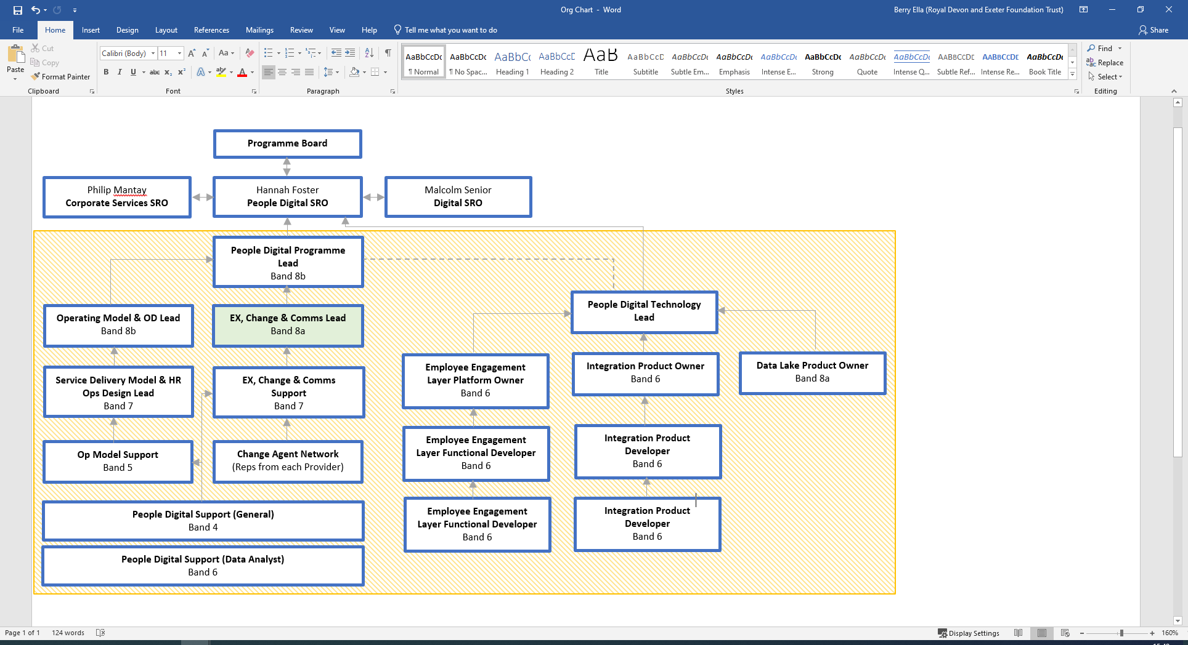
Person specification

Supporting Evidence

In the supporting evidence of your application form, you must demonstrate your experiences by giving specific examples for the criteria within the person specification.

Factors | Description
Knowledge, Training and Experience | - Educated to Degree level (or equivalent experience in relevant field)  - Overall training and experience in communications to Masters level or equivalent.  - Demonstrated history of partnering with business leaders on change and transformation initiatives  - Demonstrated history of strong stakeholder and programme management  - Experience of designing HR Policy, Process & Experience frameworks and documentation  - Experience of designing change management and communication strategies  - Demonstrable experience of enabling effective change through complex HR change programmes  - Experience of managing and working within complex transformation programmes with key digital elements  - Experience of successful stakeholder engagement programmes that are inclusive, accessible, multi organisational and multichannel
Leadership & Team Management Skills | - Facilitate knowledge transfer and capability building of team members within the line of accountability of this role  - Manage the performance of team members, including setting goals, providing feedback, and addressing performance issues.  - Staff management experience  - Budget or financial management experience
Communication Skills | - Exceptional Stakeholder Communication skills (internal and external; at local, regional and national levels), understand their needs and concerns, and develop strategies to address them.  - Facilitate cross-functional collaboration between stakeholders including staffside  - Facilitate knowledge transfer and capability building of team members within the line of accountability of this role  - Project management skills which can be evidenced  - Understanding or experience of political environment and policy context  - Strong analytical skills, and ability to problem-solve  - Ability to develop constructive and collaborative working relationships across organisational boundaries, encompassing working with contacts and colleagues at all levels.
Analytical Skills | - Implement and track performance metrics to measure the success of the digital transformation and identify areas for improvement.  - Support identifying risks associated with the programme and develop strategies to mitigate those risks.  - Interpret and report impact of the programme changes on the organisation and support development of strategies to manage impact.
Planning Skills | - Plan Co-ordinate programmes of engagement and communications for the programme  - Support strategic relationships with stakeholders including system partners and external agencies, providing timely updates and guidance to the team, Provider Leads, Provider Comms teams and other stakeholders as required.
Policy/National Alignment | - Interpret NHS Governing Body policies and guidance and ensure implications are considered throughout all programme activities  - Represent NHS Devon when sharing best practice and guidance with other NHS trusts/systems beginning their scaling people services transformation journey

About Royal Devon University Healthcare NHS Foundation Trust:
Stretching across Northern, Eastern and Mid Devon, we have a workforce of over 15,000 staff, making us the largest employer in Devon. Our core services, which we provide to more than 615,000 people, cover more than 2,000 square miles across Devon, while some of our specialist services cover the whole of the peninsula, extending our reach as far as Cornwall and the Isles of Scilly.
We deliver a wide range of emergency, specialist and general medical services through North Devon District Hospital and the Royal Devon and Exeter Hospital (Wonford). Alongside our two acute hospitals, we provide integrated health and social care services across a variety of settings, including community inpatient hospitals, outpatient clinics, and within people’s own homes. We also offer primary care services, a range of specialist community services, and Sexual Assault Referral Centres (SARC).
Our state-of-the-art equipment, leading technologies and strong links to local universities put us at the forefront of research and innovations, enabling us to provide world-class care to our local communities.
Our values are at the heart of everything we do, click here to find out more
As an inclusive employer, the Royal Devon values diversity and is committed to creating a culture of inclusivity where everyone can be themselves and reach their full potential. We believe in fostering a sense of belonging and actively encourage applications from individuals of all backgrounds, cultures, and abilities. We recognise the advantages of having a diverse workforce that reflects the communities we serve.

This job description may be further refined throughout the recruitment process. A final version will be provided ahead of interview.

