JOB DESCRIPTION
Band 4 Assistant Practitioner Bladder & Bowel Care

 | JOB DETAILS
 | Job Title: | Assistant Practitioner (Bladder and Bowel Care)
 | Band: | Band 4
 | Responsible To: | Band 7 Specialist Nurse
 | Accountable To: | Senior Specialist Nurse
 | Section/Department/Directorate: | Community Care Group – Planned

Job Purpose:
- The post holder will work as part of the Bladder and Bowel Care team delivering specialist health care that focuses on the direct bladder & bowel needs of service users. This will be primarily within the care home environment or the patient’s own home but may, where appropriate, include the clinic setting in line with their Knowledge and Skills Framework (KSF).

- The post holder will be the designated contact person for the care homes within their designated responsibility and provide support, education and advice to staff as well as direct patient assessment and treatment planning.

- The post holder will support the service manager in providing cost effective provision of incontinence products.

- The post holder will work autonomously within the clearly defined boundaries of their Assistant Practitioner Competencies and carry out specific delegated clinic tasks and responsibilities that may cross professional demarcations of care.

Key Working Relationships:

- Patients and carers
- Care Home Managers
- Care Home Staff
- Community Nursing Teams
- Community Matrons
- Cluster Managers
- General Practitioners and other members of the Primary Care Team
- Palliative Care Team
- Social Services
- Safeguarding teams
- CQC
- Intermediate Care Team and Rapid Response
- Statutory and voluntary agencies
- Secondary care services including discharge teams
- Specialist Nurses
- Out of Hours Services
- Adult Mental Health Team

Principle Duties and Responsibilities:

Clinical
- To deliver skilled clinical care to patients based on their needs and wishes
- To undertake specialist assessment of patients allocated to their care by registered members of the bladder & bowel care team.
- To interpret assessment information and plan patient care using judgement skills to decide upon and recommend best course of action.
- To develop, and implement appropriate plans of care with other members of the multi-professional team, patients, and carers
- To refer patients to other practitioners when their needs are beyond their own role or scope of practice
- To accept clinical responsibility for designated case load, taking an active role in progressing the programme of care
- To work without direct supervision of a registered practitioner in the implementation of programmes of care and evaluate effectiveness of interventions
- To support the assessment and continual evaluation of patients’ care needs through data collection, monitoring of patients’ progress and acting on findings.
- To be aware of, and respect, responsibilities and accountabilities involved in the confidential nature of the work
- To ensure that patients and carers are treated with dignity and respect at all times

Communication and Leadership
- To maintain excellent communication with patients and carers at all times
- To maintain excellent communication with other members of the multi-professional team and all other agencies with whom you have contact with
- To maintain comprehensive and accurate documentation records in line with legal and trust requirements and report as needed
- Recognise and be able to respond to challenging behaviour
- To report immediately and concerns regarding safeguarding or shortfalls in patient care
- Offer appropriate health promotion to patients
- To work collaboratively across agencies and organisational boundaries to ensure delivery of an equitable and integrated service
- To provide support and supervision to clinical support workers up to NVQ level3 and students
- To report immediately ay incidents, complaints, or other untoward occurrences

Education and Development
- To complete and maintain mandatory training needs as specified by the Trust.
- To attend organised training sessions and complete all relevant competencies within recognised time frames.
- To maintain a personal development plan to guide continuing personal and professional development to ensure clinical practice is evidence based and up to date
- To keep up to date with all policies and protocols related to relevant clinical practice
- To be involved in appraisal systems, clinical supervision and be active in identifying aims and objectives for personal development in line with departmental policy
- To help develop and deliver education to care home staff.
- To be involved in the training and development of new members of staff, students etc.
- To keep up to date with correct use of equipment/training in use of new equipment

General Responsibilities
- To observe the provisions of and adhere to all Trust policies and procedures
- To be familiar with and follow health and safety policy and procedures and to be aware of individual responsibilities under legislation
- To ensure a safe environment for patients, visitors, and staff, and report any hazards to senior person in charge. Take remedial action where appropriate
- To attend team meetings as requested by the Team Leader
- To undertake any other duties, which are appropriate to the grade, when requested by Senior Staff

The above indicates the main duties of the post, which may be reviewed in the light of experience and developments within the service. Any review will be undertaken in conjunction with the post holder.

Dimensions:

- Lone Working.
- Remote working without direct supervision
- Supervising, teaching and involvement with the development of peers and other relevant team members, carers and clients.
- See KSF profile.

ORGANISATIONAL CHART

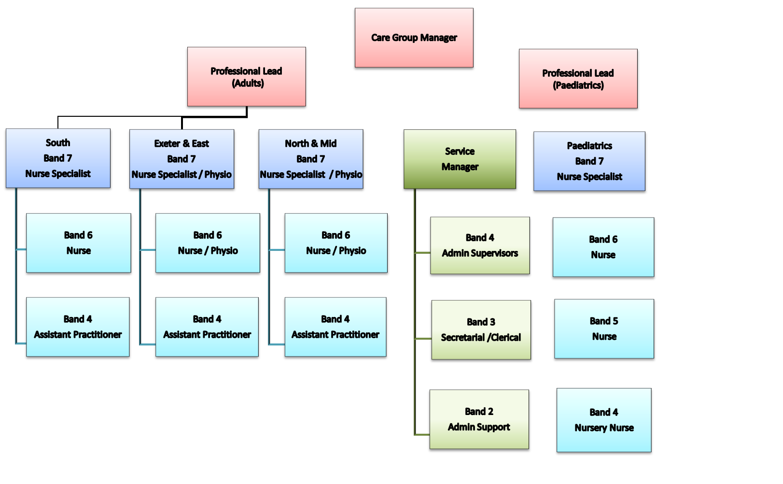

Key Result Areas:
Communication and Relationship Skills
- Communicating and building therapeutic relationships with clients, families and professional partners to ensure patient care is focal and managed effectively.
- Act at all times in a manner which illustrates respect for privacy dignity and confidentiality.
- This role requires excellent communication skills and verbal, written and use of IT. As per KSF outline.

Analytical and Judgement Skills
- Judgements on facts that require analysis.

Planning and Organisational Skills
- To support the planning, implementation and evaluating programmes of care of individual clients.
- Works without direct supervision of the registered practitioner in the implementation of programmes of care appropriate to the community, and evaluate the effectiveness of interventions and feeds back appropriately. Prioritises own tasks under the appropriate delegation of the registered practitioner.

Physical Skills
- A range of clinical skills in line with the post KSF outline.

Responsibility for Patient and Client Care
- To always work within clearly defined accountability framework.
- To demonstrate clinical competence developed through continual professional development, reflective practice and maintain a skills portfolio relevant to the service specification.
- To undertake training to develop a range of knowledge and skills in order to deliver high quality clinical interventions.
- To recognise and appropriately address risk factors to clients and carers within their healthcare setting and feedback appropriately to the registered practitioner.
- To undertake designated nursing interventions, identify any changes in the patient’s condition and refer to the appropriate professional if this is outside the post holder’s scope of practice.
- To report any untoward incidents, complaints and clinical emergencies to the appropriate professional within the appropriate timescale.
- To prevent adverse effects on health and wellbeing.
- To support good health for all patients within the local community.

Responsibility for Policy and Service Development
- To work within Royal Devon Policies
- To maintain Royal Devon Standards of Clinical Governance
- To support professional Standards of Practice

Responsibility for Financial and Physical Resources
- Support the efficient use of resources ie using appropriate continence pads.
- Assist with maintaining stocks and supplies within homes.

Responsibility for Human Resources
- Supporting the training and supervision of all care home staff.

Responsibility for Information Resources
- Inputting, storing and providing information as per KSF outline.

Responsibility for Research and Development
- To take a supporting role in collecting audit information.
- Make recommendations for and support change within the service.

Freedom to Act
- Work is managed rather than directly supervised.

Physical Effort
- Daily work involves frequent driving, sitting/standing, and walking, moving equipment, manual handling in restricted positions.
- Working hours negotiated according to service need.

Mental Effort
- Understanding of a range of procedures which are evidence based
- Community procedures
- Clinical observations
- Basic life support
- Support assessing, planning, implementing and evaluating patient care
- Infection control
- Instigate emergency procedures ie finding a collapsed patient and commencing life support.
- Accurately completing and maintaining effective patient’s records including addressing
confidentiality issues.
- Work pattern is unpredictable and subject to interruption ie calls being prioritised, other work colleagues, family/patient/carers needs.

Emotional Effort
- Caring for the terminally ill, chronically sick and their families, carers and friends. This may include having to break bad news or give distressing news to patients/relatives/carers and dealing with emotional circumstances.
- Working with patients with mental health, learning disability problems and challenging behaviour.

Working Conditions
Frequent daily contact with:
- Body fluids eg faeces, vomit
- Smells
- Infections
- Dust
- Occasional exposure to unpleasant working environment
- Driving Hazards

GENERAL

- This is a description of the job as it is at present constituted. It is the practice of this organisation periodically to examine employees' job descriptions and to update them to ensure that they relate to the job as then being performed, or to incorporate whatever changes are being proposed. This procedure is jointly conducted by each manager in consultation with those working directly to him or her. You will, therefore, be expected to participate fully in such discussions. It is the organisations' aim to reach agreement to reasonable changes, but if agreement is not possible management reserves the right to insist on changes to your job description after consultation with you.

- We are committed to serving our community. We aim to co-ordinate our services with secondary and acute care.

- We aim to make all our services exemplary in both clinical and operational aspects. We will show leadership in identifying healthcare needs to which we can respond and in determining the most cost-effective way of doing so. We will share our knowledge with neighbouring healthcare agencies and professionals.

- We recruit competent staff whom we support in maintaining and extending their skills in accordance with the needs of the people we serve. We will pay staff fairly and recognise the whole staff’s commitment to meeting the needs of our patients.

- The Trust operates a 'non smoking' policy. Employees are not able to smoke anywhere within the premises of the Trust or when outside on official business.

- All employees must demonstrate a positive attitude to Devon PCTs equality policies and Equality Scheme. Employees must not discriminate on the grounds of sex, colour, race, ethnic or national beliefs, marital status, age,

- disability, sexual orientation, religion or belief and will treat patients, colleagues and members of the public with dignity and respect.

- If the post holder is required to travel to meet the needs of the job, we will make reasonable adjustments, if required, as defined by the Disability Discrimination Act.

STAFF HEALTH AND WELLBEING
You must take responsibility for your workplace health and wellbeing:
- Be physically active at work (i.e. take breaks away from your desk, taking the stairs where possible)
- When required, gain support from Occupational health, Human resources or other sources.
- Familiarise yourself with the health and wellbeing support available from policies and/or Occupational Health
- Follow the Trust’s health and wellbeing vision of health body, healthy mind, healthy you.

If you are a line manager, in addition to the above, it is expected you will:
- Champion health and wellbeing
- Encourage and support staff engagement in delivery of the service
- Encourage staff to comment on development and delivery of the service
- Ensure during 11!’s / supervision with employees you always check how they are.

HEALTH AND SAFETY AT WORK
The employer will take all reasonably practical steps to ensure your health, safety and welfare while at work. You must familiarise yourself with the employer's Health & Safety policy, and its safety and fire rules. It is your legal duty to take care for your own health and safety as well as that of your colleagues.

The post holder is expected to comply with Trust Infection Control Policies and conduct him/herself at all times in such a manner as to minimise the risk of healthcare associated infection.

INFECTION CONTROL – ROLE OF ALL STAFF
It is the responsibility of all members of staff to provide a high standard of care to patients they are involved with. This includes good infection prevention practice
All staff have a responsibility to comply with Infection Prevention and Control policies and procedures, this includes:
- Attending mandatory and role specific infection prevention education and training.
- Challenging poor infection prevention and control practices.
- Ensuring their own compliance with Trust Infection Prevention and Control policies and procedures for example, standard precautions, hand hygiene, prevention & management of inoculation incidents

CONFIDENTIALITY
You may not disclose any information of a confidential nature relating to the employer or in respect of which the employer has an obligation of confidence to any third party other than where you are obliged to disclose such information in the proper course of your employment or as required by law. Any failure to comply with this term of your employment will be treated as an act of misconduct under the employer's disciplinary procedure.

SAFEGUARDING
To be fully aware of and understand the duties and responsibilities arising from the Children’s Act 2004 in relation to child protection and safeguarding children and young people as this applies to the worker’s role within the organisation.
To also be fully aware of the principles and practice of safeguarding applies to adults, in line with The Care Act 2014, in relation to the worker’s role, which will include recognising the types and signs of abuse and neglect.
The worker’s line manager should be made aware and kept fully informed of any concerns which the worker may have in relation to safeguarding adults and/or child protection.
Everyone within Royal Devon University Healthcare has a responsibility for, and is committed to, safeguarding and promoting the welfare of adults, at risk of abuse / neglect, and children and young people ensuring that they are protected from harm.
Royal Devon University Healthcare ensures that the Trusts Safeguarding Children Policy, Child Protection and Safeguarding Adult policies and procedures are promoted within the Trust and adhered to by all members of staff.

JOB DESCRIPTION AGREEMENT

Job holder’s Signature: .....................................................................................

Date: .....................................................................................

Manager’s Signature: .....................................................................................

Date: .....................................................................................

HAZARDS :
Laboratory Specimens  Proteinacious Dusts |  | Clinical contact with patients | Y | Performing Exposure  Prone Invasive Procedures
Blood/Body Fluids | Y | Dusty Environment |  | VDU Use | Y
Radiation |  | Challenging Behaviour | Y | Manual Handling | Y
Solvents |  | Driving | Y | Noise
Respiratory Sensitisers |  | Food Handling |  | Working in Isolation | Y

PERSON SPECIFICATION

Criteria | Essential | Desirable
Education/Qualifications/Training
Details of education, qualifications, professional registration, CPD required. | NVQ level 3 in care  Foundation Degree in Health and Social Care or be working towards.  Numeracy and Literacy skills | GCSE English and Maths
Knowledge and Experience
Specific knowledge and length of work/post registration experience required: | Minimum of 2 years experience as level 3 practitioner within multi professional team framework  Experience of developing clinical competencies at level 3 | Supervision of junior staff
Skills and Abilities
 | IT skills  Knowledge of multi professional roles  Excellent verbal and written skills  Excellent interpersonal skills  Good organisational and problem solving skills  Ability to prioritise own workload and to work to deadlines | Ability to identify own strengths and limitations
Personal Qualities and Attributes
 | Able to demonstrate drive, commitment, and enthusiasm  Able to demonstrate commitment to team working  Ability to work without supervision  Ability and willingness to undertake further training to develop clinical competencies relevant to role/service  Reliability and flexibility | Ability to motivate and enthuse others
Other Requirements
To be willing to work throughout the PCT
Flexible working re work environment and shifts

