Job Description
Job title: | People Digital Programme Lead
Remuneration: | AfC Band 8b – to be confirmed
Contract type: | FTC/ Secondment – 12 months
Employing organisation: | RDUH
Hours: | 37.5
Location: | Devon
Accountable to: | Hannah Foster (People Digital SRO),

About NHS Devon
NHS Devon is the organisation responsible for the majority of the county’s NHS budget, and developing a plan to improve people’s health, deliver high-quality care and better value for money.
The organisation is led by a diverse board, which includes representatives from local councils, primary care (GPs), and NHS trusts.
Devon is the fourth largest county in England with a diverse and growing population. It includes the cities of Plymouth and Exeter, more than 45 towns – both rural and urban – and several hundred parishes.
Our aim is to improve people’s lives in Devon – wherever they live – to reduce health inequalities and make sure we can deliver these services for the long term.
NHS Devon is one of 42 integrated care boards across England that took on the statutory functions of clinical commissioning groups (CCGs) on 1 April 2022.

Our vision
Our vision is simple: equal chances for everyone in Devon to lead long, happy and healthy lives. But there is much to be done to achieve it.
We are committed to improving and our performance for waiting times for non-urgent operations, accident and emergency departments, and for test results designed to help GPs diagnose illnesses.
And we are dedicated to working together with our health and care partners because we know people’s physical and mental health and wellbeing is influenced by more than just the care they get from their local GP or hospital.

Our values
Developed by our people, our values and behaviours shape who we are, how we work and help us to make the right decisions of behalf of people in Devon.
One Devon
- We collaborate with staff, partners, patients, families, carers, communities and professionals to develop the right services for our population
- We think and act for our population, while recognising local needs
- We share information, skills and resources
- We value and protect our climate, and work in a sustainable way that reduces our carbon footprint

Quality in everything we do
- We develop safe, effective and accessible services that put patients at the centre
- We make decisions that are evidence-based, cost-effective and innovative
- We recognise achievements and celebrate success
- We take pride in our work, learn when things go wrong, and support people to speak up

Respect for all
- We treat people with respect and compassion
- We listen to people to understand their priorities, needs, and abilities, and involve them in decisions that affect their lives
- We are proactive with our health and wellbeing and our colleagues
- We champion equality, diversity and inclusion, and challenge inequalities
- We are open, honest and transparent

Everyone is a leader
- We lead by example and with integrity
- We are kind, caring and empathetic
- We support people to learn and develop
- We demonstrate leadership and expect to be held accountable for our actions and performance
- We are responsive, consistent and professional

Equality, diversity and inclusion
Inclusion is at the heart of everything we do.
We want our workforce, patients and service users to be confident that they will be valued, listened to, supported and cared for, regardless of their age, ethnicity, gender, ability and sexuality.
We also want to overcome barriers people experience in accessing health and social care, and in working for our organisations.
Some of this work is already underway including listening to LGBTQ+ and ethnically diverse communities and people with disabilities to understand what support they need to stay well.

Working as One Devon
Devon’s health and care system is built on a strong foundation of collaboration, trust and innovation.
One Devon is a partnership of the NHS and local councils, as well as a wide range of other organisations, including the voluntary sector, who are working together to improve the lives of people in Devon.
One of the lessons learned from the COVID-19 pandemic is that people need support that is joined up across organisations and sectors – One Devon aims to do just that.
We want to make our system as strong and effective as possible, through partnership working and with the ambition to tackle health inequalities, help communities thrive and achieve the very best for everyone.

About the People Digital Programme
In response to NHS England's Workforce Plan, Future of HR and OD report and 2030 People Profession Vision, a national ‘Scaling People Services’ Vanguard programme was launched by NHS England in early 2023. It’s aim is to transform people services delivery through scaling and digitising services at an Integrated Care System (ICS) level, paving the way for a digitally advanced NHS organisation.
The aim of the ‘Scaling People Services’ programme is to drive significant efficiencies, return time to patient care and improve employee experience across each ICS. It will achieve this though simplifying, standardising, automating and consolidating the delivery of people services across organisations.
Devon was selected as the NHSE Southwest Regional Vanguard for Scaling People Services by its peers, and has set up the ‘People Digital’ Programme to drive this work. Devon will be a pioneer in delivering Scaling and Digital initiatives concurrently – we have a unique opportunity to lead the NHS in People and Digital transformation.
The People Digital programme aims to:
- Move Devon towards a unified model at a system level, leveraging common processes, policies, governance and operating models to deliver a consistent employee experience across the system, improve our People Professionals’ careers and drive people efficiencies.
- Give colleagues a consumer-grade experience and simplified route to get support from People Services, releasing time to care from frontline workers. This will be achieved by integrating our people digital landscape, automation and an intuitive people portal, known as an Employee Engagement Layer. A Data Lake and API/Integration Solution will enable a single source of truth for people data, supporting reporting and wider BI across the system

Job Summary
The People Digital Programme Lead role will be responsible for the end to end People Digital Programme – from initial planning to delivery of the full programmes first year. They will work collaboratively with key individuals in the Devon system, to oversee the operational delivery of the programme and delivery of the first year of the business case working across all workstreams, maintaining strategic focus. Their key responsibilities will include:
- Delivery of the first year of the programme on time and within budget
- Bringing experience of HR transformational programmes to support the success of the programme, working closely with Provider leads and suppliers to ensure development of the effective change management of the programme
- Leading the project management activities for the People Digital programme, including managing the programme team, escalating risks to programme delivery and finance
- Overseeing and aligning workstreams and functional areas within the People Digital programme, such as Employee Experience, Change & Comms, Operating Model, Process Design, Digital Transformation
- Working closely with the People Digital Solution implementation partner and technology provider
- Supporting senior stakeholders in Provider Organisations and the Devon System
- Working with the wider People function to ensure buy in of the solution within People teams and the wider customer base.
- Measuring and monitoring success of the programme (e.g. financial assessments of return on investment, drawing insights from KPIs)
- Adopting a continuous improvement mindset and agile programme management in order to ensure positive outcomes for the programme
- Support effective and robust Programme governance and management. Represent the People Digital programme both internally and externally, inputting into Programme meetings and other strategic forums when requirement

Key Working Relationships
No. of Staff reporting to this role: 3 direct reports and total team size of 16. See below for programme team org chart – People Digital Programme Lead role and accountable team are highlighted in yellow.
The People Digital Programme Lead role is required to deal effectively with staff of all levels and predominantly with senior stakeholders in HR, operations, finance and IM&T across the system as well as in wider national and regional teams and external supplier organisations.
Of particular importance are working relationships with:
• Internal - Executive Directors, Senior Leadership Team, IM&T, Finance, HR
• External – NHS England, system implementation partners
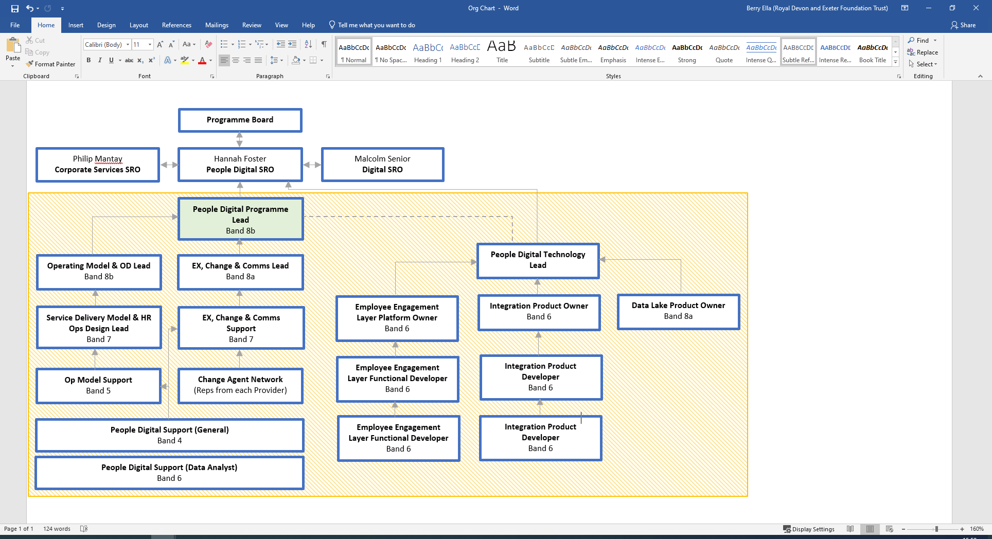
Person specification

Supporting Evidence

In the supporting evidence of your application form, you must demonstrate your experiences by giving specific examples for the criteria within the person specification.

Factors | Description
Knowledge, Training and Experience | - Educated to degree level or equivalent experience plus demonstrated additional experience of leading HR and digital transformation programmes to Master’s level. This includes strong programme management skills, including ability to manage risk, budgeting and quality assurance aspects  - Demonstrated experience managing senior stakeholder relationships, particularly working with senior leaders across local, regional and national levels  - Significant understanding of foundational concepts within HR / Digital transformation programmes  - Bring transformational and visionary ideas to the programme as well as best practice experience.  - Demonstrable experience of enabling effective change through complex HR change programmes  - Significant evidence of successful Programme delivery, ideally with public sector experience
Leadership & Team Management Skills | - Inspire and motivate project team members, through setting strategic direction, resolving conflicts and fostering a collaborative environment  - Oversee assignment of tasks/activities to project team members, ensuring a fair distribution of work that is aligned to individual strengths and expertise  - Facilitate knowledge transfer and capability building of team members within the line of accountability of this role  - Manage the performance of team members, including setting goals, providing feedback, and addressing performance issues.
Communication Skills | - Exceptional Stakeholder Communication skills (internal and external; at local, regional and national levels), understand their needs and concerns, and develop strategies to address them.  - Facilitate cross-functional collaboration between HR, IT, Finance and Operations stakeholders to align on design and process decisions.  - Present on benefits, costs, timelines and other key programme information to a range of stakeholders to generate and maintain buy-in to the programme  - Provide programme updates at various senior leadership forums such as programme boards, executive boards, and system working groups.  - Represent Devon ICS when working with other NHS and external agencies  - Facilitate knowledge transfer and capability building of team members within the line of accountability of this role
Analytical Skills | - Ability to interpret data and generate insights to inform strategy and decision-making. This includes analysing financial data to track costs and expected savings.  - Define and track performance metrics to measure the success of the digital transformation and identify areas for improvement.  - Identify and assess risks associated with the programme and develop strategies to mitigate those risks.  - Continually assess the impact of the programme changes on the organisation and develop strategies to manage impact.
Planning Skills | - Co-ordinate complex project management activities across the trusts and technology implementations (ideally including EEL, API/Integration Solution, Data Lake), including tracking dependencies, understanding change impact, resolving conflicts, overseeing workstreams, monitoring risks and measuring success.  - Support strategic relationships with stakeholders including system partners and external agencies, providing timely updates and guidance to the CPOs, Provider Leads Executive Board Members, NHSE/Regional reps and other stakeholders as required.  - Manage risk to overall programme delivery timelines and have the ability to recover and prioritise outputs to mitigate  - Support long term strategic system and trust-level planning, ensuring alignment with the wider People Digital strategy and individual People, Digital and Financial plans
Policy/National Alignment | - Interpret NHS Governing Body policies and guidance and ensure implications are considered throughout all programme activities  - Represent NHS Devon when sharing best practice and guidance with other NHS trusts/systems beginning their scaling people services transformation journey

About Royal Devon University Healthcare NHS Foundation Trust:
Stretching across Northern, Eastern and Mid Devon, we have a workforce of over 15,000 staff, making us the largest employer in Devon. Our core services, which we provide to more than 615,000 people, cover more than 2,000 square miles across Devon, while some of our specialist services cover the whole of the peninsula, extending our reach as far as Cornwall and the Isles of Scilly.
We deliver a wide range of emergency, specialist and general medical services through North Devon District Hospital and the Royal Devon and Exeter Hospital (Wonford). Alongside our two acute hospitals, we provide integrated health and social care services across a variety of settings, including community inpatient hospitals, outpatient clinics, and within people’s own homes. We also offer primary care services, a range of specialist community services, and Sexual Assault Referral Centres (SARC).
Our state-of-the-art equipment, leading technologies and strong links to local universities put us at the forefront of research and innovations, enabling us to provide world-class care to our local communities.
Our values are at the heart of everything we do, click here to find out more
As an inclusive employer, the Royal Devon values diversity and is committed to creating a culture of inclusivity where everyone can be themselves and reach their full potential. We believe in fostering a sense of belonging and actively encourage applications from individuals of all backgrounds, cultures, and abilities. We recognise the advantages of having a diverse workforce that reflects the communities we serve.

This job description may be further refined throughout the recruitment process. A final version will be provided ahead of interview.

