“Our vision is to provide safe, high quality seamless service delivered with courtesy and respect. To achieve our vision we expect all our staff to uphold our Trust Values”

J
O
B

D
E
S
C
R
I
P
T
I
O
N

JOB DETAILS
Job Title | Waste Compliance and Departmental Manager
Reports to | Deputy Service Manager (Sub B)
Band | 6
Department/Directorate | Waste Management / Estates and Facilities Management (EFM)

JOB PURPOSE
The post holder will be responsible for managing and developing operational waste management, reduction, recycling, on site waste collection and disposal activities within the Trust providing value for money and excellence in service provision.

The post holder will define and set service levels and participate in the preparation and updating of the Trust’s strategies and policies and staff training for its waste management and environmental services.

The post holder will assist the Trust in ensuring effective exchange and dissemination of information relating to waste management within the Trust and participate as required in audits, special projects and cost reduction and income generation initiatives in relation to waste activities.

The post holder will be responsible for all waste management at all sites within the Royal Devon Healthcare University portfolio and have the ability to commute to all of these areas as and when required.

KEY WORKING RELATIONSHIPS
- Facilities Service Managers
- Facilities Deputy Service Managers
- Estates and Facilities Manager
- Divisional Management Accountant
- Governance Manager
- Deputy Head of Facilities
- Deputy Director of Estates and Facilities Management
- Sustainability Manager
- Trustwide Heads of Departments / Department Managers
- Clinical Staff across the Trust
- Estates Staff
- External Waste Contractors
- NHS Waste Managers nationwide
- Internal and External Audit teams
- Internal and External Stakeholders
- Health and Safety / Risk Management
- Environment Agency / Health & Safety Executive
- External Agencies
- All Trust Staff

ORGANISATIONAL CHART
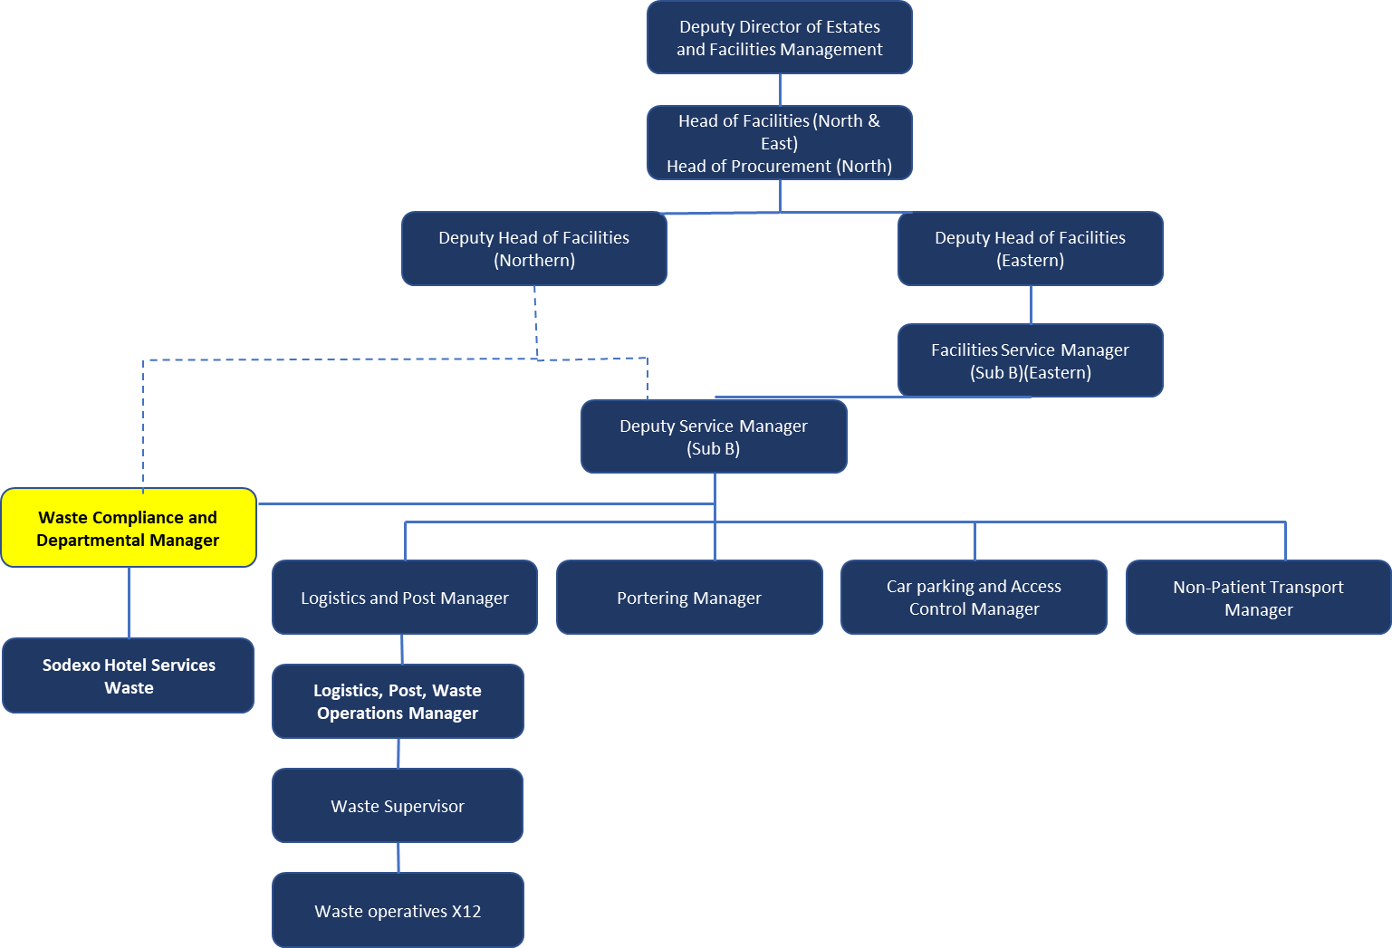

KEY RESULT AREAS/PRINCIPAL DUTIES AND RESPONSIBILITIES
COMMUNICATION/RELATIONSHIP SKILLS
- The post-holder will be required to communicate effectively with senior managers, officers, consultants and other care professionals within the Trust, providing complex information in a user friendly format.
- The post-holder will be required to communicate effectively with the relevant enforcement agencies such as the Environment Agency and the Health and Safety Executive, and other external organisations as necessary and appropriate, requesting complex specialist information relating to the Trust’s waste management.
- In addition, the post-holder will be required to communicate effectively with service providers and service users, and it is imperative that this is undertaken in a polite, courteous manner at all times.
ANALYTICAL/JUDGEMENTAL SKILLS
- Provide analytical and practical evaluation of waste disposal/treatment processes that offer alternatives to incineration, along with the supporting structures necessary for operating them within the legislation.
PLANNING/ORGANISATIONAL SKILLS
- Identify, plan and report on the effectiveness of waste collections for all waste streams being generated from Trust sites.
- Co-ordinate waste contractors to ensure the efficient and effective management of waste from Trust sites.
- To raise awareness of all waste disposal procedures and achieve optimal waste prevention, minimisation and economy by reviewing all waste streams against the Trust’s waste management policy.
- Develop and promote waste prevention/reduction initiatives and provide appropriate training to comply with any Trust-wide policies and local targets for improvement.
- Develop effective recycling systems within Trust in collaboration with other organisations on both a local and national basis.
- To raise awareness of and promote initiatives to increase recycling of wastes within the Trust.
- To investigate and take appropriate follow-up action with regard to Incident Reports relating to waste management issues.
- To maintain an effective control on waste management issues and liaise with departmental heads as necessary.
- Identify partnership, sponsorship, and grant opportunities, or other external funding sources where appropriate and applicable.
PHYSICAL SKILLS
- Standard driving and keyboard skills.
PATIENT/CLIENT CARE
- Incidental contact with patients.
POLICY/SERVICE DEVELOPMENT
- Participate in the work of the Waste Management Group (WMG) and provide information on any waste issues as required by the group.
- Ensure that the Trust Waste Management Policy is implemented across Trust sites.
- Review and propose changes to practices and procedures for the Waste Management Department.
- Prepare annual audits of waste disposal service providers to ensure compliance with the “duty of care” requirements under Section 34 of the Environmental Protection Act 1990.
- Ensure that appropriate commercial contracts are in place for the collection of waste and undertake performance monitoring of all waste related contracts and suppliers including day to day liaison, monitoring of compliance and participation in formal contract review meetings with suppliers and the Procurement Department.
- In consultation with other Trust managers and outside organisations, identify the hazards presented by each waste stream and advise on the control mechanisms required to eliminate or reduce to acceptable levels the risks to health and the environment.
- Participate in periodic reviews of the Trust’s waste management (disposal) policy. To ensure that the Trust’s Waste Policies and Procedures are complaint with all prevailing statutory regulations.
- As part of the Control of Substances Hazardous to Health (COSHH) risk assessments, the requirements of the Environmental Protection (Duty of Care) Regulations 1991 and the Carriage of Dangerous Goods by Road Act 1996, annually review the methods of containment for each waste stream, and the waste descriptions and instructions given to staff and contractors.
- Ensure that the clinical waste collection/disposal service is compliant with the
- Liaise with the Trust’s Dangerous Goods Safety Advisor (DGSA) to ensure that the Trust is compliant with the Carriage of Dangerous Goods by Road Act 1996, and that goods carried conform to the Environmental Protection Act 1990 and The Carriage of Dangerous Goods (Classification, Packaging and Labelling) and Use of Transportable Pressure Receptacles Regulations 1996.
- Ensure the administration of the statutory waste transfer documentation required under the Environmental Protection (Duty of Care) Regulations 1991 and the Control of Pollution (Special Waste) Regulations 1996 is adhered to.
- Be environmentally aware of any legislative changes to waste management to enable effective liaison with other departments.
- Produce annual reports on any aspect relating to waste management with the Trust, as required.
- Ensure that statutory requirements to maintain waste records for a minimum of two years are met.
- Ensure that a technically competent person is available at all times to ensure that the Environment Agency Waste Management Licence is adhered to.
- Manage waste in accordance with the CQC requirements, including overseeing ongoing audits and reviews necessary to meet the requirements of these initiatives.
FINANCIAL/PHYSICAL RESOURCES
- To work in collaboration with Finance, Procurement and other Trust departments to reduce waste in packaging and waste equipment disposal.
- Responsible for a delegated budget for Waste Management.
- Responsible for ordering stock and equipment for the Waste Department.
- Assist with the collation of information for tender documents, specifications and service levels in liaison with the Procurement Department and provide expert advice on standards and other performance measures in relation to waste and packaging.
HUMAN RESOURCES
- Line Management responsibility for the Waste Team.
- To be responsible for and participate in recruitment, PDR’s, absence monitoring, capability, disciplinary and other staff related matters.
- Develop and deliver staff training programmes designed to ensure that Trust employees are competent with respect to the handling and segregation of waste, environmental matters and the carriage of dangerous goods.
- The post holder is required to maintain a programme of continual professional development (CPD) to ensure current best practice is achieved.
INFORMATION RESOURCES
- Provide professional input into completion of the Estates Returns Information Collection (ERIC) and NHS Premises Assurance Model (PAM).
- To develop and maintain the Trust’s Environmental Management System.
RESEARCH AND DEVELOPMENT
- To participate in audit and survey’s as and when required, i.e. staff surveys.
FREEDOM TO ACT
- To manage the day to day operation of the Waste Management Department within the scope of Trust Policy and Standard Operating Procedures. Deputy Service Manager available to refer to when required.
- To be guided by legislation and HTM 01-07: Safe management of healthcare waste. To be a lead specialist for the Trust in Healthcare Waste Management.
PHYSICAL / MENTAL / EMOTIONAL EFFORT / WORKING CONDITIONS
- Frequent requirement for concentration. Predictable work pattern / shift.
- A willingness to provide reasonable cover for colleagues.
- Occasional exposure to emotional circumstances when dealing with staff issues and complaints.
- Occasional exposure to unpleasant substances including blood, bodily fluid, offensive waste.
APPLICABLE TO MANAGERS ONLY
Evidence that supporting employee health and wellbeing is included in any documents outlining the skills and knowledge that line managers need.

Proportion of line managers whose job descriptions include supporting employee health and wellbeing.

THE TRUST- VISION AND VALUES
Our vision is to provide safe, high quality seamless services delivered with courtesy and respect. To achieve our vision we expect all our staff to uphold our Trust values. Our Trust values are:

Honesty, Openness & Integrity
Fairness,
Inclusion & Collaboration
Respect & Dignity

We recruit competent staff that we support in maintaining and extending their skills in accordance with the needs of the people we serve. We will pay staff fairly and recognise the whole staff’s commitment to meeting the needs of our patients.

We are committed to equal opportunity for all and encourage flexible working arrangements including job sharing.

We are committed to recruiting and supporting a diverse workforce and welcome applications from all sections of the community, regardless of age, disability, gender, race, religion, sexual orientation, maternity/pregnancy, marriage/civil partnership or transgender status. We expect all staff to behave in a way which recognises and respects this diversity, in line with the appropriate standards.

GENERAL
This is a description of the job as it is now. We periodically examine employees' job descriptions and update them to ensure that they reflect the job as it is then being performed, or to incorporate any changes being proposed. This procedure is conducted by the Manager in consultation with the jobholder. You will, therefore, be expected to participate fully in such discussions. We aim to reach agreement on reasonable changes, but if agreement is not possible, we reserve the right to insist on changes to your job description after consultation with you.

The RD&E is a totally smoke-free Trust. Smoking is not permitted anywhere on Trust property, including all buildings, grounds and car parks. For help to quit call: 01392 207462.

POST  P  E  R  S  O  N  S  P  E  C  I  F  I  C  A  T  I  O  N | Waste Manager
BAND | 6

Requirements | Essential | Desirable
QUALIFICATION/ SPECIAL TRAINING  Degree level qualification in Waste or Environmental management related subject / WAMITAB Level 4 / ICERMS Healthcare Waste Management Qualification  5 x GCSE Grade A-C including Maths and English Language | E  E
KNOWLEDGE/SKILLS  In-depth knowledge of waste management.  Knowledge of NHS Waste Guidance (HTM 07-01), UK Waste legislation (both hazardous and non-hazardous) and NHS policies and procedures (i.e. infection control and Health and Safety).  Excellent communication skills.  Excellent IT skills, including Word, Excel and PowerPoint.  Innovative approach to problem solving.  Ability to use own initiative and make decisions affecting the operational service of the Department. | E  E  E  E  E  E
EXPERIENCE  Significant experience of waste management in a large organisation.  Experience of delivering training on Waste to a wide ranging audience.  Experience of Waste Management in an NHS organisation.  Experience of budget/financial management.  Experience of managing staff, including recruitment, capability, disciplinary and absence management.  Experience of completing Risk Assessments.  Experience of investigating and completing incident reports. | E  E  E  E | D  D  D
PERSONAL ATTRIBUTES  Ability to handle difficult and emotional situations.  Excellent communication skills.  Excellent organisational skills.  Ability to work as a team player.  Self-motivated and able to manage own time and meet deadlines  A flexible approach to work.  Sound personal judgement and experience in working with diverse interest groups.  Strong sense of commitment to openness, honesty and integrity in undertaking the role. | E  E  E  E  E  E  E  E
OTHER REQUIRMENTS  Full UK driving licence.  Ability to travel to other locations as required. | E  E

FREQUENCY

(Rare/ Occasional/ Moderate/ Frequent)
WORKING CONDITIONS/HAZARDS |  | R | O | M | F
Hazards/ Risks requiring Immunisation Screening
Laboratory specimens | N
Contact with patients | N
Exposure Prone Procedures | N
Blood/body fluids | Y | X
Laboratory specimens | N
Hazard/Risks requiring Respiratory Health Surveillance
Solvents (e.g. toluene, xylene, white spirit, acetone, formaldehyde and ethyl acetate) | N
Respiratory sensitisers (e.g isocyanates) | N
Chlorine based cleaning solutions  (e.g. Chlorclean, Actichlor, Tristel) | N
Animals | N
Cytotoxic drugs | N
Risks requiring Other Health Surveillance
Radiation (>6mSv) | N
Laser (Class 3R, 3B, 4) | N
Dusty environment (>4mg/m3) | Y | X
Noise (over 80dBA) | N
Hand held vibration tools (=>2.5 m/s2) | N
Other General Hazards/ Risks
VDU use ( > 1 hour daily) | Y |  |  |  | X
Heavy manual handling (>10kg) | N
Driving | Y |  | X
Food handling | N
Night working | N
Electrical work | N
Physical Effort | Y | X
Mental Effort | Y |  |  | X
Emotional Effort | Y |  | X
Working in isolation | N
Challenging behaviour | Y |  | X

