**JOB DESCRIPTION**

**1. JOB DETAILS**

**Job Title: Employee Relations Manager**

**Band: Band 7**

**Reports to: Head of Specialist HR Services**

**Department / Directorate: Human Resources**

# JOB PURPOSE

The Employee Relations Manager will be an integral member of the Specialist HR Services team, providing timely and effective advice and support in the interpretation and application of employment legislation, local and national NHS HR policy and procedures to support the delivery of Trust and Transformation & OD objectives.

They will work with senior stakeholders across the Trust to drive the application of best practice to embed good employee relations practice and HR policies, processes that create and add value to the delivery of patient care and overall performance of the Trust.

The Employee Relations Manager will lead on designated Trust-wide HR activities and change projects as agreed with the Head of Specialist HR Services.

# DIMENSIONS/ KEY WORKING RELATIONS

Areas of Responsibility: Complex Cases; Policy Development; Staff side negotiations; Terms &

Conditions; Compensation & Benefits; Equality & Diversity & Employment Legislation

No. of Staff: 1. The post holder will be expected to manage an Employee Relations Officer

The post holder will need to forge effective working relationships with stakeholders at all levels. Of particular importance are working relationships with:

|  |  |
| --- | --- |
| **Internal to the Trust** | **External to the Trust** |
| Human Resource staff        Occupational Health Department  Divisional Directors, Divisional Business  Partners & Directorate Managers  Support Function Senior Leaders              Executive Directors  Clinical Directors and medical staff  Trade Union Representatives  Clinical Staff  Non-clinical Staff | Health & Social Care Partners across the South West and other    External Agencies (e.g. ERSG; NHS Employers). |

1. **ORGANISATIONAL CHART:**

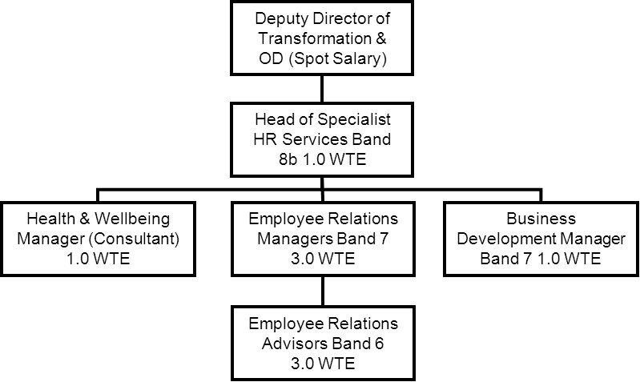

1. **KEY RESULT AREAS/PRINCIPAL DUTIES AND RESPONSIBILITIES:**

# HR Strategy / Policies

* Interpret changes to employment law and national NHS guidance to develop corporate HR strategies & policies and devise, plan and manage implementation programmes to ensure managers are aware of the changes.
* Foster and promote a positive climate of employment relations within the Trust, supporting a partnership approach in developing and maintaining good working relationships with representatives of Trade Unions and staff organisations.
* Work closely with management and staff side representatives to develop effective policies and management guidance for the Trust.
* Act as an advocate of HR, promoting HR interventions, and building the reputation and professionalism of the department.
* To review, manage and maintain appropriate administration systems such as ‘case management system’, utilising this information for Board and HR business reviews.

# Employee Relations

* Manage a complex and sensitive caseload of disciplinary, grievance, capability and attendance issues that arise from departments/managers, advising and assisting with individuals. This will involve advising managers in relation to these cases and highlighting key issues and risks from the information provided and developing action plans for the resolution of cases. This can include conflict resolution through persuasion, negotiation and mediation in accordance with formal procedures
* To support, advise and coach managers to ensure a consistent approach in line with good working practice, current employment law and in all aspects of employment relations. Report on ER activity within management teams, monitor activity and quality taking remedial action where required.



* Maintain a log of ER cases and provide regular reports to the Head of Specialist HR Services on the volume, scope and progress of all open cases.
* Ensure accurate and detailed documentation of projects and cases.
* To work closely with unions and professional bodies to identify employment issues and take appropriate action.
* Ensure that any changes or developments are managed sensitively and appropriately, identifying risks to the organisation and managing them effectively.
* Ensure that all cases you are handling are progressed in a timely and appropriate manner and are not permitted to ‘drift’ without action being taken.
* Promptly identify risks to the organisation in relation to HR activity and take appropriate action to reduce and flag the risk.
* Support cases that could, or do, result in Employment Tribunal proceedings, providing a strategic approach to the management of claims.
* Maintain close links with Occupational Health colleagues and act as a link between managers and occupational health to facilitate the implementation of advice, including return to work, reasonable adjustments, redeployments, ill health retirements as well as other work related issues.

# Training and Development

* Assist in the devising and implementing of in-house training sessions for managers on a range of subjects as requested by the Head of Specialist HR Services.
* Liaise with the Workforce Planning & Development service on in-house training sessions

# General

* As a senior member of the HR team, be a role model for a business focussed performance approach and contribute to a culture of continuous improvement.

Manage, coach and develop an Employee Relations Advisor.



The post holder will be expected to rotate to other areas of HR as requested and when the service need requires.

To provide effective support to other members of the HR team where required.



To assist in the training and coaching of other members of the HR team where required.

To lead on specific projects as agreed with the Head of Specialist HR Services.

Proactively utilise workforce information to identify areas which might require an HR intervention, and use HR expertise and specialist knowledge to assist managers in achieving improvements. To undertake job evaluation/matching following agenda for change, ensuring a consistency of approach across the trust.



* To keep up to date with current employment legislation and local and national NHS policy in order to remain competent, including mandatory training.
* To act at all times in accordance with the Trusts expectations and promote fair and equitable employment practices ensuring that managers are made aware of their responsibilities within employment legislation, local and national HR policy

Actively promote the Trust’s Equality and Diversity agenda and policy across the organisation.



To take part in regular Performance Development Reviews (PDR’s). To contribute to a safe working environment.

To undertake any training required in order to maintain competency including mandatory training, i.e. Fire, Manual Handling

* To maintain consistently high professional standards and act in accordance with the CIPD Code of Professional Conduct, and to be a role model for other members of the team.

**Other Responsibilities:**

To take part in regular performance appraisal

To undertake any training required in order to maintain competency including mandatory training, e.g.

Manual Handling

To contribute to and work within a safe working environment

The post holder is expected to comply with Trust Infection Control Policies and conduct him/herself at all times in such a manner as to minimise the risk of healthcare associated infection

As an employee of the Trust, it is a contractual duty that you abide by any relevant code of professional conduct and/or practice applicable to you. A breach of this requirement may result in action being taken against you (in accordance with the Trust’s disciplinary policy) up to and including dismissal.

The post holder is expected to comply with Trust Infection Control Policies and conduct him/her at all times in such a manner as to minimise the risk of healthcare associated infection.

# THE TRUST – Vision and Values

Our vision is to provide safe, high quality seamless services delivered with courtesy and respect. To achieve our vision we expect all our staff to uphold our Trust values. Our Trust values are:

Honesty, Openness & Integrity

Fairness,

Inclusion & Collaboration

Respect & Dignity

We recruit competent staff that we support in maintaining and extending their skills in accordance with the needs of the people we serve. We will pay staff fairly and recognise the whole staff’s commitment to meeting the needs of our patients.

We are committed to equal opportunity for all and encourage flexible working arrangements including job sharing.

We are committed to recruiting and supporting a diverse workforce and welcome applications from all sections of the community, regardless of age, disability, gender, race, religion, sexual orientation, maternity/pregnancy, marriage/civil partnership or transgender status. We expect all staff to behave in a way which recognises and respects this diversity, in line with the appropriate standards.

# GENERAL

This is a description of the job as it is now. We periodically examine employees' job descriptions and update them to ensure that they reflect the job as it is then being performed, or to incorporate any changes being proposed. This procedure is conducted by the Manager in consultation with the jobholder. You will, therefore, be expected to participate fully in such discussions. We aim to reach agreement on reasonable changes, but if agreement is not possible, we reserves the right to insist on changes to your job description after consultation with you.

The RD&E is a totally smoke-free Trust. Smoking is not permitted anywhere on Trust property, including all buildings, grounds and car parks. For help to quit call: 01392 207462.

.

**PERSON SPECIFICATION**

# POST: Employee Relations Manager BAND: 7

|  |  |  |
| --- | --- | --- |
| **REQUIREMENTS** | **At**  **Recruitment** | **At PDR** |
| **QUALIFICATIONS/SPECIAL TRAINING:**  Full Chartered Institute of Personnel Development qualification or equivalent experience.  Management qualification at degree level/equivalent experience | E    E | E    E |
| **KNOWLEDGE/SKILLS/ABILITIES:**  Able to demonstrate a knowledge and understanding of current employment legislation and the ability to analyse and interpret  Ability to apply corporately consistent judgement  Able to work with attention to detail  Develops and maintains systems to meet service needs Excellent communication and inter-personal skills especially in dealing with complex and sensitive situations  Ability to work collaboratively/coach junior member of the team | E  E  E  E    E  E | E  E  E  E    E  E |
| **EXPERIENCE:**  Able to demonstrate recent experience in a senior HR operational management role (employment relations/caseload) Recent experience at managing an employment relations caseload  Able to demonstrate effective change management experience  Able to evidence project management experience  Up-to-date experience of providing employment relations advice and services in the NHS or public sector at a senior level  Experience of undertaking workshops and seminars | E    E  E  E    D  D | E    E  E  E    E  E |
| **PERSONAL REQUIREMENTS:**  Enthusiastic, energetic and able to inspire and motivate others  Ability to organise, prioritise and manage a busy workload Goal orientated and gives clear, firm direction but manages people with sensitivity and courtesy  Able to work in a team-culture, both being part of a team and leading one  Demonstrates good communication within the Department and to  ‘customers’ outside  Customer-focused, recognising that the quality of service provided determines the success of the Department  Stamina and ability to remain calm under pressure | E  E    E    E    E    E  E | E  E    E    E    E    E  E |

* Essential/Desirable

|  |  |  |  |  |  |
| --- | --- | --- | --- | --- | --- |
|  | HAZARDS:- Updated 31st May 2013 | | | |  |
| Laboratory Specimens |  | Clinical contact with Patients |  | Dealing with violence & aggression of patients/relatives |  |
| Blood / Body Fluids |  | Dusty Environment |  | VDU Use (occasional) | x |
| Radiation / Lasers |  | Challenging Behaviour | x | Manual Handling | x |
| Solvents |  | Driving |  | Noise / Vibration |  |
| Respiratory Sensitisers |  | Food Handling |  | Working in isolation |  |
| Cytotoxic Drugs |  | Electrical work |  | Night Working |  |