**JOB DESCRIPTION**

**1. JOB DETAILS**

**Job Title: Employee Relations Advisor**

**Band: 6**

**Reports to: Employee Relations Manager**

**Department / Directorate: Human Resources**

# JOB PURPOSE

The Employee Relations Advisor provides support to their Employee Relations Manager in ensuring the responsive provision and application of employment legislation, local and national NHS HR policy and procedures to support the delivery of Trust and Transformation & OD objectives.

They will deliver a range of timely and accurate complex HR advice, information and training to managers and employees on the full range of HR employment relations issues. They will support the application of best practice to embed good employee relations practice and HR policies, processes that create and add value to the delivery of patient care and overall performance of the Trust.

The Employee Relations Advisor will support Trust-wide HR activities and change projects as agreed with the Head of Specialist HR Services and the Employee Relations Manager.

# DIMENSIONS/ KEY WORKING RELATIONS

Areas of Responsibility: Complex Cases; Policy Development; Staff side negotiations; Terms & Conditions; Compensation & Benefits; Equality & Diversity & Employment Legislation

The post holder will need to forge effective working relationships with stakeholders at all levels. Of particular importance are working relationships with:

|  |  |
| --- | --- |
| **Internal to the Trust** | **External to the Trust** |
| Human Resource staff        Occupational Health Department  Divisional Business Managers, Divisional Business Partners & Directorate  Managers        Trade Union Representatives  Clinical Staff  Non-clinical Staff | Health & Social Care Partners across the    South West and other  External Agencies (e.g. NHS Employers). |

1. **ORGANISATIONAL CHART:**

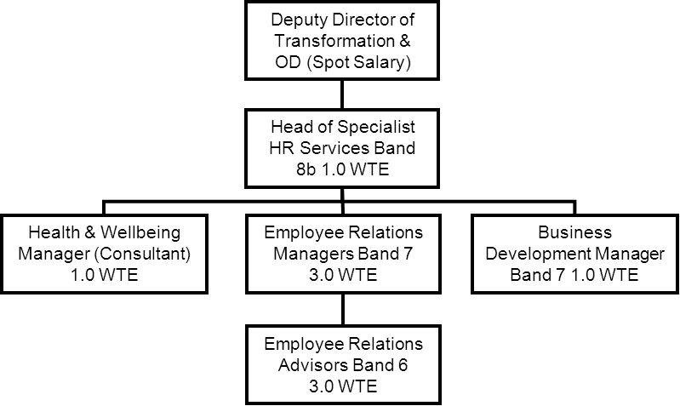

1. **KEY RESULT AREAS/PRINCIPAL DUTIES AND RESPONSIBILITIES:**

# Employee Relations

* To support the Employee Relations Managers in the delivery of an effective and responsive HR service.
* Provide specialist HR Employment Relations advice and support to managers on a range of complex employment issues including ill health, change management, redeployment, absence management, disciplinary, performance management, grievance, bullying and harassment and general employee relations seeking guidance and support where appropriate from Employee Relations Managers in more complex and high risk cases.

To regularly/accurately update information on own caseload onto internal system as required.



Ensure that all cases are managed sensitively and appropriately, in a timely manner. To be responsible for identifying risks to the organisation and promptly flagging them to the Employee Relations Manager and continue to support these cases where appropriate.

* Ensure accurate, detailed and up to date documentation of projects and employee relations cases.
* Ensure that all cases are progressed in a timely and appropriate manner and are not permitted to drift.
* Maintain close links with Occupational Health colleagues and act as a link between managers and occupational health to facilitate the implementation of advice, including return to work, reasonable adjustments, redeployments, ill health retirements as well as other work related issues.
* Contribute to the development of corporate HR strategies and policies and devise and manage implementation programmes with the support of Employee Relations Managers.
* Interpret and effectively apply current employment legislation, producing and amending policies and management guidelines in line with evolving employment legislation and national NHS guidance.
* Work closely with management and staff side representatives in the development of policies and management guidance for the Trust.
* Support the planning and implementation of new policies and guidance including organisation and provision of training programmes to ensure management awareness and competence.

Support managers in the drafting of formal documentation as appropriate.



Attending hearings where necessary to provide HR advice.

* Carry out preparatory work related to Employment Tribunal claims and attend Employment Tribunals as appropriate.
* To advise on national and local terms and conditions of employment.

# Change management

Support line managers with the launch and implementation of change management programmes with the relevant line manager in coordination with the HR Business Partner. Establish effective partnership relations with trade union colleagues.



# Management Development

Assist in the devising and implementation of in house training sessions for managers on a range of subjects.



Deliver training and coaching on workforce issues.



To support, advise and coach managers to ensure a consistent approach in line with current Trust policy and employment law and best practice.

# Trust wide HR responsibilities

Lead on and support specific workforce projects.



Proactively identify policy development opportunities and work in conjunction with the Employee Relations Manager to develop workforce policies and procedures, including the researching of best practice.

**Other Responsibilities:**

To take part in regular performance appraisal

To undertake any training required in order to maintain competency including mandatory training, e.g.

Manual Handling

To contribute to and work within a safe working environment

The post holder is expected to comply with Trust Infection Control Policies and conduct him/herself at all times in such a manner as to minimise the risk of healthcare associated infection

As an employee of the Trust, it is a contractual duty that you abide by any relevant code of professional conduct and/or practice applicable to you. A breach of this requirement may result in action being taken against you (in accordance with the Trust’s disciplinary policy) up to and including dismissal.

The post holder is expected to comply with Trust Infection Control Policies and conduct him/her at all times in such a manner as to minimise the risk of healthcare associated infection.

# THE TRUST – Vision and Values

Our vision is to provide safe, high quality seamless services delivered with courtesy and respect. To achieve our vision we expect all our staff to uphold our Trust values. Our Trust values are:

Honesty, Openness & Integrity

Fairness,

Inclusion & Collaboration

Respect & Dignity

We recruit competent staff that we support in maintaining and extending their skills in accordance with the needs of the people we serve. We will pay staff fairly and recognise the whole staff’s commitment to meeting the needs of our patients.

We are committed to equal opportunity for all and encourage flexible working arrangements including job sharing.

We are committed to recruiting and supporting a diverse workforce and welcome applications from all sections of the community, regardless of age, disability, gender, race, religion, sexual orientation, maternity/pregnancy, marriage/civil partnership or transgender status. We expect all staff to behave in a way which recognises and respects this diversity, in line with the appropriate standards.

# GENERAL

This is a description of the job as it is now. We periodically examine employees' job descriptions and update them to ensure that they reflect the job as it is then being performed, or to incorporate any changes being proposed. This procedure is conducted by the Manager in consultation with the jobholder. You will, therefore, be expected to participate fully in such discussions. We aim to reach agreement on reasonable changes, but if agreement is not possible, we reserves the right to insist on changes to your job description after consultation with you.

The RD&E is a totally smoke-free Trust. Smoking is not permitted anywhere on Trust property, including all buildings, grounds and car parks. For help to quit call: 01392 207462.

**PERSON SPECIFICATION**

# POST: Employee Relations Advisor BAND: 6

|  |  |  |
| --- | --- | --- |
| **REQUIREMENTS** | **At Recruitment** | **At 2nd KSF Gateway** |
| **QUALIFICATIONS/SPECIAL TRAINING**  Degree and professional HR qualification or equivalent experience to post graduate diploma level | E | E |
| **KNOWLEDGE/EXPERIENCE:**  Specialist operational HR employment relations knowledge  Specialist knowledge of job matching and evaluation  Sound working knowledge of Data Protection and Freedom of Information  Sound knowledge of employment legislation with the ability to demonstrate recent relevant experience in case management Project management experience | E  E    E    E  E | E  E    E    E  E |
| **SKILLS AND ABILITIES:**  High level communication skills, both verbal and written with wide range of people  Able to effectively motivate and persuade managers to achieve manage cases in line with policy and employment law  Ability to present complex and sensitive information in a range of settings using the most appropriate style  Ability to work collaboratively, methodically and flexibly to ensure exacting deadlines are achieved in a dynamic environment whilst ensuring high standards are maintained  Excellent organisational skills and the ability to appropriately prioritise own workload to meet the demands of the service Ability to manage complex, interpersonal, challenging circumstances in a robust way | E    E    E      E    E    E | E    E    E      E    E    E |
| **PERSONAL REQUIREMENTS:**  High energy and able to manage a busy caseload in with positive outlook  Responsive, resourceful, enthusiastic, flexible and approachable Team orientated, supportive to colleagues but with ability to work alone when required | E  E    E | E  E    E |
| OTHER REQUIREMENTS:  Able to travel to meet the requirements of the post  The post holder must demonstrate a positive commitment to uphold diversity and equality policies approved by the Trust | E    E | E    E |

* Essential/Desirable

|  |  |  |  |  |  |
| --- | --- | --- | --- | --- | --- |
|  | HAZARDS:- Updated 31st May 2013 | | | |  |
| Laboratory Specimens |  | Clinical contact with Patients |  | Dealing with violence & aggression of patients/relatives |  |
| Blood / Body Fluids |  | Dusty Environment |  | VDU Use (occasional) | x |
| Radiation / Lasers |  | Challenging Behaviour | x | Manual Handling | x |
| Solvents |  | Driving |  | Noise / Vibration |  |
| Respiratory Sensitisers |  | Food Handling |  | Working in isolation |  |
| Cytotoxic Drugs |  | Electrical work |  | Night Working |  |