JOB DESCRIPTION
JOB DETAILS
Job Title | Senior Biomedical Scientist
Reports to | Blood Science Deputy Laboratory Manager
Band | AfC Band 7
Department/Directorate | Haematology/Blood Transfusion, Blood Sciences, Pathology, CSS NDDH

JOB PURPOSE
To contribute to the provision of a high quality, accurate and timely diagnostic Haematology & Blood Transfusion Service. Service is provided 24 hours per day, 7 days per week.
KEY RESULT AREAS/PRINCIPAL DUTIES AND RESPONSIBILITIES
- In a lead role in a team of 13
- As one of a team, to receive, prepare and analyse approximately 1100 specimens daily
- To work a 37.5 hour week plus night and weekend working
- To be a team leader to a group of BMS and MLA staff
- To co-ordinate, supervise and train subordinate staff
- To deputise for the BS deputy manager where appropriate
- To carry out annual appraisals with subordinate staff
- To assess and implement new techniques and agreement with the Deputy Blood Science Laboratory Manager
- To continually assess current techniques for best value and performance
- To assist with budgetary control by ensuring optimum procurement
- To enter patient identification data into the laboratory computer
- To interpret results and give relevant clinical advice where necessary
- To assist with driving forward the departments quality and optimisation agendas
- To assist with compliance with ISO 15189 standards as assessed by UKAS and MHRA requirements for better blood transfusion and BSQR by working with the BS manager and the Quality Manager
- To ensure that the laboratory information system (LIMS) is operating correctly and to highlight any changes needed
Specialist duties – extra responsibilities
- To act as lead BMS for the Sickle Call & Thalassaemia Screening Programme and attend all associated meetings.
- To supervise the running, daily maintenance and stock control of the Manual and the Referral (“send away”) Sections of the Haematology/Blood Transfusion Laboratory
- To monitor and to help maintain the Haematology module of the Laboratory Computer (currently EPIC/Beaker)

The Senior Biomedical Scientist will be based in Pathology, NDDN.

The post holder will fulfil all tasks and work as part of a team. To meet the needs of the service, the post holder may be required to work in other areas as appropriate as directed by the line manager.

The department provides the full remit of investigations as required by the hospital, plus additional specialised investigations not usually performed in a laboratory of this size.

KEY WORKING RELATIONSHIPS
The post holder will provide, prepare and receive complex and sensitive information verbally, in writing and electronically which is required by work colleagues, users of the service, e.g.,
- Medical staff
- Nursing staff
- Consultant staff
- Hotel services staff
- Clinical Service Managers
- Trade representatives
- Staff within other NHS Trusts
- Members of the general public

The post holder is required to deal effectively with staff of all levels throughout the Trust, the wider Healthcare community, external organisations and the public. This will include verbal, written and electronic media.

ORGANISATIONAL CHART
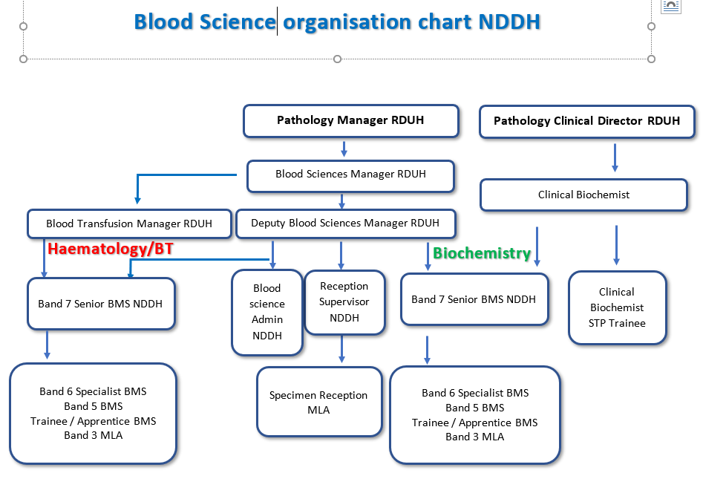

FREEDOM TO ACT
COMMUNICATION/RELATIONSHIP SKILLS
Communication and Relationship Skills
Uses all available methods of communication effectively, clearly and politely.
Contributes to laboratory meetings and education sessions.

Reports to and is managed by the Blood Science (Deputy) Manager.

Deals with enquiries from clinical and non-clinical staff, patients and others, and gives results to laboratory users and other advice as appropriate.

Works with lab manager/deputy and consultants to maintain and up to date, high quality service.

The postholder will represent the haematology department on one (or more) of the following:
- Pathology Health and Safety Committee and implements/manages it recommendations.
- Pathology Training Committee and implements/manages its recommendations.
- Pathology Quality Committee and implements/manages its recommendations.

Deals with commercial representatives.

Works with the Blood Sciences (Deputy) Manager and consultants to maintain up to date, high quality service.

ANALYTICAL/JUDGEMENTAL SKILLS
Analytical and Judgement Skills
To take day to day responsibility for the manual analysis of pathology specimens received by the laboratory and the referred analysis of samples at other sites. Checking and validating quality control performance for all tests both automated and manual and taking appropriate corrective action if needed.
To monitor validity of both internal and external quality control (QC) and patient results. To identify and resolve performance issues with analytical machinery to ensure the accuracy and precision of results.
Examination and reporting of blood film morphology by microscopy in order to check for abnormalities or diseases such as leukaemia, malaria and glandular fever.
Consultation with Consultant Haematologists as required about action required for highly abnormal results/complex blood films.
To enter both patient identification data and results into laboratory computer.
To judge from available information and training whether the results are compatible or incompatible with known clinical conditions, fall within accepted reference ranges, need to be referred to senior colleagues or referred urgently to requesting clients and whether further testing needs to be initiated.
To provide highly specialised clinical technical services. It will frequently be necessary to advise and guide medical staff in both the use and interpretation of these tests.
To screen, to analyse and to interpret results used for both diagnosis and treatment.

PLANNING/ORGANISATIONAL SKILLS
Planning and Organisational Skills
Will decide how expected jo outputs will be achieved
PATIENT/CLIENT CARE
Responsibility for Patient and Client Care
Occasional discussions with clinical teams on patient blood results. Occasional phone contact/face contact with patients.
POLICY/SERVICE DEVELOPMENT
To contribute to departmental policies for maintenance and improvements in the service.
To implement new techniques in agreement with the Blood Science (Deputy) Laboratory Manager.
To assess current techniques.
To write, develop and ensure compliance with standard operating procedures (SOP) and to propose changes for practices and procedures.
To be guided by precedent, protocols and codes of conduct.
To determine and write laboratory Standard Operating Procedures (SOP) which number some 460 documents. This requires a knowledge and practice of documentation control and maintenance to UKAS standards.
To meet with colleagues to discuss audit, quality control and training.
Assisting the BS (deputy) lab manager/with the evaluation and implementation of new or replacement analytical equipment.

FINANCIAL/PHYSICAL RESOURCES
Responsibility for Financial and Physical Resources
To assist with budgetary control.
To be an authorised co-signatory for purchase of physical assets and supplies.
To be responsible for the electronic stock control, ordering and receipt of the main analysers of the Haematology/Blood Transfusion laboratory and to assist in stock control and ordering of other supplies.
HUMAN RESOURCES
Responsibility for Human Resources
Will be the nominated departmental officer for one of the following:-
- Training officer, responsibilities including the preparation, implementation and maintenance of laboratory training policy
- Health and Safety officer, responsibilities including the preparation, implementation and maintenance of laboratory health and safety policy
- Quality officer, responsibilities including the preparation, implementation and maintenance of the laboratory quality management system
Training of all staff including the medical laboratory assistants, trainee BMSs and BMS band 5 and 6s.
To maintain competence of all staff by training and communication of procedural changes.
INFORMATION RESOURCES
Responsibility for Information Resources
To use the laboratory computer in accordance with Trust policies in the provision of information to appropriate persons.
To enter requests for specimen testing. Requires keyboard skills.
To enter data for storage and printing of results.
To create databases and spreadsheets using computerised systems for analysis of data and work trends.
To observe the strictest confidence regarding all information to which there is access within the Northern Devon Healthcare NHS Trust.
To help and advise the Laboratory Computer Manager.
To help and advise the Laboratory Computer Manager in matters concerning the configuration of the Haematology module of the laboratory computer.
To inform colleagues of developments and potential problems.
RESEARCH AND DEVELOPMENT
Responsibility for Research and Development
To prepare and store samples for occasional clinical trials.
To participate in and to suggest items for audit
PHYSICAL SKILLS
Physical Skills
To develop a high degree of hand-eye co-ordination with speed and accuracy when performing tests and maintaining apparatus. Manipulation of small tools, tubes, pipettes and complicated apparatus is required.
To use and maintain on a day-to-day basis expensive and highly complicated laboratory equipment for analytical work, safely as guided by SOPs.
To be responsible for the troubleshooting and repair (in consultation with company engineers) of highly complex analytical equipment (purchase price one hundred thousand pounds). To call out engineers when major fault is diagnosed. This requires electrical and mechanical skills.
PHYSICAL EFFORT
Physical Effort
To use and maintain on a day-to-day basis expensive and highly complicated laboratory equipment for analytical work, safely as guided by SOPs.
To be responsible for the troubleshooting and repair (in consultation with company engineers) of highly complex analytical equipment (purchase price one hundred thousand pounds). To call out engineers when major fault is diagnosed. This requires electrical and mechanical skills.
To undertake equipment testing and evaluation.
To help if needed with laboratory housekeeping, waste control, receiving and despatching supplies. This may involve bending, lifting and pushing trolleys.
The preparing of specimens for analysis and the associated paperwork will often involve long periods (greater than an hour) of sitting at a bench.
Frequent episodes of light physical effort for several short periods may be required.
Repetitive movements for processing specimens are required.
MENTAL EFFORT
Mental Effort
Frequently to concentrate for prolonged periods (greater than an hour) whilst analysing specimens and considering the significance of results.

EMOTIONAL EFFORT
Emotional Effort
To respond to unpredictable events which require work patterns to be changed at short notice e.g. urgent testing and responding to and emergency “bleep”.
Rarely, to answer the telephone to distressed patients and angry clients and to prepare specimens from family and friends whilst maintaining patient confidentiality.
Specimens from many categories of Patient (from post mortem specimens to infant specimens) with access to clinical data are routinely prepared.
WORKING CONDITIONS
Working Conditions
To work in potentially hazardous conditions (infection, chemical, equipment).
To respond to unpredictable events which require work patterns to be changed at short notice e.g. urgent testing and responding to and emergency “bleep”.
Rarely, to answer the telephone to distressed patients and angry clients and to prepare specimens from family and friends whilst maintaining patient confidentiality.
Specimens from many categories of Patient (from post mortem specimens to infant specimens) with access to clinical data are routinely prepared.

OTHER RESPONSIBILITIES
Additional tasks within the Haematology speciality:

Management of the highly specialised testing service provided by the department (haemoglobinopathies, thrombophilia, SCT screening), used for the diagnosis of diseases such as leukaemia, haemophilia and the tendency to form abnormal blood clots. Management of this service requires a high level of specialist knowledge.

These are beyond the normal remit of a department this size but are performed here because of the geography of the area.

Tasks Specific to the Blood Transfusion speciality:

Deputising for Senior BMS in blood transfusion when necessary.

Working unsupervised, frequently for prolonged periods, or alone out-of-hours.

Monitoring and maintaining adequate stocks of blood and all blood products including treatment for haemophiliacs or to prevent Haemolytic disease of the foetus & newborn (HDFN).

Provision of compatible and suitable blood and blood products as required for patients, either to cover operations or as a result of trauma/accident. This is done by electronic issue and sometimes by highly accurate manual testing techniques and requires a high level of concentration as patient survival can depend upon timely and correct blood product provision. At busy times this is particularly important as interruptions can be frequent.

Responding rapidly to emergency requests for blood and blood products including liaison with National Blood Service for emergency (blue light) blood deliveries. Liaison with service users to predict further demand.

Maintenance of fully traceable and auditable records for all blood and blood products kept and transfused, including issue of blood products to the community on a named-patient basis in accordance with NICE
guidelines and MHRA requirements.

Instigation/operation of Trust/laboratory Major Incident Procedure at any time as required.

DISCLOSURE AND BARRING SERVICE CHECKS
This post has been identified as involving access to vulnerable adults and/or children and in line with Trust policy successful applicants will be required to undertake a Disclosure & Barring Service Disclosure Check.

GENERAL
GENERAL
This is a description of the job as it is at present constituted. It is the practice of this organisation periodically to examine employees' job descriptions and to update them to ensure that they relate to the job as then being performed, or to incorporate whatever changes are being proposed. This procedure is jointly conducted by each manager in consultation with those working directly to him or her. You will, therefore, be expected to participate fully in such discussions. It is the organisations' aim to reach agreement to reasonable changes, but if agreement is not possible management reserves the right to insist on changes to your job description after consultation with you.
We are committed to serving our community. We aim to co-ordinate our services with secondary and acute care.
We aim to make all our services exemplary in both clinical and operational aspects. We will show leadership in identifying healthcare needs to which we can respond and in determining the most cost-effective way of doing so. We will share our knowledge with neighbouring healthcare agencies and professionals.
We recruit competent staff whom we support in maintaining and extending their skills in accordance with the needs of the people we serve. We will pay staff fairly and recognise the whole staff’s commitment to meeting the needs of our patients.
The Trust operates a 'non smoking' policy. Employees are not able to smoke anywhere within the premises of the Trust or when outside on official business.
All employees must demonstrate a positive attitude to Trust equality policies and Equality Scheme. Employees must not discriminate on the grounds of sex, colour, race, ethnic or national beliefs, marital status, age, disability, sexual orientation, religion or belief and will treat patients, colleagues and members of the public with dignity and respect.
If the post holder is required to travel to meet the needs of the job, we will make reasonable adjustments, if required, as defined by the Equality Act 2010
SAFEGUARDING
To be fully aware of and understand the duties and responsibilities arising from the Children’s Act 2004 and Working Together in relation to child protection and safeguarding children and young people as this applies to the worker’s role within the organisation.
To also be fully aware of the principles of safeguarding as they apply to vulnerable adults in relation to the worker’s role, which will include recognising the types and signs of abuse and neglect and ensuring that the worker’s line manager is made aware and kept fully informed of any concerns which the worker may have in relation to safeguarding adults and/or child protection.
Everyone within the Trust has a responsibility for, and is committed to, safeguarding and promoting the welfare of vulnerable adults, children and young people and for ensuring that they are protected from harm, ensuring that the Trusts Child Protection and Safeguarding Adult policies and procedures are promoted and adhered to by all members of staff.

HEALTH AND SAFETY AT WORK
The employer will take all reasonably practical steps to ensure your health, safety and welfare while at work. You must familiarise yourself with the employer's Health & Safety policy, and its safety and fire rules. It is your legal duty to take care for your own health and safety as well as that of your colleagues.

INFECTION CONTROL - ROLE OF ALL STAFF
It is the responsibility of all members of staff to provide a high standard of care to patients they are involved with. This includes good infection prevention practice.
All staff have a responsibility to comply with Infection Prevention and Control policies and procedures, this includes:
- Attending mandatory and role specific infection prevention education and training.
- Challenging poor infection prevention and control practices.
- Ensuring their own compliance with Trust Infection Prevention and Control policies and procedures for example, standard precautions, hand hygiene, prevention & management of inoculation incidents
CONFIDENTIALITY
You may not disclose any information of a confidential nature relating to the employer or in respect of which the employer has an obligation of confidence to any third party other than where you are obliged to disclose such information in the proper course of your employment or as required by law. Any failure to comply with this term of your employment will be treated as an act of misconduct under the employer's disciplinary procedure.

PERSON SPECIFICATION

Job Title | Senior Biomedical Scientist (BMS) Section Manager

Requirements | Essential | Desirable
QUALIFICATIONS/SPECIAL TRAINING :  Health and Care Professions  Council State Registration  Biomedical science MSc or Institute of Biomedical Science fellowship or equivalent  Significant laboratory experience post HCPC registration | E  E  E
KNOWLEDGE/SKILLS:  Highly specialist knowledge of all Haematology disciplines and blood transfusion  Highly specialist knowledge of analytical instrumentation operation, troubleshooting and repair  Specialist knowledge of blood coagulation  Computer literacy – capability of utilising complex proprietary information systems (e.g. computer software on analysers; pathology computer system) and generic software (e.g. e-mail, word, excel)  Ability to plan workload for self and whole department  Good interpersonal and supervision skills  Specialist knowledge of Health and Safety and COSHH requirements and their application in the workplace  Highly specialist knowledge of quality assurance procedures and their application  Good communication skills using a range of media  Ability to work both in a team and under own initiative  Ability to produce consistently high standards of work  Ability to adapt to changes in methodologies and technology  Awareness of need for Continuing Professional Development (CPD) | E  E  E  E  E  E  E  E  E  E  E  E  E | D
EXPERIENCE:  Significant Experience as a specialist Biomedical Scientist or Biomedical Scientist team leader and Haematology and/or Transfusion.  Knowledge and experience of maintaining and developing a high quality service to meet ISO15189 and the requirements of the MHRA.  Experience in staff supervision and training.  Experience in staff and physical resource leadership and management respectively. | E  E  E | D
PERSONAL REQUIREMENTS:  Ability to work in an environment which requires a high degree of concentration for sustained periods with the ability to cope with interruptions whilst continuing to maintain high quality standards  Must have a good team work ethic, good interpersonal skills, good communication skills and good organisational skills | E  E
OTHER REQUIREMENTS:  The post holder must demonstrate a positive commitment to uphold diversity and equality policies approved by the Trust  Ability to travel to other locations as required | E  E

FREQUENCY

(Rare/ Occasional/ Moderate/ Frequent)
WORKING CONDITIONS/HAZARDS |  | R | O | M | F
Hazards/ Risks requiring Immunisation Screening
Laboratory specimens | Y |  |  |  | X
Contact with patients | N
Exposure Prone Procedures | Y
Blood/body fluids | Y |  |  |  | X
Laboratory specimens | Y |  |  |  | X
Hazard/Risks requiring Respiratory Health Surveillance
Solvents (e.g. toluene, xylene, white spirit, acetone, formaldehyde and ethyl acetate) | Y | X
Respiratory sensitisers (e.g isocyanates) | N | ☐
Chlorine based cleaning solutions  (e.g. Chlorclean, Actichlor, Tristel) | Y
Animals | N
Cytotoxic drugs | N
Risks requiring Other Health Surveillance
Radiation (>6mSv) | N
Laser (Class 3R, 3B, 4) | N
Dusty environment (>4mg/m3) | N
Noise (over 80dBA) | N
Hand held vibration tools (=>2.5 m/s2) | N
Other General Hazards/ Risks
VDU use ( > 1 hour daily) | Y
Heavy manual handling (>10kg) | N
Driving | N
Food handling | N
Night working | N
Electrical work | N
Physical Effort | Y
Mental Effort | Y
Emotional Effort | Y
Working in isolation | Y
Challenging behaviour | N

