JOB DESCRIPTION

JOB DETAILS
Job Title | Capital Project Co-ordinator
Reports to | Capital Programme Manager
Band | Band 6
Department/Directorate | Capital Projects, Estates & Facilities

JOB PURPOSE
The Project Co-ordinator provides vital assistance to the project team for all aspects of projects from inception to completion ensuring the delivery of projects on time, within budget, to the required quality and which improve the patient’s environment in accordance with Trusts strategic direction.

The post holder will be responsible for assisting in driving everything forward from planning to implementation directly influencing the efficiency, success and cost-effectiveness of projects.
KEY RESULT AREAS/PRINCIPAL DUTIES AND RESPONSIBILITIES
- Provide project management support for the Capital Programme as directed by the Capital Programme Manager/Capital Projects Manager/Co-ordinator.
- Support the Project Manager in developing, managing and monitoring detailed project plans for each project and its associated work streams, with defined internal milestones.
- Proactively monitor and support the delivery of actions across work streams, ensuring that all agreed milestones are achieved.
- Set the agenda for project work streams meetings, identifying appropriate papers etc for circulation and chair project meetings as required.
- Manage risk, assumptions, issues and decision logs, ensuring they are kept up to date and accurate. Proactively manage risks and issues, ensuring they are in progress, escalating when required.
- Highlight to the Project Managers and Functional Leads any key risks or areas of concern, and identify actions to resolve potential problems.
- Produce reports as directed by Project Manager and / or Functional Leads for presentation at a range of different meetings and boards.
- Complete process mapping to show as-is and to-be for a range of departments.
- Produce gap analysis studied, highlighting how improvements could be made through each step of a process.
- Working collaboratively with a wide range of stakeholders to define requirements, understand needs and gathering input on required elements of project deliverables.
- Critically evaluate the success of each project and own role in it in order to contribute to continuous improvement and development of project management best practice.

KEY WORKING RELATIONSHIPS
Areas of Responsibility: The postholder will be part of the Capital Programme team. They will coordinate and monitor the project deliverables.

The post holder is required to deal effectively with staff of all levels throughout the Trust as and when they encounter on a day to day basis.

In addition, the post holder will deal with the wider healthcare community, external organisations and the contractors. This will include verbal, written and electronic media.

Of particular importance are working relationships with:

Internal to the Trust | External to the Trust
- Programme Team | - Design Consultants
- Managers | - Contractors
- Clinicians and Wards/Departments | - New Hospital Programme
- Finance Team | - NHS England Teams
- Estates Team | - Patients
- Digital | - Other stakeholders as required

ORGANISATIONAL CHART
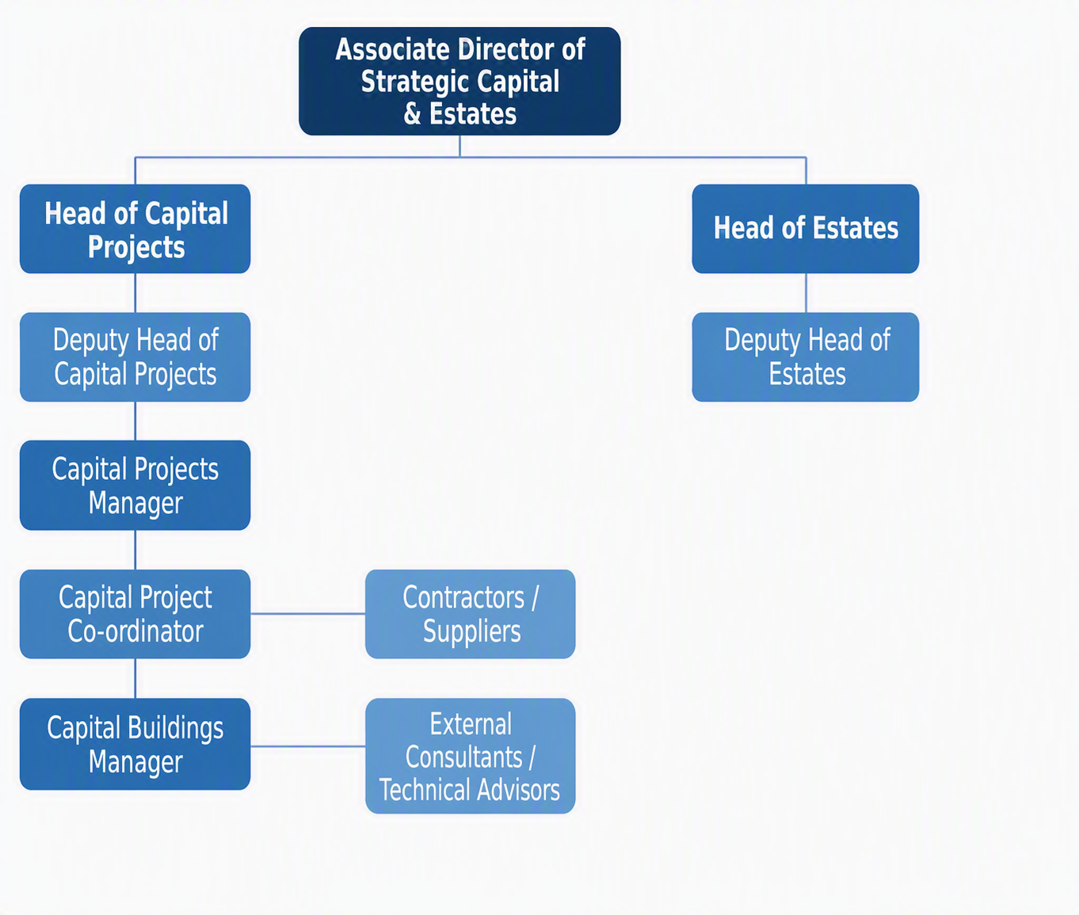

FREEDOM TO ACT
Significant discretion to work autonomously within their project area. The post holder will be guided by broad occupational policies and regulations and will decide on how expected results are best achieved.
To maintain one’s own high professional standards and explore opportunities to develop practice.

To work within Trust policies and procedures, broad occupational building and health and safety regulations.

To be responsible for organising own workload, prioritising to meet the needs of the Trust.

COMMUNICATION/RELATIONSHIP SKILLS
Support the project team in all aspects of project planning which requires providing and receiving complex information, including the co-ordination of work within the programme regardless of whether it is within areas of specialism or not. The postholder may deal with contentious situations where there may be resistance to change.

Liaise with external consultants and specialist advisors.

Maintain a good working relationship with other team members and staff within the wider organisation and have the ability to share and advise on complex technical issues.

Work together with senior clinicians, nursing, infection control, procurement and staff to ensure all concerned are actively involved in project activities in order to deliver high quality, effective and efficient patient care demonstrating best practice and value for money.

Work with Estates teams to ensure interdependent pieces of work are fully covered across all aspects of programme.

Submit regular written and oral reports and proposals to Trust committees/board/senior managers on the progress of specified projects on a regular basis.

The post holder will be expected to behave in accordance with the Trust's values of demonstrating compassion, integrity, inclusion and being empowered in their place of work.

The post holder will be expected to effectively communicate with stakeholders in difficult circumstances.

ANALYTICAL/JUDGEMENTAL SKILLS
Manage project design and specification of schemes in a multi-discipline environment including complex analysis of initial brief to completion including; feasibility, brief, costs, schedules of work, outline and detailed design, tender documentation, contracts, on-site supervision, commissioning, acceptance of works with associated approvals and final evaluation.

Manage and maintain complex programme documentation such as progress reports, RAID logs (risk, assumption, issue, decision) and project plans, all in line with programme governance. Ensure that a thorough audit trail is documented and kept at all times.

Ensure that health and safety precautions are taken into account throughout all stages of a project including risk assessments to ensure that projects can be carried out with minimum risk to staff, patients and visitors.

Provide early warning and offer a proactive approach to anticipated problem areas in order to ensure that contractual and service deadlines are achieved.

To use managerial and judgemental skills to analyse complex situations and formulate appropriate solutions/responses.

PLANNING/ORGANISATIONAL SKILLS
Project planning and project management of a complex range of clinical and non-clinical elements of the programme ensuring project deliverable requirements are captured and completed on time, within budget and to acceptable quality standards in compliance with the Trusts financial instructions and policies.

Regular reporting and updating to the Capital Programme Manager to ensure project delivery is within programme timescales.

Production of relevant project documentation and risk assessments throughout the planning, design, tendering, reporting, approval, ensuring robust project processes and procedures are in place and that key targets are established achieved and maintained, or adjustments to plans are made, all within the programme governance framework.

Completion of reports and papers for formal boards as necessary, for example progress reports.

Ensure appropriate risk control measures are in place with risks identified, managed, mitigated and action plans produced with named owners and due dates.

Management of staff working within the project and programme to achieve delivery, even though the majority of these staff will not be directly line managed by this role, nor employed by the programme.
Support the management of procurement, commissioning and successful delivery of programme deliverables to the required quality standards, within budget and in programme timescales.

Arrange access to clinical and non-clinical areas for visitors, suppliers and surveyors. Provide professional advice in terms of project planning, feasibility, design, buildability and delivery of projects.
Produce and update, schedules of work, outline and detailed design, as-is and to-be process mapping, tender documentation, contracts, on-site supervision, commissioning, acceptance of works and final evaluation.

PATIENT/CLIENT CARE
The post holder is required to put the patient, as the first priority, at the centre of all activities. The post holder will have occasional contact with patients / clients by phone or face to face and will provide non-medical information and advice to patients and carers.

POLICY/SERVICE DEVELOPMENT
Assist in the development and maintenance of the Trusts property database including estate terrier plans (leasehold or freehold), estate master drawings (as fitted information, estate records and building log books) and provide space management data in connection with the apportionment of occupancy costs. The post holder will use this information to help inform changes to the current space utilisation policy (as required) and assist in developing the service to meet the requirements of the Trust and the Capital Programme.

To support the development of business cases.

Deliver new and innovative practice to ensure the continuous improvement in efficiency and effectiveness and the development of high standards.

Manage and co-ordinate accommodation change of use and relocations including planning, spatial layouts, furniture, equipment, IT, and associated minor works ensuring compliance with standards, guidance and policies.

FINANCIAL/PHYSICAL RESOURCES
Ensure that capital costs are prepared in accordance with the current NHS Estates guidance at the various stages of outline business case, preliminary and full business case.

Work with the Capital Project Manager closely monitoring the budgetary spend for each programme of work to identify budget compliance.

Carry out day to day budget management duties, including feasibility studies with budget and detailed estimate of works including option appraisals, draft layouts, support for business plans, recommendations and associated documentation for submission of capital funding bids.

Deliver specific project finances against objectives, achieving quality outcomes and working to tight deadlines.

Provide support to Estates teams across all services as required including budget management. The postholder will assist in the procurement of specialist advisors and equipment (in excess of £50k).

HUMAN RESOURCES
The post holder will be responsible for the line management of the administrative function of the Capital Programme, which will include training, guidance, mentoring, appraisals and the day-to-day supervision of the department.

To be responsible for the effective delivery of training and awareness sessions to clinical and non-clinical staff on project plans. May be required to supervise onsite contractors.

Provide coordination of and participate in relevant meetings, providing information advice and support where requested.

INFORMATION RESOURCES
Undertake risk assessments and implement remedial measures (e.g., decanting / phasing activities) to ensure that projects can be carried out with minimum risk to staff, patients and visitors.

Regularly required to develop reports as well as a library of standard technical briefs, specifications, layouts, finishes, systems, schedule of costs and products improving the quality of capital schemes, using a range of IT systems.

Ensure that robust mechanisms are in place to regularly monitor and report performance for project activities with regular reports for project spend, progress and post project reviews.

RESEARCH AND DEVELOPMENT
The post holder will regularly undertake research and development activity, such as surveys, as a requirement of the job, to inform and develop project plans.

PHYSICAL SKILLS
Standard keyboard skills are required to project complex reports and progress plans.

PHYSICAL EFFORT
A combination of sitting, standing and walking with little requirement for physical effort. The post requires travelling, meetings in various venues and office-based work.

MENTAL EFFORT
There will be a frequent requirement for prolonged concentration when reading, interpreting and developing policy documents, reports and project plans. The post holder may be interrupted to deal with staffing or project issues.

EMOTIONAL EFFORT
There will be minimal exposure to distressing or emotional circumstances.

WORKING CONDITIONS
Use display screen equipment for substantial proportion of working day. May require visits to other sites or supplier sites.

OTHER RESPONSIBILITIES
Take part in regular performance appraisal.

Undertake any training required in order to maintain competency including mandatory training, e.g. Manual Handling and Fire Safety Training.

Contribute to and work within a safe working environment.

You are expected to comply with Trust Infection Control Policies and conduct themselves at all times in such a manner as to minimise the risk of healthcare associated infection.

As an employee of the Trust, it is a contractual duty that you abide by any relevant code of professional conduct and/or practice applicable to you. A breach of this requirement may result in action being taken against you (in accordance with the Trust’s disciplinary policy) up to and including dismissal.
You must also take responsibility for your workplace health and wellbeing:
- When required, gain support from Occupational Health, Human Resources or other sources.
- Familiarise yourself with the health and wellbeing support available from policies and/or Occupational Health.
- Follow the Trust’s health and wellbeing vision of healthy body, healthy mind, healthy you.
- Undertake a Display Screen Equipment assessment (DSE) if appropriate to role.

GENERAL
This is a description of the job as it is now. We periodically examine employees' job descriptions and update them to ensure that they reflect the job as it is then being performed, or to incorporate any changes being proposed. This procedure is conducted by the manager in consultation with the jobholder. You will, therefore, be expected to participate fully in such discussions. We aim to reach agreement on reasonable changes, but if agreement is not possible, we reserve the right to insist on changes to your job description after consultation with you.

Everyone within the Trust has a responsibility for, and is committed to, safeguarding and promoting the welfare of vulnerable adults, children and young people and for ensuring that they are protected from harm, ensuring that the Trusts Child Protection and Safeguarding Adult policies and procedures are promoted and adhered to by all members of staff.

PERSON SPECIFICATION

Job Title | Capital Project Co-ordinator

Requirements | Essential | Desirable
QUALIFICATION/ SPECIAL TRAINING  Educated to Degree level or equivalent Project Management certification | E
Extensive experience in project management or project based change management activities. | E
PRINCE2 or equivalent qualification and/or experience to post graduate diploma level | E
Record of Continuing Professional Development | E
KNOWLEDGE / SKILLS  NHS technical documents, British Standards, regulations, legislation and codes | E
Project briefing, specification and management of multi-discipline schemes | E
Understanding of Health & Safety legislation | E
Production of documents and report writing skills | E
Thorough knowledge of building construction industry practice | E
Budgetary control, planning and forecasting for capital schemes | E
Risk assessment and critical path analysis | E
Planning and building control procedures | E
Healthcare estate and technology across a number of specialist subjects including construction and engineering services | E
Knowledge of the technical design, delivery and utilisation aspects of construction projects | E
Advanced skills in software (Microsoft Word /Outlook/Access/PowerPoint, Excel, etc.) | E
Ability to analyse complex issues, appraising options while giving due regard to successful outcomes | E
Working with computer aided design tools AutoCAD |  | D
Contract administration and contract law |  | D
Construction design management (CDM) |  | D
EXPERIENCE  Good track record of project management | E
Healthcare design and standards | E
System management and development | E
Budget management for capital schemes | E
Construction process, principles, standards and techniques | E
Information systems and computer programmes | E
Experience of service / space planning |  | D
PERSONAL ATTRIBUTES  Self-motivated, with high work standards for self and others with drive and resilience. Takes personal responsibility for quality of output | E
Discretion, tact and diplomacy | E
High level of work organisation, self-motivation, drive for performance and improvement, and flexibility in approach and attitude | E
Ability to manage and deliver to deadlines and within resources | E
Concentration for prolonged periods whilst reading documents and providing clear guidance as a result | E
Demonstrate a high level of interpersonal / decision making skills, written and verbal | E
Results-driven, with commitment to deliver objectives to agreed quality standards, budget and timescales | E
Effective communicator with good written and verbal communication skills at all levels, and good negotiation skills | E
Willingness to undergo training | E
OTHER REQUIREMENTS  Flexible approach to working hours  Ability to drive | E | D

FREQUENCY

(Rare/ Occasional/ Moderate/ Frequent)
WORKING CONDITIONS/HAZARDS |  | R | O | M | F
Hazards/ Risks requiring Immunisation Screening
Laboratory specimens | NA
Contact with patients | NA
Exposure Prone Procedures | NA
Blood/body fluids | NA
Laboratory specimens | NA
Hazard/Risks requiring Respiratory Health Surveillance
Solvents (e.g. toluene, xylene, white spirit, acetone, formaldehyde and ethyl acetate) | NA
Respiratory sensitisers (e.g isocyanates) | NA
Chlorine based cleaning solutions  (e.g. Chlorclean, Actichlor, Tristel) | NA
Animals | NA
Cytotoxic drugs | NA
Risks requiring Other Health Surveillance
Radiation (>6mSv) | NA
Laser (Class 3R, 3B, 4) | NA
Dusty environment (>4mg/m3) | Y |  | X
Noise (over 80dBA) | NA
Hand held vibration tools (=>2.5 m/s2) | NA
Other General Hazards/ Risks
VDU use ( > 1 hour daily) | Y |  |  |  | X
Heavy manual handling (>10kg) | NA
Driving | Y |  | X
Food handling | NA
Night working | NA
Electrical work | NA
Physical Effort | NA
Mental Effort | Y |  |  |  | X
Emotional Effort | Y | X
Working in isolation | NA
Challenging behaviour | Y |  | X

