

JOB DESCRIPTION

JOB DETAILS
Job Title | Research Nurse Specialist/Team Lead
Reports to | Lead Research Nurse
Band | Band 7
Department/Directorate | Research & Development

JOB PURPOSE
The Research Nurse Specialist/Team Lead will be responsible for coordinating and managing the performance of a large portfolio of clinical trials and the management of a team of Clinical Research Staff.
The post holder will provide expert knowledge, skill and experience in this specialist field, and act as an expert resource to advise and support those involved in clinical trials at all levels. The post-holder will be able to autonomously plan, implement, organise and manage concurrent research projects. S/he may source and manage funding for clinical trials and will develop networks with other disciplines across the Trust and other appropriate local and national agencies. S/he will coordinate and manage the study portfolio and recruitment accrual in line with performance and monitoring metrics. They will need to liaise with other Research Teams, often National.
As a Research Nurse Specialist / Team Lead s/he will be responsible for the implementation and monitoring of the clinical requirements associated with research to ensure optimum delivery of clinical trials. S/he will therefore be required to adopt a highly visible clinical profile and accessible approach towards both research participants and staff. It will mean that s/he leads by example and empowers staff in their personal and professional development, promoting the undertaking of a broad range of research to modernise and improve patient care. S/he will ensure that research will be conducted in accordance with the Research Governance Framework and Good Clinical Practice guidelines to provide assurance that the rights, safety and well-being of trial participants are protected. K
KEY RESULT AREAS/PRINCIPAL DUTIES AND RESPONSIBILITIES
Leadership
- To assist the Lead Research Nurse / Practitioner to ensure the operational delivery of the clinical research team work plan, particularly with respect to achieving NIHR targets.
- Manage research performance in relation to team activities and study timelines and targets set by R&D and the SWP CRN.
- Collaborate with other PRC Units, Trusts and organisations within the region to improve research delivery.
- Keep up to date with research management issues through liaison with other Research Specialists /Team leaders and link with national networks.
- Assist the Lead Research Nurse/Practitioner with the training and development of clinical research practitioners and administrators to ensure retention of staff and workforce development where possible.
- Oversee the delivery of education and training regarding research for the wider Multidisciplinary Team and act as an ambassador for research.
- Contribute to the development and implementation of clinical and research policies, and Standard Operating Procedures (SOPs).
- Facilitate and maintain effective communication within the research team and between the multidisciplinary clinical team.
- Represent the R& D Department and the Royal Devon University Healthcare NHS Foundation Trust at a regional and national level.
- Work as part of the Clinical Trials Core Team contributing to the on-going development of the R&D department.
- Deputise for the Lead Research Nurse / Practitioner and provide cover for other Team Leads when required.
- Promote a blame free culture in reporting incidents and where appropriate initiating a local investigation in a timely manner.
Research
- Lead the management and delivery of a large clinical trial portfolio relevant to the PRC Unit and ensure a balanced portfolio of studies.
- Ensure that the delivery of studies meet requirements with regards to the Department of Health’s Research Governance Framework for Health & Social Care and the EU Clinical Trials Directive by implementing quality systems.
- Lead the Expression of Interest / Study Selection process for the PRC. Review and assess trial protocols, consider all potential trials in terms of capacity and capability and viable recruitment period. Identify and work with the Principal Investigator (PI), RM&G Manager and Lead Nurse/Practitioner to resolve resource implications in delivering and facilitating clinical research.
- Be responsible for promoting and overseeing the appropriate referral and recruitment of patients to clinical research studies. Work with investigators and support the clinical research team to develop strategies to overcome barriers to recruitment and to solve other problems relating to specific studies.
- Act as PI for suitable studies and promote the non-medic PI role.
- Decide and delegate roles for the clinical research team in terms of study delivery, using the right skill mix for the study complexity.
- Oversee the coordination of study visits including off site visits and ensure the team adhere to the lone worker policy.
- Work with other departments within the Trust to ensure that trial specific investigations and procedures are undertaken as required by the trial protocol, in order to establish eligibility ensure and safety of patients within clinical trials.
- Ensure both accurate costing for clinical trials and appropriate negotiation of required financial support to deliver clinical trials.
- Ensure clear, accurate and concise records are kept for research projects in accordance with all regulatory requirements including the Data Protection Act.
- Oversee the maintenance of Trial Master Files and essential documents.
- Ensure that the team respond to data queries generated by the study coordinating team within a timely manner and review monitoring visit reports within the team.
- Ensure that the team record and report adverse and serious adverse events that occur whilst the participant is in the clinical trial to the trial co-coordinator/ PI and R&D office in line with the study protocol, local policies and regulatory requirements.
- Assess and evaluate the progress of on-going clinical trials for which the post holder has responsibility, maintaining accurate records of the status of studies and providing regular updates to the department on the status of the studies. This will involve ensuring that EDGE (Local Patient Management System) is updated with key trial data and validated efficiently.
- Promote collaborative working across the network and with other clinical researchers, within the CRN and NIHR structure.
- Ensure high quality publicity about clinical research is visible in the department including easy access to information about current trials for patients and the public.
- Co-operate with external and internal audit, data monitoring and quality assurance by working with R&D, sponsors, study monitors and external bodies.
- Oversee study close down and the preparation of results of research for presentation as posters, abstracts, papers or scientific presentations.
KEY WORKING RELATIONSHIPS
The post holder is required to deal effectively with staff of all levels throughout the Trust as and when they encounter on a day to day basis
In addition, the post holder will deal with the wider healthcare community, external organisations and the public.
This will include verbal, written and electronic media.

Of particular importance are working relationships with:
- PRC Core Team:
- Commercial Research Manager
- PRC Administrator
- Research Nurses/Practitioners
- Pharmacy Team
- Administrative Team Trust Lead Research Nurses Trust Research Team Leads Trust Pharmacy Trials Team Trust Diagnostic Services Trust Finance Team
- Research and Development Department Principal Investigators
- Study participants and their families
- Study sponsors and Clinical Research Associates South West Peninsula Clinical Research Network

ORGANISATIONAL CHART
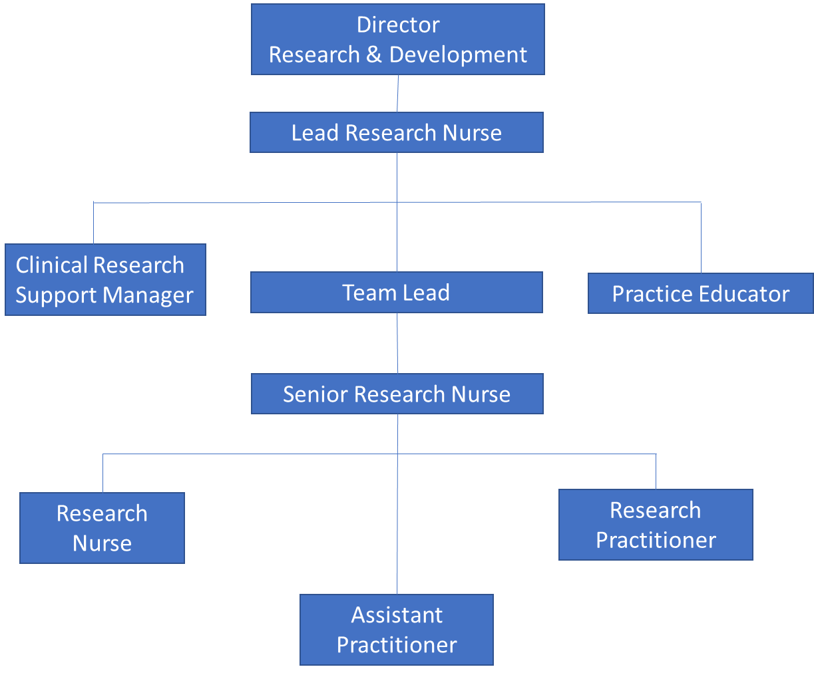

FREEDOM TO ACT
- Works to achieve agreed objectives and timescales, as prescribed to meet internal and external reporting deadlines, given freedom to organise own workload to meet criteria.
- Post would work within guidelines directed by the NIHR and be able to act autonomously on a day to day basis running the team.
- Act as a professional lead and work within the relevant professional code of conduct. (e.g. NMC Scope of Professional Practice and Code of Conduct) demonstrating accountability for own actions and awareness of own limitations
COMMUNICATION/RELATIONSHIP SKILLS
- Communicating with multiple clinicians to determine which projects should go ahead which can be complex in nature.
- Having difficult conversations with sponsors when studies are under- performing which require knowledge and tact.
- Being able manage different staff expectation and show some empathy when staff are asked to move around to different projects that they may not want to work on which would require persuasive and negotiation skills.
- Resolve relevant complaints and issues at a local level in partnership with patients, carers and their family and other healthcare professionals.
- Ability to explain complex concepts to patients in an understandable way overcoming barriers to understanding and recognising which communication methods work.
- Act as an expert resource and provide complex advice regarding study set up, recruitment planning and study delivery.
ANALYTICAL/JUDGEMENTAL SKILLS
- Appraise research findings that inform and influence practice, policy and service provision and demonstrate the ability to make research and clinical judgments based on this appraisal.
- Be able to judge where the workforce needs to invest their efforts and be able to predict whether trials will reach target is the assigned time and the resource to commit to this.
- Be able to balance a diverse portfolio of studies which may have shortened recruitment windows and ensure adequate resource is allocated to this.
- Review incident reports related to the relevant area, carrying out investigations and taking appropriate action where required.
- Monitor clinical standards within the research team and identify action plans to address any areas of concerns. Work with the Trust Lead Nurse for Patient Safety and Risk where there are persistent problems.
- The post holder will be required to assess and evaluate potential side effects of trial drugs which were not predictable at the time of study entry.
PLANNING/ORGANISATIONAL SKILLS
- Monitor and plan in advance the research workload within the department and manage team performance.
- Ensure accurate patient trial documentation, including the use of electronic data capture systems and ensure relevant information is recorded in patients’ medical notes.
- Use capacity tools to identify staffing to be assigned to specific projects and establish how the project will practically run. This requires formulation and adjustment to keep the project on track.
PATIENT/CLIENT CARE
- Ensure Trust policies are applied to support reporting of complaints and concerns by research participants that may be related to their participation in research and to ensure these complaints are appropriately managed and acted upon in accordance with requirements of the UK Policy Framework for Health and Social Care Research.
- Proactively seek feedback from participants and their families during their research involvement.
- Be highly visible in the clinical area, working alongside and supporting staff in a managerial and clinical capacity.
- Act as a specialist resource and role model for all aspects of research clinical practice in order to optimise patient care.
- Ensure the environment is suitable for patient care and research processes, recognising the importance of privacy, dignity and diversity.
- Demonstrate professional development and an in-depth knowledge of current clinical and research practice and encourage and ensure the development of others.
- Provide on-going specialised advice and information to patients and their carers/families with regard to participation in clinical research.
- Where appropriate receive and document written informed consent from research subjects and act as an expert resource in informed consent.
- Ensure the safe and accurate collection of clinical research data such as venepuncture, history taking, standard observations (height weight, BP, temperature, heart rate) and other assessments such as ECG, physical examinations, disease specific outcome measures, questionnaires, rated scales and qualitative interviewing as required by the protocol through clinical supervision of the research team.
- Ensure staff competency to centrifuge, process, track and ship samples in line with protocol requirements.
- Ensure the safe administration of any treatments and drugs given within the context of a clinical trial and act as a specialist clinical resource to the members of the team.
- Support the research team to monitor treatment toxicity/side effects and initiate changes to care as required by the protocol, escalating issues to the Principle Investigator where required.
- Refer to other specialists as required in order to provide optimal care of the participant.
- Treat all persons encountered during the course of duties with respect and courtesy
- Act as a professional lead and work within the relevant professional code of conduct. (e.g. NMC Scope of Professional Practice and Code of Conduct) demonstrating accountability for own actions and awareness of own limitations.
- Ensure the on-going registration of clinical staff with relevant professional bodies.
POLICY/SERVICE DEVELOPMENT
- Responsible for the development and implementation of local PRC policies and guidance to ensure the Trust meets its responsibilities relating to PRC contractual obligations and its strategic objectives and contributes to the development of the national franchise model.
- The post holder will have the responsibility for developing, implementing and monitoring the performance of the PRC against key performance indicators and contracted activity.
- Adheres to Professional Body Code and Scope of professional conduct / practice and policies which govern clinical practice at local and national level including Trust policies.
- Works within the range of research guidelines, ethical principles and protocols, whilst adhering to organisational policies and procedures.
- Observes the confidentiality of patient information at all times, in accordance with the data protection act and Caldicott regulations.
- Contributes to the development of nursing practice within their area of work through the application of nursing research.
- Contributes to the ongoing development of the department, is instrumental in the development of policies and SOPs which may impact on other personnel within the department.
- Ensures that nursing team members are aware of, and implement local, regional and national policies governing research and nursing practice.
FINANCIAL/PHYSICAL RESOURCES
- Have an awareness of the clinical trials workforce budget and understand the various income streams including Core Network Funding, Research Capability Funding and study income.
- Assist the Lead Research Nurse / Practitioner to ensure financial stability or the clinical trials workforce budget.
- Have responsibility for the non–pay budget within own team including managing clinical trial equipment costs and training and travel costs.
- Ensure the clinical research team are aware of, and work within financial and budgetary guidelines.
- Ensure accurate costings for clinical research workforce activity during study set up. Oversee all commercial costing meetings relevant to the Division and utilise planning tools such as the intensity toolkit.
- Identify resource implications for individual studies and the portfolio of studies within the Division.
- Ensure research equipment is maintained in an effective working and good clinical order
HUMAN RESOURCES
- Oversee the recruitment of new personnel, ensure that an appropriate and safe skill mix is maintained and act strategically to enable retention of staff.
- Act as line manager for the Senior Research Nurses/ Practitioners within the team and oversee the management of other members of the research staff within the team (Research Nurse/Practitioner, Research Assistant Practitioner, Research HCA, and Research Administrator). This will include clinical supervision and mentorship to members of staff and students.
- Ensure all staff within sphere of responsibility have access to essential training and achieve 100% compliance.
- Be responsible for the deployment of HR policies including proactively managing sickness and performance in line with the Trust policy.
- The post holder will also be responsible for Disciplinary and Grievance matters in relation to staff and staff welfare.
- Ensure the health, safety and security of the clinical research team.
- Lead in the recruitment of Senior Research Nurses/Practitioners within the clinical team.
- Undertake all mandatory training and ensure that the clinical workforce is up to date with mandatory training.

INFORMATION RESOURCES
- Responsible for collecting, recording, verifying and entering study data into the trial database with a high degree of accuracy. This can to be up to daily.
- Competent in and uses on a daily basis Microsoft Word, spreadsheet and database programs, patient administration systems
- Ensure accurate patient trial documentation, including the use of electronic data capture systems and ensure relevant information is recorded in patients’ medical notes.
RESEARCH AND DEVELOPMENT
- Research is a major component of the post.
- Lead the management and delivery of a large clinical trial portfolio relevant to the clinical team and ensure a balanced portfolio of studies.
- Lead the Expression of Interest / Study Selection process for the clinical team. Review and assess trial protocols, consider all potential trials in terms of capacity and capability and viable recruitment period. Identify and work with the Principal Investigator (PI), RM&G Manager and Lead Nurse/Practitioner to resolve resource implications in delivering and facilitating clinical research.
- Promote collaborative working across the network and with other clinical researchers, within the CRN and NIHR structure.
- Co-operate with external and internal audit, data monitoring and quality assurance by working with R&D, sponsors, study monitors and external bodies.
PHYSICAL SKILLS
- Highly developed skills with high degree of precision appropriate for a Registered Nurse
- Cover trials visits which may include physical and neurological assessments, observations and skills such as venepuncture and cannulation
PHYSICAL EFFORT
- There is the possibility of exposure to episodes of light exertion. For example, whilst moving and handling patients with physical limitations or who are attached to medical devices.
- There may be a requirement to physically manoeuvre (with appropriate aids) heavy pieces of equipment around the research facility/clinical area on an infrequent basis.
- There will be times when you will be required to sit for varying lengths of time in a restricted position inputting data into trial database/writing reports.
- Frequent requirement to exert moderate physical effort as trial locations are in different sites.
MENTAL EFFORT
- Frequent requirement for concentration when undertaking research activities, for example: collecting, recording, verifying and entering study data with a high degree of accuracy, report writing and associated tasks.
- May have to adapt to tight deadlines / changes in deadlines which can cause an unpredictable work pattern and need for differing workforce.
EMOTIONAL EFFORT
- The post holder will be frequently exposed to circumstances that are distressing or emotional as they will be required to support participants during the discussion and decision-making process regarding trial entry with patients who have exhausted all conventional treatments.
WORKING CONDITIONS
- There will be times when you would be required to work in isolation
- There will be exposure to VDU screens whilst inputting trial related data.
- Dependent on the trials there would rarely be exposure to body fluids, for example collection of samples and specimens from patients (stools, blood, saliva).
OTHER RESPONSIBILITIES
Take part in regular performance appraisal.

Undertake any training required in order to maintain competency including mandatory training, e.g. Manual Handling

Contribute to and work within a safe working environment

You are expected to comply with Trust Infection Control Policies and conduct him/herself at all times in such a manner as to minimise the risk of healthcare associated infection

As an employee of the Trust, it is a contractual duty that you abide by any relevant code of professional conduct and/or practice applicable to you. A breach of this requirement may result in action being taken against you (in accordance with the Trust’s disciplinary policy) up to and including dismissal.

You must also take responsibility for your workplace health and wellbeing:
- When required, gain support from Occupational Health, Human Resources or other sources.
- Familiarise yourself with the health and wellbeing support available from policies and/or Occupational Health.
- Follow the Trust’s health and wellbeing vision of healthy body, healthy mind, healthy you.
- Undertake a Display Screen Equipment assessment (DES) if appropriate to role.

APPLICABLE TO MANAGERS ONLY
Leading the team effectively and supporting their wellbeing by:
- Championing health and wellbeing.
- Encouraging and support staff engagement in delivery of the service.
- Encouraging staff to comment on development and delivery of the service.
- Ensuring during 1:1’s / supervision with employees you always check how they are.
DISCLOSURE AND BARRING SERVICE CHECKS
This post has been identified as involving access to vulnerable adults and/or children and in line with Trust policy successful applicants will be required to undertake a Disclosure & Barring Service Disclosure Check.
GENERAL
This is a description of the job as it is now. We periodically examine employees' job descriptions and update them to ensure that they reflect the job as it is then being performed, or to incorporate any changes being proposed. This procedure is conducted by the manager in consultation with the jobholder. You will, therefore, be expected to participate fully in such discussions. We aim to reach agreement on reasonable changes, but if agreement is not possible, we reserve the right to insist on changes to your job description after consultation with you.

Everyone within the Trust has a responsibility for, and is committed to, safeguarding and promoting the welfare of vulnerable adults, children and young people and for ensuring that they are protected from harm, ensuring that the Trusts Child Protection and Safeguarding Adult policies and procedures are promoted and adhered to by all members of staff.

PERSON SPECIFICATION

Job Title | Research Nurse Specialist / Team Lead

Requirements | Essential | Desirable
QUALIFICATION/ SPECIAL TRAINING  Registered Nurse or Healthcare Professional  Relevant Healthcare Degree or equivalent demonstrable experience  Research Training (e.g. GCP, degree module, informed consent)  Post graduate /Master’s level qualification or willing to work towards or equivalent experience  Management or Leadership Qualification | E  E  E  E | D
KNOWLEDGE/SKILLS  Knowledge of the Research Governance Framework and the International Conference on Harmonisation Good Clinical Practice Guidelines  In depth knowledge of clinical trials & research methodologies High level of interpersonal and communication skills  In-depth knowledge of data collection and data entry for clinical trials Good leadership skills and proven managerial ability  Pertinent clinical skills  IT skills including ability to work with databases  Ability to organise and prioritise own workload and work to tight deadlines  Ability to think strategically and make independent decisions Critical appraisal skills  Evidence of budgetary control | E  E  E  E  E  E  E | D
EXPERIENCE  Extensive experience of clinical research within the NHS setting Broad  and recent clinical experience relevant to the post  Line Management experience within the NHS  Proven record of meeting participant recruitment targets Experience of delivering commercial and academic research | E  E  E
PERSONAL ATTRIBUTES  Ability to work autonomously  High level of interpersonal and communication skills Flexible and adaptable  Willingness to learn, instigate and develop efficient working systems  Ability to work cohesively as a member of a team  Willingness to undertake any necessary training and development to enhance work performance  Commitment to openness, honesty and integrity in undertaking the role  Willingness and ability to work across sites including community | E  E  E  E  E  E  E
OTHER REQUIREMENTS  The post holder must demonstrate a positive commitment to uphold diversity and equality policies approved by the Trust.  Committed to further professional development  Ability to travel to other locations | E  E  E

FREQUENCY

(Rare/ Occasional/ Moderate/ Frequent)
WORKING CONDITIONS/HAZARDS |  | R | O | M | F
Hazards/ Risks requiring Immunisation Screening
Laboratory specimens | Y |  |  | X
Contact with patients | Y |  |  | X
Exposure Prone Procedures | N
Blood/body fluids | Y |  |  | X
Laboratory specimens | Y |  |  | X
Hazard/Risks requiring Respiratory Health Surveillance
Solvents (e.g. toluene, xylene, white spirit, acetone, formaldehyde and ethyl acetate) | N
Respiratory sensitisers (e.g isocyanates) | N
Chlorine based cleaning solutions  (e.g. Chlorclean, Actichlor, Tristel) | N
Animals | N
Cytotoxic drugs | N
Risks requiring Other Health Surveillance
Radiation (>6mSv) | N
Laser (Class 3R, 3B, 4) | N
Dusty environment (>4mg/m3) | N
Noise (over 80dBA) | N
Hand held vibration tools (=>2.5 m/s2) | N
Other General Hazards/ Risks
VDU use ( > 1 hour daily) | Y |  |  | X
Heavy manual handling (>10kg) | N
Driving | Y |  | X
Food handling | N
Night working | N
Electrical work | N
Physical Effort | Y |  | X
Mental Effort | Y |  |  |  | X
Emotional Effort | Y |  |  |  | X
Working in isolation | Y |  |  | X
Challenging behaviour | Y |  | X

