JOB DESCRIPTION

1. Job Details
Job Title: | Podiatry Diabetes Footcare Education Healthcare Assistant
Responsible to: | Diabetes Lead Podiatrist
Professionally Responsible to: | Podiatry Professional Lead
Grade: | Band 3
Unit: | Podiatry Service
Location: | North Devon District Hospital (NDDH) / South Molton Community Hospital (SMCH)

2. Job Purpose
To provide patient education sessions on wards and in community clinic locations
To provide patient support, assessment and training to inpatient ward staff at NDDH and SMCH
To assist qualified Podiatry staff in specialised clinics
To provide advice to high risk patients and general patients with a diabetes podiatric need supporting the work of Diabetes Lead and Link Podiatrists
To advise the Podiatrists of any changes in patients’ conditions and liaise across inpatient and community settings
To provide foot care advice and support to individual patients, relatives and carers

3. Dimensions

To liaise with all Podiatrists across 10 clinic locations across North Devon
To also work alone managing own caseload
To work in a variety of environments including Podiatry departments, wards, out patient environment, minor theatre units, GP practices, nursing/residential homes and patient home

4. Organisational Chart
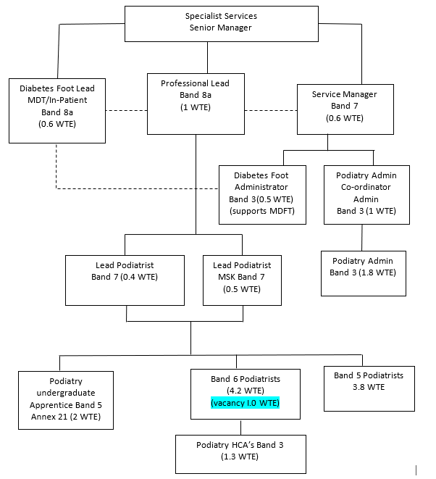

5. Main Tasks/ Duties and Areas of Responsibility

Clinical duties and responsibilities

To advise on foot health and provide education to patients on wards and in outpatient clinic areas
To provide training and support ward staff to complete foot checks
To take part in diabetic screening and the delivery of foot health education accordance with the agreed protocols using appropriate equipment e.g. monofilaments and Doppler’s
To refer patients on to Podiatrists within service protocols when necessary
Will occasionally assist the Podiatrist in wound management for high-risk patients preparing the equipment and patients for debridement and redressing the wound /ulcer following treatment by the Podiatrist working within the Trust Infection Control policy
To be responsible for the maintenance of appropriate documentation for patient’s records, statistical analysis captured on a daily basis, participating in departmental audits as necessary
To check in and out CSSD packs in accordance with service protocol
To access Epic when necessary to retrieve/ update patient notes in all clinical settings
To support ward staff in the update of Epic in relation to podiatry patients
To occasionally provide assistance to patients throughout the clinic sessions with hosiery, splints etc
To follow trust protocol when regularly moving patients in wheelchairs etc to and from clinics/wards/waiting rooms. This may be difficult in confined and often busy environments
To work sympathetically with patients who may have been given a poor prognosis/ diagnosis such as amputation many of who are elderly, have complex medical conditions or are terminally ill
To accurately collect and record data which may be complex and of a sensitive nature
The post holder will be responsible for collating data and outcome measures to support the quarterly transformation funding report
To attend regular staff meetings being an active member of the team engaging in discussions and decision making

Health and Safety
To be responsible for the Health and Safety of self, colleagues, patients and carers
To report any accidents, near misses and defects in equipment following Trust guidelines
To ensure that Health and Safety legislation is complied with at all times including workplace risk assessments, individual patient risk assessments, policies such as control of infection, sharps policy and lone working guidelines fire, resuscitation and manual handling policy
To be responsible for the safe use and daily maintenance of equipment
To attend mandatory training in line with Trust policy
To assess and manage risk as per Trust guidelines when working alone or in a changing busy environment where events may be unpredictable which occurs frequently on a daily basis
To support assessments of podiatric conditions with moderate physical effort on a daily basis
To deal with the health and safety implications of frequent exposure to difficult working conditions on a daily basis e.g. unpleasant strong odours, blood, sepsis, vomit gangrene etc and the occasional exposure to verbal and potential violent aggression
To comply with Health and Safety regulations with regard to COSSH. e.g. acids glues grinding dust in both outpatient clinic, ward and orthotics laboratory

Training and personal development
To keep CPD files up to date actively participating to develop new and update existing skills
To participate in the yearly mandatory resuscitation, manual handling and fire training
To take part in a yearly appraisal
To take part in clinical supervision at least six weekly within agreed protected time in line with Trust policy
The post holder will be given opportunities to undertake training to improve his/her skills

6. Communication and Working Relationships

Key Liaisons:
Patients/ carers/ relatives
Podiatry Professional Lead
Lead Podiatrists
Podiatrists and Podiatry assistants
Podiatry Operational Service Manager
Admin/ clerical staff
Ward staff
District Nurses/ Auxiliaries/ support staff
Specialist Nurses
Ambulance liaison
Neighbouring Trust staff
GP practice staff
Public Health workers/ school nurses
Computer/ information services staff
NHS Supplies
Other statutory Agency staff
Nursing/ Residential homes
Other Allied Health Professionals

Voluntary agencies

To work effectively and efficiently with all podiatrists within the Royal Devon University Healthcare Trust
To have close working relationship and communication with both primary and secondary care professionals including GP’s, nurses, AHP's plus engagement in multidisciplinary working to ensure a seamless delivery of care to patients
To liase with the administrative staff and office co-ordinator
To deal sensitively with patients, most of whom present with complex clinical conditions or multiple pathologies and frequently have physical, psychological and emotional conditions e.g. high levels of anxiety or aggression or confusion caused by pain, spreading infection, hearing loss, learning difficulties, physical difficulties, amputation, limited mobility, dementia, terminal illness
To be able to effectively and carefully deliver information directly to patients regarding difficult diagnosis or poor prognosis in a caring manner
To meet regularly with Podiatry Professional Lead / Lead and Specialist Podiatrists / Podiatry Operational Service Manager for advice and support
To deal with verbal complaints, verbally aggressive or distressed patients with the ability to diffuse the problem and avoiding escalation
To encourage productive relationships with all podiatry staff, Trust staff and outside agencies

This job description is not substantive and will be reviewed by the jobholder and appropriate manager as changes and developments are identified

HAZARDS:
Laboratory Specimens  Proteinacious Dusts |  | Clinical contact with patients | X | Performing Exposure  Prone Invasive Procedures | X
Blood/Body Fluids | X | Dusty Environment |  | VDU Use | X
Radiation |  | Challenging Behaviour | X | Manual Handling | X
Solvents |  | Driving | X | Noise | X
Respiratory Sensitisers |  | Food Handling |  | Working in Isolation | X
Cytotoxic drugs |  | Night working

Reviewed September 2022

PERSON PROFILE

Job Title: | Podiatry Assistant
Grade: | Band 3
Department: | Podiatry Service

CRITERIA REQUIRED | ESSENTIAL | DESIRABLE
Qualifications & Training | GCSE or equivalent qualification to demonstrate numeracy and literacy  Demonstrable experience of direct patient care in a healthcare setting  Demonstrable experience in a clinical setting in a healthcare assistant role  Proven knowledge of clinical procedures  Proven evidence of team working abilities  Proven ability to work unsupervised | Documented evidence of CPD NVQ level 3 in foot care as accredited by SOCAP
Specific Knowledge & Skills | Excellent oral and written communication skills  Demonstrate organisational skills  Practical ability to use Podiatry instruments and equipment safely  Demonstrate flexibility  Knowledge of standards of record keeping  Evidence of IT skills to ECDL standard or equivalent.  Ability to develop personal skill to carry out role | Counselling skills  Some knowledge of Podiatry
Special Experience | Managing own caseload  Working with the public  Experience of team and independent working | Working in a care environment  Some knowledge of the NHS
Physical Skills & Effort | Work under pressure and respond to change  To have the capability to assist and handle patients who may be immobile, wheelchair bound or bed-bound often in confined spaces
Emotional Effort | To have a responsible and caring attitude  To have developed skills to directly deal with patients in distress  To be able to act appropriately on receiving and conveying information of a sensitive/distressing nature
Mental Effort | Ability to work in a wide and unpredictable range of settings with frequent interruptions  To work under pressure with a high caseload
Requirements due to Working Environment | Ability to share workspace with others  Work in an environment which maybe unpleasant, malodorous, dirty due to blood sepsis etc.  Ability to travel independently to North Devon clinic locations

