JOB DESCRIPTION
1. JOB DETAILS

Job Title: Genomic Associate
Band: AfC Band 5
Duration: Fixed term, 12 months
Working pattern: Part time, 0.6 WTE
Reports to: Principal Genetic Counsellors
Department / Directorate: Peninsula Clinical Genetics, Specialist Services Division

2. JOB PURPOSE
The Genomic Associate (GA) is a newly established Healthcare Science Associate role within the Genomic Counselling workstream. The Genomic Associate role is designed to support the Clinical Genetics service and will have a role in several areas:

- Gathering patient and family information for assessments
- Supporting Whole Genome Sequencing (WGS) arrangements
- Supporting research recruitment for PCG studies

The Genomic Associate will work under the guidance of the Principal Genetic Counsellors. They will also work in collaboration with the Research Practitioner team. The Genomic Associate will gather relevant information from patients before and after clinic to support their assessment. They may be asked to focus on a specific area of care, such as the inherited cardiac service. The Genomic Associate will liaise with other departments and NHS trusts to obtain relevant information, including confirming diagnoses and test results. The Genomic Associate will have a direct clinical role in supporting the consent and sample arrangements for patients who have been identified for WGS testing. They will also support the research team to increase opportunities for research participation for patients within the Peninsula Clinical Genetics service. The role requires excellent interpersonal ability, experience in a clinical setting and strong organisational skills.

3. DIMENSIONS / KEY WORKING RELATIONS
Peninsula Clinical Genetics (PCG) is hosted by Royal Devon University Healthcare NHS Foundation Trust (RDUH). The main office is currently based at the hospital’s Heavitree site, Exeter. There are two satellite offices, in Plymouth and Truro, staffed by GC/GNCs and admin/secretarial staff. RDUH have electronic patient records (Epic) and PCG also uses a computerised patient management system, TrakGene. These systems can also be accessed and updated from the Plymouth and Truro offices, clinic locations and secure remote working sites, e.g. home. Videoconferencing via MSTeams is used in combination with face to face meetings, as appropriate.

There are currently eleven GC/GNCs (10 WTE) and seven consultants (5 WTE). The department hosts two STP trainees (2 WTE) and three Specialty Registrars. The clinical team is fully supported by an admin and clerical team. There is a Cluster Manager who is responsible for the Genetics Cluster (which includes Clinical Genetics, Exeter Genomic Laboratory and the SW Genomic Medicine Service Alliance), which sits within the Specialised Services Division of the Trust.

Clinics are held at all the main hospitals in the region (RDUH (Heavitree), Derriford Hospital in Plymouth, Treliske Hospital in Truro, North Devon District Hospital in Barnstaple and Torbay Hospital) and several community hospitals across the region. A significant proportion of consultations are now offered as virtual appointments (telephone and video). It is the goal of PCG, so far as is possible, to provide an equitable and accessible service throughout the Peninsula.

There are strong links with specialists in related disciplines in all hospitals in the Peninsula. PCG is an integral part of the Peninsula Cancer, Inherited Cardiac Conditions and Fetal Medicine networks. PCG has a satellite pre-implantation genetic diagnosis (PGD) service with Guy’s and St Thomas’ Hospital, the country’s leading PGD provider. PCG is a research-active department, with Consultants and GC/GNCs recruiting patients to a large number of national research studies and collaborating with international researchers on specific conditions.

Exeter Genomic Laboratory is held in very high national and international regard and has particular expertise in the use of exome and whole genome sequencing technologies. There is close liaison between the clinical and scientific teams. A recent focus has been effective multidisciplinary working in the context of variant interpretation; seeing genetic counsellors, clinicians and scientists collaborating to implement the new ACGS guidelines. The Exeter Genomic Laboratory is a partner in the South West Genomic Laboratory Hub.

Key working relationships:

- Principal Genetic Counsellors
- Genetic Counsellor/Genetic Nurse Counsellor team
- Research Practitioners and Lead Research Nurse
- Family History team
- Consultant Clinical Geneticists
- Clinical Scientists and Laboratory team
- Admin/Clerical/Secretarial team
- Cluster Manager
- Lead Clinician
- Admin Service/Line Manager
- Clinical Nurse Specialists & Allied health Professionals
- ORGANISATIONAL CHART:

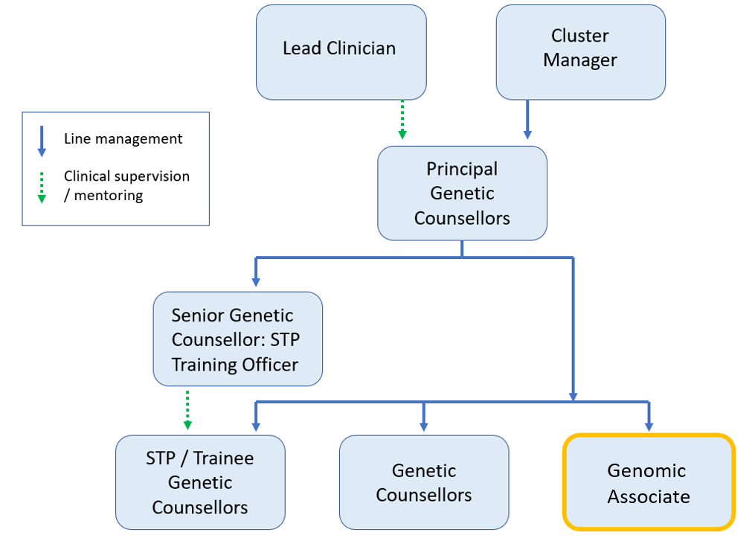

5. KEY RESULT AREAS/PRINCIPAL DUTIES AND RESPONSIBILITIES:
The post holder will work within the agreed job plan as below:

Communication with patients (with supervision from Consultants & Genetic Counsellors)
- Provide tailored information about WGS (whole genome sequencing) testing and research, as guided by Genetic Counsellors and Consultant Geneticists.
- Gather family history in a sensitive and empathetic manner.
- Communicate appropriately with patients regarding plans for their care within the Genetics service.
- Identify and respond to emerging issues for the patient and family and report any concerns to appropriate member of the clinical team.
- Support clinicians in obtaining informed consent for genetic investigations.
- Uphold the confidentiality of the individuals who have used the Genetics Service, acknowledging the specific sensitivity of the information and issues involved e.g. termination of pregnancy, non-paternity.
- Provide information and support to patients involved in research or clinical trials through the Genetics Service.

Communication with colleagues (with supervision as above)
- Liaise with laboratory colleagues as required to confirm availability of samples and results.
- Liaise regionally, nationally and internationally with other laboratories, departments, e.g.: histology, surgery, screening, midwifery, psychiatry, cardiology, cancer registry to obtain and provide information.
- Discuss all cases with supervising colleagues and follow their guidance.
- Liaise with administrative staff regarding patient records, appointments and WGS processes.
- Work with the Family History team to gather detailed information for genetic assessment.
- Work with the Research Team to identify appropriate patient studies and facilitate recruitment.

Patient Care (with supervision as above)
- Obtain informed consent for WGS following Consultant or Genetic Counsellor assessment.
- Confirm diagnostic and family information to support assessment.
- Obtain informed consent for research studies where delegated to do so by the Principle Investigator.
- Construct or update pedigrees and records in line with departmental policy.
- May be required to assist in the running and organisation of regional specialty clinics.
- Ensure that the views of patients, or those speaking on their behalf are heard and that complaints, both formal and informal, are received courteously and responded to promptly according to Trust guidelines.
- Ensure equity of access to information and risk assessment by identifying extra support for patients who English may not be their first language or who have a disability and may require additional support e.g. use of interpreters, involvement of learning disability nurse specialist.
- May be required to undertake venepuncture, height / weight / blood pressure measurements, with appropriate training.
- Recognise own limitations: assess the need for onward referral and refer for advice to members of the genetic counselling / medical team where appropriate.
- Help to arrange biochemical tests where requested by supervising colleagues.

Planning & Organisation
- Maintain appropriate records for WGS including tracking of samples, consent and results.
- Gather family history detail in support of genetic counsellors, consultants, and in collaboration with the family history team.
- Obtain all relevant clinical and laboratory information requested.
- Assist in specialist clinics if required e.g.: preparing cases for cardiac MDT.
- Attend clinic with the doctor or specialist genetic counsellor if required.
- Assist in monitoring and auditing within the department
- Maintain appropriate research records, in collaboration with Research Team.

Policy & Service Development
- Propose changes to working practices within the department.
- With guidance, design protocols and policies to enhance the smooth running of services

Information Resources
- Ensure that all clinical documents are up-to-date, accurate, legible and appropriately completed, including pedigrees and electronic records (the department primarily records data on the EPIC system).
- Accurately record data on patient information systems and use in-house databases.
- Create databases or spreadsheets using computerised systems.

Staff Supervision & Training
- Provide advice and demonstrate workplace activities to new and less experienced members of staff.

Research & Development
- Assist in surveys or audits of own and departmental clinical practice to maintain clinical governance and audit profile of the department.
- May be required to assist in patient data collection for the purpose of genetic related departmental research / audit.

Professional
- Take personal responsibility for continuing professional self-development and keep up to date with changes in the practice of medical genetics.
- Attend appropriate meetings and seminars.
- Demonstrate a commitment to lifelong learning and self-development objectively reviewing own performance and development needs within the Trust and AGNC competency frameworks and where relevant NMC requirements.
- Take opportunities to represent or contribute to the development of the speciality/profession at local, regional, and national level.
- Participate in Good Clinical Practice (GCP) training.

Continually evaluate own practice and performance with genetic counselling team
- Maintain an effective working environment in which the service delivered is continually reviewed.
- Contribute to the creation of a climate of co-operation and flexible team working.
- Contribute to the effective management of change in response to clinical or organisational demands.
- Where appropriate: Adhere to the NMC or GCRB code of conduct, renew annual membership and maintain registration.

Other Responsibilities:

Take part in regular performance and development review.

Undertake any training required in order to maintain competency including mandatory training, e.g. Fire, Manual Handling.

Contribute to and work within a safe working environment.

Comply with Trust Infection Control Policies and conduct yourself at all times in such a manner as to minimise the risk of healthcare associated infection.

As an employee of the Trust, it is a contractual duty that you abide by any relevant code of professional conduct and/or practice applicable to you. A breach of this requirement may result in action being taken against you (in accordance with the Trust’s disciplinary policy) up to and including dismissal.

You must also take responsibility for your workplace health and wellbeing:
- When required, gain support from Occupational Health, Human Resources or other sources.
- Familiarise yourself with the health and wellbeing support available from policies and/or Occupational Health.
- Follow the Trust’s health and wellbeing vision of healthy body, healthy mind, healthy you.
- Undertake a Display Screen Equipment assessment (DES) if appropriate to role.
This post has been identified as involving access to vulnerable adults and/or children and in line with Trust policy successful applicants will be required to undertake a Disclosure & Barring Service Disclosure Check.

Diversity at RDUH
The RDUH is committed to working to become a national exemplar for diversity and inclusion. We aim to create a positive sense of belonging for everyone, regardless of their background or identity, to value visible and invisible differences and to create a sense of belonging.
For us, inclusion is about positively striving to meet the needs of different people and creating environments where everyone feels respected and able to achieve their full potential. However, we know that there is a lot to learn and do, and we are committed to doing so because it’s the right thing to do for both staff and the people we care for. No person (staff, patient or public) will receive less favourable treatment on the grounds of the nine protected characteristics as governed by the Equality Act 2010 regardless of race, age, disability, ethnicity, nationality, gender, gender reassignment, sexual orientation, religion or belief, marriage and civil partnerships. We have set up staff B.A.M.E., Disability and LGBTQIA+ networks to help guide our ongoing work.

GENERAL
This is a description of the job as it is now. We periodically examine employees' job descriptions and update them to ensure that they reflect the job as it is then being performed, or to incorporate any changes being proposed. This procedure is conducted by the Manager in consultation with the jobholder. You will, therefore, be expected to participate fully in such discussions. We aim to reach agreement on reasonable changes, but if agreement is not possible, we reserve the right to insist on changes to your job description after consultation with you.
Everyone within the Trust has a responsibility for, and is committed to, safeguarding and promoting the welfare of vulnerable adults, children and young people and for ensuring that they are protected from harm, ensuring that the Trusts Child Protection and Safeguarding Adult policies and procedures are promoted and adhered to by all members of staff.

PERSON SPECIFICATION

REQUIREMENTS | Essential | Desirable
QUALIFICATIONS / TRAINING
Registered General/Children’s Nurse, Registered Midwife or  Registered Health Visitor with current N.M.C Registration  OR  Degree or equivalent in a relevant subject (e.g. Healthcare and/or Biological Science/Medical Genetics) PLUS relevant experience in a healthcare setting  OR  Equivalent skills and experience | E  E  E
Good Clinical Practice (GCP) Training |  | D
Counselling certificate |  | D
Genetics training /experience |  | D
Diploma or degree in health / nursing related Studies |  | D
Continuing professional development/ reflective profile |  | D
KNOWLEDGE / SKILLS
Ability to work within a multidisciplinary environment, as part of a team | E
Ability to assess, plan, deliver, prioritise and evaluate patient interaction | E
Recognition of own level of competence and limitations and able to communicate these to appropriate staff member | E
Excellent verbal, telephone and written communication skills | E
Ability to identify own learning needs | E
Ability to plan and prioritise workload effectively | E
Ability to use IT effectively to maintain appropriate records, including tracking samples and recording patient information | E
Counselling skills |  | D
Knowledge of genetics |  | D
Experience of pedigree construction |  | D
Knowledge of the Mental Capacity Act |  | D

EXPERIENCE
Experience in a patient/client facing setting | E
Experience coping with upset or distressed individuals | E
Experience dealing with sensitive or potentially distressing information | E
Experience of research |  | D
Experience of working in a Regional Genetics service |  | D
Experience of NHS record keeping |  | D
Experience of electronic patient record systems (e.g. – Epic) |  | D
PERSONAL ATTRIBUTES
Excellent attention to detail | E
Highly motivated, flexible and adaptable | E
Ability to work within a multidisciplinary team | E
Ability to self-motivate and work autonomously when needed | E
Awareness and respect for the needs and values of patients and colleagues | E
Commitment to further professional training | E
Empathetic demeanour | E
An appreciation of the impact of inherited disease on patients and their families. | E
OTHER REQUIREMENTS
Phlebotomy |  | D
Knowledge and previous experience of using PC software, including word processing and databases. | E

HAZARDS:- Updated May 2023
Laboratory Specimens | √ | Clinical contact with Patients | √ | Dealing with violence & aggression of patients/relatives
Blood / Body Fluids | √ | Dusty Environment |  | VDU Use | √
Radiation / Lasers |  | Challenging Behaviour | √ | Manual Handling | √
Solvents |  | Driving | √ | Noise / Vibration
Respiratory Sensitisers |  | Food Handling |  | Working in isolation (occasional) | √
Cytotoxic Drugs |  | Electrical work |  | Night Working

