JOB DESCRIPTION

This post has been identified as involving access to vulnerable adults and/or children and in line with Trust policy successful applicants will be required to a undertake an Enhanced Disclosure Check.

1. JOB DETAILS

Job Title: Biomedical Scientist

Band: 6

Responsible to: Clinical Director – Diagnostic Services

Accountable to: Laboratory Manager

Section/Department/
Directorate: Blood Sciences

2. JOB PURPOSE

To ensure provision of the scientific service commitment of the laboratory in line with Trust objectives and commensurate with grade and responsibilities.
• To provide a high-quality analytical, advisory and interpretive service to clinicians for the processing of pathological specimens in the specialty of Haematology, Immunology and Blood Transfusion.
• To ensure departmental quality standards are maintained through adherence to standard operating procedures, implementation of quality control programmes and instrumentation maintenance and troubleshooting.
• To assist the department in the continual training of staff.
• Participate in the Departmental Out-of-Hours shift and on-call services as an autonomous practitioner.
• To contribute to the maintenance of quality standards by actively participating in audit and quality management activities.
• To play an active role in the coordination of all trial and development work carried out by the laboratory.

3. KEY WORKING RELATIONSHIPS

- Clinical Head of Department
- Laboratory Manager
- Deputy Laboratory Manager
- Band 7 BMS Haematology
- Band 7 BMS Immunology
- Band 7 BMS Transfusion
- Other BMS
- MTO staff
- Trust and PCT Clinical/Nursing Staff

4. DIMENSIONS

- The laboratory provides a comprehensive service of routine and specialised analysis for Haematology, Immunology and Transfusion investigations
- The laboratory has full UKAS accreditation and the MHRA for provision of blood products
- The department offers a full clinical interpretive service in all areas
- The department employs 30 scientific members of staff within the areas of Automated Haematology, Coagulation, Proteins, Morphology, Automated Immunology, Flourescent Microscopy, Blood Grouping, Cross Matching, Product Issue, Specialist Serology.

5. ORGANISATIONAL CHART

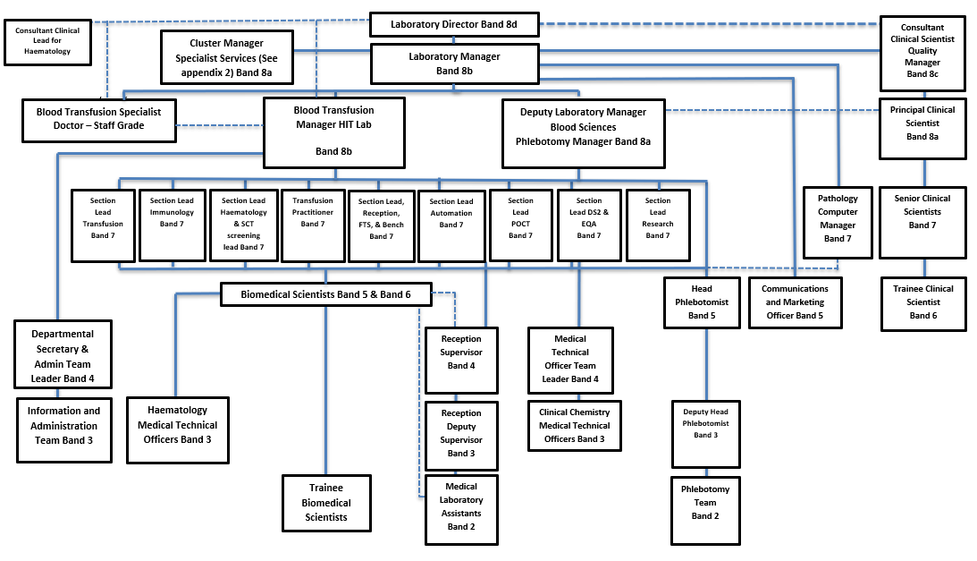

6. KEY RESULT AREAS / PRINCIPAL DUTIES AND RESPONSIBILITIES
Scientific and Technical
- To work unsupervised throughout the sections of Haematology, Coagulation, and Blood Transfusion
- To be responsible for ensuring all work in the section is completed and undertaken to the quality standards agreed by the Quality Management Team.
- To operate and quality control the departments’ automated equipment and point of care equipment.
- To undertake manual and semi-automated assays.
- To be responsible for validating all results produced when operating the analysers or undertaking manual techniques.
- To undertake all work in accordance with current SOPs and departmental policies.
- When necessary to undertake the work of more junior grades
- To undertake final approval of results from the laboratory computer system.
- To maintain, troubleshoot and repair faults on laboratory instruments and point of Care equipment and liase with service engineers as required.

Quality Systems, Organisation, Objectives and Planning
- To maintain competency and knowledge levels required to perform duties commensurate to grade
- To maintain IT skills and knowledge sufficient to operate the departments’ current IT system
- To use the departments’ computerised Quality Management system
- To undertake departmental audits
- To report any non conformancies and undertake remedial action using the current laboratory reporting system.
- To undertake all work in a manner consistent with Trust policies
- To maintain Health and Care Professions Council registration
- To work in compliance with UKAS, MHRA and HTA standards and legal requirements.
- Review daily Quality Control results for analyser systems.
- Participate in research and development programs as required.
- Work closely with other staff groups to ensure that all R&D samples are processed in an efficient manner.
• Play an active role in the development, verification, validation and implementation of new assays.

Training, Education, CPD, Development and Human Resources
- To supervise trainee BMS, MTO and MLA staff.
- To assist in the training of BMS, MTO and MLA staff
- To undertake CPD to maintain Health and Care Professions Council registration
- To participate in the departments’ Annual Performance Review and Development Interviews
- To participate in the departments’ annual competency assessment scheme
- To undertake training required in order to maintain competency, including mandatory training i.e. Fire, Manual Handling

Communication
- To give appropriate scientific advice on Haematology and Transfusion tests and blood/blood products to clinical staff within the Trust and Community
- To use electronic and verbal communication within the department and the Trust
- To participate in departmental meetings meetings
- To be active in the departments’ change and improvement processes.

Out of Hours Working
- To participate in Haematology/Transfusion out of hours working. During these periods, to be the sole HCPC registered BMS in the department.
- To be able to prioritise workload and provide accurate, timely and relevant reports to users.

Other
- To contribute to and work within a safe working environment.
- The post holder is expected to comply with Trust Infection Control Policies and conduct him/herself at all times in such a manner as to minimise the risk of healthcare associated infection.

THE TRUST - PURPOSE AND VALUES

We are committed to serving our community by being a high quality specialist Hospital with consultant-led services. We aim to co-ordinate our services with primary and community care, and to develop a limited number as Sub-Regional Referral Centres with appropriate levels of research, development and educational involvement. Where appropriate, and consistent with our services, we may provide services aimed at preventing disease and debilitation.

We aim to make all our services exemplary in both clinical and operational aspects. We will show leadership in identifying healthcare needs to which we can respond and in determining the most cost-effective way of doing so. We will share our knowledge with neighbouring healthcare agencies and professionals.

We recruit competent staff whom we support in maintaining and extending their skills in accordance with the needs of the people we serve. We will pay staff fairly and recognise the whole staff’s commitment to meeting the needs of our patients.

GENERAL

This is a description of the job as it is now. We periodically examine employees' job descriptions and update them to ensure that they reflect the job as it is then being performed, or to incorporate any changes being proposed. This procedure is conducted by the Manager in consultation with the jobholder. You will, therefore, be expected to participate fully in such discussions. We aim to reach agreement on reasonable changes, but if agreement is not possible, the Trust reserves the right to insist on changes to your job description after consultation with you.

As an employee of the Trust, it is a contractual duty that you abide by any relevant code of professional conduct and/or practice applicable to you. A breach of this requirement may result in action being taken against you (in accordance with the Trust’s disciplinary policy) up to and including dismissal.

The RD&E is a totally smoke-free Trust. Smoking is not permitted anywhere on Trust property, including all buildings, grounds and car parks. For help to quit call 01392 207462.

JOB DESCRIPTION AGREEMENT:

Jobholder’s Signature: ................................................................................

Date: .................................................................................

Manager’s Signature: .................................................................................

Date: ................................................................................

ROYAL DEVON & EXETER NHS FOUNDATION TRUST
PERSON SPECIFICATION

POST: Biomedical Scientist
BAND: 6

REQUIREMENTS |  | E/D* | MET | NOT MET
QUALIFICATIONS/SPECIAL TRAINING:
State Registration HCPC  Have a suitable honours degree or equivalent  IBMS Specialist Portfolio or equivalent |  | E  E  E
KNOWLEDGE/SKILLS:
Experience of Haematology and Coagulation  Experience of Blood Morphology  Experience of Hospital Blood Transfusion  Knowledge of Clinical Immunology |  | E  E  E  D
EXPERIENCE:
Post HCPC registration experience in a UK based combined Haematology/Transfusion Laboratory  Use of laboratory computer system  Experience of Flow Cytometry  Experience of Automated Transfusion |  | D  E  D  D
PERSONAL REQUIREMENTS:
Excellent Team Worker  Good Communication Skills  Able to work in a busy environment  Good Attendance Record  Initiative and Enthusiasm  Ability to Meet Deadlines |  | E  E  E  E  E  E
OTHER REQUIREMENTS:
Ability to participate in 24 hour / 7 day work pattern  Evidence of CPD  Flexible work patterns | E  E  D
Reason to appoint/not appoint
*Essential/Desirable

HAZARDS:
Laboratory Specimens Proteinacious Dusts |  | Clinical contact with patients |  | Performing Exposure Prone Invasive Procedures
Blood / Body Fluids |  | Dusty environment |  | VDU Use | 
Radiation |  | Challenging Behaviour |  | Manual Handling | ✓
Solvents |  | Driving |  | Noise
Respiratory Sensitisers |  | Food Handling |  | Working in isolation
Processing Chemistry |  | Handling Cytotoxic Drugs |  | Night Working

