

JOB DESCRIPTION

JOB DETAILS
Job Title | Dietetic Support Worker – Acute
Reports to | B7 Clinical Team Lead for the Acute Dietetic Team
Band | B3
Department/Directorate | Nutrition and Dietetics / Specialist Services

JOB PURPOSE
The post holder will support registered dietetic staff in the provision of the dietetic service to inpatients and outpatients. They will review the patient’s nutritional intake after assessment and plan made by the registered dietitian. They may make alterations to nutritional care plans (within protocols and scope of practice) as they monitor patient progression.
Any patient falling outside their scope of practice, or who are deteriorating, are referred onto the registered dietitian. The post holder will regularly work independently with the supervision of a registered dietitian.

KEY RESULT AREAS/PRINCIPAL DUTIES AND RESPONSIBILITIES
The Dietetic Support Worker will have the following key duties and responsibilities:
- Assist the registered dietitian with the triage and prioritisation of referrals in line with Departmental policy. After the registered dietitian has assessed and made the nutritional care plan review progress of patients under dietetic care on the ward/outpatients or over the telephone. Monitor patient compliance and tolerance of specialist dietary products and report back to registered dietitian.
- Obtain baseline anthropometric measurements e.g. height, weight, body mass index (BMI), mid upper arm circumferences (MUAC) and handgrip strength as required for monitoring of patient progress. Enter food records into dietary assessment packages as required.
- Liaise with ward and catering staff to ensure meals and nutritional supplements/snacks prescribed are received. Assist patients and housekeepers in making appropriate choices for special diets using set procedures, often working alone with support available. Carry out taste testing of nutritional supplements with patients.
- To assist the registered dietitian and nursing staff with effective home enteral feeding discharge planning including the provision of one to one pump training for patients/carers on how to use an enteral feeding pump at home, complete associated paperwork and patient registrations and liaise with community partners.
- Promote the importance of nutrition and hydration within the multidisciplinary team and the wider healthcare community.
- Contribute to development of patient care by attending and participating in relevant team, departmental or clinical and multi-disciplinary team (MDT) meetings.
- Provide training to other healthcare professionals, medical and dietetic students on use of nutritional screening tools, e.g. Malnutrition Universal Screening Tool (MUST) with either a one to one or group basis as requested.
- Help organise and run health promotion and department events and be innovative with regards to events organisation and be self-directed in the setting up and management of events.
- To support the day to day running of the Nutrition and Dietetic Department with ordering supplies, patient information leaflets and nutritional samples.
- Check voicemail messages regularly throughout day and document in message book.
- Any other duties as required by Line Manager / Nutrition and Dietetic Service Manager.

KEY WORKING RELATIONSHIPS
Areas of Responsibility: To review plans of care put in place by the registered dietitian. To support the registered dietitian in group education sessions and health promotion activities. Monitor stock levels of nutritional samples, home enteral feeding equipment and diet sheets and patient written information.

No. of Staff reporting to this role: none

The post holder is required to deal effectively with staff of all levels throughout the Trust as and when they encounter on a day to day basis. In addition, the post holder will deal with the wider healthcare community, external organisations and the public. This will include verbal, written and electronic media.

Of particular importance are working relationships with:

Internal to the Trust | External to the Trust
- Dietetic team  - Catering Department  - Members of multi-disciplinary team.  - Patients and carers  - Ward staff | - Home feeding company nurses and team.

ORGANISATIONAL CHART
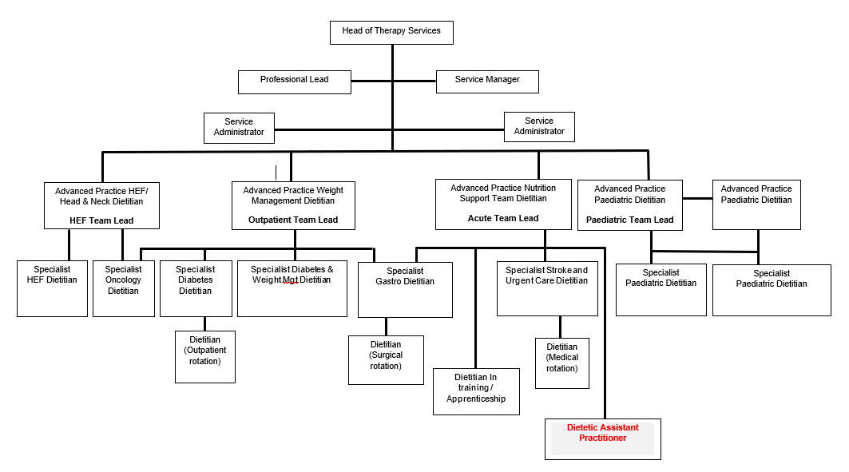

FREEDOM TO ACT
- The post holder will review and monitor nutritional care plans using established precedents, standard operating procedures and good practice.
- A registered dietitian is available for reference at regular intervals. Work may be checked on a random basis.
- The post holder will refer any patients that are deteriorating or outside their sphere of competence to a registered dietitian for ongoing review and care.

COMMUNICATION/RELATIONSHIP SKILLS
- To utilise excellent interpersonal skills when encouraging patients and parents/carers with their nutritional intake, or making changes to long standing nutritional behaviours, such as empathy, tact and motivational skills.
- To adapt and deliver age appropriate communication styles to ensure people of all ages, as well as carers, are able to participate in the consultation and be empowered to make dietary changes.
- To support patients and carers with barriers to understanding due to learning disabilities or other neurological conditions.
- To utilise alternative communication methods for people with language difficulties such as those with deafness or for those who English is not their first language.
- To support patients, carers, staff and relatives by providing education and advice as appropriate under the instruction of the registered dietitian.
- To provide written information as appropriate.
- To provide appropriate and timely information to all relevant members of the healthcare team regarding patients’ nutritional progress, highlighting any variations to patient complexity and expected outcomes from treatment plans delivered.
- To challenge inequality at all levels.
- To gain valid informed consent.

ANALYTICAL/JUDGEMENTAL SKILLS
- To gather relevant clinical, social and nutritional information when reviewing patients and be able to adapt advice based on this analysis to carers as required.
- To recognise and escalate the nutritionally deteriorating patient to the registered dietitian.

PLANNING/ORGANISATIONAL SKILLS
- To organise their own workload under the supervision of the registered dietitian.
- To be responsible for administrative arrangements in the area they work e.g. booking rooms for others.
- To ensure the department resources are stocked, up to date and organised for ease of use.
- Organise agendas and take minutes/actions at team meetings.

PATIENT/CLIENT CARE
- To provide clinical nutritional assessment, nutritional care planning and nutritional advice to patients and their carers contributing to their well-being and care. The nutritional care plan may need modifications during monitoring and evaluation within prescribed parameters and standard operating procedures.
- To provide nutritional education to patients and/or carers including use of equipment such as enteral feeding pumps, making up nutritional supplements.
- To support and run group sessions for patients and carers under the guidance of the registered dietitian

POLICY/SERVICE DEVELOPMENT
- To comment on any proposed changes to services or policies as required.
- To contribute to the improvement of the dietetic service by evaluation of own work, and make constructive suggestions as to service improvements.
- Maintain personal safety by following lone working policy and respect property and equipment within the working environment in accordance with Trust and team guidelines.

FINANCIAL/PHYSICAL RESOURCES
- Order supplies from EROS for the dietetic team on request.
- To ensure appropriate stock levels of nutritional samples for ward use are maintained.
- To ensure diet sheets and other written patient resources are ordered in a timely way and discarded when obsolete or out of date.
- Order, supply and maintain stock levels of feeding tubes and ancillaries and keeping relevant spread sheets updated.

HUMAN RESOURCES
- To assist with induction of new staff and students as appropriate.
- Contribute to the training of ward staff on an individual or group basis as required.

INFORMATION RESOURCES
- To maintain timely and accurate personally generated records and information as required, this includes entering information on to electronic databases.
- Compile audit results into a report for registered dietitian.
- Assess food records using dietary assessment computer packages as required under the direction of the supervising dietitian and carry out accurate nutritional assessments and macronutrient analysis. This information is inputting information compiled by others.
- To undertake internet and literature searches as requested by the dietitian.
- Organise agendas and take minutes/actions at team meetings.
- Maintain department social media pages and lead on social media support pages and services for patients.

RESEARCH AND DEVELOPMENT
- To participate in team audit activity and peer review to ensure best practice.
- To provide information for clinical trials as requested. Support registered dietitian with any research activities.
- To keep updated in changes in guidelines, protocols and evidence-base so as to inform practice.

PHYSICAL SKILLS
- The post holder will use standard keyboard skills. Data recorded must be accurate, timely and comprehensive.
- Obtain baseline anthropometric measurements e.g. height, weight, body mass index (BMI), mid upper arm circumferences (MUAC) and handgrip strength required for monitoring of patients’ progress.
- Manual dexterity is required when educating patients and carers to use an enteral feeding pump. This includes connecting the feed bag to giving set, manipulating giving sets into the feeding pump and connecting giving set to the feeding tube (gastrostomy, jejunostomy or nasogastric).

PHYSICAL EFFORT
- The postholder will frequently sit and stand in restricted positions at the patients’ bedside, during administrative tasks, when performing food measurements and when training on the use of the enteral feeding pump. This is a substantial proportion of the working day.
- The post holder will occasionally exert moderate physical effort in a shift with lifting and handling objects (diet sheets, nutritional supplements; enteral feeding pump, with stand and feed) that weigh up to 15kg.
- There may be an occasion where the post holder will complete anthropometric measurements such as weight and height.

MENTAL EFFORT
- The post holder will have a frequent requirement for concentration where the work pattern is predictable. The postholder may need to adjust priorities for caseload based on service requirements.

EMOTIONAL EFFORT
- The postholder will have occasional exposure to distressing emotional circumstances such as distressed dementia patients, those with delirium or after a life changing diagnosis.
- There may be occasional direct exposure to highly challenging behaviour from people with dementia.
- There will be infrequent or rare indirect exposure to distressing emotional circumstances such as death of a patient or details of a safeguarding incident.

WORKING CONDITIONS
- Frequent VDU use.
- The post holder may have occasional exposure to verbal aggression from patients with dementia, delirium or learning disabilities.
- There may be incidental exposure to uncontained bodily fluids such as vomit, sputum or urine but would not be required to deal with these fluids.

OTHER RESPONSIBILITIES
Take part in regular performance appraisal.

Undertake any training required in order to maintain competency including mandatory training, e.g. Manual Handling

Contribute to and work within a safe working environment

You are expected to comply with Trust Infection Control Policies and conduct him/herself at all times in such a manner as to minimise the risk of healthcare associated infection

As an employee of the Trust, it is a contractual duty that you abide by any relevant code of professional conduct and/or practice applicable to you. A breach of this requirement may result in action being taken against you (in accordance with the Trust’s disciplinary policy) up to and including dismissal.

You must also take responsibility for your workplace health and wellbeing:
- When required, gain support from Occupational Health, Human Resources or other sources.
- Familiarise yourself with the health and wellbeing support available from policies and/or Occupational Health.
- Follow the Trust’s health and wellbeing vision of healthy body, healthy mind, healthy you.
- Undertake a Display Screen Equipment assessment (DES) if appropriate to role.

DISCLOSURE AND BARRING SERVICE CHECKS
This post has been identified as involving access to vulnerable adults and/or children and in line with Trust policy successful applicants will be required to undertake a Disclosure & Barring Service Disclosure Check.

GENERAL
This is a description of the job as it is now. We periodically examine employees' job descriptions and update them to ensure that they reflect the job as it is then being performed, or to incorporate any changes being proposed. This procedure is conducted by the manager in consultation with the jobholder. You will, therefore, be expected to participate fully in such discussions. We aim to reach agreement on reasonable changes, but if agreement is not possible, we reserve the right to insist on changes to your job description after consultation with you.

Everyone within the Trust has a responsibility for, and is committed to, safeguarding and promoting the welfare of vulnerable adults, children and young people and for ensuring that they are protected from harm, ensuring that the Trusts Child Protection and Safeguarding Adult policies and procedures are promoted and adhered to by all members of staff.

PERSON SPECIFICATION

Job Title | Dietetic Support Worker – Acute

Requirements | Essential | Desirable
QUALIFICATION/ SPECIAL TRAINING  - GCSE Grade C or equivalent in English and Mathematics  - NVQ Level 3 or equivalent  - Food Hygiene certificate | E  E | D
KNOWLEDGE/SKILLS  - Excellent communication skills, both verbal and written  - Good time management, ability to plan and prioritise work  - Ability to motivate, negotiate and encourage  - Computer and keyboard skills – must be competent on computers and able to use Word/Excel/Powerpoint/Publisher to a high standard  - Ability to concentrate on tasks with an unpredictable work pattern  - Ability to use own initiative, but recognise own limitations and seek instruction when needed  - Ability to take instruction and carry out duties under direction of supervising Dietitian  - Demonstrates an ability to learn new skills  - Ability to follow Trust, Department Policies and Guidelines  - Awareness and ability to maintain patient confidentiality  - Knowledge of available nutritional supplements / enteral feeds used in hospitals and the differing clinical indications  - Teaching and presentation skills | E  E  E  E  E  E  E  E  E  E  E | D
EXPERIENCE  - Work in a healthcare and/or food related environment  - Demonstrates experience of working well as part of a team  - Demonstrates experience of working with the public/patients  - Experience of working with adults with dementia  - Ability to write and present information using Powerpoint, Word, Publisher and Excel  - Experience of carrying out audits or service development  - Production of information leaflets  - Experience of organising and managing events | E  E  E  E | D  D  D  D
PERSONAL ATTRIBUTES  - Interest in food and working in a healthcare environment  - Patience and enthusiasm for working with people  - Self-motivated and enthusiastic with the ability to work independently and flexibly  - Reliable  - Empathy with people and able to cope with distressed individuals in tactful and sensitive manner  - Team player, able to maintain effective working relationships | E  E  E  E  E  E  E
OTHER REQUIREMENTS  - The post holder must demonstrate a positive commitment to uphold diversity and equality policies approved by the Trust.  - Ability to travel to other locations as required.  - Willingness to undertake training as identified by training needs  - Enthusiastic towards post | E  E  E  E  E

FREQUENCY

(Rare/ Occasional/ Moderate/ Frequent)
WORKING CONDITIONS/HAZARDS |  | R | O | M | F
Hazards/ Risks requiring Immunisation Screening
Laboratory specimens | N
Contact with patients | Y
Exposure Prone Procedures | Y
Blood/body fluids | Y
Hazard/Risks requiring Respiratory Health Surveillance
Solvents (e.g. toluene, xylene, white spirit, acetone, formaldehyde and ethyl acetate) | N
Respiratory sensitisers (e.g isocyanates) | N
Chlorine based cleaning solutions  (e.g. Chlorclean, Actichlor, Tristel) | N
Animals | N
Cytotoxic drugs | N
Risks requiring Other Health Surveillance
Radiation (>6mSv) | N
Laser (Class 3R, 3B, 4) | N
Dusty environment (>4mg/m3) | N
Noise (over 80dBA) | N
Hand held vibration tools (=>2.5 m/s2) | N
Other General Hazards/ Risks
VDU use ( > 1 hour daily) | Y
Heavy manual handling (>10kg) | Y
Driving or ability to use transport | Y
Food handling | Y
Night working | N
Electrical work | N
Physical Effort | Y
Mental Effort | Y
Emotional Effort | Y
Working in isolation | Y
Challenging behaviour | Y

