JOB DESCRIPTION

1. JOB DETAILS

Job Title: Appointment Slot Administrator

Band: 3

Responsible To: Team Leader / Admin Line Manager

Accountable To: Admin Service Manager

Department/Division: Operational Services – Central Booking Office

2. JOB PURPOSE

- Support the Administration Line Managers by:
  - Coordinating a professional, efficient and effective reception and appointment booking service to patients and visitors in accordance with Trust policies and standards
  - Coordinating an organised and efficient clinical Out Patient timetable
  - Setting up and altering clinics as required and coordinating room availability
- Ensure all referral processes, pending lists, reminder service reports, appointments and enquiries are dealt with in an efficient and timely manner and escalate to senior manager as appropriate
- Undertake general clerical duties to maximise all available outpatient capacity in an appropriate way
- Ensure all information is secure and confidentiality of information is maintained at all times
- Provide excellent customer care which may include communication with distressed and anxious patients and relatives, treating them with tact and empathy
- Ensure the professional image of the Trust is maintained at all times

3. KEY WORKING RELATIONS

- Administrative Services Manager/Administrative Line Manager
- Consultants and other members of the clinical team
- Patients and their relatives
- GPs
- Divisional Management team
- Senior Nursing staff and other ward staff
- Other members of the multi-professional clinical team
- Health Records & IM&T Departments
- Administration and secretarial teams across the Trust
- Central Support Team

4. DIMENSIONS

- The post holder will be part of a Trust Administration team. This post may involve some evening/weekend working as required.

5. ORGANISATIONAL CHART
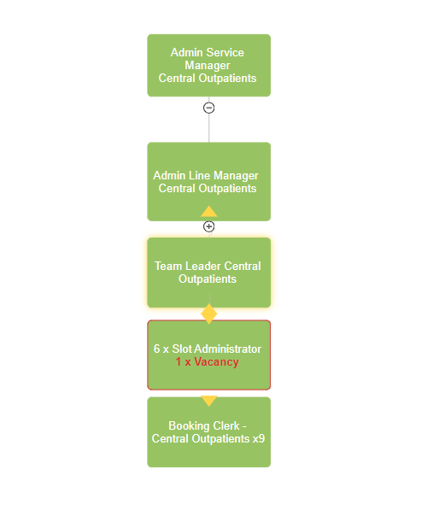

6. KEY RESULT AREAS/PRINCIPAL DUTIES AND RESPONSIBILITIES:

Supervisory
- To act in a supervisory capacity to a team of clerical staff including allocating work, resolving straight forward staffing issues and sharing best practice
- To use own initiative to prioritise daily workload of self and team to meet the changing demands of the service

Administrative functions
- To ensure outcomes are recorded timely and follow up appointments are made where appropriate
- Monitor clinics daily to ensure full utilisation of slots and escalate any issues to Admin Line Managers
- Monitor pending lists and action any Appointment Slot Issue requests ensuring all patients are booked within waiting times and breach dates
- To liaise with Consultants to ensure referral grading is undertaken on a daily basis
- To liaise closely with medical secretaries and provide specialist knowledge where necessary
- To understand the outpatient waiting list and Referral To Treatment (RTT), NHS E-Referral Service processes to ensure that RTT waiting times meet NHS standards and targets and are managed in line with the Trust Access policy
- Use multiple computer systems as required within the department such as PAS, NHS E-referrals, CRIS
- Ensure accurate and up-to-date patient details are maintained on patient information systems such as EPIC in line with Trust Information Governance policy
- Maintain health records and patient files in line with Trust Health Records Policy
- Respond to complaints where appropriate, escalating to Line Manager if unable to resolve

Service delivery/improvement
- Contribute to the NHS service improvement/modernisation agenda e.g. service redesign
- Work as part of the team in developing processes within the department to meet the demands of a growing service
- Participate in team and directorate meetings as required
- Contribute to audits regarding departmental procedures
- Have a flexible approach to working hours to meet the demands of the service
- Adhere to the Trust Access Policy and Health Records Policy and appropriate standard operating procedures, Key Performance Indicators, government targets and standard operational policies

Communication
- Maintain direct contact with clinicians and senior managers to ensure clinics run smoothly with maximum capacity and appropriate bookings
- Make and receive telephone calls both external and internal according to Trust standards
- Take messages, ensuring they are actioned and/or received by the correct recipient
- Communicate effectively including discussion and written communication
- Proactively manage email communication in line with the RD&E’s Email Best Practice guidance
- Provide excellent customer care, in a calm and professional manner – some situations may be challenging
- Organise and/or support meetings through effective communication

Governance
- Undertake training as required to maintain competency/comply with trust policies
- Work within Trust policies – including those for confidentiality, data protection, health and safety fire protection, and annual appraisal
- Adhere to the Trust Access Policy, Key Performance Indicators, government targets and standard operational policies and procedures

Resource Management
- Provide cover in periods of absence as directed by department manager, this may involve moving to other areas
- Monitor use of supplies and stationery and ensure this is done efficiently and cost effectively in line with the needs of the service

Additional Responsibilities
- The post holder will be expected to carry out any other duties as required, commensurate with their pay band
- The post holder will be required to facilitate and support new starters to carry out their role
- The post holder will understand the limitations of the role and how to access support

Trustwide Responsibilities
To take part in regular performance appraisal
To undertake any training required in order to maintain competency including mandatory training, e.g. Manual Handling
To contribute to and work within a safe working environment
The post holder is expected to comply with Trust Infection Control Policies and conduct him/herself at all times in such a manner as to minimise the risk of healthcare associated infection

As an employee of the Trust, it is a contractual duty that you abide by any relevant code of professional conduct and/or practice applicable to you. A breach of this requirement may result in action being taken against you (in accordance with the Trust’s disciplinary policy) up to and including dismissal.

The post holder is expected to comply with Trust Infection Control Policies and conduct him/her at all times in such a manner as to minimise the risk of healthcare associated infection.

THE TRUST – Vision and Values

Our vision is to provide safe, high quality seamless services delivered with courtesy and respect. To achieve our vision we expect all our staff to uphold our Trust values. Our Trust values are:

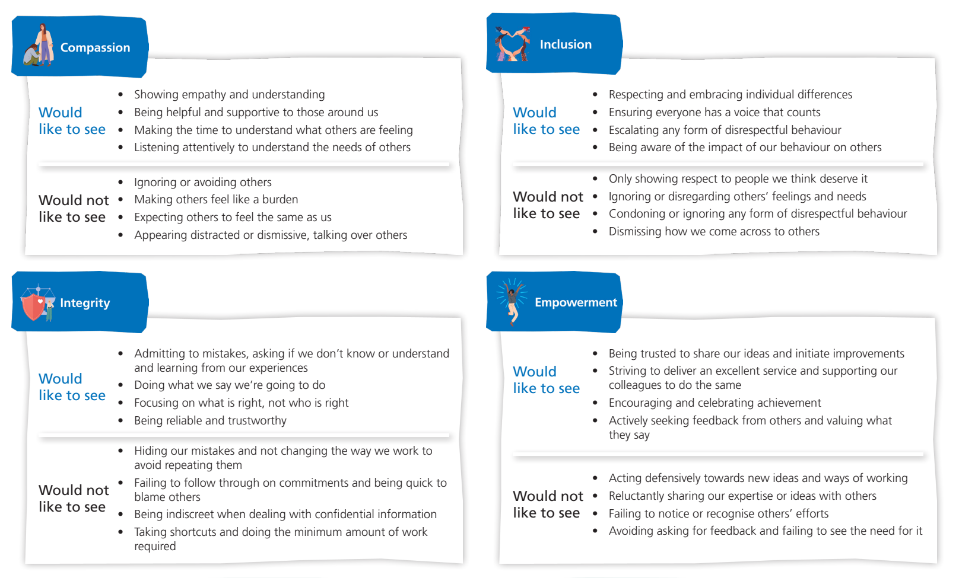
We recruit competent staff that we support in maintaining and extending their skills in accordance with the needs of the people we serve. We will pay staff fairly and recognise the whole staff’s commitment to meeting the needs of our patients.

We are committed to equal opportunity for all and encourage flexible working arrangements including job sharing.

We are committed to recruiting and supporting a diverse workforce and welcome applications from all sections of the community, regardless of age, disability, gender, race, religion, sexual orientation, maternity/pregnancy, marriage/civil partnership or transgender status. We expect all staff to behave in a way which recognises and respects this diversity, in line with the appropriate standards.

GENERAL

This is a description of the job as it is now. We periodically examine employees' job descriptions and update them to ensure that they reflect the job as it is then being performed, or to incorporate any changes being proposed. This procedure is conducted by the Manager in consultation with the jobholder. You will, therefore, be expected to participate fully in such discussions. We aim to reach agreement on reasonable changes, but if agreement is not possible, we reserve the right to insist on changes to your job description after consultation with you.

The RD&E is a totally smoke-free Trust. Smoking is not permitted anywhere on Trust property, including all buildings, grounds and car parks. For help to quit call: 01392 207462.

PERSON SPECIFICATION

POST: Appointment Slot Administrator
BAND: 3
REQUIREMENTS | Essential / Desirable at:
 | Recruitment | 1st PDR or (award of) increment
QUALIFICATIONS / TRAINING:  Minimum of 3 qualifications to include GCSE grade A-C/4-9 or equivalent in Maths and English  NVQ Level 3 in Business Admin or equivalent level of experience  Clinical Document Management (CDM)  Patient Administration System (PAS) Level 3 outpatients  ECDL, CLAIT or equivalent | E  E  D  D  D | E  E  E  E  E
KNOWLEDGE / SKILLS:  Excellent planning & organisational skills  Ability to prioritise workload to respond to changing demand  Ability to liaise and communicate with staff at all levels  Motivation and negotiation skills  Excellent interpersonal & communication skills inc. demonstrating empathy & sensitivity to patients and relatives  Ability to promote good working liaisons (staff, patients, relatives)  Extracting information / Listening Skills  Ability to handle complex enquiries - distressed & anxious patients  Ability to deal with challenging behaviour  Ability to provide excellent customer care  Knowledge of IT databases and computer systems  Comprehensive PC skills - databases, word-processing, email, Excel  Understanding of hospital IT systems  Knowledge of PAS or equivalent information system  Analytical skills & ability to problem solve  Proven strong administration skills  Accurate data entry  Excellent telephone manner  Knowledge of Trust procedures  Able to work independently, with minimum supervision | D  D  E  D  E  E  E  E  E  E  E  E  D  D  D  E  E  E  D  D | E  E  E  E  E  E  E  E  E  E  E  E  E  E  E  E  E  E  E  E
EXPERIENCE:  Previous clerical experience  Working in an NHS/clinical environment e.g. hospital, GP surgery, CCG  Previous reception experience or dealing with the general public | E  D  D | E  E  E
PERSONAL ATTRIBUTES:  Enthusiastic highly motivated & committed to delivering a service  Understand team work and work within a team  Able to plan and organise workload  Able to prioritise own work load and meet deadlines  Ability to work un-supervised  Can remain calm and professional in a busy environment  Empathetic, but able to understand professional boundaries  Smart appearance, adhering to the Uniform Policy  Welcoming friendly and approachable manner  An adaptable approach to work  Flexible approach to working hours  Commitment to continual development to inc. relevant new systems, policies and procedures  Adheres to relevant Trust policies & procedures  Adheres to confidentiality & data protection requirements | E  E  E  E  E  E  E  E  E  E  D  E  E  E | E  E  E  E  E  E  E  E  E  E  E  E  E  E

Hazards within the role, used by Occupational Health for risk assessment
Laboratory specimens |  | Clinical contact with patients |  | Dealing with violence & aggression of patients/relatives
Blood / Body Fluids |  | Dusty environment |  | VDU Use | 
Radiation / Lasers |  | Challenging behaviour |  | Manual Handling | 
Solvents |  | Driving |  | Noise / Vibration
Respiratory sensitisers |  | Food Handling |  | Working in isolation
Cytotoxic drugs |  | Electrical work |  | Night working

