JOB DESCRIPTION

The Trust is committed to recruiting and supporting a diverse workforce and so we welcome applications from all sections of the community, regardless of age, disability, gender, race, religion, sexual orientation, maternity/pregnancy, marriage/civil partnership or transgender status. The Trust expects all staff to behave in a way which recognises and respects this diversity, in line with the appropriate standards.

1. JOB DETAILS

Job Title: Divisional Management Accountant

Band: 6

Reports to: Senior Divisional Management Accountant

Directorate: Finance

2. JOB PURPOSE

To provide information, advice and support to Directorate Managers and budget holders within the Directorates

3. DIMENSIONS/ KEY WORKING RELATIONS

- Director of Finance & Information
- Head of Financial Management
- Management Accountants
- Directorate Managers
- Budget Holders

- ORGANISATIONAL CHART:

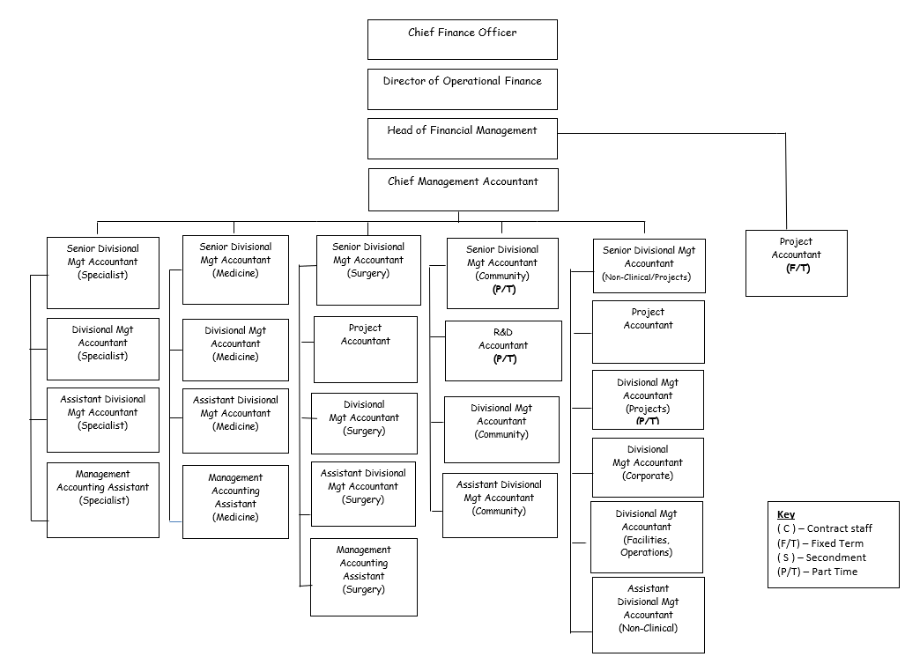

- KEY RESULT AREAS/PRINCIPAL DUTIES AND RESPONSIBILITIES:

- To provide on-going financial support to Directorates, monitoring their expense, income and activity against budgets. This includes participation in Budget Meetings, Quarterly Reviews and other Directorate meetings;

- To analyse and investigate variances and interpret results. To produce monthly financial reports and financial forecasts in close liaison with Directorate Managers with the aim of providing accurate year to date and year end projections;

- To develop skills in monitoring income against both budget and contracts, in order to ensure that the full implications of changes in activity are understood.

- To analyse complex problems relating to business case production and analysis. Influence and advise regarding allocation of finances within directorates and provides assessments on financial decisions and financial risk without necessarily referring to management.

- To update the general ledger and other financial systems as necessary to ensure accurate and up-to-date reporting.

- To prepare expense, income and activity budgets as part of the annual planning cycle. To carry out periodic reviews of budgets to reflect current operational practice, in conjunction with Directorate Managers;

- To use in depth specialist financial knowledge to respond appropriately to budget holders queries, investigating all areas of concern, within an agreed timescale, thereby maintaining good working relationships;

- To provide formal and informal financial training to budget holders. To provide advice on complex financial issues to non-financial mangers whilst being aware of Trust wide issues.

- To assist in the development of more junior staff members within the team, including the assistant management accountant and coding clerk;

- To assist in the completion of other monitoring returns, both internal and external, including Annual Accounts, Financial Returns and Reference Costs;

- To assume responsibility for specific/ad hoc Trust wide duties, liaising with Management Accounts where appropriate

- To prioritise and identify own work schedule, whilst meeting agreed objectives.

- To perform other duties as required from time to time by Senior Finance Managers.

This is a description of the job as it is at present constituted. It is the practice of this organisation periodically to examine employees’ job descriptions and to update them to ensure that they relate to the job as then being performed, or to incorporate whatever changes are being proposed. This procedure is jointly conducted by each Manager in consultation with those working directly with them. You will, therefore, be expected to participate fully in such discussions. It is the Trust’s aim to reach agreement to reasonable changes, but, if agreement is not possible, Management reserves the right to insist on changes to your job description after consultation with you.

Other Responsibilities:

- To take part in regular performance appraisal
- To undertake any training required in order to maintain competency including mandatory training, i.e. Fire, Manual Handling
- To contribute to and work within a safe working environment
- The post holder is expected to comply with Trust Infection Control Policies and conduct themselves at all times in such a manner as to minimise the risk of healthcare associated infection

THE TRUST - PURPOSE AND VALUES

We are committed to serving our community by being a high quality specialist Hospital with consultant-led services. We aim to co-ordinate our services with primary and community care, and to develop a limited number as Sub-Regional Referral Centres with appropriate levels of research, development and educational involvement. Where appropriate, and consistent with our services, we may provide services aimed at preventing disease and debilitation.

We aim to make all our services exemplary in both clinical and operational aspects. We will show leadership in identifying healthcare needs to which we can respond and in determining the most cost-effective way of doing so. We will share our knowledge with neighbouring healthcare agencies and professionals.

We recruit competent staff that we support in maintaining and extending their skills in accordance with the needs of the people we serve. We will pay staff fairly and recognise the whole staff’s commitment to meeting the needs of our patients.

We are committed to equal opportunity for all and encourage flexible working arrangements including job sharing.

GENERAL

This is a description of the job as it is now. We periodically examine employees' job descriptions and update them to ensure that they reflect the job as it is then being performed, or to incorporate any changes being proposed. This procedure is conducted by the Manager in consultation with the jobholder. You will, therefore, be expected to participate fully in such discussions. We aim to reach agreement on reasonable changes, but if agreement is not possible, the Trust reserves the right to insist on changes to your job description after consultation with you.

The RD&E is a totally smoke-free Trust. Smoking is not permitted anywhere on Trust property, including all buildings, grounds and car parks. For help to quit call: 01392 207462.

As an employee of the Trust, it is a contractual duty that you abide by any relevant code of professional conduct and/or practice applicable to you. A breach of this requirement may result in action being taken against you (in accordance with the Trust’s disciplinary policy) up to and including dismissal.

The post holder is expected to comply with Trust Infection Control Policies and conduct themselves at all times in such a manner as to minimise the risk of healthcare associated infection.

PERSON SPECIFICATION

POST: Divisional Management Accountant
BAND: 6
REQUIREMENTS | At  Recruitment | At 2nd KSF  Gateway
QUALIFICATIONS / TRAINING  Professional Accountancy Qualification (CCAB Recognised – final stages of qualification or equivalent experience)  Professional Accountancy Qualification (CCAB Recognised – Certificate Level or equivalent)  Degree (Or Equivalent) | D  E  E | E  E  E
KNOWLEDGE / SKILLS  A good knowledge and experience of computer based management accounting systems and Microsoft Office applications  Good communication, presentation and interpersonal skills both orally and in writing  Strong numerical skills, ability to understand and interpret complex financial information  Excellent organisational and time management skills  Ability to advise finance and non finance managers providing detailed advice and guidance | E  E  E  E  E | E  E  E  E  E
EXPERIENCE  Management Accounting experience  Experience of budgetary control  Experience within the Finance function of the NHS | E  D  D | E  E  E
PERSONAL ATTRIBUTES  Good Communicator  Confident  Self Motivated  Team Worker  Ability to act on advice without reference to Manager to achieve agreed objectives  Able to prioritise and meet deadlines | E  E  E  E  E  E | E  E  E  E  E  E
OTHER REQUIREMENTS

* Essential/Desirable

HAZARDS IDENTIFIED (tick as appropriate):
Laboratory specimens  Proteinacious Dusts |  | Clinical contact with  patients |  | Performing Exposure  Prone Invasive Procedures
Blood / Body Fluids |  | Dusty environment |  | VDU use | Y
Radiation |  | Challenging Behaviour | Y | Manual handling
Solvents |  | Driving |  | Noise
Respiratory Sensitisers |  | Food handling |  | Working in isolation

