JOB DESCRIPTION

JOB DETAILS

Job Title: Assistant Therapy Practitioner – Post COVID Service

Band: 4

Responsible To: The Clinical Lead

Accountable To: Clinical Operational Manager

Directorate/Department: Community Division/Specialist Services

2. JOB PURPOSE

The post holder is responsible for providing therapy assessment & treatment of a specified caseload of patients within the Post COVID services working particularly with the Post COVID team. This includes a Consultant lead Physiotherapists, Occupational Therapists and Nurses. The post holder will be provided with relevant training to gain appropriate knowledge and skills in Post COVID.

Patient management will include: assessment and information gathering to identify patient needs; physical and cognitive assessments, development of treatment plans and review of progress at regular intervals; and delivery of care and rehabilitation. The post holder will work alongside the Post COVID team and provide close liaison with family, carers and external agencies to ensure safe and effective care.

This position is based in the community, with face to face clinics taking place at The Royal Devon & Exeter Hospital (Wonford). It also involves virtual working and assisting with group sessions. This post will be static within a clinical speciality area, but there may be a requirement for the post holder to work flexibly in other areas as required.

3. KEY WORKING RELATIONSHIPS

All Post COVID team members.
Members of multi-disciplinary team.
G.Ps & external agencies
Social care teams – care managers and social care assessors
Community services such as UCR and community rehab
Single point of access (SPOA)

4. ORGANISATIONAL CHART

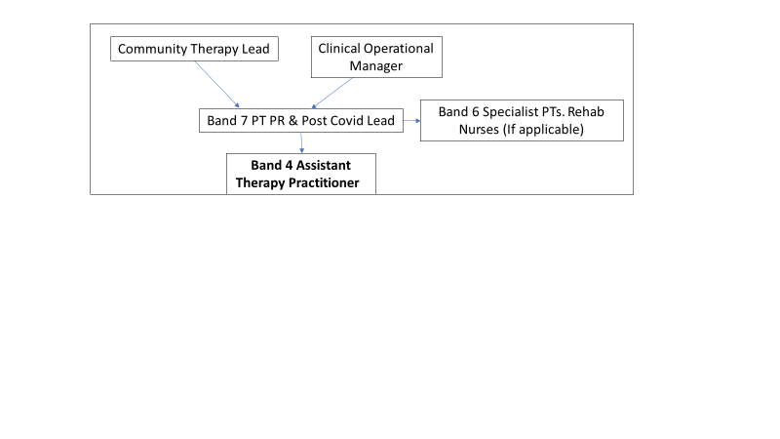

5. KEY RESULT AREAS/PRINCIPAL DUTIES AND RESPONSIBILITIES

Clinical & Professional
To understand the nature of conditions that effect the Post COVID population including fatigue, brain fog, breathlessness, anxiety and depression, and the symptoms that present as a result. To deliver therapy assessments and rehabilitation to support symptom management.
To have an understanding of effects of POST COVID including an understanding of emotional and psychological impact.

To communicate condition related information to patients and relatives and/or sensitive information with empathy and reassurance. To be aware of barriers to understanding for example knowledge and understanding and levels of cognition.
Treatment activities might include following and adapting exercise and mobility programmes; practising personal activities of daily living such as washing and dressing and educating & advising patients and their families about their situation and options for the future as well as supporting virtual run groups
To provide appropriate and timely information to all relevant members of the healthcare team regarding patients’ therapeutic progress with appropriate support from senior specialist therapy staff and the Post COVID team.
To provide written reports and referrals as appropriate via EPIC.
To be responsible and accountable for specific therapy assessment within the core competencies for which training has been undertaken.
To use appropriate outcome measures and set realistic and attainable treatment goals with patients with guidance from senior specialist therapy staff.
To organise, prioritise and adjust own workload providing assessment and treatment as required within the specified scope of practice, ensuring treatment and requests for treatment are prioritised and dealt with promptly and efficiently.
To receive regular supervision from senior specialist therapy staff and request support when dealing with situations that are beyond his/her experience / competencies.
To assist with induction of new staff as appropriate.
To update patient records with an accurate record of patient activities. To submit regular data about activity levels as required.
To be responsible for the safe use of clinical and other equipment and to report any necessary repairs which need to be undertaken. To ensure appropriate stock levels are maintained and to be able to order and supply equipment appropriately.
To ensure that all Trust Standards, Policies & Procedures and Statutory Acts & Regulations are known and implemented/adhered to as necessary/appropriate. To participate in team audit activity and peer review to ensure best practice. To provide information for RD&E clinical trials as required. To keep updated in changes in guidelines, protocols and evidence-base so as to inform practice. To comment on any proposed changes to services or policies as required.
To participate in the Trust-wide rota for seven-day cover service in medicine for the service.

Training and Development

To take responsibility for own on-going clinical personal development to ensure relevant clinical knowledge and skills are attained.
To ensure up-to-date personal development plans and that personal objectives are completed.
To contribute to the improvement of the therapy service by evaluation of own work, and make constructive suggestions as to service improvements.
To attend and contribute to team in-service training sessions to ensure continued personal development.
To provide advice to multidisciplinary team members, patients and carers as required with support and guidance from senior specialist therapy staff.

Other

To actively assist in the smooth running of the service throughout the Royal Devon University Healthcare Trust.
To undertake any additional duties commensurate with this grade as required.
The Post holder is expected to comply with Trust Infection Control Policies and conduct him/herself at all times in such a manner as to minimise the risk of healthcare associated infection.
Maintain personal safety by following lone working policy and respect property and equipment within the working environment in accordance with trust and team guidelines.
To contribute to and work within a safe working environment
As an employee of the Trust, it is a contractual duty that you abide by any relevant code of professional conduct and/or practice applicable to you. A breach of this requirement may result in action being taken against you (in accordance with the Trust’s disciplinary policy) up to and including dismissal.
This post has been identified as involving access to vulnerable adults and/or children and in line with Trust policy successful applicants will be required to undertake a Disclosure & Barring Service Disclosure Check

THE TRUST – VISIONS AND VALUES

Our vision is to provide safe, high quality seamless services delivered with courtesy and respect. To achieve our vision we expect all our staff to uphold our Trust values. Our Trust values are:

Honesty, Openness & Integrity
Fairness,
Inclusion & Collaboration
Respect & Dignity

We recruit competent staff that we support in maintaining and extending their skills in accordance with the needs of the people we serve. We will pay staff fairly and recognise the whole staff’s commitment to meeting the needs of our patients.

We are committed to equal opportunity for all and encourage flexible working arrangements including job sharing.

We are committed to recruiting and supporting a diverse workforce and welcome applications from all sections of the community, regardless of age, disability, gender, race, religion, sexual orientation, maternity/pregnancy, marriage/civil partnership or transgender status. We expect all staff to behave in a way which recognises and respects this diversity, in line with the appropriate standards.

GENERAL

This is a description of the job as it is now. We periodically examine employees' job descriptions and update them to ensure that they reflect the job as it is then being performed, or to incorporate any changes being proposed. This procedure is conducted by the Manager in consultation with the jobholder. You will, therefore, be expected to participate fully in such discussions. We aim to reach agreement on reasonable changes, but if agreement is not possible, we reserve the right to insist on changes to your job description after consultation with you.

The RD&E is a totally smoke-free Trust. Smoking is not permitted anywhere on Trust property, including all buildings, grounds and car parks. For help to quit:
call 01884 836 024
email stopsmoking.devonpct@nhs.net.

ROYAL DEVON & EXETER NHS FOUNDATION TRUST
PERSON SPECIFICATION

POST: Assistant Occupational Therapy Practitioner – Post COVID Service
BAND: 4

REQUIREMENTS | E/D* | MET | NOT MET
QUALIFICATIONS/SPECIAL TRAINING:  Level 5 Diploma for Assistant Practitioners in Healthcare, HPD, Level 4 Diploma in Sports Therapy or equivalent or  Foundation Degree or equivalent experience.  GCSE Maths and English Grade A-C | E  E
KNOWLEDGE/SKILLS:  Knowledge of acute hospital structure and organisation  Understanding of the role of therapy services within a hospital multidisciplinary team structure  Understanding and experience of working with elderly patients  Evidence of the ability to communicate with a range of different people using a range of methods  Professional approach and appearance  Organisational skills such as prioritisation & time management  Evidence of problem solving and reasoning skills  Evidence of ability to assess risk  Knowledge of occupational therapy treatment programmes | E  E  E  E  E  E  E  E  E
EXPERIENCE:  Evidence of relevant acute NHS work  Previous appropriate experience for example work as band 3 Therapy Technical Instructor, band 2 Therapy Assistant or band 2 Health Care Assistant  Clerical skills – basic typing / word processing / IT skills | D  D  E
PERSONAL REQUIREMENTS:  Evidence of ability to work as Team member  Understanding of Trust values | E  E
OTHER REQUIREMENTS:  Enthusiastic towards post  Evidence of flexible approach.  Ability to work flexibly over 7 days  Hold a current driving licence | E  E  E  E
* Essential/Desirable

HAZARDS:
Laboratory Specimens  Proteinacious Dusts |  | Clinical contact with patients | ✓ | Performing Exposure  Prone Invasive Procedures
Blood/Body Fluids | ✓ | Dusty Environment |  | VDU Use | ✓
Radiation |  | Challenging Behaviour | ✓ | Manual Handling | ✓
Solvents |  | Driving | ✓ | Noise
Respiratory Sensitisers |  | Food Handling |  | Working in Isolation

