
JOB DESCRIPTION

1. JOB DETAILS

Job Title: Specialist Clinical Pharmacist – Education and Training

Band: Band 8a

Reports to: Clinical Pharmacy Manager

Department / Directorate: Pharmacy / Clinical Support and Specialist Services

2. JOB PURPOSE

To lead an effective education and training programme with a primary focus on pharmacist professional development. This role will have set out strategy and vision for the delivery of effective education and training within the pharmacy department.

To contribute to the clinical pharmacy provision and the development of medicines management and optimisation throughout the patient care pathway.

To provide strategic development of the department education and training programme.

To participate in the wider pharmacy service and its development in response to patient care needs.

3. DIMENSIONS/ KEY WORKING RELATIONS
Associate Director of Pharmacy
Clinical Pharmacy Manager
Pharmacists, Medicines Management Technicians & Distribution team providing ward-based pharmacy services to clinical areas
NMP Lead

Key liaison with the following organisations from an Education and Training strategic standpoint:
Devon Partnership Trusts
Devon ICB
Health Education England
PWDS
Primary Care Networks
University of Exeter
Devon ICS Pharmacy Workforce Lead

- ORGANISATIONAL CHART:

See next page
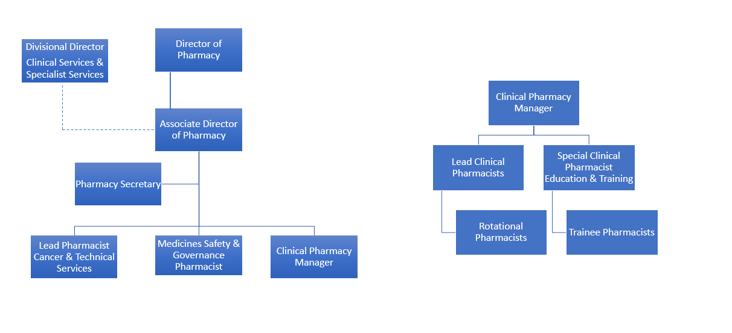

- KEY RESULT AREAS/PRINCIPAL DUTIES AND RESPONSIBILITIES

Education and Training Role
- Co-ordinate and deliver a comprehensive newly qualified pharmacist programme, including ward-based placed assessments and portfolio based practices underpinned by the Foundation Pharmacy Framework

- Develop and maintain the education and training strategy for the acute and community services pharmacists in partnership with key stakeholders

- Provide mentoring and supervision for pharmacists working at ward levels and those undertaking training and development, e.g. diploma, prescriber training.

- Co-ordinate and deliver training to trainee pharmacists, student pharmacy technicians, pharmacy undergraduates and other pharmacy professionals within specialist area.

- Be a representative for regional and national strategic developments for professional development including working with the University of Exeter, Royal Pharmaceutical Society and Health Education England to promote the Royal Devon University Healthcare NHS Foundation Trust (RDUH) as an exemplar.

- Work in partnership with the Education & Training pharmacist at other RDUH site to align vision and strategy

Clinical Specialist Role
  - Support and provide clinical assessment of drug therapy

  - Contribute to Medicines Reconciliation, obtaining accurate medication histories, developing pharmaceutical care plans for all patients and communicating these as appropriate on transfer to another care provider

  - Provide expert advice to medical and nursing staff on the safe, effective use of medicines in these patient groups, including dosages and administration where information is lacking and medical opinion differs

  - Resolve any medication-related problems with the medical, nursing staff and other healthcare professionals, including the patients' GP and other primary care professionals as appropriate.

  - Participate in the discharge planning for patients at ward level, including patient and carer education prior to discharge and communication with GP, pharmacists and other healthcare professionals as needed to aid the smooth transfer of patients

  - Participate in education programmes for wider clinical team, patients and carers within specialist area

  - Lead and contribute to clinical and service audit within specialist area and wider clinical service and implement recommendations for change

  - Participate in practice and clinical research

  - Work with medical and nursing staff to report and investigate medication-related adverse events and formulate action plans to reduce errors and risks related to the use of medicines

Divisional Role
  - Support delivery of work programmes focussing specifically on audit of drug use against local and national commissioning policies, ensuring that the most cost-effective therapy is prescribed and ensuring patients are treated using the most appropriate supply routes, e.g. homecare

  - Provide assurance on formulary compliance for the division and address areas of poor compliance within the clinical service lines and build engagement with the Devon Joint Formulary

  - Actively seek ways to reduce drug expenditure and to work with medical and nursing staff to reduce drug wastage

  - Support the assessment and safe introduction of new treatments and services by horizon-scanning and flagging implications for drug expenditure and pharmacy services

Development of Clinical Pharmacy Services
  - To work closely with other health care professionals across the Trust and wider health community to develop policies and procedures to optimise the use of medicines

  - Write and implement departmental policies and procedures as requested by the Clinical Pharmacy Manager

  - Work closely with the Clinical Pharmacy Manager to support the planning, provision and development of clinical pharmacy services across the Trust

Education and Training
- To undertake to keep up-to-date with developments in Pharmacy in order to maintain a high level of professional knowledge and competence

- Attend relevant study days and courses to support own professional and personal development

- Maintain a record of Continual Professional Development in order to maintain professional registration with the General Pharmaceutical Council

- Contribute to the training of doctors, nurses and other healthcare professionals, including students and trainees

Miscellaneous and other duties
- Provide ad-hoc support to on-call pharmacists for out-of-hours enquiries related to specialist area

- To participate in the late night, weekend and bank holiday rota according to departmental need and work as part of a seven day services provision

- To participate in other duties appropriate to grade at the request of the relevant manager

- Please note that in order to deliver a high standard of care to patients the Pharmacy service operates 7 days a week and staff are therefore required to work some weekends as part of their contracted hours.

Other responsibilities
- To participate in the annual appraisal scheme and undertake appraisal of pharmacy team members as requested by the Clinical Pharmacy Manager

- To undertake any training required in order to maintain competency including mandatory training, e.g. Manual Handling

- To contribute to and work within a safe working environment

As an employee of the Trust, it is a contractual duty that you abide by any relevant code of professional conduct and/or practice applicable to you. A breach of this requirement may result in action being taken against you (in accordance with the Trust’s disciplinary policy) up to and including dismissal.

The post holder is expected to comply with Trust Infection Control Policies and conduct him/her at all times in such a manner as to minimise the risk of healthcare associated infection.
This post has been identified as involving access to vulnerable adults and/or children and in line with Trust policy successful applicants will be required to undertake a Disclosure & Barring Service Disclosure Check.

THE TRUST – Vision and Values

Our vision is to provide safe, high quality seamless services delivered with courtesy and respect. To achieve our vision we expect all our staff to uphold our Trust values. Our Trust values are:

Honesty, Openness & Integrity
Fairness,
Inclusion & Collaboration
Respect & Dignity

We recruit competent staff that we support in maintaining and extending their skills in accordance with the needs of the people we serve. We will pay staff fairly and recognise the whole staff’s commitment to meeting the needs of our patients.

We are committed to equal opportunity for all and encourage flexible working arrangements including job sharing.

We are committed to recruiting and supporting a diverse workforce and welcome applications from all sections of the community, regardless of age, disability, gender, race, religion, sexual orientation, maternity/pregnancy, marriage/civil partnership or transgender status. We expect all staff to behave in a way which recognises and respects this diversity, in line with the appropriate standards.

GENERAL

This is a description of the job as it is now. We periodically examine employees' job descriptions and update them to ensure that they reflect the job as it is then being performed, or to incorporate any changes being proposed. This procedure is conducted by the Manager in consultation with the jobholder. You will, therefore, be expected to participate fully in such discussions. We aim to reach agreement on reasonable changes, but if agreement is not possible, we reserve the right to insist on changes to your job description after consultation with you.

The RDUH is a totally smoke-free Trust. Smoking is not permitted anywhere on Trust property, including all buildings, grounds and car parks. For help to quit call: 01392 207462.

PERSON SPECIFICATION
POST: Specialist Clinical Pharmacist – Professional Development and Acute Medicine
BAND: 8a

REQUIREMENTS | At Recruitment | At PDR
QUALIFICATIONS/SPECIAL TRAINING :  Pharmacy Degree  Membership of the General Pharmaceutical Council  Commitment to study for post graduate qualification  Minimum 5 years post-registration experience  Post-graduate clinical qualification  Independent prescriber qualification (or willingness to work towards)  Evidence of Continuing Professional Development  Member of the Royal Pharmaceutical Society | E  E  E  E  E  D  E  D | E  E  E  E  E  E  E  E
KNOWLEDGE/SKILLS:  Awareness of commissioning frameworks & influence on clinical services  Excellent current knowledge of best clinical practice  Effective written and oral communication skills  Excellent interpersonal skills  Influencing/negotiation skills  Understanding of hospital pharmacy systems  IT skills including experienced user of MS Office & databases  Critical appraisal of clinical evidence  Mentoring skills | D  E  E  E  D  E  E  E  E | E  E  E  E  E  E  E  E  E
EXPERIENCE:  Clinical experience across a range of specialities  Strong track record of medicines management within Acute Medicine  Experience of working with MDTs and committees  Clinical audit  Clinical guideline development  Service development  Interpretation of drug expenditure reports & horizon scanning | E  D  E  D  D  D  D | E  E  E  E  E  E  E
PERSONAL REQUIREMENTS:  Able to plan & organise own ward work and that of others  Deliver to tight deadline & work effectively under pressure, prioritising effectively  Methodical & analytical  Flexible  Creative thinker & able to problem solve  Good team-worker  Able to deal with complaints from service users and health care staff | E  E  E  E  E  E  E | E  E  E  E  E  E  E
* Essential/Desirable

Hazards within the role, used by Occupational Health for risk assessment
Laboratory Specimens Proteinacious Dusts |  | Clinical contact with patients |  | Performing Exposure Prone Invasive Procedures
Blood / Body Fluids |  | Dusty environment |  | VDU Use | √
Radiation | √ | Challenging Behaviour |  | Manual Handling | √
Solvents |  | Driving |  | Noise
Respiratory Sensitisers |  | Food Handling |  | Working in isolation | √
Handling Cytotoxic Drugs | √

