
JOB DESCRIPTION

1. JOB DETAILS

Job Title: Assistant Buyer

Band: 3

Reports to: Buyer

Department / Directorate: Procurement / Finance

2. JOB PURPOSE

  - Sourcing, negotiating, ordering and expediting goods and services required by The Trust’s departments using approved processes and systems, effectively and efficiently, producing good value for money.
  - Building a good relationship with end users, be their first point of contact, and pass on more difficult problems to the team Buyer as agreed.
  - Dealing with a high volume of customer and supplier queries, primarily over the telephone and e-mail, to ensure that goods and services are selected, ordered and received in the appropriate time.
  - Supporting colleagues in the Procurement Department to ensure the procurement services is as effective as it can be.
  - Delivering good value such as savings, cost efficiencies and benefits for the Trust.
  - Carrying out operational tasks associated with the procurement of goods and services and effectively contribute towards the Trust’ value for money and cash releasing saving targets.
  - Producing standard documentation from the procurement computerised systems as required by the service, customers or suppliers, keeping systems up to date and accurate.
  - Arranging for quick quotations and official quotations for purchases of a value of up to £50,001 under the supervision of the buyers.
  - Maintaining and negotiating contracts up to a value of £50,001 (with assistance from the buyer).
  - Keeping up-to-date statistical data regarding the team’s workload.

3. KEY WORKING RELATIONSHIPS

  - Reporting to the Buyer and being accountable to the Team leader - operational purchasing.
  - Required to forge effective and professional working relationships with staff at all levels, both inside and outside the Trust, particularly with the following:
- Procurement and Logistics staff
- Clinical staff
- Order requisitioners and staff throughout the Trust
- Suppliers of goods, services or capital items
- Payments staff
- Estates staff
- Projects and Support managers
- Management Accountants as appropriate
- Other Procurement staff within the NHS including PPSA staff

4. DIMENSIONS

- Develop productive working relationships with customers of all levels seeking to influence the customer choice towards standardised products.
- Build collaborative relationships and achieve positive performance against quality and value for money targets.
- Provide an advice and enquiry service to The Royal Devon University Healthcare NHS Foundation Trust sites on routine procurement issues.
- Request and analyse quotations for purchases of a value of up to £50,001 as well as maintain contracts up to £50,001.

5. ORGANISATIONAL CHART

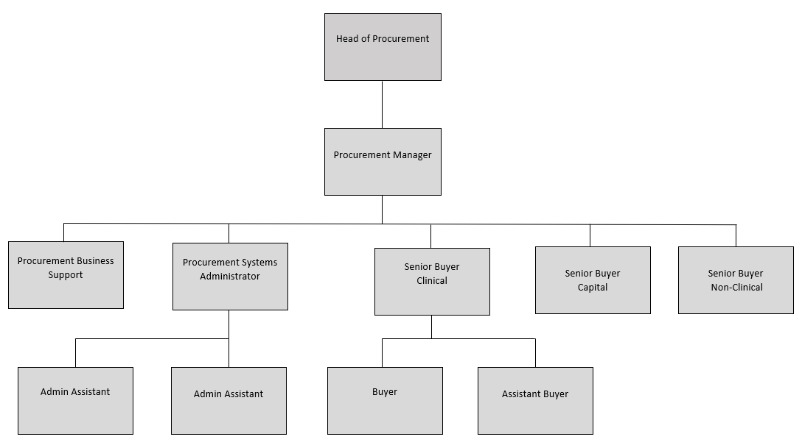

6. KEY RESULT AREAS / PRINCIPAL DUTIES AND RESPONSIBILITIES

- To ensure that all orders, invoice queries and new product requests within a designated area of responsibility are processed in line with procedures.
- To take telephone calls from customers and suppliers, answer enquiries regarding products, services, supplier information, orders etc, discuss quotes received etc.
- To actively seek opportunities to compare products requested for suitable alternatives looking to maximise savings when ever possible.
- To carry out operational tasks associated with the procurement of goods and services and effectively contribute towards the Trust’s value for money and cash releasing saving targets, as well as those of other organisations to whom the service is contracted.
- To verify the Trust Procurement credit card bank statement monthly.
- To liaise with the Buyers on Standing Orders and Call Off Orders to understand the Trust’s requirements and create requisitions / orders under the supervision of the Buyers.
- To actively manage contracts up to a value of £50,001.
- To ensure Indemnity Forms are completed by the Suppliers before any loan / trial equipment are delivered to the Trust.
- To take responsibility for allocated departments within the Trust and to visit on a regular basis to enable good relations between the departments and Procurement.
- To cover absence, to place urgent orders on behalf of Theatres for overnight deliveries which may include telephoning the order through to the supplier, informing the Distribution Centre (Warehouse) of the order number and the expected time of delivery i.e. pre 9am or pre 12pm.
- When required, to liaise with Cash Management to resolve any invoice queries.
- Under direction, to assist the line manager to implement changes that will enhance the service and raise suggestions to improve procedures and processes.
- To undertake any other duties commensurate with the grade as may be required by any of the Procurement Management Team.

Other Responsibilities:

To take part in regular performance appraisal.
To undertake all training required to maintain competence including mandatory training, i.e. Fire, Manual Handling, Information Governance.
To contribute to, and work within a safe working environment.
Comply with Trust Infection Control Policies and conduct yourself at all times in such a manner as to minimise the risk of healthcare associated infection.

THE TRUST - PURPOSE AND VALUES

We are committed to serving our community by being a high-quality specialist Hospital with consultant-led services. We aim to co-ordinate our services with primary and community care, and to develop a limited number as Sub-Regional Referral Centres with appropriate levels of research, development and educational involvement. Where appropriate, and consistent with our services, we may provide services aimed at preventing disease and debilitation.

We aim to make all our services exemplary in both clinical and operational aspects. We will show leadership in identifying healthcare needs to which we can respond and in determining the most cost-effective way of doing so. We will share our knowledge with neighbouring healthcare agencies and professionals.

We recruit competent staff whom we support in maintaining and extending their skills in accordance with the needs of the people we serve. We will pay staff fairly and recognise the whole staff’s commitment to meeting the needs of our patients.

We are committed to equal opportunity for all and encourage flexible working arrangements including job sharing.

GENERAL

This is a description of the job as it is now. We periodically examine employees' job descriptions and update them to ensure that they reflect the job as it is then being performed, or to incorporate any changes being proposed. This procedure is conducted by the Manager in consultation with the jobholder. You will, therefore, be expected to participate fully in such discussions. We aim to reach agreement on reasonable changes, but if agreement is not possible, the Trust reserves the right to insist on changes to your job description after consultation with you.

The Royal Devon University Healthcare NHS Foundation Trust is a totally smoke-free Trust. Smoking is not permitted anywhere on Trust property, including all buildings, grounds and car parks. For help to quit, call 01392 207462.

As an employee of the Trust, it is a contractual duty that you abide by any relevant code of professional conduct and/or practice applicable to you. A breach of this requirement may result in action being taken against you (in accordance with the Trust’s disciplinary policy) up to and including dismissal.

The post holder is expected to comply with Trust Infection Control Policies and conduct him/her at all times in such a manner as to minimise the risk of healthcare associated infection.


PERSON SPECIFICATION
POST: Assistant Buyer
BAND: 3
REQUIREMENTS | At Recruitment | At KSF 2nd Gateway
QUALIFICATIONS/SPECIAL TRAINING:  5 GCSE including Maths and English or A Level or equivalent experience  IT Literate | E  E | E  E
KNOWLEDGE/SKILLS:  Good written and verbal communication skills  Ability to deal with customers and suppliers in challenging situations  Ability to prioritise workload  Ability to analyse data, interpret, evaluate to determine best value for money  Computer literacy including Microsoft Office Applications (Word, Excel, Outlook)  Ability to identify opportunities for cost reductions  Experience in procurement  Experience of negotiation | E  E  E  E  E  E  D  E | E  E  E  E  E  E  E  E
EXPERIENCE:  Recent experience of working with modern business systems and use of office equipment.  Basic working knowledge and understanding of procurement, including quotations, purchase orders, tenders and payment methods.  Basic understanding of contracts  Conversant with NHS Terms & Conditions of Contract | E  D  D  D | E  E  E  E
PERSONAL REQUIREMENTS:  Outstanding customer service skills  Excellent interpersonal skills  Excellent telephone manner  Good organisational skills  Good and assertive communication skills  Accurate and numerate  Ability to Prioritise  Flexible / Enthusiastic Approach  Proactive, Punctual and Reliable  Excellent Team Player  Willing to undertake development opportunities | E  E  E  E  E  E  E  E  E  E  D | E  E  E  E  E  E  E  E  E  E  E
* Essential/Desirable
Hazards within the role, used by Occupational Health for risk assessment
Laboratory Specimens Proteinaceous Dusts |  | Clinical contact with patients |  | Performing Exposure Prone Invasive Procedures
Blood / Body Fluids |  | Dusty environment |  | VDU Use | X
Radiation |  | Challenging Behaviour |  | Manual Handling | X
Solvents |  | Driving |  | Noise
Respiratory Sensitisers |  | Food Handling |  | Working in isolation
Handling Cytotoxic Drugs

