JOB DESCRIPTION

This post has been identified as involving access to vulnerable adults and/or children and in line with Trust policy successful applicants will be required to undertake a Criminal Records Bureau Disclosure Check.

The Trust is committed to recruiting and supporting a diverse workforce and so we welcome applications from all sections of the community, regardless of age, disability, gender, race, religion, sexual orientation, maternity/pregnancy, marriage/civil partnership or transgender status. The Trust expects all staff to behave in a way which recognises and respects this diversity, in line with the appropriate standards.

1. JOB DETAILS

Job Title: Phlebotomist

Band: 2

Reports to: Head Phlebotomist & Phlebotomy Manager

Department / Directorate: Diagnostic Divisional Manager

Section/Department/Division: Phlebotomy, Specialist Services.

2. JOB PURPOSE
Collection of blood samples from patients, staff and also patients with difficult venous access referred by GP’s and other Healthcare organisations.

3. DIMENSIONS/ KEY WORKING RELATIONS
A team of over 20 Phlebotomists is responsible for collecting blood samples from approximately 100,000 patients a year. This service is provided for most areas of the Trust on 365 days of the year.

Close co-operation with other members of the phlebotomy team, Medical, Nursing and Laboratory staff is required to secure an efficient phlebotomy service.

Phlebotomy Manager, Head Phlebotomist and other members of the Phlebotomy team.
Patients
Infection Control Team
Hospital Medical and Nursing staff
Consultant Medical staff
Laboratory staff

4. ORGANISATIONAL CHART:

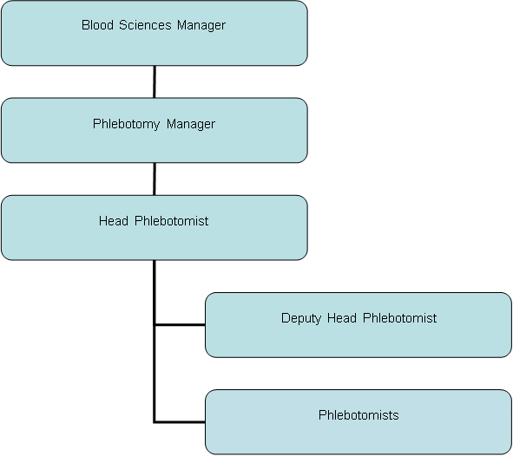

5. KEY RESULT AREAS/PRINCIPAL DUTIES AND RESPONSIBILITIES:

Phlebotomy
- To collect blood samples from patients, including those that are terminally ill, confused, agitated and mentally ill
- To ensure that high standards are maintained in patient identification in compliance with Standard Operating Procedures
- To assess, before blood sampling, the patient with regard to existing clinical conditions, e.g. axillary lymph nodes previously removed, existing cannulation and infusion and the decision to be made with regard to the site for venesection
- When taking blood from renal patients to assess their venous access and where possible take blood from their hands.
- To select the most appropriate equipment and method for venepuncture based on the clinical assessment of the patient
- To understand the hazards of taking blood samples from high risk patients, e.g. HIV/Hep A, B, C positive, MRSA, active TB and take the necessary Infection Control precautions
- Understand the anatomy and physiology of the vein and surrounding tissue including major arteries and nerves
- To recognise the complications of venepuncture in patients with tortuous, thin walled thrombosed and inflamed veins and veins that should not be used
- To understand the contraindications for performing venepuncture
- To assess patients on more than one level and manage aggressive and abusive behaviour and language
- To support patients when they are distressed, including patients who are needle phobic, both before and after the procedure
- To be familiar with and have an understanding of the full range of Pathology blood tests and their required sample tubes and post phlebotomy transport requirements
- To be able to work independently and make own decisions regarding procedures and techniques to be used
- To adhere to the Departments and the Trust Phlebotomy Procedures
- To record workload data and submit a monthly report to the Head Phlebotomist

Communication
- In a caring and sensitive manner to explain the procedure to the patient.
- To liaise with Medical and Nursing staff regarding special patient requirements that affect Phlebotomy
- Deal with enquiries from the general public and the ward staff regarding Phlebotomy issues

Out of Hours working
- To participate on rota covering Saturdays, Sundays and Bank holidays

Training and education
- To continue to develop Phlebotomy skills with particular regard to difficult venous access
- To keep updated with all aspects of phlebotomy
- To keep updated with all Trust mandatory training requirements

Human Resources
- To recognise the importance of harmonious relationships and maintain an atmosphere conducive to this
- To take part in individual performance reviews

Health and Safety
- To follow safe working practice with regard to taking blood samples from the increasing number of ‘High Risk’ patients
- To follow the Trust’s and the Phlebotomy Health & Safety requirements
- The post holder is expected to comply with Trust Infection Control Policies and conduct him/herself at all times in such a manner as to minimise the risk of healthcare associated infection.
- To adhere to all other national and local policies
- To be aware of COSHH and risk assessments as appropriate
- To undertake any training required in order to maintain competency including mandatory training i.e. Fire, Manual Handling and basic Life Support and Transfusion updates.

Other Responsibilities:
To take part in regular performance appraisal
To undertake any training required in order to maintain competency including mandatory training, i.e. Fire, Manual Handling
To contribute to and work within a safe working environment
The post holder is expected to comply with Trust Infection Control Policies and conduct him/herself at all times in such a manner as to minimise the risk of healthcare associated infection
THE TRUST - PURPOSE AND VALUES

We are committed to serving our community by being a high quality specialist Hospital with consultant-led services. We aim to co-ordinate our services with primary and community care, and to develop a limited number as Sub-Regional Referral Centres with appropriate levels of research, development and educational involvement. Where appropriate, and consistent with our services, we may provide services aimed at preventing disease and debilitation.

We aim to make all our services exemplary in both clinical and operational aspects. We will show leadership in identifying healthcare needs to which we can respond and in determining the most cost-effective way of doing so. We will share our knowledge with neighbouring healthcare agencies and professionals.

We recruit competent staff that we support in maintaining and extending their skills in accordance with the needs of the people we serve. We will pay staff fairly and recognise the whole staff’s commitment to meeting the needs of our patients.

We are committed to equal opportunity for all and encourage flexible working arrangements including job sharing.

GENERAL

This is a description of the job as it is now. We periodically examine employees' job descriptions and update them to ensure that they reflect the job as it is then being performed, or to incorporate any changes being proposed. This procedure is conducted by the Manager in consultation with the jobholder. You will, therefore, be expected to participate fully in such discussions. We aim to reach agreement on reasonable changes, but if agreement is not possible, the Trust reserves the right to insist on changes to your job description after consultation with you.

The RD&E is a totally smoke-free Trust. Smoking is not permitted anywhere on Trust property, including all buildings, grounds and car parks. For help to quit call: 01392 207462.

As an employee of the Trust, it is a contractual duty that you abide by any relevant code of professional conduct and/or practice applicable to you. A breach of this requirement may result in action being taken against you (in accordance with the Trust’s disciplinary policy) up to and including dismissal.

The post holder is expected to comply with Trust Infection Control Policies and conduct him/her at all times in such a manner as to minimise the risk of healthcare associated infection.

PERSON SPECIFICATION
POST: Phlebotomist

BAND: 2
REQUIREMENTS | At  Recruitment | At 2nd KSF  Gateway
QUALIFICATIONS / TRAINING  GCSE grade C/4 or above in 4 subjects including English & Mathematics or equivalent e.g. NVQ level 2 in a science subject | E
KNOWLEDGE / SKILLS  Knowledge of anatomy/physiology, pathology and infection control  Good eye/hand co-ordination  General IT skills  Good communication skills  Knowledge of RD&E ward locations  Understands requirements of working with sensitive & confidential information  Able to work with nervous & distressed patients | D  E  E  E  D  E  E | E  E
EXPERIENCE  Trained Phlebotomist  Experience of working in health care environment  Experience of working in hospital environment  Able to work on ones own and as part of a team  Good attendance record | D  E  D  E  E | E

HAZARDS IDENTIFIED (tick as appropriate):
Laboratory specimens  Proteinacious Dusts | X | Clinical contact with  patients | X | Performing Exposure  Prone Invasive Procedures | X
Blood / Body Fluids | X | Dusty environment |  | VDU use | X
Radiation |  | Challenging Behaviour | X | Manual handling | X
Solvents |  | Driving |  | Noise
Respiratory Sensitisers |  | Food handling |  | Working in isolation | X

