

JOB DESCRIPTION

JOB DETAILS
Job Title | Departmental Secretary & Administrative Team Leader
Reports to | Laboratory Manager
Band | AfC Pay scale 4
Department/Directorate | Blood Sciences. Diagnostics Division

JOB PURPOSE
- To manage a full time quality secretarial and administrative service to the Laboratory managers within the Blood Sciences Departments.
- To manage a full administrative and clerical service to the Blood Sciences Departments.
- This post will ensure that the secretarial team will provide a professional, efficient, accurate and timely service.
- This post will be responsible for the team leadership of the administration team.
- The coordinate the direct to patient service.

KEY RESULT AREAS/PRINCIPAL DUTIES AND RESPONSIBILITIES
- Primary role to provide a full quality and, as appropriate, confidential secretarial and administrative service to Senior staff in the Blood Sciences Laboratories.
- Required to have a high degree of autonomy to monitor, prioritise and organise own workload accordingly.
- To manage senior staff members diaries (this will include informing all appropriate people/departments of annual or other leave).
- To manage any miscellaneous clerical items for staff of the Blood Science
Laboratories.
- Supervising the handling of reference laboratory invoices and liaise with relevant Finance Departments regarding outstanding results or financial disputes.
- Supervise the use of pivot table database to produce monthly and quarterly billing for the Department with regards to work performed on Supraregional Assay Service and Research basis and ensure an accurate record is maintained.
- Supervising the liaison with Senior BMS staff and Laboratory Manager to investigate invoicing anomalies or discrepancies as and when necessary.
- Supervise the raising of credit notes when required.
- Update staff records.
- Use system to record all sickness absences for all Departmental Senior BMS', MTO'S, MLA and Phlebotomy staff and update excel spreadsheet for dashboard production purposes. Produce reports for Senior members of staff for the purpose of the informal/formal sickness review.
- Record Departmental Professional Development Review data for staff.
- Manage the maintenance of departmental mandatory training records and ensure staff remain up to date with mandatory Trust training.
- Provide monthly report of mandatory training and PDR’s for Blood Sciences.
- Use knowledge and experience to organise and develop the office procedures to produce an efficient, coherent system and suggest and help implement changes in how the administrative office interacts in the whole department and directorate at large.
- To provide supervision to Support Secretaries and Administrative Assistants on a day to day basis.
- Engendering a learning organisation; sharing expertise across the trust and ensuring team members complete required and essential (mandatory) learning as required.
- Ensuring that all documentation is produced to an excellent standard.
- To ensure records and filing systems are maintained in line with Trust policies.
- To ensure secretaries are able to provide a full and comprehensive quality service.
- To ensure effective bring forward systems, ensuring necessary range of papers are available to management team.
- To ensure stationery levels are maintained at all times.
- To carry out routine analysis of information as directed by manager, carrying out research to support analysis of information.
- To contribute to the NHS service improvement by participating fully in new projects and developments such as service redesign.
- To communicate with staff, external organisations and colleagues in a courteous, professional and timely manner at all times.
- To manage all day to day correspondence within the department – initiating appropriate responses in order to provide, staff and other parties with required information in a friendly and professional manner.
- Receiving telephone calls and accepting messages on behalf of members of the management team and taking appropriate action where necessary.
- To manage email communication in a timely way and in line with the RD&E’s Email Best Practice guidance.
- To organise meetings as required, including agreeing with other attendees and renegotiating any changes.
- Participate in team and directorate meetings as required.
- To act as liaison and support for Blood Transfusion committees.

KEY WORKING RELATIONSHIPS
No. of Staff reporting to this role: 3
The post holder is required to deal effectively with staff of all levels throughout the Trust as and when they encounter on a day to day basis.
In addition, the post holder will deal with the wider healthcare community, external organisations and the public.
This will include verbal, written and electronic media.

Of particular importance are working relationships with:
Internal to the Trust | External to the Trust
- Head of Departments  - Laboratory Managers  - Deputy Laboratory Managers  - Senior Technical and Scientific Staff  - Medical / Nursing Staff  - Medical Records staff  - Clerical and MLA staff  - Personnel  - Phlebotomy  - Estates Department  - Catering Department | - Patients  - Commercial customers  - Access to Work  - Suppliers

ORGANISATIONAL CHART
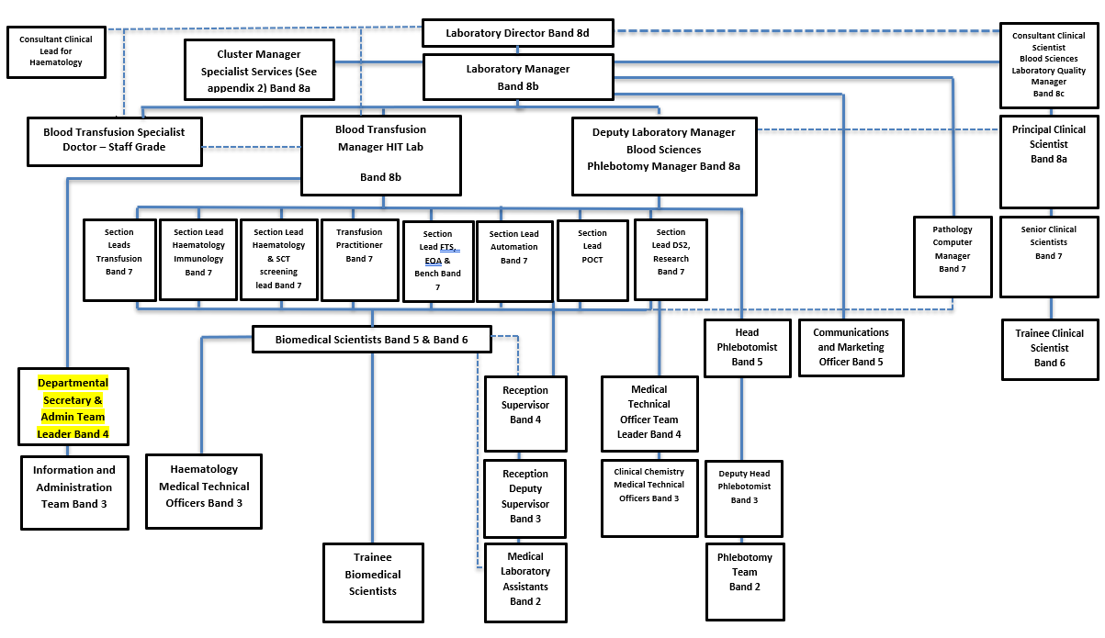

FREEDOM TO ACT
The post holder is required to work independently to defined laboratory policies and procedures.
The post holder is required to manage their own workload and that of the administration team.

COMMUNICATION/RELATIONSHIP SKILLS
The post holder must effectively communicate with patients, users of the service and other professional bodies including Consultants, GP's, Nursing staff and Senior members of laboratory staff on a regular basis.
Regular contact with third party suppliers of consumables and services is required, expediting deliveries and reconciling order delays/problems.
The role involves receiving telephone calls and accepting messages on behalf of members of the management team and taking appropriate action where necessary.
The post holder has oversight of the generic Blood Sciences and Commercial emails and must ensure all communications are dealt with in a timely way and in line with the Tryst Email Best Practice guidance.

ANALYTICAL/JUDGEMENTAL SKILLS
The post holder must exercise judgement when dealing with enquiries from Trust staff, patients and customers (commercial services).
The role requires the analysis of information to resolve problems relating to work tasks within the team and occasionally within the wider laboratory.

PLANNING/ORGANISATIONAL SKILLS
The post holder plans staff rotas and cover; arranges meetings; manages diaries, and organises events.

PATIENT/CLIENT CARE
The post holder will deal directly with commercial customers to provide advice, information and guidance.
There is no direct patient care but the activities of the laboratory have a direct effect on patient outcomes.
POLICY/SERVICE DEVELOPMENT
The post holder is responsible for the development and upkeep of policies and procedures for the administration team. Approval of these documents will be overseen by the Blood Sciences management team.
FINANCIAL/PHYSICAL RESOURCES
The post holder is required to:
Monitor use of supplies and ensure this is done efficiently and cost effectively in line with the needs of the service.
Maintain stock control of stationary and office consumables, re-ordering supplies where necessary.
Use the UNIT4 procurement system to place orders for Blood Sciences.

HUMAN RESOURCES
The post holder provides day to day supervision to the administration team, including allocating and checking of work, authorising annual leave and resolving straight forward staffing issues, including return to work interviews and straight forward absence management monitoring.
The role includes updating the Trust HR/payroll system in relation to employee records i.e. mandatory training, absence for all Blood Sciences staff.
Supporting recruitment campaigns by undertaking shortlisting of candidates is also required.
The post holder is responsible for providing training to junior staff on systems and processes.

INFORMATION RESOURCES
The post holder will be required to:
Update, maintains, stores clinical or non-clinical records.
Take formal minutes.
Create databases to collect and monitor information.
RESEARCH AND DEVELOPMENT
The role supports a broad range of R&D activities that are undertaken by technical and clinical staff.
PHYSICAL SKILLS
The role requires keyboards skills for regular use of computer systems.
PHYSICAL EFFORT
Light physical effort/ Keyboard work for long periods;; pushing notes trolleys; moving equipment
MENTAL EFFORT
The role requires concentration for administrative and secretarial duties and may be interrupted for higher priory tasks.
EMOTIONAL EFFORT
There is limited exposure to distressing or emotional circumstances.
The post holder will be required to deal with low level staffing issues
WORKING CONDITIONS
Office or similar conditions, VDU use.
OTHER RESPONSIBILITIES
Take part in regular performance appraisal.

Undertake any training required in order to maintain competency including mandatory training, e.g. Manual Handling

Contribute to and work within a safe working environment

You are expected to comply with Trust Infection Control Policies and conduct him/herself at all times in such a manner as to minimise the risk of healthcare associated infection

As an employee of the Trust, it is a contractual duty that you abide by any relevant code of professional conduct and/or practice applicable to you. A breach of this requirement may result in action being taken against you (in accordance with the Trust’s disciplinary policy) up to and including dismissal.

You must also take responsibility for your workplace health and wellbeing:
- When required, gain support from Occupational Health, Human Resources or other sources.
- Familiarise yourself with the health and wellbeing support available from policies and/or Occupational Health.
- Follow the Trust’s health and wellbeing vision of healthy body, healthy mind, healthy you.
- Undertake a Display Screen Equipment assessment (DES) if appropriate to role.

GENERAL
This is a description of the job as it is now. We periodically examine employees' job descriptions and update them to ensure that they reflect the job as it is then being performed, or to incorporate any changes being proposed. This procedure is conducted by the manager in consultation with the jobholder. You will, therefore, be expected to participate fully in such discussions. We aim to reach agreement on reasonable changes, but if agreement is not possible, we reserve the right to insist on changes to your job description after consultation with you.

Everyone within the Trust has a responsibility for, and is committed to, safeguarding and promoting the welfare of vulnerable adults, children and young people and for ensuring that they are protected from harm, ensuring that the Trusts Child Protection and Safeguarding Adult policies and procedures are promoted and adhered to by all members of staff.

PERSON SPECIFICATION

Job Title | Departmental Secretary & Administrative Team Leader

Requirements | Essential | Desirable
QUALIFICATION/ SPECIAL TRAINING  Educated to ‘A’ Level standard or equivalent  Minimum GCSE (or equivalent) grade A-C in English and Mathematics  RSA Stage III Typing or equivalent  ECDL,CLAIT or equivalent  Audio Typing qualification or equivalent  Medical Terminology qualification or equivalent  NVQ Level 3 in Business Administration or equivalent | E | D  D  D  D  D  D
KNOWLEDGE/SKILLS  Accurate Audio Typing  Ability to liaise and communicate with staff at all levels  Excellent interpersonal and communication skills  Ability to promote good working liaisons between staff, MDT, patients and their relatives.  Proven ability to motivate staff and encourage teamwork  Excellent planning and organisational skills  Ability to prioritise workload to respond to changing demand  Understanding of hospital network systems  Comprehensive PC skills including databases, word-processing and email, including Microsoft Excel  Excellent telephone manner  Ability to handle complex enquiries from patients, some of whom may be distressed and anxious about their care  Familiarity with medical terminology | E  E  E  E  E  E  E  E  E  E  E | D
EXPERIENCE  Extensive proven experience in a secretarial/administrative post  Previous experience in a hospital/healthcare setting  Previous experience / training in the supervision of staff including recruitment, appraisals sickness management | E | D  D
PERSONAL ATTRIBUTES  Enthusiastic highly motivated and committed to developing a service  A flexible approach to work  Remain calm and professional in a busy environment  Able to prioritise own work load and meet deadlines  Adheres to data protection and confidentiality requirements  Able to work independently and with minimum supervision | E  E  E  E  E  E
OTHER REQUIREMENTS  The post holder must demonstrate a positive commitment to uphold diversity and equality policies approved by the Trust.  Ability to travel to other locations as required. | E

FREQUENCY

(Rare/ Occasional/ Moderate/ Frequent)
WORKING CONDITIONS/HAZARDS |  | R | O | M | F
Hazards/ Risks requiring Immunisation Screening
Laboratory specimens | Y |  | X
Contact with patients | N
Exposure Prone Procedures | N
Blood/body fluids | Y |  | X
Hazard/Risks requiring Respiratory Health Surveillance
Solvents (e.g. toluene, xylene, white spirit, acetone, formaldehyde and ethyl acetate) | N
Respiratory sensitisers (e.g isocyanates) | N
Chlorine based cleaning solutions  (e.g. Chlorclean, Actichlor, Tristel) | N
Animals | N
Cytotoxic drugs | N
Risks requiring Other Health Surveillance
Radiation (>6mSv) | N
Laser (Class 3R, 3B, 4) | N
Dusty environment (>4mg/m3) | N
Noise (over 80dBA) | N
Hand held vibration tools (=>2.5 m/s2) | N
Other General Hazards/ Risks
VDU use ( > 1 hour daily) | Y |  |  |  | X
Heavy manual handling (>10kg) | N
Driving | N
Food handling | N
Night working | N
Electrical work | N
Physical Effort | N
Mental Effort | Y |  |  | X
Emotional Effort | Y | X
Working in isolation | N
Challenging behaviour | N

