JOB DETAILS

Job Title: Radiotherapy Helper

Band: 3

Reports to: Radiotherapy Services Manager

Department/Directorate: Radiotherapy Department / Specialist Services Division

Job Purpose:

The Oncology Centre in Exeter provides a radiotherapy treatment service for patients across the North, East and West Devon catchment area. External beam radiotherapy is delivered by three linear accelerator treatment machines, with up to 40 patients being treated on each machine per day. Radiotherapy treatment planning is undertaken on a dedicated CT scanner within the department.
Internal radiotherapy is also delivered in Exeter using a brachytherapy treatment unit.

The radiotherapy service regularly operates for extended working hours to ensure that all patients receive their treatment in a timely way.

The department uses bespoke radiotherapy scheduling, recording and verification software called ARIA to plan and deliver treatments, and all appointment bookings are managed via this system.

The post holder is required to:

- Assist in the preparation and delivery of a high quality, accurate radiotherapy service to cancer patients under the direction and supervision of registered Therapeutic Radiographers

- Be responsive to the social and healthcare needs of the individual patient whilst at all times respecting the privacy and dignity of the patient

- Support patients and medical staff during clinical examination and assessment

- Participate in the accurate registration, scheduling and appointing of patients on a radiotherapy pathway using the radiotherapy record and verification system, taking waiting times targets and concurrent treatments e.g. chemotherapy into account

- Assist in the tracking of patients referred for radiotherapy and enter information about appointments and decisions onto the cancer waiting times (CWT) tracking system

- Highlight any potential waiting times target breach situations to clinical staff

- Book patient transport as requested

- Work flexible hours in line with the department’s extended opening hours

Key Working Relationships:

Patients and their carers
Clinical Oncologists
Radiotherapy Services Manager
Specialist Registrars
Radiographers
Radiotherapy Assistant Practitioners and Helpers
Radiotherapy Physicists and Engineers
Student Radiographers and trainee Clinical Scientists
Nurses
Admin and Clerical staff

Organisational Chart:

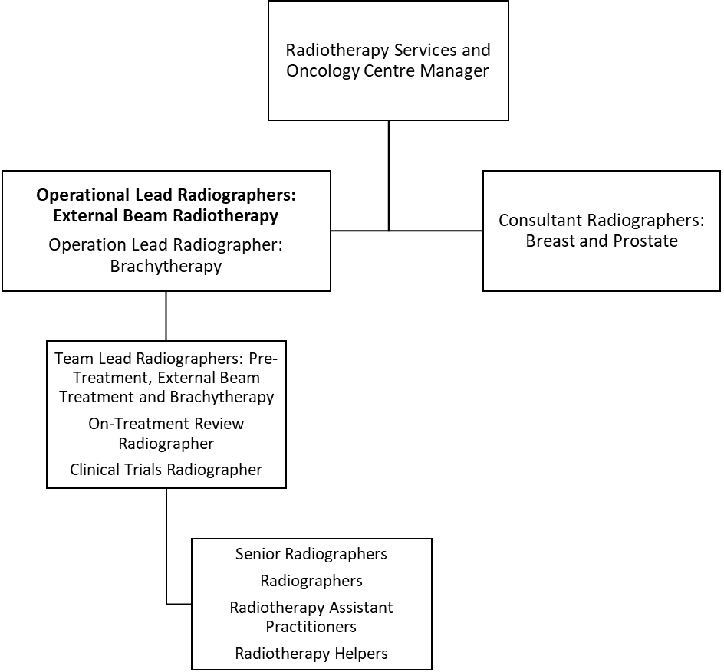

Principal Duties and Responsibilities:

Administrative

- Participate in the registration and scheduling of patients referred for radiotherapy treatment using specialised radiotherapy software systems (Aria) and the Trust’s electronic patient information system (EPIC)
- Participate in all aspects of the radiotherapy booking processes
- Complete departmental documentation and amend patient appointments as directed by the Radiographers
- Enter patients’ details onto registration, cancer waiting times, planning and treatment databases as directed
- Liaise with Patient Transport and Ambulance services, or the portering service, other wards and departments as necessary to facilitate the transport or transfer needs of individual patients
- Have a flexible approach to working hours in line with departmental opening times which can vary according to workload demand

Clinical Pre-treatment and Treatment

- Assist in the care of patients attending the department, helping each patient as necessary e.g. with undressing for treatment and examination or attending to basic hygiene/toileting needs
- Participate in specific aspects of pre-treatment procedures, including provision of basic patient information and care and daily assessment of patient condition
- Correctly identify the patient and enquire re wellbeing, referring to the Radiographers if there are any concerns or issues raised
- Provide patients with simple advice and explanations with regard to their radiotherapy treatment preparations; ensure that the treating Radiographers are kept informed of accurate timings for patient preparations
- Undertake treatment floor support, ensuring that patients are escorted to the correct treatment unit at the appropriate time
- Assist in patient movement and transfer, taking account of the local policies for manual handling
- Ensure consumables are topped up in clinical areas
- Using the appropriate infection control procedures, disinfect and store all equipment after use and at the end of clinical sessions
- Act as chaperone or supporter for the patient during clinical procedures
- Run patient on-treatment review clinics, supporting medical staff and patients
- Provide patients with simple advice on directions to facilities within the department and to other departments within the Trust, acting as an escort where necessary

Professional Standards

- Participate in effective clinical risk management
- Maintain and develop knowledge and skills in accordance with the Continuing Professional Development policy
- Undertake regular performance appraisal
- Undertake any mandatory training as required by Trust policies e.g. fire training, resuscitation training and manual handling training
- Comply with Trust infection control policies and to act at all times in such a manner as to minimise the risks of spread of infection
- Be aware of and comply with all other Trust policies
- Maintain a professional manner and appearance at all times
- Demonstrate knowledge of the Trust incident reporting procedure
- Ensure that a professional yet welcoming atmosphere is maintained at all times

Quality

- Support the Radiotherapy Services Manager in setting, monitoring and developing standards of care
- Demonstrate an understanding of quality strategies and processes to improve the care of patients
- Identify non-conformities within the quality system and address these issues using the appropriate systems
- Participate in audit as required
- Work within the framework of the Oncology Quality Management System (ISO9001:2015 standard) to ensure that patient care is maintained at the highest possible level
- Implement the procedures and work instructions described in the department in the Quality Management System and report any variances

Teaching, Supervision and Training

- Participate in the induction of new staff through the demonstration of Radiotherapy booking processes and systems
- Supervise the radiotherapy clerical officers in the performance of their duties

Other Responsibilities

- Undertake any training required in order to maintain competency, including mandatory training, e.g. Fire, Manual Handling
- Contribute to and work within a safe working environment
- The post holder is expected to comply with Trust Infection Control Policies and conduct him/herself at all times in such a manner as to minimise the risk of healthcare associated infection
- Adhere to the Ionising Radiation Regulations 2017, IR(ME)R 2017 and the departmental Local Rules at all times

This post has been identified as involving access to vulnerable adults and/or children and in line with Trust policy successful applicants will be required to undertake a Disclosure & Barring Service Disclosure Check

General

This is a description of the job as it is now. We periodically examine employees' job descriptions and update them to ensure that they reflect the job as it is then being performed, or to incorporate any changes being proposed. This procedure is conducted by the manager in consultation with the jobholder. You will, therefore be expected to participate fully in such discussions. We aim to reach agreement on reasonable changes, but if agreement is not possible, we reserve the right to insist on changes to your job description after consultation with you.

Everyone within the Trust has a responsibility for, and is committed to, safeguarding and promoting the welfare of vulnerable adults, children and young people and for ensuring that they are protected from harm, ensuring that the Trusts Child Protection and Safeguarding Adult policies and procedures are promoted and adhered to by all members of staff.

PERSON SPECIFICATION

POST: Radiotherapy Helper

REQUIREMENTS | Essential | Desirable
Qualifications / Special Training:

Good general education to GCSE level | ✓
Knowledge / Skills:

Experience of working in an oncology environment |  | ✓
Good IT skills | ✓
Experience of data base management | ✓
Experience of Trust Electronic Patient Information system (EPIC) |  | ✓
Organised and able to work in a busy environment | ✓
Ability to prioritise workload to respond to the changing demands | ✓
Excellent telephone manner | ✓
Excellent communication skills | ✓
Experience:

Previous clerical experience |  | ✓
Previous healthcare experience |  | ✓
Previous experience of communicating with the public, particularly in difficult or stressful situations | ✓
Personal Attributes:

Remain calm in a busy situation | ✓
Able to work in a multi-disciplinary team | ✓
Able to manage enquiries from patients, some of whom may be anxious or distressed due to the nature of their illness | ✓
Able to communicate clearly and effectively with patients’ carers and other staff | ✓
Other Requirements:

Flexible working (to include extended day / bank holiday working) | ✓
Committed to further self-development | ✓

Hazards within the role, used by Occupational Health for risk assessment
Laboratory Specimens  Proteinacious Dusts |  | Clinical contact with patients |  | Performing Exposure  Prone Invasive Procedures
Blood/Body Fluids | X | Dusty Environment |  | VDU Use | X
Radiation | X | Challenging Behaviour |  | Manual Handling | X
Solvents |  | Driving |  | Noise
Respiratory Sensitisers | X | Food Handling |  | Working in Isolation

