JOB DESCRIPTION

1. JOB DETAILS

Job Title: Reporting Sonographer

Band: 7 Ultrasound

Reports to: Superintendent Radiographer

Department / Directorate: Diagnostics

2. JOB PURPOSE

- To work to a high professional standard and to produce high quality ultrasound images.
- To provide a diagnostic and reporting service for referrals to the general ultrasound department.
- To provide a diagnostic ultrasound and reporting service for referrals to the Foetal and Maternal assessment Unit from the Obstetricians, Gynaecologists, G.P.s, Midwives and external ultrasound departments in Tiverton , Axminster and Exmouth..
- To assist in the day to day running of the department and to maintain high standards of patient care.
- To maintain good working relationships with all wards and other departments and to participate in multidisciplinary meetings relating to the delivery of the ultrasound service where appropriate.
- If required, to work independently within the outlying Primary Care Trust hospitals and similar locations.
- To encourage and participate in the concept of continuing professional development.
- To provide professional support and guidance for all staff involved in ultrasound imaging and participate in formal training of such staff if required.

3. KEY WORKING RELATIONS

- Radiology Services Manager and Superintendent Radiographer
- Consultant Radiologists and Radiology Registrars
- FAMU Associate Specialist and Obstetricians.
- Departmental nursing Staff and Midwives.
- Sonographers ,Radiographers and support staff within the Department
- Medical, nursing and administrative staff from wards and departments throughout the trust
- Patients , their partners and associated carers
- Student Sonographer, Midwives and Medical Students
- External Medical staff for referral.
- Administrative, Clerical and Support staff.
- Medical, nursing and Administrative staff from the wards and departments throughout the trust.
- Neonatal Nurses and Paediatricians.

4. DIMENSIONS

The department of medical imaging carries out approximately 235000 examinations per year.
The general ultrasound department performs approximately 40,000+ examinations per year for the Foundation Trust., GP’s and community. We provide one stop clinics for the urologists, rapid access for jaundiced patients and rapid access for DVT patients. There are ultrasound lists provided at 3 Community Hospitals.
The department is equipped with five high spec ultrasound machines in purpose built ultrasound rooms.
The Obstetric Department provides a diagnostic imaging service in pregnancy for approximately 4000 women per year. All are offered routine scans at 11-14 weeks with Nuchal Translucency Testing and also an Anomaly scan at around 20 weeks. Multiple pregnancies receive additional monitoring and follow up scans are performed where more information is needed for growth, foetal well-being, and placental site or to monitor anomalies. The department also provides diagnostic imaging for gynaecological in patients, an early pregnancy assessment unit and an emergency gynaecological clinic.
It is equipped with four high quality ultrasound imaging rooms and has access to further equipment in the gynaecological day case unit.
The service in both departments is supported by a computer generated reporting system. The department also has a role in teaching as part of the Peninsula Medical School and provides training for Doctors studying the Advanced Diploma in Ultrasound.
We have a role in training radiologist Registrars, on-going Sonographer training programme, as well as a Student Radiographer Programme.

- ORGANISATIONAL CHART:
- 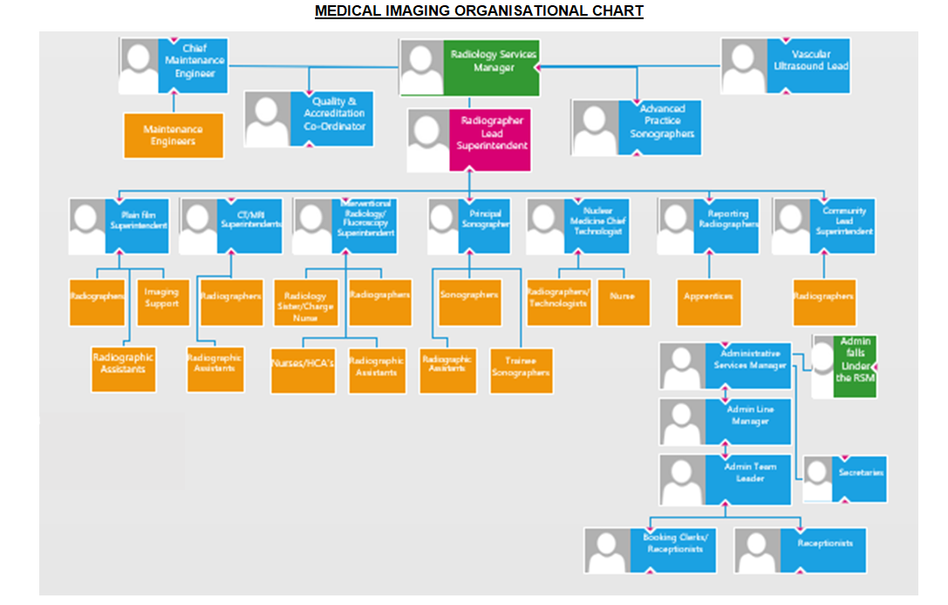

6. KEY RESULT AREAS/PRINCIPAL DUTIES AND RESPONSIBILITIES:

Communications

- To communicate in a concise and appropriate manner complex information regarding Ultrasound scanning procedures to patients and relatives, other hospital staff and G.P.’s.
- To communicate information relating to foetal abnormalities and demise to pregnant patients and relatives, offering emotional support in such distressing situations.
- To be able to provide reassurance and overcome patient concerns and barriers to understanding in order to obtain the level of co-operation required to achieve a successful outcome to scanning procedures.
- To provide clear, concise ultrasound reports.
- To work and communicate efficiently with other members of staff throughout the trust and beyond. To assist in the provision of an efficient ultrasound imaging service to the Trust.
- To ensure that the Superintendent Radiographer/Radiology Services manager is made aware of any matter which does or has the potential to affect the provision of the ultrasound imaging service currently offered by Diagnostic Services.
- To inform a referring clinician of urgent or unexpected results, as appropriate.
- To liaise with appropriate staff regarding follow-up Outpatient appointments for patients after ultrasound imaging, as appropriate.

Leadership and Management

- On a daily basis be able to apply organisational and planning skills in the allocating and re allocating of time and resources to meet rapidly changing operational and clinical requirements.
To be aware of the need for the highest level of patient care at all times, with particular reference to the hazards posed by cross infection and similar risks.
- To be responsible for his/her actions and patient workload and be able to work unsupervised as well as part of a multidisciplinary team.
- When required, to supervise the work of other qualified staff, students and support workers performing duties within the ultrasound imaging areas of the department.
- To participate in the practical training of student radiographers and support and assist junior members of the radiographic staff in their duties, cascading necessary information and training as required.
- To be familiar with and adhere to all departmental guidelines.
- To maintain a high standard of professional conduct and appearance at all times.
- To ensure the correct procedures are followed regarding the input of data and images onto CRIS, INSIGNIA and Viewpoint.

Professional and Clinical

- To work as a clinical member of the ultrasound team to provide an efficient, high quality specialised service.
- To carry out a wide range of ultrasound procedures and to provide professional guidance to other staff working within ultrasound imaging.
- To make every effort to remain aware of the latest developments in diagnostic ultrasound and act as a ‘clinical expert’ in this area of work
- Working within protocols, to provide accurate and timely clinical reports on a range of ultrasound examinations.
- To work to a high level of specialist expertise in ultrasound imaging, demonstrating the practical application of professional skills that are underpinned by a robust theoretical knowledge.

- To be responsible for the correct care and use of complex equipment and resources generally throughout the department, but with particular reference to the problems of manoeuvring of large equipment in confined clinical areas.
- To make autonomous decisions using professional knowledge, experience and advanced analytical judgement skill to ensure the most appropriate imaging examination is performed.
- To work within the relevant trust guidelines when dealing with situations that present possible infection risks e.g. exposure to bodily fluids or that has the potential for compromising personal well-being such as aggressive or challenging patient behaviour.
- Whilst working within defined occupational standards, protocols and professional guidelines be prepared to exercise a degree of freedom to act when clinical findings indicate a need to do so.
- To be responsible for entering clinical data onto the RIS system and ensuring all images obtained are available on Insignia.
- To be able to work to the highest levels of professional competence, whilst at the same time having to provide the maximum degree of physical, emotional and mental effort required to perform accurate examinations on patients who can be critically injured, terminally ill or otherwise immobile and unable to offer any assistance.
- To assist in the evaluation and assessment of new and replacement items of equipment relevant to ultrasound imaging.

Training, Education and CPD

- To show evidence of maintenance of general technical and professional skills and participation in Continuous Professional Development to such a level required to remain eligible for registration by the Health Professions Council.
- To maintain and continually update the specialist skills required to perform cross sectional imaging procedures, evidenced by participation in specialised post graduate training courses and programmes and to maintain a portfolio detailing this activity.

Quality systems, Human Resources and Organisational Objectives

- To be aware of and adhere to, all relevant Trust wide and Departmental policies and procedures.
- To be aware of legislation relevant to patient confidentiality and to work to “best practice” guidelines at all times.
- To have a flexible approach to working hours, and be prepared to participate fully in such shift, extended working day and on call working rotas as may be required.
- To be prepared to carry out duties appropriate to role and grade in any area of the Radiology department if exceptional circumstances make this necessary
- Participate in the Departmental appraisal scheme and using this to agree performance objectives and establishing a personal development plan.
- To attend and participate fully in all Departmental meetings.
- To work closely with the Superintendent Radiographer in the monitoring and evaluation of existing processes and procedures associated with Ultrasound, participating fully in the development and introduction of revised improved methods of service delivery.
- To be prepared to participate in research and on-going audit activities within Ultrasound imaging, and to suggest appropriate subjects for activities for consideration by the Division of Radiology and departmental audit and research co-ordinators.

Other Responsibilities:

To take part in regular performance appraisal
To undertake any training required in order to maintain competency including mandatory training, e.g. Manual Handling
To contribute to and work within a safe working environment
The post holder is expected to comply with Trust Infection Control Policies and conduct him/herself at all times in such a manner as to minimise the risk of healthcare associated infection

As an employee of the Trust, it is a contractual duty that you abide by any relevant code of professional conduct and/or practice applicable to you. A breach of this requirement may result in action being taken against you (in accordance with the Trust’s disciplinary policy) up to and including dismissal.

The post holder is expected to comply with Trust Infection Control Policies and conduct him/her at all times in such a manner as to minimise the risk of healthcare associated infection.

This post has been identified as involving access to vulnerable adults and/or children and in line with Trust policy successful applicants will be required to undertake a Disclosure & Barring Service Disclosure Check

THE TRUST – Vision and Values

Our vision is to provide safe, high quality seamless services delivered with courtesy and respect. To achieve our vision we expect all our staff to uphold our Trust values. Our Trust values are:

Honesty, Openness & Integrity
Fairness,
Inclusion & Collaboration
Respect & Dignity

We recruit competent staff that we support in maintaining and extending their skills in accordance with the needs of the people we serve. We will pay staff fairly and recognise the whole staff’s commitment to meeting the needs of our patients.

We are committed to equal opportunity for all and encourage flexible working arrangements including job sharing.

We are committed to recruiting and supporting a diverse workforce and welcome applications from all sections of the community, regardless of age, disability, gender, race, religion, sexual orientation, maternity/pregnancy, marriage/civil partnership or transgender status. We expect all staff to behave in a way which recognises and respects this diversity, in line with the appropriate standards.

GENERAL

This is a description of the job as it is now. We periodically examine employees' job descriptions and update them to ensure that they reflect the job as it is then being performed, or to incorporate any changes being proposed. This procedure is conducted by the Manager in consultation with the jobholder. You will, therefore, be expected to participate fully in such discussions. We aim to reach agreement on reasonable changes, but if agreement is not possible, we reserve the right to insist on changes to your job description after consultation with you.

The RD&E is a totally smoke-free Trust. Smoking is not permitted anywhere on Trust property, including all buildings, grounds and car parks. For help to quit call: 01392 207462.

PERSON SPECIFICATION

POST: Reporting Sonographer
BAND: 7

REQUIREMENTS | At  Recruitment | At 2nd KSF  Gateway
QUALIFICATIONS / TRAINING  BSc in Diagnostic Radiography or equivalent or Registered Midwife  Current registration with the Health Professions council  PG Dip or equivalent in Medical Ultrasound  Training and experience in abdominal, obstetric and gynaecological ultrasound  Nuchal Translucency Accreditation, Vascular ultrasound, paediatric ultrasound | E  E  E  E  D | E  E  E  E  E
KNOWLEDGE / SKILLS  Proven skills in performing a wide range of examinations and procedures in Ultrasound, with documented evidence of the ability to report on a range of ultrasound imaging procedures.  Ability to demonstrate up to date knowledge of ultrasound imaging techniques.  Ability to provide a high level of patient care in accordance with current protocols. | E  E  E | E  E  E
EXPERIENCE  Proven ability to work unsupervised as a member of a multidisciplinary team.  Experience of working unsupervised with particular reference to out of hours working.  Experience of supervising, mentoring & assessing Student Radiographers and Assistant Practitioners. | E  E  D | E  E  E
PERSONAL ATTRIBUTES  Flexible approach to duties and ability to participate in shift and extended day  Ability to communicate well with all grades and disciplines of staff, patients and relatives.  Be reflective in thinking and outlook and be available as a source of advice, coping with multiple demands during the working day. | E  E  E | E  E  E
OTHER REQUIREMENTS  Be prepared to deal with distressing and emotional situations on a daily basis, e.g. relating to foetal abnormalities and /or death to patients and relatives who may be distressed, aggressive or abusive.  To be physically able to safely and competently position and manoeuvre patients and equipment as a routine part of the daily duties, including wheelchairs, beds and stretchers and have a particular awareness of the potential health risks for staff associated with prolonged sessions of U/S sessions.  Ability to travel across sites as short notice. | E  E  D | E  E  E

* Essential/Desirable

HAZARDS:- Updated 31st May 2013
Laboratory Specimens | X | Clinical contact with Patients | X | Dealing with violence & aggression of patients/relatives | X
Blood / Body Fluids | X | Dusty Environment |  | VDU Use (occasional) | X
Radiation / Lasers |  | Challenging Behaviour | X | Manual Handling | X
Solvents |  | Driving | X | Noise / Vibration
Respiratory Sensitisers |  | Food Handling |  | Working in isolation | X
Cytotoxic Drugs |  | Electrical work |  | Night Working

