

JOB DESCRIPTION – Apprentice Medical Physics Technologist
(Radiotherapy Technology)

1. JOB DETAILS

Job Title: Apprentice Medical Physics Technologist
(Radiotherapy Technology)

Band: 5 Annex U

Reports to: Lead Physicist

Department / Directorate: Medical Physics / Specialist Services

2. JOB PURPOSE

To put our patients first by working as one team, leading, listening and striving for the best

To Work within the Medical Physics department as a trainee Clinical Technologist under the Healthcare Science (Medical Physics Technologist) Apprenticeship programme and complete the full BSc Healthcare Science (Medical Physics Technologist) qualification at the associated Higher Education Institution.

Work under the supervision of a Registered Practitioner.

As part of the multi-disciplinary team, the post holder will provide a key role in supporting the use of imaging, care and support to individuals as specified in standard protocols, or written care or service plans, in a range of environments.

The Apprentice Medical Physics Technologist will be based at one of the two acute hospital in the SEND Medical Physics Network (Royal Devon, Eastern and Northern services and Torbay Hospital). They will also be allocated to work across other sites within SEND Medical Physics, including community sites and non-NHS sites. The post holder may be required to work outside standard working hours to enable them to make the most of their training and participate fully in the service delivery.

Apprentices will be contracted to work 37.5 hours per week, divided into 80% workplace based and 20% protected study time. Study time will be either within the department or at the associated Higher Education Institution (HEI). Attendance of training at the HEI is considered to be essential and annual leave must be arranged outside these sessions. The post holder will be expected to discuss their planned study with their mentor or superintendent radiographer each week.

The post holder will fulfil all tasks and work as part of a team responsible for providing an efficient service in the Medical Physics Department. To meet the needs of the service, the post holder may be required to work in other areas and hospitals as appropriate, as directed by the line manager.

The post holder will have a close working relationship with staff across a variety of professional boundaries in order to maintain efficient links with other wards and Departments throughout the Trust.

3. KEY WORKING RELATIONSHIPS

- Medical Physics Department
- Clinical Scientists
- Departmental administrative, clerical and support staff
- Superintendent Radiographers
- Radiotherapy Services Manager
- Consultant Clinical Oncologists
- Therapeutic radiographers across all modalities
- Radiographic assistants
- Imaging Support Workers
- Departmental nursing staff
- Radiotherapy Engineers
- RDUH staff across the trust at all levels
- Patients, relatives and carers
- University of West of England Staff

The post holder is required to deal effectively with staff of all levels throughout the Trust, the wider Healthcare community, external organisations and the public. This will include verbal, written and electronic media.

4. DIMENSIONS

SEND Medical Physics supports provides services in support of clinical departments across the SEND (South East North Devon). Services include Radiotherapy Physics, Diagnostic Radiology Physics, Nuclear Medicine Physics, Radiation Safety, and Clinical Engineering. Services are also provided to external NHS and non-NHS customers.
- ORGANISATIONAL CHART

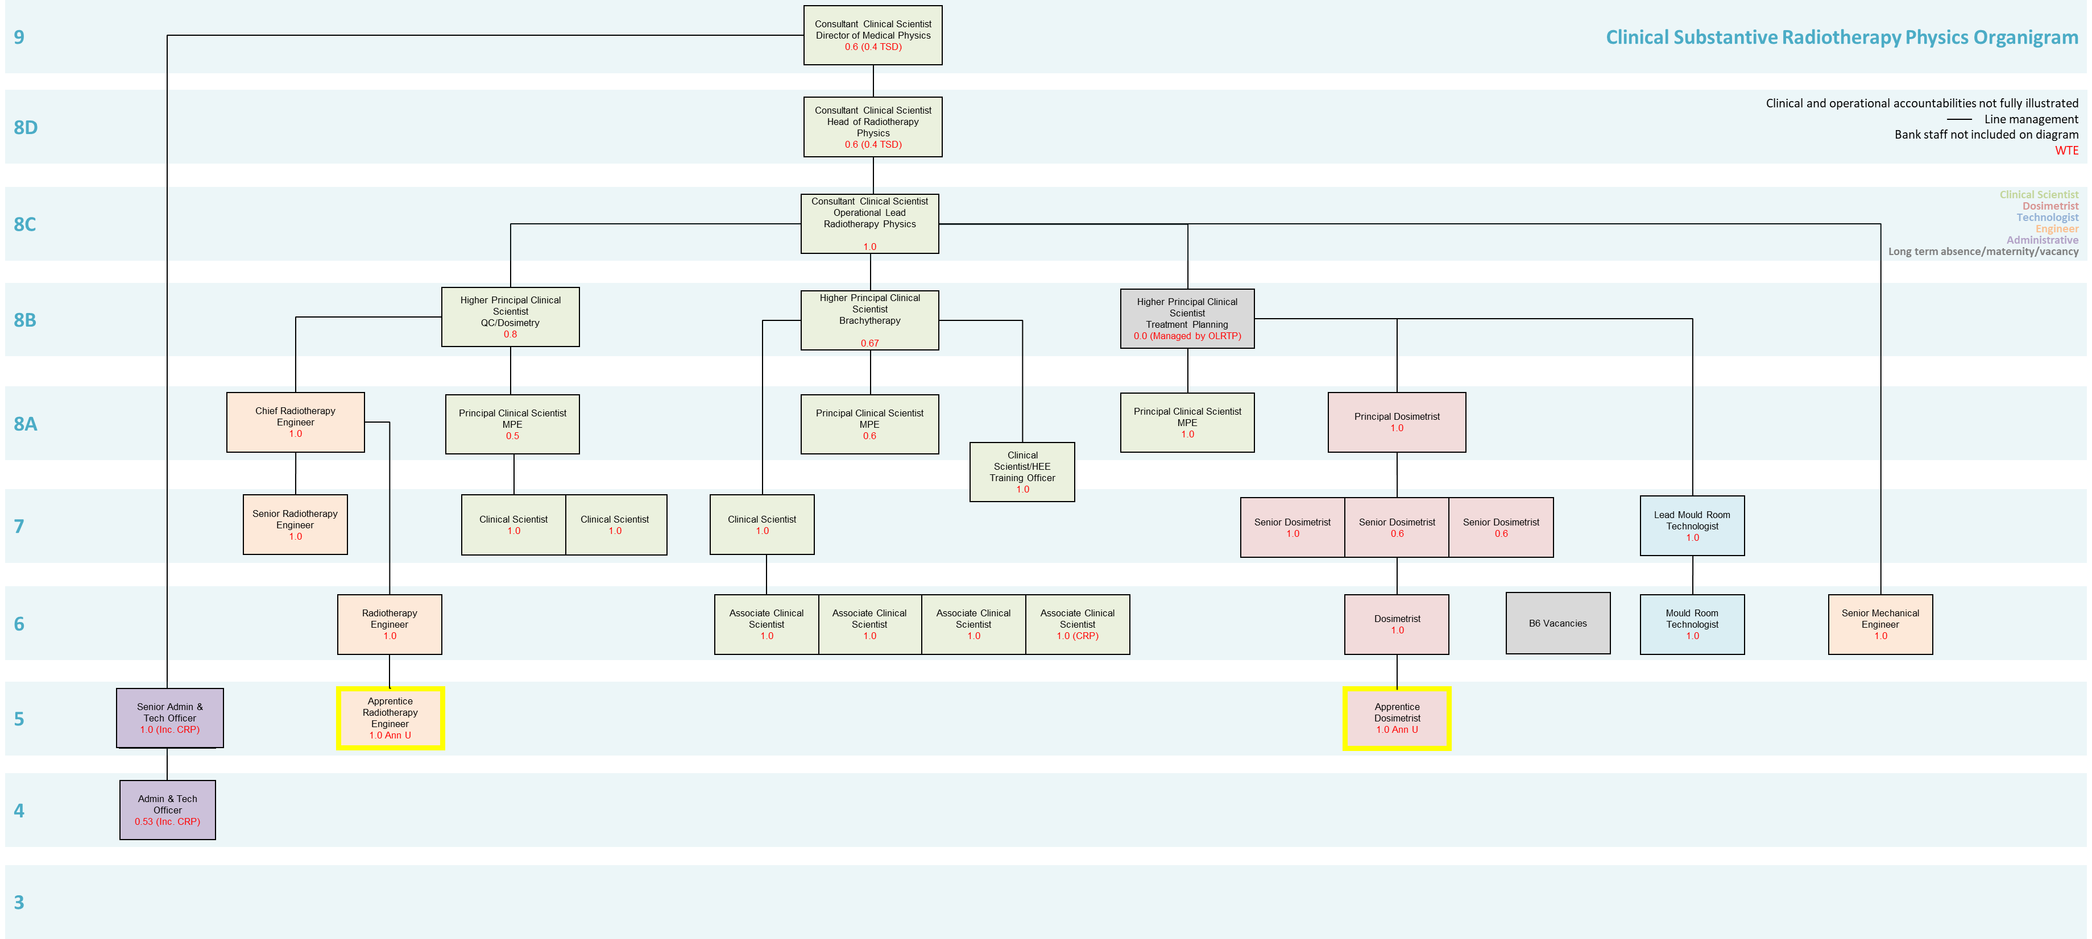
6 Principal Duties and Responsibilities
To work as part of a team responsible for providing an efficient service.

Attend mandatory block weeks for the Healthcare Science (Medical Physics Technologist) Apprenticeship programme at the University of West of England.

Make a commitment to study both within working hours and at home during the duration of the apprenticeship course.

Attend virtual tutorials and webinars and complete all e-learning as instructed by the University of West of England.

To perform a range of medical physics procedures, as detailed within the apprenticeship programme, within the Medical Physics department under the supervision of a qualified healthcare scientist at all times.

To ensure that the Ionising Radiation Regulations 2017, IRMER 2017 and associated codes of practice and guidance notes together with the Health and Safety at Work Act are understood and adhered to in respect of staff, patients and members of the public.

Works within the boundaries of existing competence, adhering to the Trust Radiation Safety Policy and national and local standard operating procedures/protocols.

To immediately report any fault errors to the supervising scientist. To make appropriate entries in the fault log.

7 Communication and Relationship Skills
This role requires excellent communication skills including verbal, written and use of IT

Able to exchange information with patients/clients requiring support, tact and reassurance.

Form professional relationships with patients/clients and communicates and cooperates with them in a way that respects their views, autonomy and culture.

Constructively manage barriers to effective communication and works cooperatively with patients and team members.

Understand the implications of the Mental Capacity Act and acts to assess capacity as appropriate.

Understand the safeguarding adult’s issues and act within the guidance of the policy to keep adults within their care safe.

Able to keep accurate contemporaneous documentation using and supporting the organisation’s documentation.

Report effectively to the relevant team on progress and outcome of work.

Communicate with other staff and agencies as appropriate in written and oral format to report on progress and outcome of work.

Attend meetings and feedback relevant information.

To give advice to other healthcare workers and professionals on general radiation protection issues and be able to explain the general risks of radiation to clients whilst knowing when to defer to a qualified healthcare scientist.

8 Analytical and Judgement Skills
Carries out delegated assessment of equipment performance and report any unexpected deviations.

Undertake delegated risk assessments providing accurate feedback to the team as necessary

Recognise the need for further advice, guidance and support as appropriate.

To acquire knowledge and learn to apply this in a practical setting.

To use all equipment in accordance with manufacturer’s instructions, recognising and reporting faults occurring to any equipment to a senior radiographer in that area.

To liaise and discuss requests with the supervising healthcare scientists to ensure appropriate procedures are performed within departmental protocols and national guidelines.

9 Planning and Organisational Skills
Be able to plan and successfully undertake the academic components of the Healthcare Science (Medical Physics Technologist) Apprenticeship course whilst continuing to achieve clinical competencies.

The post holder will be expected to:

To plan and undertake their continued studies both in the workplace and at home.

To assist staff to ensure the department is working effectively at all times by contributing towards good control of workflow and maximising the use of resources.

Prioritise own tasks under the appropriate delegation of the registered practitioner.

To actively participate in departmental meetings.

Participate in the regular QA testing of all protective equipment used in the department (as required by IRR 2017), including protective lead aprons, screens and other such related equipment.

10 Physical Skills
A range of scientific skills including; dexterity and accuracy for complex measurement.

Ability to undertake training to provide assessment of equipment within the defined scope of practice.

Be able to safely move and manipulate a range of tests equipment using defined methods where appropriate.

To use Radiography systems in accordance with departmental protocols ensuring data and images are correctly inputted and correlated.

11 Responsibility for Patient and Client Care

To work within clearly a defined accountability framework.

To demonstrate clinical competence developed through continual professional development, reflective practice and maintenance of a skills portfolio relevant to the service specification.

To recognise and appropriately address risk factors to patients/clients and carers within their healthcare setting and feedback appropriately to the registered practitioner

To report any incidents, untoward incidents, complaints and near misses to self, patients or carers to the appropriate professional within the stated timescales and record these on datix.

12 Responsibility for Policy and Service Development
To work to Trust Policies, Procedures and Standard Operating Procedures (SOP).

To maintain Trust Standards of Clinical Governance.

To support Professional Standards of Practice

The post holder will work in accordance with departmental policies, protocols and procedures.

13 Responsibility for Financial and Physical Resources
The post holder has no budgetary responsibilities but is responsible for the safe and correct use of expensive therapy and image acquisition equipment.

Support the efficient use of resources including; maintaining stocks and supplies and ordering equipment & resources as agreed or directed.

Ensure safe and efficient use of stock and equipment including; ensuring equipment is checked appropriately and any defects reported.

Demonstrate and instruct the use of equipment to ensure safety.

14 Responsibility for Human Resources
Supporting peers, including bank and agency staff in the clinical area.

Maintaining own professional development and attending training, including all mandatory training to enhance the role within the clinical area.

Be prepared to share knowledge and experience both formally and informally.

Take a flexible approach in supporting colleagues during times of workload pressures.

Participate in the training and induction of other staff/students as appropriate.

Participate in supervision and appraisal process, identifying own areas of development, & undertaking relevant activities to meet objectives set in Personal Development Review Plan.

Keep a record of own training and development, maintain a portfolio, working to sustain acquired competencies for the post.

15 Responsibility for Information Resources
Inputting, storing and providing information on relevant IT systems and records.

Accurately completing and maintaining effective patient records including confidentiality issues.

To be able to work with the departments’ OIS and PACS systems.

16 Responsibility for Research and Development

The post holder will be required to contribute to developing his / her own team’s evidenced based practice including research.

To engage in active participation in data collection for audit and quality assurance purposes.

17 Decision Making

Adhere to professional and organisational standards of practice, policies and procedures and work within guidelines under the supervision of a qualified Healthcare Scientist.

Work alone at times in a variety of settings, under the direction of the Registered Practitioner with access to support and supervision.

May be required to take decisions alone and then escalate to appropriate Healthcare Scientist.

18 Physical Effort
Daily work involves frequent sitting/standing, walking, moving equipment and manual handling.

Medical Physics procedures may necessitate working in restricted positions or limited space.

Moving & handling of equipment in order to perform complex measurements.

Undertake training to use and manipulate equipment on a daily basis to assess performance of diagnostic equipment.

18 Mental Effort
The post holder will sometimes be expected to cover the duties of colleagues in posts of the same pay band or lower and within the range of the post holder’s knowledge and skills.

There will be periods of occasional intense concentration when dealing with very complex equipment.

Must be willing to undertake the training involved in this post in order to become a qualified Clinical Technologist. Being able to undertake some study in own time whilst continuing to work within the Medical Physics Department.

Work in an unpredictable pattern when required.

Read and decipher complex information.

Ability to use and concentrate for long periods using IT.

20 Emotional Effort
Able to deal with occasional distressing / emotional circumstances.

Ability to cope and deal with areas of conflict.

21 Working Conditions
Occasional exposures to bodily fluids, infection and unpleasant smells. Occasional aggressive behaviour / verbal abuse from patients and relatives.

Due to risks from ionising radiation, the post holder must adhere to the Ionising Radiation Regulations 2017 (IRMER 17), Ionising Radiation Regulations 2017 (IRR 17) and associated codes of practice and guidance notes, and the Health and Safety at Work

PERSON SPECIFICATION

POST: Apprentice Medical Physics Technologist (Radiotherapy Technology)
BAND: 5 Annex U

REQUIREMENTS | At Recruitment
QUALIFICATIONS/SPECIAL TRAINING:  128 points from A level (ABB, including at least one relevant science from Biology, Chemistry, Physics, Maths or Physiology)  GCSE English, Maths and Double Science grade 4 (C) or above.  Or other qualifications sufficient to register with UWE | E  E
KNOWLEDGE/SKILLS:  Good Knowledge of the Medical Physics Management system.  Knowledge of relevant national standards, e.g IR(ME)R 2017, IRR’17 and associated codes of practice  Sound knowledge of a range of equipment performance issues and how to escalate concerns.  Knowledge of correct assessments of radiotherapy and imaging equipment.  To be able to demonstrate a basic knowledge of IT skills  Knowledge of accountability, relevant SOP’s policies and importance of accurate documentation.  Knowledge of client conditions related to the setting.  Health, safety and risk awareness.  Safeguarding and MCA understanding.  Demonstrates a commitment to lifelong learning. | D  D  D  D  E  D  D  D  E
EXPERIENCE:  Proven experience of working in an appropriate scientific / health care setting. | D
PERSONAL REQUIREMENTS:  Flexible approach to duties and ability to participate in shift/extended day schedules when required.  Ability to communicate well with all grades and disciplines of staff, clients, patients and relatives.  Be reflective in thinking and outlook and be available as a source of advice, coping with multiple demands during the working day.  Highly motivated and committed to delivering the service.  Ability to remain calm in a busy environment  Good hand/eye co-ordination skills and aptitude for precision  Good communication skills, written and verbal.  Ability to work autonomously.  Ability to work under pressure and with flexibility.  Empathetic and demonstrates patient focus.  Able to manage own emotions and cope in sometimes difficult situations.  Basic computer skills.  Understand the need for professional conduct.  Demonstrate understanding of the boundaries of their existing competence and authority levels for delegation of tasks.  Competent listening and observation skills.  Positive interpersonal skills.  Good co-ordination/organisation skills.  Ability to work positively and professionally as part of a team.  Able to contribute to the training of other staff/students.  Willingness/commitment to undertake training.  Understands and demonstrates commitment to the Trust’s values. | E  E  E  E  E  E  E  E  E  E  E  E  E  E  E  E  E  E  D  E  E
OTHER REQUIREMENTS:  Able to deal with occasional distressing / emotional circumstances.  Moving & handling of equipment (<=15kg) in order to perform complex measurements.  The post holder must demonstrate a positive commitment to uphold the trust values at all times.  Flexible working in a range of clinical settings, environments and shift patterns.  Ability to travel to meet needs of the job.  Clean Driving Licence | E  E  E  E  E  D
* Essential/Desirable

Hazards within the role, used by Occupational Health for risk assessment
Laboratory Specimens Proteinacious Dusts |  | Clinical contact with patients |  | Performing Exposure Prone Invasive Procedures
Blood / Body Fluids | √ | Dusty environment |  | VDU Use | ✓
Radiation | √ | Challenging Behaviour |  | Manual Handling | ✓
Solvents |  | Driving | √ | Noise
Respiratory Sensitisers |  | Food Handling |  | Working in isolation
Handling Cytotoxic Drugs

