
JOB DESCRIPTION

1. JOB DETAILS

Job Title: Recruitment Administrative Assistant

Band: 2

Reports to: Recruitment Line Manager

Department / Directorate: Recruitment/ People Division

2. JOB PURPOSE

Being responsible for Stage 1 of the recruitment process – advertising, shortlisting, inviting candidates to interview, processing interview paperwork, managing the Recruitment Inbox and supporting the Recruitment Administrators on a daily basis.

Acting as part of the recruitment team to action all details on the employment lifecycle of an employee of the Trust from recruitment to contract.

3. DIMENSIONS/ KEY WORKING RELATIONS

Internal to the Trust
Recruitment Manager
Service Managers
Recruiting Managers
Employees of the Trust ( Both Clinical and Non – Clinical)
Internal Applicants

External to the Trust
Applicants
Colleges and Universities
Companies – to seek references
External Recruitment Agencies
Other NHS organisations

Dimensions:

Approximately 15,000 employees of the Royal Devon and Exeter NHS Foundation Trust

- ORGANISATIONAL CHART:

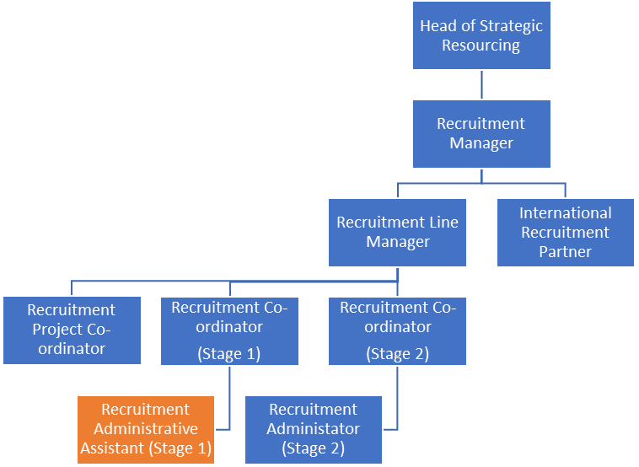

5. KEY RESULT AREAS/PRINCIPAL DUTIES AND RESPONSIBILITIES:

Act as a point of contact for information and advice on HR policies and procedures answering / resolving queries in person, via telephone, letter and/ or via email. Communicate information to help promote good practice including members of the public applying for vacancies.

Liaise with managers to ensure adequate information is gathered in order to advertise a vacancy, issue application forms, obtaining shortlists, seek references and preparing correspondence relating to interviews and appointment of staff.

Communicate employment legislation to new employees with regards to eligibility to work where there may be barriers to understanding due to cultural or language difficulties

Ensure all documentation processed complies with policies and procedures including equal opportunities regulations and advise managers on required changes as necessary, formatting documents if required.

Assist managers in deciding on a suitable advertising method. Use recruitment knowledge and persuasive skills to ensure optimum audience is targeted for a vacancy. Monitor the numbers of applications received for open vacancies and use judgment to decide when to close a vacancy early due to high volumes.

Communicate effectively with advertising agents to ensure adverts are placed within time limits and promote the Trust effectively.

Allocate suitable interview slots, confirm attendance and re-arrange interviews at short notice. Contact disabled applicants to enquire and arrange if any special arrangements need to be made for the interview.

Provide feedback to unsuccessful candidates at the shortlisting and interview stage using tact and sensitivity.

Create, update and/or maintain HR records via HR systems including the Electronic Staff
Record system, Healthroster, Career Gateway and NHS Jobs.

Other Responsibilities:

To take part in regular performance appraisal
To undertake any training required in order to maintain competency including mandatory training, e.g. Manual Handling
To contribute to and work within a safe working environment
The post holder is expected to comply with Trust Infection Control Policies and conduct him/herself at all times in such a manner as to minimise the risk of healthcare associated infection

As an employee of the Trust, it is a contractual duty that you abide by any relevant code of professional conduct and/or practice applicable to you. A breach of this requirement may result in action being taken against you (in accordance with the Trust’s disciplinary policy) up to and including dismissal.

The post holder is expected to comply with Trust Infection Control Policies and conduct him/her at all times in such a manner as to minimise the risk of healthcare associated infection.

THE TRUST – Vision and Values

Our vision is to provide safe, high quality seamless services delivered with courtesy and respect. To achieve our vision we expect all our staff to uphold our Trust values. Our Trust values are:

Compassion
Integrity
Inclusion
Empowerment

We recruit competent staff that we support in maintaining and extending their skills in accordance with the needs of the people we serve. We will pay staff fairly and recognise the whole staff’s commitment to meeting the needs of our patients.

We are committed to equal opportunity for all and encourage flexible working arrangements including job sharing.

We are committed to recruiting and supporting a diverse workforce and welcome applications from all sections of the community, regardless of age, disability, gender, race, religion, sexual orientation, maternity/pregnancy, marriage/civil partnership or transgender status. We expect all staff to behave in a way which recognises and respects this diversity, in line with the appropriate standards.

As users of the disability confident scheme, we operate a Guaranteed Interview Scheme for job applicants with disabilities. If you let us know, when you apply, that you would like to use this scheme, we will guarantee you an interview, if you meet the essential criteria listed in the person specification section of the job description.
We will also make any reasonable adjustments you require to our selection process. Please let us know what you need.

GENERAL

This is a description of the job as it is now. We periodically examine employees' job descriptions and update them to ensure that they reflect the job as it is then being performed, or to incorporate any changes being proposed. This procedure is conducted by the Manager in consultation with the jobholder. You will, therefore, be expected to participate fully in such discussions. We aim to reach agreement on reasonable changes, but if agreement is not possible, we reserve the right to insist on changes to your job description after consultation with you.

The RD&E is a totally smoke-free Trust. Smoking is not permitted anywhere on Trust property, including all buildings, grounds and car parks.
For help to quit, please contact our Specialist Stop Smoking Advisor on 01392 406133.


PERSON SPECIFICATION
POST: Recruitment Administrative Assistant
BAND: 2
REQUIREMENTS | At  Recruitment | At PDR
QUALIFICATIONS / TRAINING  Minimum of 3 qualifications to include GCSE grade A-C/4-9 in English and Maths or equivalent experience  NVQ 2 in Administration or equivalent experience | E  E | E  E
KNOWLEDGE / SKILLS  Able to problem solve  Able to work quickly, methodically and accurately  Able to demonstrate a basic knowledge of Agenda for Change conditions of service  Excellent interpersonal skills  Proven strong administration skills  Accurate data entry  Excellent telephone manner  Knowledge of IT databases and computer systems  Comprehensive PC skills - databases, word-processing, email, Excel  Ability to liaise and communicate with staff at all levels  Excellent interpersonal & communication skills inc. demonstrating empathy & sensitivity to candidates and managers | E  E  D  E  E  E  E  E  E  E  E | E  E  E  E  E  E  E  E  E  E  E
EXPERIENCE  Previous clerical and computer experience gained in a working environment  Previous experience of working in an HR environment  Experience of Recruitment and selection Processes  Demonstrate knowledge and ability to use Word and Excel  Previous experience of NHS Systems, ESR or Oracle systems, NHS jobs, Healthroster | E  D  D  E  D | E  E  E  E  E
PERSONAL ATTRIBUTES  Deliver high customer service with good communication / interpersonal skills  Ability to be a team worker  Ability to work in a busy environment, meet deadlines and prioritise effectively  Adaptable and Flexible – (may be required to attend evening / weekend job fairs | E  E  E  E | E  E  E  E
OTHER REQUIREMENTS:  Appreciation of and ability to work in a confidential environment | E | E
* Essential/Desirable

HAZARDS:- Updated 6th March 2024
Laboratory Specimens |  | Clinical contact with Patients |  | Dealing with violence & aggression of patients/relatives
Blood / Body Fluids |  | Dusty Environment |  | VDU Use (frequent) | X
Radiation / Lasers |  | Challenging Behaviour |  | Manual Handling | X
Solvents |  | Driving |  | Noise / Vibration
Respiratory Sensitisers |  | Food Handling |  | Working in isolation
Cytotoxic Drugs |  | Electrical work |  | Night Working

