JOB DETAILS

Job Title: Therapeutic Radiographer

Band: 5

Reports To: Radiotherapy Services Manager

Department / Directorate: Cancer Services / Specialist Services Division

Job Purpose:

To participate in the day-to-day provision of a safe and high-quality radiotherapy treatment service, rotating through pre-treatment, external beam treatment, brachytherapy treatment and other clinical areas of work as required.

To provide information and support to patient and their carers, demonstrating empathy and compassion at all times.

To communicate effectively with the wider oncology multidisciplinary team and other services as required ensuring the delivery of optimum patient care.

A flexible approach to work is essential since hours of work will vary, to include shift/extended day working, weekend on-call and bank holiday working.

Key Working Relationships:

Patients and their carers
Consultant Clinical Oncologists
Specialist Registrars and trainees
Radiographers, Assistant Practitioners and Radiotherapy Helpers
Radiotherapy Clinical Scientists and Technicians
Student Radiographers and trainee Clinical Scientists
Nursing staff
Admin and Clerical staff

Organisational Chart:

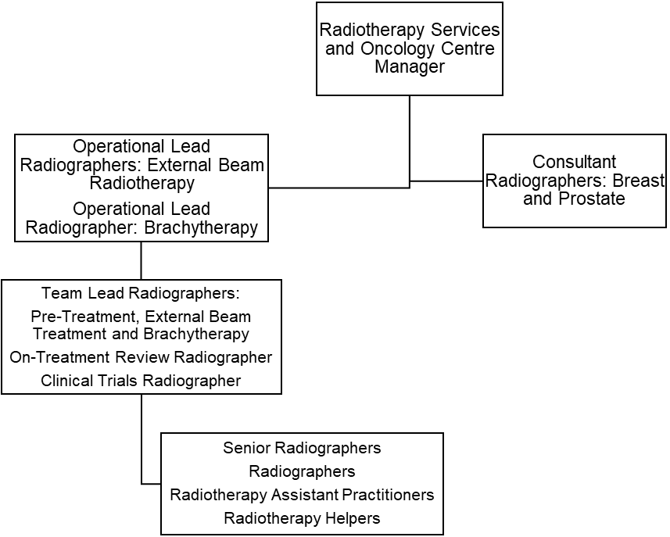

Principal Duties and Responsibilities:

Clinical

- Rotate through all areas of the department as directed, developing and maintaining an appropriate level of clinical knowledge and expertise in each area
- Provide a safe and accurate technical service when planning or delivering radiotherapy treatment, whilst maintaining a high duty of care to all patients
- Be responsible for the safe use of highly complex and expensive equipment
- Use a high level of skill to manipulate and position the patient in order to achieve an accurate treatment set-up
- Maintain a high level of concentration at all times, given the need to deliver highly complex treatments with minimal tolerance margins
- Ensure that all treatment equipment is safe and accurate to operate
- Undertake the appropriate machine checks prior to the clinical use of the linear accelerator and report any variances immediately
- Ensure that equipment is available for QA and maintenance at the agreed times, thus complying with local arrangements to ensure safety and to reduce the potential for hazards associated with radiation exposure
- Use a high level of skill when tattooing patients in order to enable precise set-up information
- Demonstrate specialist knowledge of treatment side effects and their management
- Participate in the management of treatment machine scheduling, taking particular care to minimise delays and breaks in treatment in accordance with Trust policy, clinical guidelines and national waiting times targets
- Undertake specialised dose calculations and check complex planning data relating to the delivery of radiotherapy treatment
- Input complex treatment data into the computerised Record and Verify patient information system
- Maintain and continually develop knowledge of IGRT procedures and protocols in order to participate in the acquisition, comparison, assessment and manipulation of images used for the purpose of radiotherapy verification
- Maintain highly accurate treatment and statistical records
- Communicate effectively with treatment, pre-planning and/or brachytherapy Radiographers in order to facilitate the highest standard of patient care and treatment delivery
- Communicate effectively with the multidisciplinary team in order to facilitate the highest standard of patient care and treatment delivery
- Authorise the patients’ radiotherapy treatment on the basis of their clinical condition using theoretical knowledge and clinical experience and in accordance with IRMER
- Ensure that all patients receive accurate information and documentation relating to their treatment, potential side-effects and management of side-effects prior to the onset of treatment
- Ensure that the patient gives informed consent prior to treatment
- Communicate effectively with the patient, often having to use skills of persuasion, empathy or reassurance in order to deliver or receive complex/highly sensitive information whilst maintaining patient confidentiality and dignity at all times, and ensuring that accurate records of any such communications are produced when appropriate
- Provide a supportive and confidential environment for patients, their carers and other staff members
- Provide support to terminally ill patients and/or their carers on a daily basis
- Maintain a professional and reassuring manner when exposed to bodily fluids or foul odours caused by tissue necrosis, and to radiotherapy treatment reactions, often on a daily basis
- Work flexible shift patterns to ensure the required service capacity is maintained
- Participate in weekend on call and bank holiday working

Teaching, Training and Research:

- Participate in the induction of new staff and mentor staff within own area of accountability
- Undertake on-going student appraisals and validation of suitability to practice
- Participate in the collection of data for commercial clinical treatment trails as requested
- Participate in the implementation of radiotherapy clinical trials

Quality:

- Support the Radiotherapy Services Manager in setting, monitoring and developing standards of care
- Demonstrate an understanding of quality strategies and processes designed to improve the care of patients
- Participate in the quality assurance system and audit
- Identify non-conformities within the quality system and report / address these issues using the appropriate systems
- Participate in the quality assurance system and audit.
- Ensure clinical practice is based on validated research
- Assist where appropriate in the collection of data for research purposes
- Demonstrate the work of the department to other professionals or interested parties as required

Professional Standards

- Maintain and develop knowledge and skills in accordance with the Continuing Professional Development policy
- Update specialist skills and knowledge in all aspects of radiotherapy planning and delivery on an annual basis in order to maintain clinical competence
- Undertake regular performance appraisal
- Undertake mandatory training as required by Trust policies e.g. fire training, resuscitation training and manual handling training
- Comply with Trust infection control policies and to act at all times in such a manner as to minimise the risks of spread of infection
- Be aware of and comply with current regulations governing the administration of ionising radiations
- Be aware of and comply with all other Trust policies
- Ensure familiarity and compliance with all local and national legislation issued by the Trust relating to radiation exposure and/or health and safety issues in order to promote good working practice and a safe working environment for staff, patients and their carers
- Contribute to and work within a safe working environment
- Participate in effective clinical risk management
- Demonstrate knowledge of the Trust incident reporting procedure
- Comply with the Society of Radiographers’ Professional Code of Conduct
- Maintain a professional manner and appearance at all times

This post has been identified as involving access to vulnerable adults and/or children and in line with Trust policy successful applicants will be required to undertake a Disclosure & Barring Service Disclosure Check

General

This is a description of the job as it is now. We periodically examine employees' job descriptions and update them to ensure that they reflect the job as it is then being performed, or to incorporate any changes being proposed. This procedure is conducted by the manager in consultation with the jobholder. You will, therefore be expected to participate fully in such discussions. We aim to reach agreement on reasonable changes, but if agreement is not possible, we reserve the right to insist on changes to your job description after consultation with you.

Everyone within the Trust has a responsibility for, and is committed to, safeguarding and promoting the welfare of vulnerable adults, children and young people and for ensuring that they are protected from harm, ensuring that the Trusts Child Protection and Safeguarding Adult policies and procedures are promoted and adhered to by all members of staff.

PERSON SPECIFICATION

POST: Band 5 Therapeutic Radiographer

REQUIREMENTS | Essential | Desirable
Qualifications / Special Training:

Degree in Radiotherapy or equivalent qualification of the College of Radiographers | ✓
HCPC Registration | ✓
Appropriate clinical radiotherapy experience at undergraduate level | ✓
Knowledge / Skills:

Good understanding of radiotherapy pathways | ✓
Ability to recognise and manage side-effects related to radiotherapy treatment | ✓
Evidence of involvement in the procedures for radiotherapy planning and verification | ✓
Ability to interpret treatment planning data and calculate treatment doses | ✓
Experience of record and verify software | ✓
Treatment planning and verification image assessment skills | ✓
Able to communicate complex or sensitive information to patients using a variety of communication techniques | ✓
Understand the principles of quality assurance and audit and their importance in radiotherapy |  | ✓
Understand the significance of radiotherapy research / audit and the use validated results to improve practice |  | ✓
Knowledge and application of the legislative regulations relating to the use of ionising radiation (IRR, IRMER) | ✓
Understand the principles of governance in radiotherapy |  | ✓
Experience:

Evidence of multidisciplinary team working | ✓
Experience in a variety of radiotherapy modalities | ✓
Experience of effective interaction with patients and their carers | ✓
Personal Attributes:
Enthusiastic, highly motivated and committed to providing a safe and high-quality radiotherapy service | ✓
Good organisational and time management skills | ✓
Able to work under pressure and deal with sensitive or stressful situations | ✓
The flexibility to enable working across different service sections, occasionally at short notice | ✓
Ability to communicate effectively with patients, carers and the wider multidisciplinary team | ✓
Other Requirements:

Strong commitment to own further professional development | ✓
Willingness to participate in staff and student development | ✓
Willingness to rotate through all operational areas of the service | ✓
Willingness to participate in flexible working hours, on call and bank holiday rotas | ✓

Hazards within the role, used by Occupational Health for risk assessment
Laboratory Specimens  Proteinacious Dusts |  | Clinical contact with patients | X | Performing Exposure  Prone Invasive Procedures | X
Blood/Body Fluids | X | Dusty Environment |  | VDU Use | X
Radiation | X | Challenging Behaviour |  | Manual Handling | X
Solvents |  | Driving |  | Noise
Respiratory Sensitisers | X | Food Handling |  | Working in Isolation

