Trust Fellow (Registrar) Acute Medicine ST6+

JOB TITLE

Trust Fellow (Registrar) Acute Medicine

DATE OF VACANCY

BASE

RDUH
Barrack Road
Exeter
EX2 5DW



Hi, I’m Vanessa Purday, Chief Medical Officer of Royal Devon University Healthcare NHS Foundation. Thank you for the interest that you have shown in working with us, at what is an unprecedented time for healthcare across the UK but also an exciting time for our organisation, now one of the largest healthcare Trusts in the country.
The Royal Devon is a special place to work. We combine scale with a family-like feel, fostering both creativity and personal care. Our agility and forward-thinking approach ensure we can adapt to the evolving NHS landscape, deliver the best care for our patients and provide excellent career progression for colleagues.
Vanessa Purday
We are especially proud of our Medical department, nationally recognised for its multidisciplinary expertise and research. We are committed to building on this success and are seeking exceptional clinicians to join our dynamic and inclusive team here in Devon.
I wish you every success with your application and look forward to meeting you soon.

We welcome enquiries for further information and strongly encourage informal visits either in person or virtually so that you can get a feel for what it’s like to work with us. A list of contacts is detailed in the final section of this pack
August 2026

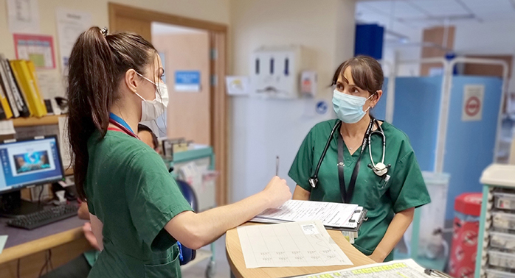
Introduction

To provide high quality care to medical patients in a busy teaching hospital. The appointee will have the opportunity to undertake a diverse range of clinical work on a variety of medical wards at the Royal Devon University Healthcare NHS Foundation Trust.
“Inclusion is one of our core values, and we take pride in having a diverse workforce and a culture that respects everybody”
You will gain valuable clinical experience caring for patients with a wide range of conditions, delivering high quality care and working as part of a dynamic multi-disciplinary team. There is an on-call commitment. We would welcome applications from people interested in pursuing the portfolio pathway.
The role will include working clinically in 3 distinct environments including:
Same Day Emergency Care – Here you will manage patients acutely that can have their care completed in the same day this includes procedures and investigations

Acute Medical Unit – You will have the take divided with another registrar to provide zones of care and mutual support. There is direct consultant presence from 8am to 10pm.

Ambulatory Care/Virtual Ward – This is where patient follow ups and ongoing procedures occur. It is an ideal environment to develop outpatient and practical skills.
The role will be varied and is a great option for those who enjoy the diagnostic process, managing acutely unwell patients, performing practical procedures and teaching others these skills. There will be ample opportunity to be involved in teaching undergraduates, resident doctors and nurses. There will be the opportunity to work with a wide variety of specialties to develop your skills in various disciplines.

Highlights of the role
Training and development. There are many training and development opportunities that you are encouraged to seek out and participate in. These include structured teaching sessions, participation in clinics, Audits and QIPs. You will have a £500 study budget per annum to support professional development
Service development. The Royal Devon’s core services support a population of more than 615,000 people across more than 2,000 square miles across Devon. The scale of operation brings opportunities to establish and develop innovative new services to better meet the needs of our patients such as harnessing technology to deliver remote patient consultations and disease monitoring.
Rota Detail. The post involved evening and weekend working
Electronic patient record. We went live with the Epic electronic patient record system across our Eastern services in 2020 and our Northern services in 2022. We are optimising the way we use the system, but we are already seeing huge benefits for our patients. Epic is transforming the way we deliver care across our Trust, allowing teams to share the caseload across Devon and provide care to patients remotely.
Location and relocation. We are fortunate to be based in the beautiful South West of England, with the cultural city of Exeter, the rolling moors of Exmoor and Dartmoor, and a multitude of stunning beaches on our doorsteps. We have low rates of crime and excellent education - schools and further education colleges are good or outstanding, and Exeter boasts a top Russell group university.
A more comprehensive explanation of all of these elements can be found within this job pack, but if you have any questions then please do get in touch. Contact details are at the back of this pack.

About Royal Devon University Healthcare NHS Foundation Trust
Our core services support a population of over 615,000 people and cover more than 2,000 square miles across Devon. This makes us one of the largest providers of integrated health care in the UK, and the biggest employer in Devon, with more than 15,000 staff.
We have two acute hospitals, 20 community locations, outpatient clinics and community teams who care for people within their own homes. We also provide primary care and a range of specialist services which extends our reach throughout the South West Peninsula as far as Cornwall and the Isles of Scilly.
We have a strategy to embrace change, innovation and technology in our ambitions to be a digitally-enabled, clinically-led teaching organisation. We are developing new ways of working and focus our multi-million annual investment programme into new infrastructure, equipment and facilities to ensure we deliver the highest quality care and outcomes. There has never been a better time to join us.
The Royal Devon is committed to supporting the personal and professional development of our Medical Staff and in turn improving the care offered to our patients. This might include developing or introducing innovative care models and bringing these to rural patients, teaching the doctors of tomorrow or undertaking award-winning clinical research. Examples include our inflammatory bowel disease research team who were recognised with the national team award for their contribution to the NIHR portfolio, and our recent launch of a world-first national genetic testing service from our labs, which can rapidly test DNA samples of babies and children, so we can provide life-saving treatment.
You’ll find more information about the role and the Trust in this pack. Further information is also available on our website www.royaldevon.nhs.uk.


About the Trust and
service structure
The Royal Devon’s Board of Directors is chaired by Dame Shan Morgan and is comprised of both executive and non-executive directors. The executive directors manage the day to day operational and financial performance of the Trust.
“More information
about our structure and services can be found
on the Trust website at www.royaldevon.nhs.uk ”
These consist of the chief executive officer (Sam Higginson),
deputy chief executive officer (Chris Tidman), chief medical officer (Vanessa Purday), chief nursing officer (Carolyn Mills), interim chief operating officer (Phil Luke), chief finance officer (Angela Hibbard), and chief people officer (Hannah Foster).
This post will be based at the Royal Devon and Exeter Hospital (Wonford) (RD&E)
Our Trust-wide operational service structure is divided into five care groups, each with a medical director, a care group director and a director of patient care. For the Medicine Care Group the medical director is Dr Helen Lockett, the care group director is Karen Donaldson and the director of patient care is Nolwenn Luke

Department of Acute Medicine
The Acute Medical Unit (AMU - 52 beds, including 8 side rooms) specialises in the initial assessment and management of acutely ill patients. Patients are admitted either by GP, directly from ED or occasionally directly from a specialist clinic or ward/department within the acute trust. AMU is a short stay area and patients will either be discharged or moved to another ward for ongoing treatment, usually within 48 hours.
AMU is staffed by a number of Acute Medicine consultants but also has daily visits from other medical teams, ensuring patients are seen by the appropriate specialist early on in their admission. There are also a large number of therapists and allied healthcare professionals based on the unit who help with the treatment and discharge planning of patients

Senior medical staff
There are currently 14 consultants working on AMU. We are supported by a large team of junior doctors including SAS, higher specialist trainees and numerous resident doctors in training. AMU care is Consultant–led and there is Consultant presence on the Unit from 08.00-22.00 daily and an on-call Consultant is available off-site out of these hours. All patients on AMU are reviewed at least daily by a Consultant.
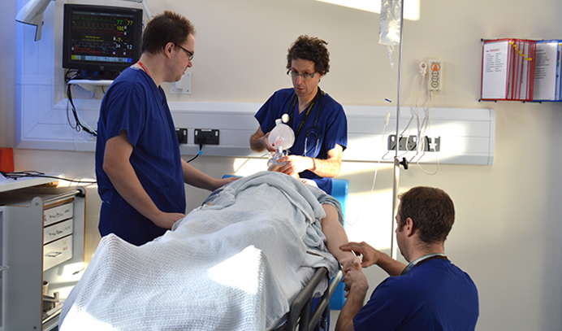

Research
Investigator-led and clinical trial research has a prominent place in the Royal Devon. Patients are given the opportunity to participate in a wide number of studies.
The University of Exeter Medical School has an excellent research reputation from basic biomedical research through to patient-centred research. The group is supported by the University of Exeter and NIHR biomedical research centre and currently provides research training to three PhD students and two visiting fellows.
The Research, Innovation, Learning and Development (RILD) building on the RD&E Wonford site is a £27.5m development which consists of the Wellcome Wolfson Centre for Medical Research, the National Institute for Health Research (NIHR) Exeter Clinical Research Facility, and a new Post Graduate Education Centre. The RILD is now home to a number of the Medical School’s laboratory-based research teams, comprising both clinical research areas and class two and three medical research laboratories, complete with offices, meeting rooms and write-up areas.
Active assistance in the planning and design of research projects is available from the Research and Development Support Unit based on the RD&E Wonford hospital site. The Trust has an active academic strategy to facilitate research, development and teaching.
Candidates who wish to pursue a research interest alongside their clinical work will be strongly encouraged.

University of Exeter Medical School
The University of Exeter is high-ranking in both UK and global standings and is a member of the Russell Group of leading research-based institutions. It has ambitious plans for the future and has invested heavily in its facilities in recent years.
The Medical School’s cutting-edge research is driven by important clinical questions. It focuses on translational and applied research in areas of greatest health burden and greatest opportunity for scientific advance, principally: diabetes, cardiovascular risk and ageing; neurological disorders and mental health; environment and human health; and health services research. It spans basic through clinical science to clinical trials and health policy.
UEMS delivers two highly-regarded and innovative undergraduate degrees: the BSc in Medical Sciences and Bachelor of Medicine, Bachelor of Surgery (BMBS). In addition, the Medical School offers a range of postgraduate programmes and courses. The curriculum reflects today’s evolving models of care and patient experience in acute, primary and community care settings.
Building on the excellent educational reputation of the Peninsula College of Medicine and Dentistry and using problem-based learning in small groups, the BMBS programme reflects the belief that doctors need to adopt a socially accountable approach to their work and to understand the human and societal impact of disease as well as the community-wide context of contemporary healthcare provision.
UEMS graduates will be both capable and confident, whether they are clinicians, managers, educators or researchers and will be committed to life-long scholarship. Years one and two of the BMBS programme are based at the St Luke’s Campus in Exeter and lay the scientific foundations for the future years of the course. There is clinical contact from year one and students begin acquisition of a range of transferable skills, learning science within a clinical context.
UEMS students spend years three and four of their programme at the Royal Devon and Exeter (Wonford) Hospital and North Devon District Hospital, as well as at the Royal Cornwall Hospital in Truro and in their surrounding general practices and community health environments.

The Senior Medical Staff in the Acute Medical Department are all involved in teaching students. The postholder is encouraged to develop interests in education and training and there are many opportunities to develop these interests both locally and more widely.

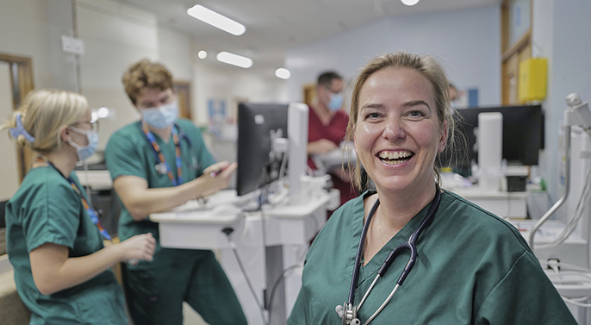
Rota outline

Below is an example of the work schedule you may work

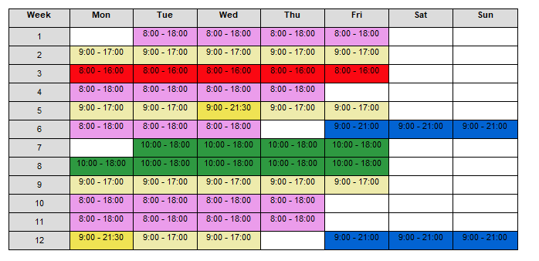

Person specification
Applicants must demonstrate on the application form that they fulfil all essential criteria to be considered for shortlisting. Appointment is subject to pre-employment checks, including occupational health, DBS checks and a minimum of three satisfactory references, including one from your current Responsible Officer.
Requirement | Essential attributes | Desirable attributes
Qualifications and training
Professional qualifications | Primary Medical Qualification (MBBS or equivalent)  Full MRCP (UK) at the time of application  Participation in Audit / QI projects. | Distinctions, Prizes, Scholarships.  Additional postgraduate qualifications.
Professional training and memberships | Full GMC registration & license to practice.  Eligible to work in the UK.  Advanced Life Support | Advanced Life Support  Advanced Trauma Life Support (ATLS).  Advanced or European Paediatric Life Support (APLS or EPLS).
Clinical experience
Clinical knowledge and skills | Demonstrates a clear, logical approach to clinical problems and an appropriate level of clinical knowledge.  Able to priorities clinical need.  Caring approach to patients.  Demonstrates awareness of breadth of clinical issues.  Clinical feedback from colleagues & patients.  Evidence of experience in a range of acute medical specialties, with experience of managing patients on unselected medical take during core training or equivalent  Able to work without direct supervision where appropriate and direct the work of others  Able to maximise safety and minimise risk  Demonstrates awareness of breadth of clinical issues.  Clinical feedback from colleagues & patients.  Minimum 24 months practical NHS experience | Experience in the transfer of ventilated patients.  Demonstrates awareness of breadth of clinical issues.  Clinical feedback from colleagues & patients.
Non-clinical skills
Teaching | Enthusiasm for teaching & training  Evidence of contribution to Departmental / Trust / Regional teaching programmes | Defined educational roles or qualifications  Higher qualification in medical education
Management of change and quality improvement | Demonstrates willingness to implement evidence-based practice. | Demonstrates understanding of quality improvement and clinical governance within the NHS.  Evidence of effective personal contributions to clinical audit, governance and risk reduction.  Evidence of involving patients in practice.
Innovation, research, publications and presentations | Understanding of the principles of scientific method and interpretation of medical literature.  Demonstrates a critical and enquiring approach to knowledge acquisition.  Evidence of relevant research, presentations or publications. | Evidence of relevant research, presentations or publications.
Management and leadership experience | Experience in organising and managing theatre lists. | Experience of formal leadership roles or training.
Communication and personal skills | Good spoken and written English language skills.  Communicates effectively with patients, relatives, colleagues, nurses, and allied health professionals.  Information technology skills.  Ability to work with multi-professional teams and to establish good professional relationships.  Evidence of patient and colleague feedback.  Excellent presentation skills, engages audience. | Evidence of patient and colleague feedback.  Excellent presentation skills, engages audience.  Information technology skills
Other requirements
Motivation and management of personal practice | Punctual and reliable.  Good personal organizational and prioritization skills, achieve deadlines.  Takes responsibility for personal practice and is able to cope well with stressful situations.  Commitment to continuing medical education and professional development.  Flexible and adaptable attitude. | Demonstrates initiative in personal practice.  Willingness to undertake additional professional responsibilities at  local level.
Commitment to post | Demonstrates enthusiasm for RDUH as a place to work.

Main conditions of service
Appointment is to the RDUH Local Trust Doctor terms and conditions. These are locally agreed and may be amended or modified from time to time by local negotiation with the BMA local negotiating committee.
The employer is the Royal Devon University Healthcare NHS Foundation Trust. The appointee
will be professionally accountable to the medical director and managerially accountable to the chief executive officer.
The postholder is required to have full registration with a licence to practice with the General Medical Council and to ensure that such registration is maintained for the duration of the appointment.

Salary scale
This is as described in the Medical and Dental Terms and Conditions, and in line with the National Resident Doctor Contract. The current scale is from £73,992. Starting salaries will be dependent on grades and experience.

Leave
Annual leave entitlement is as described in the Terms and Conditions of Service. Study leave entitlement is 30 days per year
Further details are available in the Medical Staff Leave

Duty to be contactable
Subject to the provisions in Schedule 8, specialty doctors must ensure that there are clear and effective arrangements so that the employing organisation can contact a post holder immediately at any time during a period when a post holder is on-call.

Indemnity
The post-holder is not contractually obliged to subscribe to a professional defence organisation but should ensure that they have adequate defence cover for non-NHS work.

Clinical supervision
Trust doctors will have access to clinical supervision.

Professional performance
The Trust expects all doctors to work within the guidelines of the GMC Guide to Good Medical Practice. You will work with clinical and managerial colleagues to deliver high quality clinical care, within the management structure of the Trust and are expected to follow Trust policies and procedures, both statutory and local, including participation in the WHO surgical checklist.
You will be expected to take part in personal clinical audit, training, quality assessment and other professional activities, including continuing medical education, annual appraisal and revalidation. It is expected that you will participate in multi-source feedback from both colleagues and patients. You will undertake administrative work associated with management of your clinical and professional practice.
You will also participate in activities that contribute to the performance of the department and the Trust as a whole, including clinical and academic meetings, service development and educational activities. Service developments that require additional resources must have prior agreement from the Trust.

Reporting concerns
The Trust is committed to providing safe and effective care for patients. There is an agreed procedure that enables staff to report “quickly and confidentially, concerns about the conduct, performance or health of medical colleagues”, as recommended by the chief medical officer (December 1996).
All medical staff practising in the Trust must ensure that they are familiar with the procedure and apply it if necessary.

Serious untoward incidents
It is expected that you will report all risks, incidents and near misses in accordance with the Trust governance structure. You will be required, on occasion, to lead or assist with investigation of incidents and implementation of risk-reducing measures to safeguard patients, visitors and staff. You must comply with the Duty of Candour legislation.

Research and audit
Audit is supported by the clinical audit and effectiveness department and we encourage all levels of staff to undertake quality improvement projects. Research within the Trust is managed in accordance with the requirements of the Research Governance Framework. You must observe all reporting requirement systems and duties of action put in place by the Trust to deliver research governance.

Safeguarding children and vulnerable adults
The Trust is committed to safeguarding children and vulnerable adults and you will be required to act at all times to protect patients. The appointees may have substantial access to children under the provisions of Joint Circular No HC (88) 9 HOC 8.88 WHC (88) 10. Please be advised that, in the event that your appointment is recommended, you will be asked to complete a form disclosing any convictions, bind-over orders or cautions and to give permission in writing for a DBS check to be carried out. Refusal to do so could prevent further consideration of the application.

Rehabilitation of offenders
Attention is drawn to the provisions of the Rehabilitation of Offenders Act 1974 (Exceptions) Order 1975 as amended by the Rehabilitation of Offenders Act 1974 (Exceptions) (Amendment)
Order 1986, which allow convictions that are spent
to be disclosed for this purpose by the police and to
be taken into account in deciding whether to engage an applicant.
This post is not protected by the Rehabilitation of Offenders Act, 1974. You must disclose all information about all convictions (if any) in a court of law, no matter when they occurred. This information will be treated in the strictest confidence.

Health and safety
Employees are required to take reasonable care to avoid injury or accident while carrying out their duties, in compliance with the Health and Safety at Work Act 1974, various statutory regulations, Trust and departmental guidelines, policies and procedures. This will be supported by provision of appropriate training and specialist advice.

Infection prevention and control
The Trust is committed to reducing hospital-acquired infections. All staff are expected to ensure that infection risks are minimised in line with national and Trust policies and best practice. They are supported in this by the infection prevention and control team.

Our approach to inclusion
and diversity
Inclusion is fundamental to our approach to organisational development, culture, service improvement, and public and patient engagement. It is one of our core values and we have an inclusion lead to provide strategic oversight to the inclusion agenda. Our inclusion steering group is chaired by our CEO, Sam Higginson, and reports its progress to the Board of Directors.
Our aim is to create a positive sense of belonging for everyone, regardless of their background or identity, and to value visible and invisible differences, so everybody is respected and valued, and everyone feels comfortable bringing their whole selves to work and able to reach their full potential.
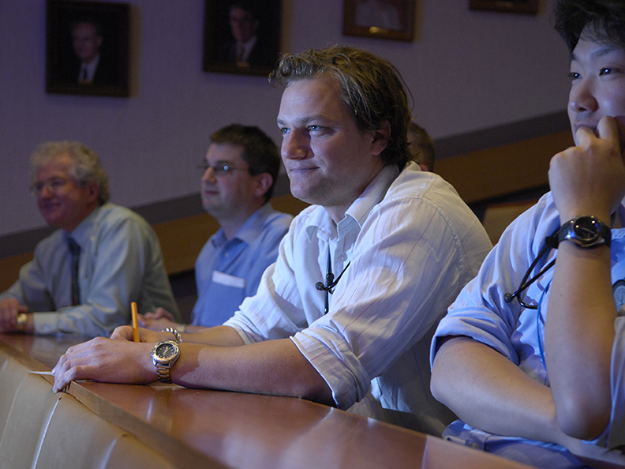
We have staff inclusion champions who provide information to colleagues and promote inclusion opportunities. We also have a range of networks which colleagues can join, including:
- Disability network
- LGBTQ+ network
- Ethnic minority network
Once colleagues join us, we can share with them more information, including how to join any of these groups.


Living in Devon
Devon offers a quality of life few other English counties can match. Where else will you find such a unique landscape that encompasses over 450 miles of dramatic coastline, rugged moorland and gently winding rivers?
Interspersed with vibrant market towns, chocolate-box villages and sleepy hamlets, it is easy to see why we are consistently voted as one of the top places to live in the country.
“Devon didn’t just top our rankings, it blew away the competition. Simply put, it has everything.”
The Telegraph:
England’s 48 counties ranked from best to worst.
Devon’s outdoor lifestyle is its biggest draw. This natural playground is unsurpassed with over a third of the county designated as Areas of Outstanding Natural Beauty. You’ll have over 5,000 km of footpaths and 250km of off-road cycle paths to explore, not to mention endless opportunities to surf along the vast stretch of Atlantic coastline or paddleboard across tidal estuaries.
There are good transport links to the rest of Devon, including the M5 and regular trains to Exeter with its art galleries, museum and theatres. Your taste buds will find plenty to savour here too - Devon is rightly proud of the farmers and producers who make the South West one of the best regions in the UK to enjoy locally produced food and drink. Northern Devon also benefits from an excellent range of community, private schools and colleges for further education.
Whether you fancy surfing or fishing, cycling or climbing, fine dining or hearty pub fare, the county really does have it all.

Vibrant cities
A thriving, forward-looking city, Exeter is home to the world-leading Met Office, boasts the UK’s first leisure centre built to ultra-energy-efficient Passivhaus standard and has one of the top 20 universities in
the country.
At the very heart of the city is Exeter Cathedral, an architectural gem surrounded by cobbled streets and beautiful old buildings, many of them shops and eateries. In the compact city centre, you can stroll alongside parts of the ancient Roman wall, visit the remains of Rougemont Castle or explore the depths of Exeter’s historic Underground Passages. Exeter Phoenix Arts Centre and the Royal Albert Memorial Museum (RAMM), add to the cultural mix, plus you’ll have performance venues such as the Northcott Theatre, the Barnfield Theatre and Corn Exchange close to the city centre.
The main shopping area provides a wide range of leading High Street brands alongside an eclectic mix of independent shops, many to be found in the narrow thoroughfares off Cathedral Close and the High Street. Nearby Fore Street is a haven for all things vintage and retro. Exeter also has a historic quayside, a great spot to sit and watch the world go by at one of the many cafes and restaurants with al fresco dining.

Friendly market towns
You’ll find an array of historic towns across North Devon and Torridge such as Okehampton, famed for its easy access to stunning Dartmoor. Heading towards North Devon, you’ll also have delights such as the charming harbour town of Ilfracombe and the riverside port of Bideford.


Great for families
More information about the
area and help with relocating
can be found at www.royaldevon.nhs.uk/careers
Outstanding Ofsted-rated primary schools, high-ranking secondaries and proximity to two leading universities are some of the biggest draws to Devon, making this a desired destination for families. Whether you have young children or teenagers in tow, the sheer quality of education and extra-curricular activities available are guaranteed to impress.

Living and travelling
Housing wise, housing stock is diverse, with everything from thatched moorland cottages to Georgian townhouses and contemporary builds. Time and distance are different here, too. Many residents in this – the fourth largest county in the UK – are happy to travel up to an hour or more for work. This means there’s a great deal of choice when it comes to finding somewhere to live.
Transport links are also good. The county has more than 8,000 miles of road – the largest road network anywhere in the country, although (it has to be said) many are narrow Devon lanes.
From Exeter’s main station, Exeter St David’s, there are fast and frequent rail services to Bristol (1 hour), London (around 2 hours to Paddington) and Birmingham (under 3 hours to Birmingham New Street). Exeter itself has an impressive rail network with no fewer than nine stations serving different parts of the city. There are a number of branch lines providing services to Mid and North Devon, Dartmoor and the Exe Estuary. Exeter International Airport provides flights to numerous destinations throughout the UK, Europe and even North America.

Contacts

The Trust welcomes informal enquiries.
Contact names are detailed below:
Title: Clinical Lead AMU
Name Dr Mark Daly
Email: mark.daly1@nhs.net
Title: Operations Manager (Medicine)
Name Harriet Finch
Email: harrietfinch@nhs.net
North Devon District hospital
Raleigh Park
Barnstaple
EX31 4JB
Tel: 01271 322577
Royal Devon and Exeter hospital
Barrack Road
Exeter
EX2 5DW
Tel: 01392 411611

