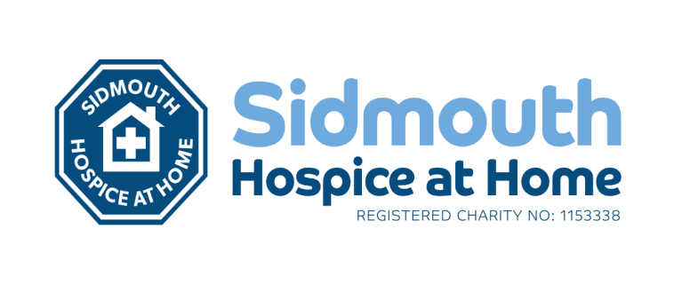



PERSON SPECIFICATION
POST: Sidmouth Hospice at Home Nurse Specialist
BAND: 6

REQUIREMENTS | At Recruitment | At  Review | MET | NOT  MET
QUALIFICATIONS/SPECIAL TRAINING:
Registered Nurse | E | E
BSc (Hons) Health Studies – Degree level  Diploma in Palliative Care or Diploma Level qualification in associated field, or working towards. | D  D | D  E
Teaching and mentorship/supervision qualification | D | D
HEAB 306 Specialist approaches to Palliative care and Care of the Dying or equivalent | D | E
Advanced Communication skills training | D | E
KNOWLEDGE/SKILLS:
Excellent communication skills. | E | E
An in-depth knowledge and understanding of life-limiting conditions in the palliative and end of life stages of the disease acting as an expert practitioner. | E | E
Understanding clinical skills required at end of life: Just in Case medications, syringe drivers, catheterisation, verification of expected death, manual handling, tissue viability. | E | E
Knowledge of available community-based services, access to social services, and financial benefits for palliative patients. | D | E
Understand CHC and fast track processes at end of life. | D | E
Understand the significance of nursing research and use validated results to improve practice.  Ability to manage a caseload effectively and communicate with colleagues to ensure continuity of care. | E  E | E  E
EXPERIENCE:
At least 2 years minimum experience working in healthcare. | E | E
Experience of caring for palliative patients and those approaching the end of life.  Experience of working in Community setting | E  D | E  E
PERSONAL ATTRIBUTES:
Excellent communication skills | E | E
Enthusiastic, highly motivated, organised and committed to service improvement and development. | E | E
Dynamic, creative, innovative and an ability to problem solve in complex situations | E | E
Ability to work independently, as a team member and alongside the community nursing team. | E | E
Empathetic and calm in stressful situations and an ability to facilitate difficult conversations with patient and family members. | E | E
OTHER REQUIREMENTS
Flexible working in order to prioritise workload  Ability to reflect on practice.  Able and willing to work weekends, out of hours and on-call, as required to cover the needs of the service.  IT skills to maintain communications and patient records.  Driving licence.  Able to do the physical and manual handling required by the role. | E  E  E  E  E  E | E  E  E  E  E  E
* Essential/Desirable
HAZARDS:
Laboratory Specimens Proteinacious Dusts |  | Clinical contact with patients | ✓ | Performing Exposure Prone Invasive Procedures | ✓
Blood / Body Fluids | ✓ | Dusty environment |  | VDU Use
Radiation |  | Challenging Behaviour | ✓ | Manual Handling | ✓
Solvents |  | Driving | ✓ | Noise
Respiratory Sensitisers |  | Food Handling |  | Lone Working | ✓
Handling Cytotoxic Drugs

