JOB DETAILS

Job Title: Senior Therapeutic Radiographer

Band: 6

Reports to: Radiotherapy Services Manager

Department/Directorate: Radiotherapy Department / Specialist Services Division

Job Purpose:

The post holder will be an experienced therapeutic radiographer who is employed in a senior supervisory capacity.

The post holder will:

- Contribute to the provision of a high quality, safe and efficient radiotherapy service for patients with emphasis on compliance against national policies, procedures and regulations plus national waiting times targets at all times

- Rotate through all pre-treatment and treatment sections of the department as rostered, demonstrating a high level of clinical expertise in the preparation and delivery of radiotherapy treatment

- Provide information and support for patients undergoing radiotherapy planning and treatment

- Be responsible for the clinical supervision and support of subordinate staff, Assistant Practitioners and Student Radiographers working within their team

- Deputise for the Team Lead Radiographers as the need arises.

- Contribute to the development, maintenance and audit of the local Quality Management System

- Participate in flexible hours working to support the department’s extended day working pattern, the on-call rota for emergency treatment referrals and the provision of a bank holiday service

The post holder is expected to work closely with all members of the wider multi-disciplinary team, to include Clinical Oncologists, Radiotherapy Clinical Scientists, Technicians and Engineering plus other relevant professional groups in the provision of timely and high-quality patient care.

Key Working Relationships:

Radiographers, Radiotherapy Assistant Practitioners and Radiotherapy Helpers
Radiotherapy Services Manager; Operational Lead and Team Lead Radiographers
Patients and their carers
Clinical Oncologists and Specialist Registrars
Radiotherapy Physicists and Technicians
Student Radiographers / trainee Physicists
Admin and Clerical Staff
Nursing staff, Cancer Nurse Specialists, other AHPs involved in patient care

Organisational Chart:

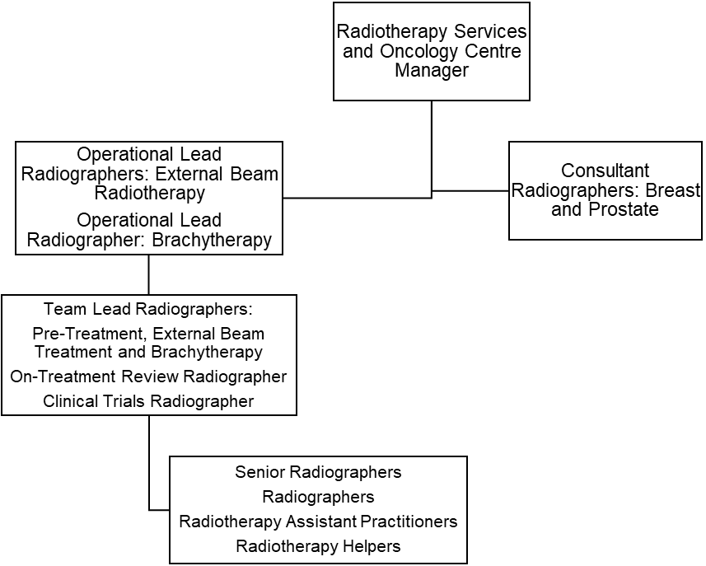

Principal Duties and Responsibilities:

Clinical

- Rotate through all areas of the department as directed, developing and maintaining an appropriate level of clinical knowledge and expertise in each area
- Set and maintain a high standard of patient care and clinical accuracy in all aspects of the service, demonstrating an ability to participate in the resolution complex issues using problem solving skills and effective autonomous decision-making
- Take responsibility for the safe use of highly complex and expensive equipment
- Undertake the appropriate machine checks prior to the clinical use of the linear accelerator and report any variances immediately; ensure that all treatment equipment is safe and accurate to operate
- Ensure that equipment is available for QA and maintenance at the agreed times, thus complying with local arrangements to ensure safety and to reduce the potential for hazards associated with radiation exposure
- Maintain and continually develop knowledge of radiotherapy pre-treatment and treatment techniques and practices in order to participate in the implementation of these within the department
- Maintain and continually develop knowledge of verification imaging procedures and protocols in order to be responsible for the acquisition, comparison, assessment and manipulation of images used for the accurate verification of radiotherapy treatments
- Demonstrate critical thinking in order to determine the suitability and efficacy of treatment prescriptions, treatment set-ups and departmental procedures and protocols
- Use a high level of skill to manipulate and position the patient in order to achieve an accurate treatment set-up
- Maintain a high level of concentration at all times, given the need to deliver highly complex treatments with minimal tolerance margins
- Use a high level of skill when tattooing patients in order to enable precise patient reproducibility
- Plan pre-treatment and treatment workloads according to the needs of patients and the availability of appropriate staff
- Develop and maintain specialist knowledge of the ARIA record & verify system, providing support in the use of the system to other team members as required
- Develop and maintain knowledge of the Activity Capture data system, providing support in the use of system to other team members as required
- Calculate and check specialised dose calculations and complex planning data relating to the delivery of treatment
- Undertake the data entry, checking and/or authorisation of complex treatment data in the computerised patient information system (ARIA)
- Maintain highly accurate treatment records
- Participate in the management of radiotherapy machine scheduling, taking particular care to minimise delays and breaks in treatment in accordance with Trust policy and clinical guidelines
- Ensure that patients receiving concurrent modalities of treatment are managed in accordance with the appropriate time intervals between implementation of each modality
- Ensure that all patients receive accurate information and documentation relating to their treatment, potential side-effects and management of side-effects prior to the onset of treatment
- Ensure that the patient gives informed consent prior to treatment

- Communicate effectively with the patient, often having to use skills of persuasion, empathy and reassurance in order to deliver or receive complex/highly sensitive information whilst maintaining patient confidentiality and dignity at all times and ensuring that accurate records of any communications are produced when appropriate; overcome any barriers to effective communication that might exist
- Demonstrate specialist knowledge of treatment side effects and their management; take responsibility for the referral of patients for clinical assessment by a Consultant (or other appropriate healthcare professional) prior to continuation of treatment when side effects become acute
- Be able to authorise the patients’ treatment, using own theoretical knowledge and clinical experience, on the basis of clinical condition and in accordance with IRMER; recognise when it might be appropriate to withhold patient treatment
- Provide a supportive and confidential environment for patients and their carers
- Provide support to terminally ill patients and/or their carers, often on a daily basis
- Communicate effectively with the multidisciplinary team in order to facilitate the highest standard of patient care and treatment delivery
- Maintain a professional and reassuring manner when exposed to bodily fluids or foul odours caused by tissue necrosis or treatment reactions, often on a daily basis
- Use appropriate manual handling techniques and equipment to ensure safety for both the patient and all members of the team, including own self
- Ensure that all completed treatments are appropriately summarised and that the treatment details are accurately filed in the patients’ electronic records
- Participate in the delivery of the on-call service for emergency referrals
- Work flexible hours, to include bank holiday working and overtime as necessary, to support service delivery

Managerial

- Organise and manage a team of Radiographers, Assistant Practitioners, Radiotherapy Helpers and Radiotherapy students in a designated area of work by demonstrating effective team leadership skills
- Set and maintain high standards of quality for all aspects of work undertaken in the external beam radiotherapy service, ensuring that staff have the appropriate skills and knowledge for their assigned duties
- Use effective time management skills to organise daily clinical sessions
- Take responsibility for own safe use of highly expensive, highly complex radiotherapy treatment equipment and the supervise others doing the same
- Be responsible for communicating equipment breakdowns and faults to the Engineering and Physics teams, ensuring correct procedures are followed for the safety of staff and patients
- Be aware of national waiting times targets and participate in local strategies to ensure these targets are met
- Have specialist knowledge of legislation relating to the safe use of ionising radiation (IRR, IRMER), ensuring own compliance across the service and promptly reporting areas of non-compliance
- Deputise for the Team Leads as required

Teaching, Training and Research

- Participate in specialist clinical training and supervision for Radiographers, Assistant Practitioners, Helpers, new members of staff and other healthcare professionals as requested
- Participate in the induction of new staff and mentor staff within the area of accountability
- Participate in student appraisal and validation of suitability to practice; be responsible for the supervision of students in the rostered clinical area in conjunction with the student appraisers
- Participate in-house research and technical developments where appropriate
- Participate in the local implementation of radiotherapy clinical trials

Quality

- Support the Radiotherapy Services Manager in setting, monitoring and developing standards of care
- Demonstrate specialist knowledge in the management of the departmental Quality Management System (QMS)
- Demonstrate an understanding of the quality strategies and processes that will improve the care of patients
- Ensure own compliance with QMS procedures and protocols and supervise others doing the same
- Identify and report non-conformities within the departmental QMS, and participate in addressing these issues appropriately
- Participate in internal and external audit of the QMS plus departmental visits by regulatory bodies e.g. HSE, CQC
- Assist, where appropriate, in the collection of data for research or audit purposes
- Demonstrate the work of the department to other professionals or interested parties as required

Professional Standards

- Act as a role model for other staff members
- Maintain a professional manner and appearance at all times
- Take professional responsibility for own actions
- Comply with the Society of Radiographers’ Professional Code of Conduct
- Maintain and develop knowledge and skills in accordance with the Continuing Professional Development policy to ensure that mandatory HCPC professional registration is retained
- Participate in own regular performance appraisal and personal development planning
- Maintain and update own specialist skills and knowledge in all aspects of radiotherapy service delivery; keep up to date with the latest technical and scientific developments and new practices relating to clinical oncology
- Be aware of and comply with current regulations governing the administration of ionising radiations
- Undertake essential training as required by the Trust, to include fire training, information governance and manual handling training
- Comply fully with Trust infection control policies, acting at all times in such a manner as to minimise the risks of spread of infection
- Participate in effective clinical risk management
- Contribute to the provision of a safe working environment
- Comply fully with the Trust incident reporting procedure
- Be aware of and comply with all other Trust policies
- Ensure that matters of a confidential nature (relating to either the patient or another staff member) are not divulged without the appropriate authority to do so

This post has been identified as involving access to vulnerable adults and/or children and in line with Trust policy successful applicants will be required to undertake a Disclosure & Barring Service Disclosure Check

General

This is a description of the job as it is now. We periodically examine employees' job descriptions and update them to ensure that they reflect the job as it is then being performed, or to incorporate any changes being proposed. This procedure is conducted by the manager in consultation with the jobholder. You will, therefore be expected to participate fully in such discussions. We aim to reach agreement on reasonable changes, but if agreement is not possible, we reserve the right to insist on changes to your job description after consultation with you.

Everyone within the Trust has a responsibility for, and is committed to, safeguarding and promoting the welfare of vulnerable adults, children and young people and for ensuring that they are protected from harm, ensuring that the Trusts Child Protection and Safeguarding Adult policies and procedures are promoted and adhered to by all members of staff.

PERSON SPECIFICATION

POST: Senior Therapeutic Radiographer

REQUIREMENTS | Essential | Desirable
Qualifications / Special Training:

Degree in Radiotherapy or equivalent qualification of the College of Radiographers | ✓
HCPC Registration | ✓
Evidence of relevant post-qualification clinical experience | ✓
Evidence of Continuing Professional Development | ✓
Knowledge / Skills:

In depth and up to date specialist knowledge of radiotherapy pre-treatment, verification imaging and treatment practices | ✓
Expertise in the use of radiotherapy record and software systems | ✓
Ability to contribute to the day to day operational management of a service section |  | ✓
Able to communicate complex or sensitive information using a variety of communication techniques | ✓
Evidence of successful multidisciplinary team working | ✓
Ability to lead and motivate a team |  | ✓
Able to question and challenge practice |  | ✓
Understand the principles of quality assurance, quality management and audit and their importance in radiotherapy | ✓
Able to problem-solve and make autonomous decisions |  | ✓
Able to support the implementation new and relevant protocols |  | ✓
Understand the significance of radiotherapy research / audit and the use validated results to improve practice |  | ✓
Knowledge and application of the legislative regulations relating to the use of ionising radiation (IRR, IRMER) | ✓
Understand the principles of governance in radiotherapy |  | ✓
Knowledge of cancer patient pathways | ✓
Experience:

Post-qualification clinical experience across all areas of radiotherapy service delivery | ✓
Evidence of ability to support and supervise other staff |  | ✓
Experience of multidisciplinary team working | ✓
Personal Attributes:

Enthusiastic, highly motivated and committed to providing a high quality service to patients and their carers | ✓
Able to work under pressure and deal with sensitive or stressful situations | ✓
Good time management and organisational skills; ability to prioritise effectively | ✓
Ability to communicate well with all groups of patients, carers and staff | ✓
Proven ability to communicate with people over a wide range of professional and organisational backgrounds | ✓
Other Requirements:

Strong commitment to own further professional development | ✓
Willingness to participate in service development | ✓
Willingness to participate in staff and student development | ✓
Willingness to participate in flexible working hours, on call and bank holiday rotas | ✓

Hazards within the role, used by Occupational Health for risk assessment
Laboratory Specimens  Proteinacious Dusts |  | Clinical contact with patients | X | Performing Exposure  Prone Invasive Procedures | X
Blood/Body Fluids | X | Dusty Environment |  | VDU Use | X
Radiation | X | Challenging Behaviour |  | Manual Handling | X
Solvents |  | Driving |  | Noise
Respiratory Sensitisers | X | Food Handling |  | Working in Isolation

