

JOB DESCRIPTION

JOB TITLE | Admin and Clerical Officer
GRADE | Band 3
LOCATION | Exeter NHS Dental Access Centre
RESPONSIBLE TO | Senior Dental Nurse / Admin Manager
ACCOUNTABLE TO | Senior Manager
JOB SUMMARY
To provide a quality reception, telephone handling, advice and appointment service and assist professional staff with clerical and administrative duties, including typing up of patient and referral letters. To assist the managers and clinicians to ensure that the service is efficiently organised and effectively delivered.

This post contains a range of complex duties requiring a range of skills. The post involves liaising with healthcare professionals, hotel services, support staff and members of the public.

Posts at this level consist of a variety of tasks not requiring supervision though supervision is usually readily available to ensure that the clerical services, appointments system and cash management system run efficiently.
Key Working Relationships
- Hotel services and support staff
- Members of the public/patients
- Senior Dental Officer
- Senior Dental Nurse
- General Manager
- Deputy Operational Manager
- External agencies

ORGANISATION CHART
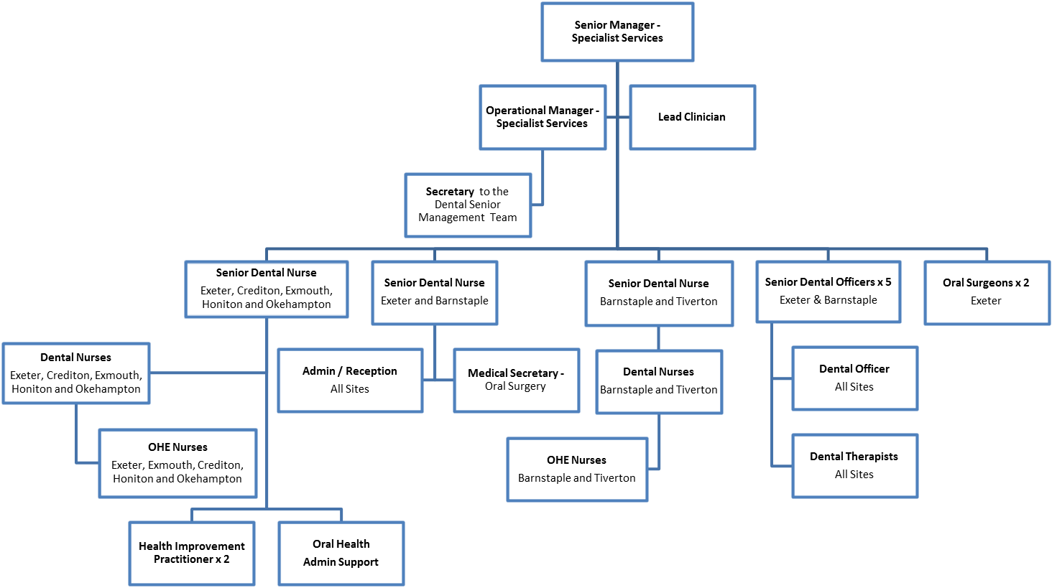
PRINCIPAL RESPONSIBILITIES
- To participate in reception duties including dealing with staff, patients and their carers, both in person and on the telephone, in a courteous and efficient manner. To assist the general public on matters relating to the provision of service within Northern Devon Healthcare NHS Trust and other NHS Health Care Providers
- Under the direction of the dental services Senior Nurses or General Manager/Deputy Operational Manager to provide administrative support in the organisation and running of the department including liaison with other agencies and departments.
- To accept routine administrative duties as delegated by the Senior Management Team within the general scope of the job description and grade.
- To carry out audio typing / word processing of letters etc. using Microsoft office packages such as Excel, Access and Email and R4 Dental software system and any additional secretarial clerical support necessary to cover for the absence of other clerical staff as necessary.
- To become a proactive and integral part of the community nursing team, contributing to the efficient and effective running of the department.
- Responsible for keeping reception and waiting areas tidy, to include ensuring the notice boards are updated, toys are cleaned and leaflets and patient comments cards are restocked.

Communication and Relationship Skills
- Provides and receives sensitive information.
- The post holder must be able to work as part of a dental team and demonstrate good communication skills, requiring tact and persuasive skills to overcome barriers to understanding.
- Able to communicate effectively and network with all external agencies linking and working with dental services as required
- To provide an effective channel of communication in relation to information services within the localities dental service.
- To ensure effective communications with patient enquires including the young, elderly, those with learning disabilities and mental health problems, relatives and carers, responding appropriately and in confidence to sensitive information.
- Accurate message taking, delivering message in an appropriate timescale

Analytical and Judgement Skills
- To be responsible for monitoring of waiting lists, and with the support of the senior nurse/s or operational manger make adjustments as necessary.

Planning and Organisational Skills
- To plan and assess the main responsibilities of the day, to ensure that the work is prioritised and dealt with promptly and deadlines are met in a controlled and efficient manner.
- To assist in the maintenance and updating of the general filing systems.

Physical Skills
- Operation of telephone booking system and data entry onto computer
- Keyboard skills / RSA 3 or equivalent plus audio typing skills in order to produce letters and documents for internal and external distribution that are of a high quality in terms of presentation and accuracy and adhere to Trust policies and guidelines.

Responsibility for Patient and Client Care
- Daily contact with patients at reception desk and making appointments
- To deal sensitively with patients who have high levels of anxiety and aggression caused by dementia or poor mobility, pain and system capacity.

Responsibility for Policy and Service Development
- To be involved in administration and clerical service policy planning and protocol development as required.
- To be aware of and adhere to the Trust policies which relate to the Health and Safety regulations with regard to accidents / incidents.

Responsibility for Financial and Physical Resources
- To follow the NHS and local guidelines for the patient charges and related cash management administration, which involves taking of money from patients, ensuring the correct procedures are followed for the banking of money and any follow up administration for outstanding payments and overcharging.
- Responsible for ordering stocks and supplies using Web Basket system.

Responsibility for Human Resources
- To assist with the provision of administrative and IT advice to clerical staff as required.
- Demonstrates duties to new starters.
- To undertake any necessary training in support of the duties of the post holder.
- To attend staff meetings and minute activity.

Responsibility for Information Resources
- Responsible for the operation of the department’s telephone booking system including the entry of the appropriate data into the computer, ensuring the data is completing accurate and up-to-date.
- To ensure that all information relating to clients and staff gained through employment with the Trust is kept confidential. Disclosure to any unauthorised person is a serious disciplinary offence.
- To be responsible for the efficient retrieval and dispatch of case notes as required.
- To photocopy and distribute written material as required.

Responsibility for Research and Development
- To assist with data collection and collation in audits and research studies conducted by dental service staff.

Freedom to Act
- Works under direction of the Salaried Dental Services General Manager, Deputy Operational Manager, Senior Nurse or Senior Dental Officer
- Someone generally available for reference

Physical Effort
- Lifting of printer paper, unpacking stationary stores
- Frequent sitting in a restricted position when word processing or inputting data

Mental Effort
- Work pattern is generally predictable, sometimes unpredictable behaviour of patients with frequent periods of concentration required during audio typing

Emotional Effort
- Dealing with patients with learning disabilities

Working Conditions
- Mainly office based using a computer for significant proportion of day

General

- This is a description of the job as it is at present constituted. It is the practice of this organisation periodically to examine employees' job descriptions and to update them to ensure that they relate to the job as then being performed, or to incorporate whatever changes are being proposed. This procedure is jointly conducted by each manager in consultation with those working directly to him or her. You will, therefore, be expected to participate fully in such discussions. It is the organisations' aim to reach agreement to reasonable changes, but if agreement is not possible management reserves the right to insist on changes to your job description after consultation with you.

- We are committed to serving our community. We aim to co-ordinate our services with secondary and acute care.

- We aim to make all our services exemplary in both clinical and operational aspects. We will show leadership in identifying oral health needs to which we can respond and in determining the most cost-effective way of doing so. We will share our knowledge with neighbouring healthcare agencies and professionals.

- We recruit competent staff that we support by maintaining and extending their skills in accordance with the needs of the people we serve. We will pay staff fairly and recognise the whole staff’s commitment to meeting the needs of our patients.

- The Trust operates a 'non smoking' policy. Employees are not able to smoke anywhere within the premises of the Trust or when outside on official business.

- All employees must demonstrate a positive attitude to Northern Devon Healthcare NHS Trust’s equality policies and Equality Scheme. Employees must not discriminate on the grounds of sex, colour, race, ethnic or national beliefs, marital status, age, disability, sexual orientation, religion or belief and will treat patients, colleagues and members of the public with dignity and respect.

- If the post holder is required to travel to meet the needs of the job, we will make reasonable adjustments if required, as defined by the Disability Discrimination Act.

- The post-holder must be willing to work flexibly and respond to requests to cover other clinic receptions as and when they arise.
Health and Safety at Work

The employer will take all reasonably practical steps to ensure your health, safety and welfare while at work. You must familiarise yourself with the employer's Health & Safety policy, and its safety and fire rules. It is your legal duty to take care for your own health and safety as well as that of your colleagues.

Infection Control
It is the responsibility of all members of staff to provide a high standard of care to patients they are involved with. This includes good infection prevention practice.

All staff have a responsibility to comply with Infection Prevention and Control policies and procedures, this includes:

- Attending mandatory and role specific infection prevention education and training.
- Challenging poor infection prevention and control practices.
- Ensuring their own compliance with Trust Infection Prevention and Control policies and procedures for example, standard precautions, hand hygiene, prevention and management of inoculation incidents
- Keeping all work areas clean and tidy

Confidentiality

You may not disclose any information of a confidential nature relating to the employer or in respect of which the employer has an obligation of confidence to any third party other than where you are obliged to disclose such information in the proper course of your employment, or as required by law. Any failure to comply with this term of your employment will be treated as an act of misconduct under the employer's disciplinary procedure.

Job Description Agreement

Job holder’s Signature: .................................................................................................

Date: ................................................................................................................................

Manager’s Signature: .....................................................................................................

Date: .................................................................................................................................

PERSON SPECIFICATION

Criteria | Essential | Desirable | How Tested?  Application Form, Interview or Test | Met / Not Met
Education/Qualifications/Training
Typing/Word processing to RSA3 or equivalent)  Good standard of general education including English and Mathematics GCSE to a C grade or equivalent  ECDL or equivalent | E  E | D | Application Form  Application Form
Knowledge and Experience
Experience of working with people  Good keyboard and administrative skills  Audio Typing  Experience of Word, Excel and E-mail  Experience of Access and PowerPoint | E  E  E | D  D | Interview  Interview  Interview
Skills and Abilities
Ability to prioritise | E |  | Interview
Personal Qualities and Attributes
Effective communication skills  Good inter-personal skills and ability to work well in a team  Sense of humour  Ability to remain calm in difficult situations involving distressed and angry patients  Ability to self motivate, use initiative and be proactive | E  E  E  E  E |  | Interview  Interview  Interview  Interview  Interview
Other Requirements
Car owner/driver |  | D

