
JOB DESCRIPTION

1. JOB DETAILS

Job Title: Clinical Coding Officer

Band: Band 3

Reports to: Clinical Coding Service Manager

Department / Directorate: Digital Services

2. JOB PURPOSE

To critically analyse medical, intervention and procedural terminology and other clinical information and assign accurate diagnostic, intervention and procedure codes for all inpatient, day case and regular day activity using the relevant coding classifications, namely ICD10 and OPCS-4, to enable the Trust to meet both its business and clinical information requirements.

3. DIMENSIONS/ KEY WORKING RELATIONS

- Head of Clinical Coding
- Clinical Coding Service Manager
- Clinical Coding Trainer
- Clinical Coding Audit Team
- Clinical Coding Data Assurance Lead
- Clinical Coding Staff
- Clinicians/Medical Staff
- Information analysts
- Medical Secretaries
- Other administrative Staff

- ORGANISATIONAL CHART:
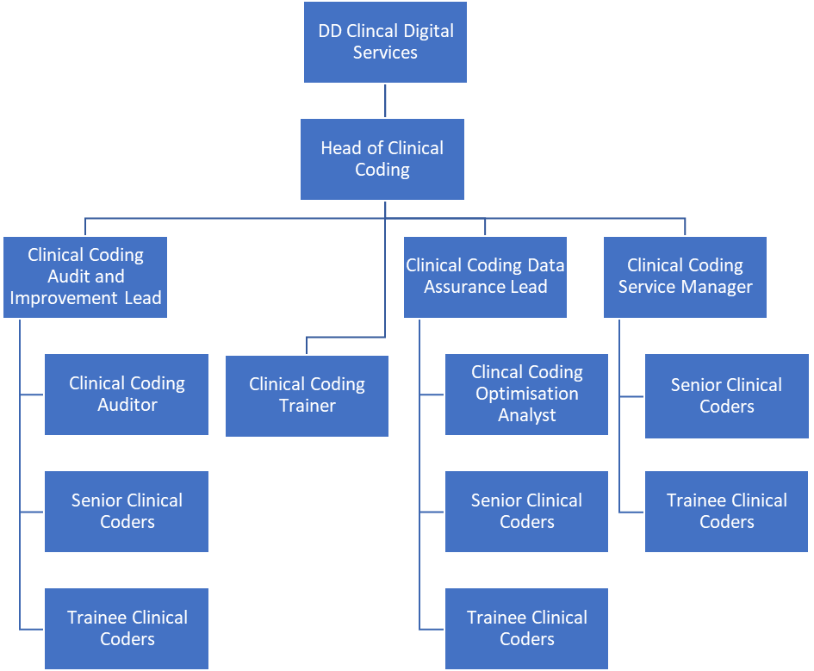

5. KEY RESULT AREAS/PRINCIPAL DUTIES AND RESPONSIBILITIES:

- Abstract clinical information from Electronic Patient Record (EPR), translate and assign accurate diagnostic, intervention and procedure codes using ICD10/OPCS-4 classifications following and in-keeping with the national coding standards.
- Be aware and open to translating information of a distressing nature
- Successfully complete NHS Digital CCS E-Learning modules as pre-requisite to the Clinical Coding Standards course (CCSC)
- Receive a six-month period of mentorship following appointment
- Undertake in person the NHS Digital CCS Clinical Coding Standards course within 6 months of appointment
- Undertake an in-house/on line/external Anatomy, Physiology & Medical Terminology course including end of course examination/s with final certification to demonstrate relevant achievement
- Undertake all further training necessary working towards Accredited Clinical Coder status (ACC)
- Undertake the in-house coding examination 12 months following appointment and training.
- Undertake all further training necessary in order to sit the NCCQ (UK) qualification after a minimum two year period from appointment.
- Undertake clinical coding Refresher training (CCSRC) every 3 years post achievement of ACC status to maintain and refresh coding knowledge and skills in line with NHS Digital TCDS continued learning/training requirements
- Refer to electronic ICD10/OPCS4 Reference books on a regular basis in order to process accurate coded data
- Work within and maintain up to date knowledge of all coding standards published by NHS Digital TCDS. (Classifications Service)
- Be responsible for updating personal coding classifications following changes to standards published by the NHS Digital TCDS (Classification Service)
- Take responsibility for completing own workload within the agreed Trust daily coding targets for both trainee and ACC status in order to achieve the required monthly coding deadlines
- Use judgement where necessary to translate cases where information is not always clear
- Contact clinical staff as necessary for clarification of information within source documentation where there is ambiguity
- Participate in feedback sessions with the Head of Clinical Coding/Clinical Coding Service Manage/Auditor regarding outcomes of internal coding audit.
- Liaise with all staff, both clinical and clerical to raise issues surrounding all aspects of the coding process and to clarify coding issues raised.
- Cover for fellow colleagues as and when required.
- Raise complex coding issues with the Clinical Coding Service Manager/ Trainer/ Auditor to ensure correct coding resolution is reached following the Trust and CCS national coding query mechanism.
- Produce and maintain a personal portfolio of evidence of coding career progression.

Other Responsibilities:

To take part in regular performance appraisal

To undertake any training required in order to maintain competency including mandatory training, e.g. Manual Handling

To contribute to and work within a safe working environment

The post holder is expected to comply with Trust Infection Control Policies and conduct him/herself at all times in such a manner as to minimise the risk of healthcare associated infection

As an employee of the Trust, it is a contractual duty that you abide by any relevant code of professional conduct and/or practice applicable to you. A breach of this requirement may result in action being taken against you (in accordance with the Trust’s disciplinary policy) up to and including dismissal.

The post holder is expected to comply with Trust Infection Control Policies and conduct him/her at all times in such a manner as to minimise the risk of healthcare associated infection.

THE TRUST – Vision and Values

Our vision is to provide safe, high quality seamless services delivered with courtesy and respect. To achieve our vision, we expect all our staff to uphold our Trust values. Our Trust values are:

Compassion
Integrity
Inclusion
Empowerment

We recruit competent staff that we support in maintaining and extending their skills in accordance with the needs of the people we serve. We will pay staff fairly and recognise the whole staff’s commitment to meeting the needs of our patients.

We are committed to equal opportunity for all and encourage flexible working arrangements including job sharing.

We are committed to recruiting and supporting a diverse workforce and welcome applications from all sections of the community, regardless of age, disability, gender, race, religion, sexual orientation, maternity/pregnancy, marriage/civil partnership or transgender status. We expect all staff to behave in a way which recognises and respects this diversity, in line with the appropriate standards.

GENERAL

This is a description of the job as it is now. We periodically examine employees' job descriptions and update them to ensure that they reflect the job as it is then being performed, or to incorporate any changes being proposed. This procedure is conducted by the Manager in consultation with the jobholder. You will, therefore, be expected to participate fully in such discussions. We aim to reach agreement on reasonable changes, but if agreement is not possible, we reserve the right to insist on changes to your job description after consultation with you.

PERSON SPECIFICATION

POST: Clinical Coding Officer
BAND: 3

REQUIREMENTS | At  Recruitment
QUALIFICATIONS / TRAINING  - Degree/A level Biology/Human Biology/Sciences  - GNVQ in Health & Social Care or BTEC or AMSPAR qualification Medical Terminology.  - 5 GCSE’s A-C (or equivalent) including English, Maths and Biology/Human Biology/Sciences  - BTEC Level 3 qualification or equivalent experience  - Completed NHS Classifications Service NHS Digital CCS Clinical Coding Standards Course (Band 4) | D  D  E  E  D
KNOWLEDGE / SKILLS  - Excellent analytical skills  - Excellent data extraction skills  - Good PC and keyboard skills  - Good communication skills  - Working knowledge of Anatomy/Physiology and Medical Terminology | E  E  E  E  E
EXPERIENCE  - Previous experience within the NHS  - Working knowledge/background in an acute hospital setting | D  D
PERSONAL ATTRIBUTES  - Ability to work on own as well as part of a team  - Positive and flexible approach to all demands/aspects of the role  - Ability to complete work within strict deadlines  - Ability to work in a busy environment  - Excellent attention to detail with the ability to concentrate for long periods  - Ability to approach work in a calm manner and able to maintain accuracy under pressure  - Ability to communicate with immediate colleagues and staff at all levels  - Possess a positive attitude to changes in working practices in line with new coding standards and coding process and Trust systems  - Excellent motivation for continuous training and on-going personal development | E  E  E  E  E  E  E  E  E
OTHER REQUIREMENTS:  - To embrace and undertake all necessary training required in order to undertake the NCCQ(UK) in line with 3 year clinical coder career progression  - Undertake the in-house coding examination at 12 months from appointment  - Willingness to undertake NHS Digital TCDS Clinical Coding training courses  - Be extremely motivated to undertake self-directed study  - Ability to use a keyboard for significant periods during the working day (adhering to and in line with Trust Health & Safety guidelines) | E  E  E  E  E
* Essential/Desirable

HAZARDS: - Updated 11th July 2017
Laboratory Specimens |  | Clinical contact with Patients |  | Dealing with violence & aggression of patients/relatives
Blood / Body Fluids |  | Dusty Environment |  | VDU Use (occasional) | √
Radiation / Lasers |  | Challenging Behaviour |  | Manual Handling | ✓
Solvents |  | Driving |  | Noise / Vibration
Respiratory Sensitisers |  | Food Handling |  | Working in isolation
Cytotoxic Drugs |  | Electrical work |  | Night Working

