

JOB DESCRIPTION

JOB DETAILS
Job Title | Simulation Trust Doctor
Reports to | Human Factors and Simulation Senior Fellow / Clinical Lead for Simulation
Band | Paid at the appropriate point of the Trust Dr scale
Department/Directorate | Simulation

JOB PURPOSE
- The purpose of this post is to support core human factors and simulation education across our diverse trust.
- Principally this role will see the successful applicant supporting the delivery of the simulation programme for foundation doctors, in accordance with the foundation programme curriculum.
- Delivery of other programmes and sessions will also be required, as directed.

- The post holder will also support the delivery of simulation delivery to external services to the organisation, as directed by the Operational Lead.
- K
KEY RESULT AREAS/PRINCIPAL DUTIES AND RESPONSIBILITIES
- Actively contribute to the development of the service
- Actively identify and participate in own development requirements
- Actively contribute to the effective delivery of the service
- To work alongside the simulation team to set up, implement and the effective delivery of simulation practice.
- To support the development of existing faculty and new faculty. (i.e. through supporting the ‘Train the Trainers’ programme).
- Planning and co-ordinating own day-to-day work, considering the needs of the service.
- Work without close supervision and make independent decisions to solve day to day problems when working to short timescales
- To be actively involved with innovation and development within the sphere of simulation, and digital learning technologies.
- Support the effective monitoring of systems and processes, in relation to simulation activity. Including population of databases with regard to (not an exclusive list): collecting research data, session delivery outcomes, equipment logs, maintenance of equipment.
- To provide appropriate fidelity of simulation delivery; via appropriate scene setting, costuming and moulage, as requested.
- Participate in off-site delivery / visits, as required.
- Supports the development of effective training materials, in suitable formats (using email, Word, PowerPoint etc).

KEY WORKING RELATIONSHIPS
Areas of Responsibility:
- The post holder will be based in RILD, Exeter and will provide equipment and course support, as directed by either the Clinical lead for simulation or Human Factors & Simulation Fellow.
- The post holder will be required to work autonomously as appropriate
- Delivery of simulation sessions, which may be ‘external’, ‘internal’ or ‘in-situ ’, so this should be taken into account when preparing for specific courses, as appropriate.
- To provide support and training to faculty, instructors and staff in the use of simulation equipment.

Of particular importance are working relationships with:

Internal to the Trust | External to the Trust
- Clinical Lead for Simulation  - Simulation Team  - Local Simulation Faculty (LSF) from  other areas of the trust  - IT Services  - Medical Electronics  - Medical Education team | - External Companies (i.e. Laerdal / Gaumard / LifeCast / SMOTs)  - External NHS organisations
- Resuscitation Service

ORGANISATIONAL CHART
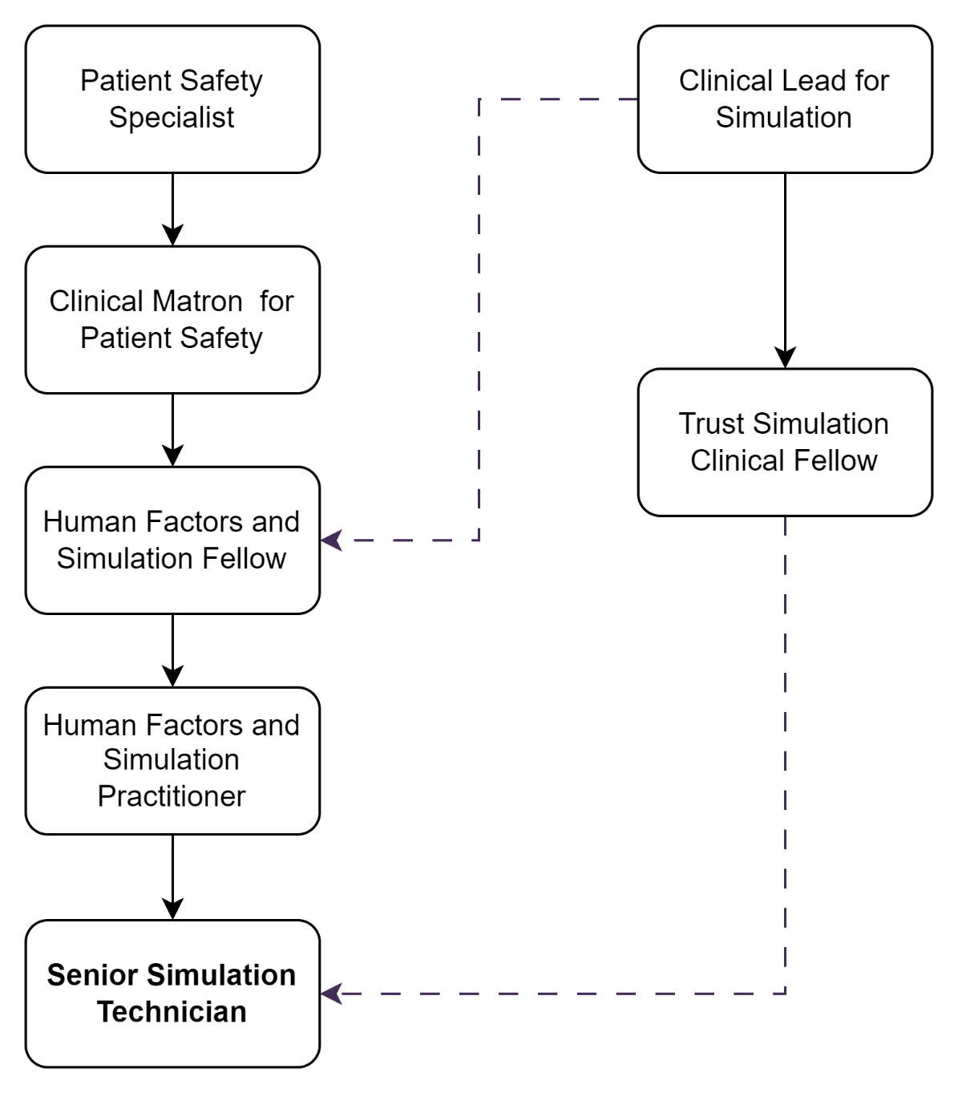

FREEDOM TO ACT
To carry out the role with minimal supervision upon completion of induction process.

COMMUNICATION/RELATIONSHIP SKILLS
- To support the Central Simulation Team (CST) with administration duties including simulation diary management, support the booking review process, general service organisation processes and / or support meetings through effective communication
- To communicate with colleagues both internal and external to the organisation in a courteous, professional and timely manner at all times
- Take messages, ensuring they are actioned and/or received by the correct recipient
- Provide excellent customer care, in a calm and professional manner
- Maintain learner confidentiality and psychological safety
- Effective liaison with the simulation administration support role, to ensure accurate and contemporary records are maintained of all simulation activities and usage of the simulation resources.
- The post holder may be required to attend regional simulation meetings.
- Attend and contribute to team meetings

ANALYTICAL/JUDGEMENTAL SKILLS
Identify own training and development needs and undertake appropriate training/education as required.

Participate in an annual individual performance review process where objectives will be agreed, performance monitored and personal development needs discussed.

To attend all statutory and mandatory training as and when required to do so.

Act responsibly in respect of colleague’s health, safety and welfare following safe work practices and complying with the Trust’s Health and Safety Policies.

PLANNING/ORGANISATIONAL SKILLS
- Organisational skills to support the design, delivery and debrief process of simulation.
- To take up opportunities for development around the use of high-fidelity manikins.

PATIENT/CLIENT CARE
Indirect contact on occasion when in situ simulation is performed
POLICY/SERVICE DEVELOPMENT
Will be expected to support and / or identify areas for service development.
FINANCIAL/PHYSICAL RESOURCES
None
HUMAN RESOURCES
None required but may be asked if they would like to support interview process for future posts within the department. There may be a requirement to manage an apprentice in the future however this is not a role currently required

INFORMATION RESOURCES
Is likely to need to overcome IT and technical issues. Not an expectation to be involved in modifying systems and processes
RESEARCH AND DEVELOPMENT
We have been involved in research within the department however this is not a regular occurrence. There may be opportunity but it is not an expectation.

PHYSICAL SKILLS
Monitor use and order equipment, supplies and stationery in an efficiently and cost-effective manner, in line with the needs of the service; as authorised / directed by the Human Factors & Simulation Practitioner.

PHYSICAL EFFORT
The role potentially may require the post holder to move heavy equipment but is overseen the by manual handling processes. It does require a moderate level of physical effort.
MENTAL EFFORT
Undertake training as required to maintain competency/comply with trust policies.

Work within Trust policies – including those for confidentiality, data protection, health and safety fire protection, and annual appraisal.
Adhere to the Trust Access Policy, Key Performance Indicators, government targets and standard operational policies and procedures.
EMOTIONAL EFFORT
The post holder will be required to lead the de-briefing process which will require high levels of concentration and effort, over a pro longed period of time.
Delivering emotive subject matter education, so the post holder will need to be sensitive to the needs of learners
To support individuals / teams who may demonstrate distress / anxiety / frustration in an appropriate manner

WORKING CONDITIONS

Occasionally, may be requested to work irregular hours in accordance with the needs of the role, to cover service commitments (i.e. early starts, evenings or weekends). Time off in lieu or altered weekly hours will be agreed prior to this.

OTHER RESPONSIBILITIES
- The post holder will be expected to carry out any other duties as required, commensurate with their pay band
- The post holder will be required to support the team during course delivery. This will include welcoming candidates and faculty, providing refreshments and lunch as agreed with the senior team.
- The post holder will understand the limitations of the role and how to access support

Trust-wide Responsibilities
- To take part in regular performance appraisal
- To undertake any training required in order to maintain competency including mandatory training, e.g. Manual Handling
- To contribute to and work within a safe working environment
- The post holder is expected to comply with Trust Infection Control Policies and conduct him/herself at all times in such a manner as to minimise the risk of healthcare associated infection

As an employee of the Trust, it is a contractual duty that you abide by any relevant code of professional conduct and/or practice applicable to you. A breach of this requirement may result in action being taken against you (in accordance with the Trust’s disciplinary policy) up to and including dismissal.

The post holder is expected to comply with Trust Infection Control Policies and conduct him/her at all times in such a manner as to minimise the risk of healthcare associated infection.

DISCLOSURE AND BARRING SERVICE CHECKS
Required
GENERAL
This is a description of the job as it is now. We periodically examine employees' job descriptions and update them to ensure that they reflect the job as it is then being performed, or to incorporate any changes being proposed. This procedure is conducted by the manager in consultation with the jobholder. You will, therefore, be expected to participate fully in such discussions. We aim to reach agreement on reasonable changes, but if agreement is not possible, we reserve the right to insist on changes to your job description after consultation with you.

Everyone within the Trust has a responsibility for, and is committed to, safeguarding and promoting the welfare of vulnerable adults, children and young people and for ensuring that they are protected from harm, ensuring that the Trusts Child Protection and Safeguarding Adult policies and procedures are promoted and adhered to by all members of staff.

The RDUH is a totally smoke-free Trust. Smoking is not permitted anywhere on Trust property, including all buildings, grounds and car parks. For help to quit call: 01392 207462.

PERSON SPECIFICATION

Job Title | Simulation Trust Doctor

Requirements | Essential | Desirable
QUALIFICATION/ SPECIAL TRAINING  Medical Healthcare Qualification  Requires registration with the GMC  Simulation / Teaching Qualification | E  E | D
KNOWLEDGE/SKILLS  Knowledge of standard audio-visual equipment: projectors, microphones, portable screens, media players, etc.  Excellent planning & organisational skills  Ability to prioritise workload to respond to changing demand  Ability to use high fidelity manikins  Ability to liaise and communicate with staff at all levels  Excellent interpersonal & communication skills  Ability to promote good working relationships  Computer technology and troubleshooting  Knowledge of IT and computer systems  Comprehensive PC skills - databases, word-processing, email, Excel  Understanding of hospital IT systems  Analytical skills & ability to problem solve  Knowledge of Trust procedures | E  E  E  E  E  E  E  E  E | D  D  D  D
EXPERIENCE  Working in the NHS as a medical practitioner in clinical environment e.g. hospital, GP surgery, CCG  Experience with providing technical support in networking, computer hardware or software. | E | D
PERSONAL ATTRIBUTES  Enthusiastic highly motivated & committed to delivering a service  Understand good team-working and work as part of a team  Able to plan and organise workload  Able to prioritise own work load and meet deadlines  Ability to work independently and un-supervised  Can remain calm and professional in a busy environment  Empathetic, but able to understand professional boundaries  Smart appearance, adhering to the Uniform Policy  Welcoming friendly and approachable manner  Adaptable & flexible approach to work and working hours  Commitment to continual development  Adheres to relevant Trust values, policies & procedures  Adheres to confidentiality & data protection requirements | E  E  E  E  E  E  E  E  E  E  E  E  E

FREQUENCY

(Rare/ Occasional/ Moderate/ Frequent)
WORKING CONDITIONS/HAZARDS |  | R | O | M | F
Hazards/ Risks requiring Immunisation Screening
Laboratory specimens | N
Contact with patients | N
Exposure Prone Procedures | N
Blood/body fluids | N
Laboratory specimens | N
Hazard/Risks requiring Respiratory Health Surveillance
Solvents (e.g. toluene, xylene, white spirit, acetone, formaldehyde and ethyl acetate) |  | Y
Respiratory sensitisers (e.g isocyanates) | N
Chlorine based cleaning solutions  (e.g. Chlorclean, Actichlor, Tristel) |  |  | Y
Animals | N
Cytotoxic drugs | N
Risks requiring Other Health Surveillance
Radiation (>6mSv) | N
Laser (Class 3R, 3B, 4) | N
Dusty environment (>4mg/m3) | N
Noise (over 80dBA) | N
Hand held vibration tools (=>2.5 m/s2) | N
Other General Hazards/ Risks
VDU use ( > 1 hour daily) |  |  |  |  | Y
Heavy manual handling (>10kg) |  |  |  | Y
Driving |  | Y
Food handling | N
Night working | N
Electrical work | N
Physical Effort |  |  | Y
Mental Effort |  |  |  |  | Y
Emotional Effort |  |  |  |  | Y
Working in isolation |  | Y
Challenging behaviour | N

