

JOB DESCRIPTION

JOB DETAILS
Job Title | Rotational Pharmacy Technician
Reports to | Dispensary Manager
Band | 4
Department/Directorate | Pharmacy / Specialist Services

JOB PURPOSE
To effectively participate in the provision of the pharmacy service to the Northern Devon Healthcare NHS Trust on a rotational basis within the pharmacy department following standard operating procedures.
KEY RESULT AREAS/PRINCIPAL DUTIES AND RESPONSIBILITIES
The pharmacy department provides pharmacy services to the acute hospital, community hospitals, hospice and mental health services.
The Rotational Pharmacy Technician will be willing to work in all areas of the pharmacy department and to be able to deputise for the senior technicians when called upon to do so. The areas include dispensary (both in-patient and out-patient) and technical services. This will include the supply of clinical trial medications.
The Rotational Pharmacy Technician will be based in the acute hospital.
The post holder will fulfil all tasks and work as part of a team. To meet the needs of the service, the post holder may be required to work in other areas as appropriate as directed by the line manager.
KEY WORKING RELATIONSHIPS
The Rotational Pharmacy Technician will work effectively with all members of the pharmacy team.
The post holder is required to deal effectively with staff of all levels throughout the Trust, the wider Healthcare community, external organisations and the public. This will include verbal, written and electronic media.

ORGANISATIONAL CHART
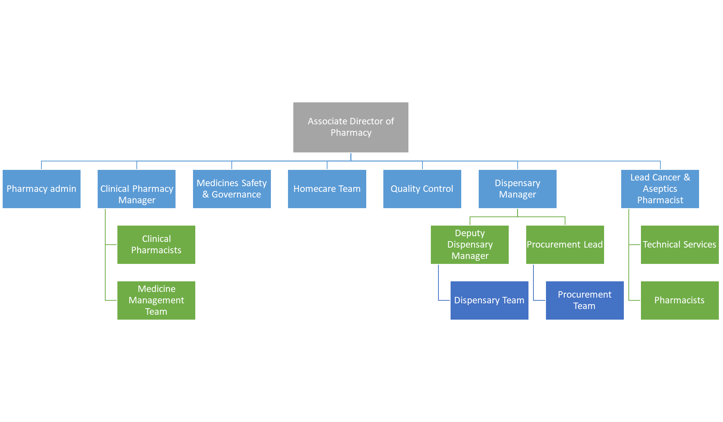

FREEDOM TO ACT
Business continuity planning will need to take place in liaison with line management and issues should be escalated in a timely manner.

COMMUNICATION/RELATIONSHIP SKILLS
Ensure all communication, which may be complex, contentious or sensitive, is undertaken in a responsive and inclusive manner, focusing on improvement and ways to move forward.
Counsel patients in order to provide effective and appropriate advice to patients on medication use in order to ensure their understanding of their medication including benefits of their medication and possible side effects.
Ensure all communication is presented appropriately to the different recipients, according to levels of understanding, type of communication being imported and possible barriers such as language, culture, understanding or physical or mental health conditions.

ANALYTICAL/JUDGEMENTAL SKILLS
Participate in the checking of in-patient, outpatient and clinical trial prescriptions by undertaking the South West Pharmacy Education and Training Accredited Checking Pharmacy Technician (ACPT) scheme in line with departmental policy.
Participate in the pre and in-process checking of aseptically prepared products by undertaking the South West Medicines Information and Training Pre and In-process Checking Scheme.
Assess patient’s own medication for suitability for use on discharge.

PLANNING/ORGANISATIONAL SKILLS
Able to plan own day-to-day workload. Deputise for senior technicians when necessary and to organise other staff as necessary.

PATIENT/CLIENT CARE
Counsel patients on the use their medications. Contribute in the timely supplies of medications for inpatients, out patients and patients requiring chemotherapy.

POLICY/SERVICE DEVELOPMENT
Contribute to the development of policies and services related to the delivery of the pharmacy services, including clinical trials.

FINANCIAL/PHYSICAL RESOURCES
Handles money in the form of prescription payments for outpatient prescriptions. Handling of medicines and associated pharmaceutical resources.

HUMAN RESOURCES
Supervise and train junior members of staff and students.

INFORMATION RESOURCES
Inputs and accesses information regarding patient data and medicines supplies and stocks. Participate in audit data collection and inputting when necessary.

RESEARCH AND DEVELOPMENT
To participate in the pharmacy provision of clinical trial medication. To be involved in the development of standard operating procedures and recordkeeping in line with Good Clinical Practice.

PHYSICAL SKILLS
Adequate manual dexterity for dispensing prescriptions in the dispensary and technical services areas.
PHYSICAL EFFORT
Regular lifting boxes, walking to wards, sitting to input data. Standing for long periods of time.

MENTAL EFFORT
Requires long periods of concentration for all aspects of work. Calculations necessary for dispensing and checking prescriptions.

EMOTIONAL EFFORT
Counselling patients who have a long term condition which may be fatal.

WORKING CONDITIONS
Ensure that a clean, tidy and safe working environment is maintained within the Dispensary
Frequent use of VDU throughout day
Dispense medicines in accordance to COSHH regulations. Handling medicines including cytotoxic drugs. Handling potentially hazardous materials that have been returned to the pharmacy or brought in by patients
The post holder will be expected to work flexible hours as required to provide extended hours and weekend / bank holiday working
OTHER RESPONSIBILITIES
To participate in other duties appropriate to grade at the request of the relevant manager.
To participate in flexible working arrangements including late duties, weekends and bank holidays as appropriate.
To take part in regular performance appraisal.
To undertake any training required in order to maintain competency including mandatory training, i.e. Fire, Manual Handling.
To contribute to and work within a safe working environment.
Working in line with the dispensary SOPs and Trust Policies.
The post holder is expected to comply with Trust Infection Control Policies and conduct him/herself at all times in such a manner as to minimise the risk of healthcare associated infection
As an employee of the Trust, it is a contractual duty that you abide by any relevant code of professional conduct and/or practice applicable to you. A breach of this requirement may result in action being taken against you (in accordance with the Trust’s disciplinary policy) up to and including dismissal.

APPLICABLE TO MANAGERS ONLY
DISCLOSURE AND BARRING SERVICE CHECKS
This post has been identified as involving access to vulnerable adults and/or children and in line with Trust policy successful applicants will be required to undertake a Disclosure & Barring Service Disclosure Check.

GENERAL
This is a description of the job as it is now. We periodically examine employees' job descriptions and update them to ensure that they reflect the job as it is then being performed, or to incorporate any changes being proposed. This procedure is conducted by the Manager in consultation with the jobholder. You will, therefore, be expected to participate fully in such discussions. We aim to reach agreement on reasonable changes, but if agreement is not possible, we reserve the right to insist on changes to your job description after consultation with you.

The RD&E is a totally smoke-free Trust. Smoking is not permitted anywhere on Trust property, including all buildings, grounds and car parks. For help to quit call: 01392 207462.

This i

PERSON SPECIFICATION

Job Title | Rotational Pharmacy Technician

REQUIREMENTS | At  Recruitment | At PDR
QUALIFICATIONS / TRAINING  Registered Technician with General Pharmaceutical Council  Accredited checking Pharmacy Technician qualification  Good Clinical Practice training | E  D  D | E  D  D
KNOWLEDGE / SKILLS  Understanding of pharmaceutical problems  VDU use  Stock Control systems  Computerised dispensing system  Ability to solve problems | E  E  E  E  E | E  E  E  E  E
EXPERIENCE  Working a pharmacy technician in hospital including technical services  Working as an accredited checking technician in a hospital | D  D | E  E
PERSONAL ATTRIBUTES  Methodical approach and able to work independently and manage own workload  Team worker  Flexible  Honesty/Integrity  Good written and oral communicator  Professional attitude | E  E  E  E  E  E | E  E  E  E  E  E
OTHER REQUIREMENTS:  The post holder must demonstrate a positive commitment to uphold diversity and equality policies approved by the Trust.  Ability to travel to other locations as required | E  E | E  E

FREQUENCY

(Rare/ Occasional/ Moderate/ Frequent)
WORKING CONDITIONS/HAZARDS |  | R | O | M | F
Hazards/ Risks requiring Immunisation Screening
Laboratory specimens | Y |  | Y
Contact with patients | Y |  |  |  | Y
Exposure Prone Procedures | N
Blood/body fluids | N
Laboratory specimens | Y | Y
Hazard/Risks requiring Respiratory Health Surveillance
Solvents (e.g. toluene, xylene, white spirit, acetone, formaldehyde and ethyl acetate) | Y/N |  | Y
Respiratory sensitisers (e.g isocyanates) | Y |  | Y
Chlorine based cleaning solutions  (e.g. Chlorclean, Actichlor, Tristel) | Y |  | Y
Animals | N
Cytotoxic drugs | Y |  | Y
Risks requiring Other Health Surveillance
Radiation (>6mSv) | N
Laser (Class 3R, 3B, 4) | N
Dusty environment (>4mg/m3) | Y |  | Y
Noise (over 80dBA) | Y |  | Y
Hand held vibration tools (=>2.5 m/s2) | N
Other General Hazards/ Risks
VDU use ( > 1 hour daily) | Y |  |  |  | Y
Heavy manual handling (>10kg) | Y |  | Y
Driving | N
Food handling | N
Night working | N
Electrical work | N
Physical Effort | Y |  |  | Y
Mental Effort | Y |  |  | Y
Emotional Effort | Y |  |  | Y
Working in isolation | N
Challenging behaviour | Y |  |  | Y

